Norma's Sansevierias
INDEX & Table of Contents

001 | 046 | aethiopica | (scabrifolia form) per Al Lauis – recvd as angustifolia ex Dr Chen
002 | 016 | caethiopica | F/C SL 84-125, HBG 55140 (green form?)
003 | 035 | aff aethiopica | ex J.C.
004 | 070 | angustiflora | in flower 10/04
005 | 12 | angustiflora | ex Smoley as ‘Lilly’ 5-78
006 | 13 | angustiflora | ex Smoley as ‘illy’ USDA 193581, FBG 66-632, 1980 (name changed by J.C in 1996
007 | 28 | angustiflora | #HBG, ISI 649
008 | 071 | aubrytiana | ex Dan Mahr - longest leaf is ~24” X 4”
009 | 27 | aubrytiana | ex Doctor Mahr.1
010 | 022 | bracteata | HBG 61041
011 | 011 | caespitosa | ex JC, clumping, cross-like, SW Africa
012
013 | 055 | canaliculata Dwarf | ex J.C.
014 | 003 | caulescens | looks like gracilis
015 | 042 | caulescens
016 | 18 | caulescens | HBG
017
018
019 | 027 | concinna | spoonleaf ex J.C
020 | 059 | concinna | Pfennig 115 – HBG
021 | 073 | conspicua
022 | 074 | conspicua Blue Form
023 | 075 | Ed Eby (aka patens) | HBG 62111, John Bleck E Brown UCSB ‘86021” offset
024 | 01 | cylindrica patula | ex Vicent Price Estate 1976
025 | 076 | cylindrica variegata
026 | 077 | cylindrica variegata | 3 very long spikes
027 | 036 | dawei | Uganda, HBG 61031
028 | 069 | aff. dawei
029 | 078 | desertii | FC NYESTROOM
030 | 054 | ehrenbergii | juvenille (maybe rorida)
031 | 26 | erhenbergii | ex J.C.
032 | 080 | fasciata
033 | 033 | fischeri | formerly singularis
034 | 082 | fischeri | Of fl Blue Tanzania
035 | 083 | fischeri | ~6 small spikes
036 | 081 | fischeri – Maktaw
037 | 084 | forskaoliana
038 | 085 | francissii | Small plant
039 | 14 | francissii | ex J.C. as FKH 432
040 | 086 | suffruiticosa
041 | 024 | grandicuspis | ex Smoley
042 | 087 | grandis | ex Grigsby's
043 | 066 | subspicata | ex UCBG - ex Rauh – HBG 61019 grandis rosea
044 | 088 | subspicata | ex Kirk as grandis rosea
045 | 089 | guineensis 'San Remo’
046 | 090 | guineensis 'White Stripped Giant' | HBG 60921
047 | 091 | hallii 'Baseball Bat' #1
048 | 092 | hallii 'Blue Bat' | David Cheng & Juan C. 9
049 | 093 | hallii 'Leopard Bat | ex Juan C. [3 similar plants]
050 | 019 | hargesia | ex Grigsby’s – Somalia F/C Lav1970
051 | 037 | hargesia | HBG 61013
052 | 094 | humbertiana | UCSB 81-160 HBG ?
053 | 095 | hyacinthoides | ex Manny Singer
054 | 096 | hyacinthoides | MV 4908 HBG 70084
055 | 097 | hyacinthoides | 2nd plant
056 | 060 | imractcata | ex B. Hartelle (probable spelling is ebracteata)
057 | 020 | intermedia | ex CSSA show 1993 Pfennig 460, HBG 61071
058 | 061 | intermedia | ex AH - HBG 80285
059 | 098 | javanica | ex Kenneth Quinn
060 | 007 | Juan’s hybrid | #10 on his list
061 | 100 | kirkii Blue Beauty | Norma calls it ‘Blue Beauty’
062 | 04 | kirkii pulchra coppertone | ex J.C
063 | 02 | kirkii pulchra | ex HBG Cons (on front porch)
063a | 02a | kirkii pulchra seed
063b | 02b | kirkii pulchra seed2
063c | 02c | kirkii pulchra flower head
064 | 101 | kirkii pulchra variegata | ex The Plant Man
065 | 102 | kirkii pulchra variegata | no tag but ID obvious
066 | 103 | kirkii var kirkii superclone
067 | 006 | Sp ‘Koko’ | 0-11/98 – ex Lee Eby
068 | 079 | liberica cv. | SL-85-2012 – HBG 55097
069 | 067 | macrophylla
070 | 030 | masoniana | ex HBG
071 | 104 | masoniana | ex HBG
072 | 015 | masoniana (large form) | ex HBG
073 | 034 | masoniana variegata | Ex J.C.
074 | 044 | masoniana variegata | ex J.C
075 | 05 | masoniana variegata | ex J.C.
076 | 03 | metalica | ex Grigsby’s, 1978
077 | 22 | metalica | maybe
078 | 105 | Midnight Star (deserti x trifasciata) | ex Juan USDA 19514
079 | 105a | Midnight Star (deserti x trifasciata) | 2nd plant
080 | 25 | No Name Seedling | ex Teneriffe Botanical Gardens, Vcanary Islands 4-12-89, End sp AED
081 | 106 | NOID #01 (aethiopica?) | may be aethiopica - in bloom
082 | 107 | NOID #02 (ballyi) | tag says Alan Butler
083 | 108 | NOID #03 (concinna?) | in bloom
084 | 109 | NOID #04 Moonshine Reversion
085 | 110 | NOID #05 (cylindrica?)
086 | 111 | NOID #06 grandis rosea?) | in 6” pot]
087 | 112 | NOID #07 (trifasciata futura?) | short-wide - gilt edge
088 | 117 | NOID #08 (pinguicula or rorida?)
089 | 113 | NOID #09 (hallii Blue Bat’) | looks like hallii Baseball Bat']
090 | 115 | NOID #10 sp | large plant with crescent X-section med green
091 | 017 | NOID #11 | Hawaiian Seaking (?)
092 | 018 | NOID #12 | ex Smoley (note golden tips on lvs)
093 | 043 | NOID #13 | fountain like . . could be t. 'Stellette'
094 | 116 | NOID #14 sp | Kansas University 1-12-83 EnSp from AW)
095 | 114 | NOID #15 sp | Looks like conspicua
096 | 19 | NOID #16 | ex HGB (scrappy plant looks like ballyi or phillippsiae
097 | 20 | NOID #17 | looks like Koko
098 | 21 | NOID #18 | looks like rorida
099 | 07 | NOID #19 | hahnii silver marginted type
100 | 08 | NOID #20 | could be craggi
101 | 118 | parva
102 | 005 | parva Gilt Edge | ex Manny Singer
103 | 063 | parva variegata | In blue pot
104 | 021 | ;Ed Eby’ patens variegata | AW – showing variegation in new growth
105 | 119 | ‘Ed Eby’ patens
106 | 120 | pearsonii
107 | 121 | pearsonii | Tumbleweed 1993
108 | 039 | pinguicula | ex Northridge Gardens
109 | 040 | pinguicula | ex J.C., LAV 12240, Kenya
110 | 045 | pinguicula | HBG 54463, Kenya, lvs in a loose rosette to 8”, stiff stout lvs tipped with a very sharp spine
111 | 123 | powelii (or not?)
112 | 050 | robusta (?) | Not t. robusta – 9.94GR
113 | 124 | rorida | HGB 61842 Lav et al 23328A
114 | 062 | rorida juvenille
115 | 057 | rorida variegata recurved form | ex J.C
116 | 047 | roxburgiana | 08/96
117 | 125 | roxburgiana | J C, 12-28-01 {rough under leaf]
118 | 126 | scabrafolia | aka aethiopica
119 | 127 | seronera | Tanzania Barad
120 | 038 | sp. aff Balyi | F/C Wangala Sta Lav-Bleck
121 | 128 | sp. ‘Alva' | from Koko crater
122 | 010 | sp. ‘AW MB’ | F/C Wangala Sta. #3, near Voi, Kenya
123 | 130 | sp. ‘Chimanimani Mtns | 48661021 1st plant'
124 | 129 | sp.. ‘Chimanimani Mtns | 2nd plant
125 | 131 | sp. ‘Dr J. Barad’ Tanzania | 1971 (looks like Masoniana)
126 | 132 | sp. ‘Galana' | 'Galana' is probably sp. 'Galana Ranch'. This looks like the one I had,
127 | 013 | sp ‘Galana Ranch’ ? | FC Poways S.N. 8/12/86, Galana Ranch, Kenya; HBG 65339
128 | 028 | sp ‘Horwood’ | ex Abbey or Northridge Gardens
129 | 133 | sp ‘Horwood’
130 | 058 | sp.‘Horwood’ | Large mature plan
131 | 134 | sp.‘Horwood’ | tag says horwoodi
132 | 014 | sp. ‘Ian Turner’ | Ian Turne , Zaire
133 | 135 | sp. ‘Kenya'
134 | 041 | sp ‘Koko’ | ex Ed Eby via Lee Eby
135 | 136 | sp. ‘Lake Sibaya' | ex JC who apparently got it from Manny Singer
136 | 064 | sp. ‘Lake Sibaya’
137 | 137 | sp. ‘Malawi’ | HBG 61017
138 | 138 | sp. ‘Masai' | Hartung HBG 71626
139 | 24 | sp Nova | P.L. 6084
140 | 122 | sp. ‘PF 1084’
141 | 11 | sp Rauh | Rauh 888 Kenya, UCBG-614-1, HBG 61019
142 | 09 | Sp ‘Somalia’? | F/C Somalia LAV 23154 (has Grigsby’s tag – looks like t. Wagner’s Gold
143 | 023 | sp ‘Stella’ | ex Smoley
144 | 051 | sp ‘Stella’
145 | 139 | ‘Stelette'
146 | 140 | elliptica | looks like powelii or patens
147 | 141 | sp.‘Wellesley College' | may be Subspicata HBG
148 | 142 | stuckyi | probably according to Norma
149 | 008 | suffruiticosa | ex Ron Lafon SN 10/8/86 – in granite at Kishma Fern House
150 | 009 | suffruiticosa
151 | 048 | suffruiticosa | (?)
152 | 143 | sulcata
153 | 10 | sulcata variegata | ex Grigsby’s 135-78
154 | 002 | thrisiflora | FC Hill wagt, Uitenhage W1988
155 | 144 | thrysiflora | “Manny’s thrysiflora”
156 | 052 | transvaalensis
157 | 145 | trifasciata
158 | 146 | trifasciata ‘Black Gold' | ex Fr.N.Plant
159 | 029 | trifasciata ‘Black Sport’ | (aka Austrian Black)–ex Northridge Gardens, HBG 77662
160 | 049 | trifasciata ‘Black Sport’ | aka ‘Austrian Black’
161 | 001 | trifasciata ‘Cragii’
162 | 004 | trifasciata ‘Esmaralda’ | ex Dr. Chen – Smoley (aka Manda’s Dwarf)
163 | 147 | trifasciata ‘Futura'
164 | 148 | trifasciata ‘Futura Simplex'
165 | 149 | trifasciata ‘Gold Flame' | maybe reverted to trifasciata type
166 | 150 | trifasciata ‘Grandmother Seibert'
167 | 16 | trifasciata Jade hahnii (Missing Photo) | could be h. ‘Jade Dwarf’
168 | 151 | trifasciata ‘Laurentii Compacta' | tag says ’compacta’ - has a trifasciata pup
169 | 152 | trifasciata ‘Laurentii Gilt Edge'
170 | 153 | trifasciata ‘Laurentii Lillian True' | 1st plant
171 | 154 | trifasciata ‘Laurentii Lillian True' | 2nd plant
172 | 155 | trifasciata ‘Laurentii Mein Liebling’
173 | 032 | trifasciata ‘Laurentii Stovers Sensation’ | ex HBG 60922 ex Bill Barnett, 1992, N.E. Brown Silver Leaf form
174 | 053 | trifasciata ‘Laurentii Sunrise’ | not Sunburst
175 | 156 | trifasciata ‘Morgenstern's Futura Aura’ | looks like Silver Frost
176 | 157 | trifasciata ‘Nelsonii Stacking’ | aka Wounded Knee LOL
177 | 158 | trifasciata ‘Okeechobee'
178 | 026 | trifasciata ‘Silver Queen’ | ex Manny Singer 1980
179 | 23 | trifasciata ‘Silver Queen’ | ex Manny Singer ~1968
180 | 065 | trifasciata ‘Twisted Sister’
181 | 025 | trifasciata ‘Wagner's Gold’ | ex Lee Eby
182 | 17 | trifasciata hahnii | ex Tropic World (?)
183 | 15 | trifasciata Malachite | ex Abby Gardens #300
184 | 06 | trifasciata X desertii | USDA-19528
185 | 056 | varians | Cape Flora South Africa
186 | 159 | volkensii
187 | 012 | aff zanzibarica | Syn erhenbergii JC
188 | 031 | zeylonica | recvd as St Croix, Virgin Islands 10/12/98, Man. FL
189
190

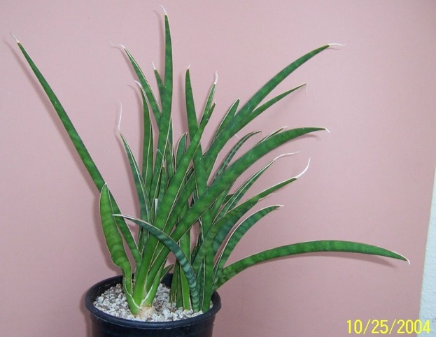
001 046 aethiopica (scabrifolia form) per Al Lauis
recvd as angustifolia ex Dr Chen

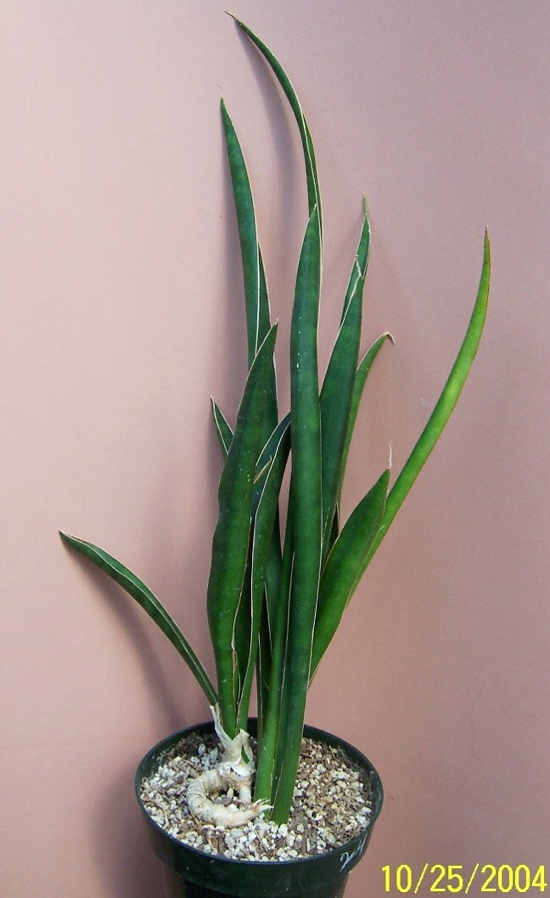
002 016 aethiopica F/C SL 84-125, HBG 55140 (green form?)

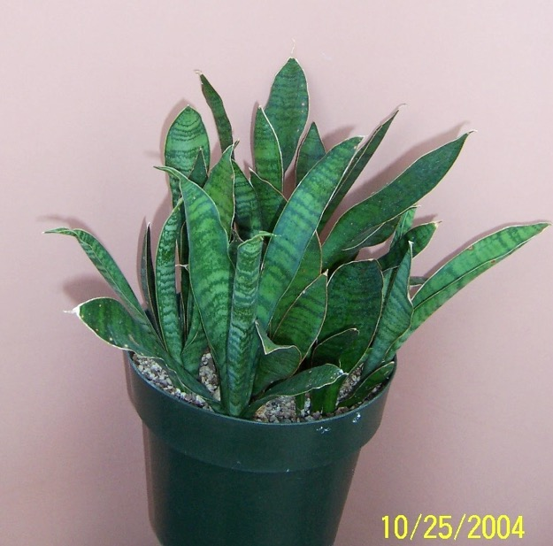
003 035 aff aethiopica ex J.C.

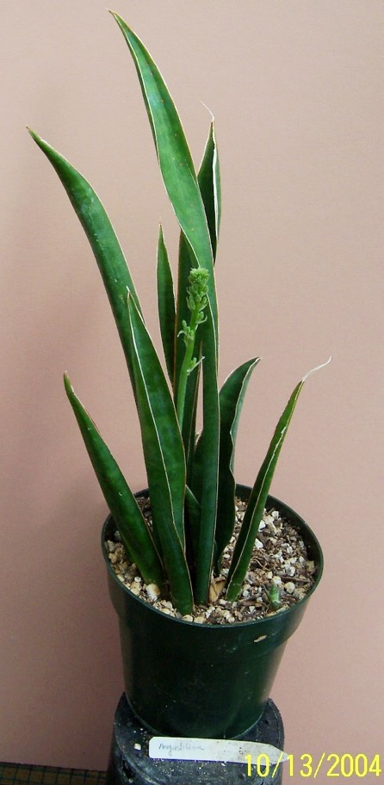
004 070 angustiflora with Inflorescence
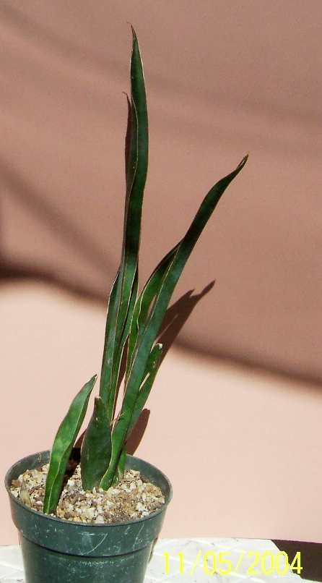
005 12 angustiflora ex Smoley as ‘Lilly’ 5-78
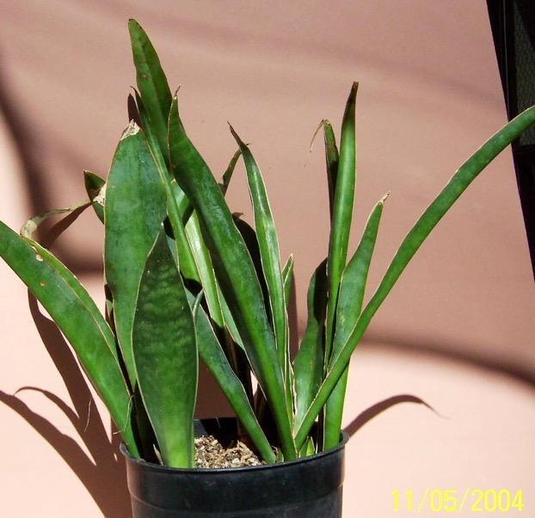
006 13 angustiflora ex Smoley as ‘Lilly’ USDA 193581, FBG 66.632, 1980 (name changed by J.C in 1996

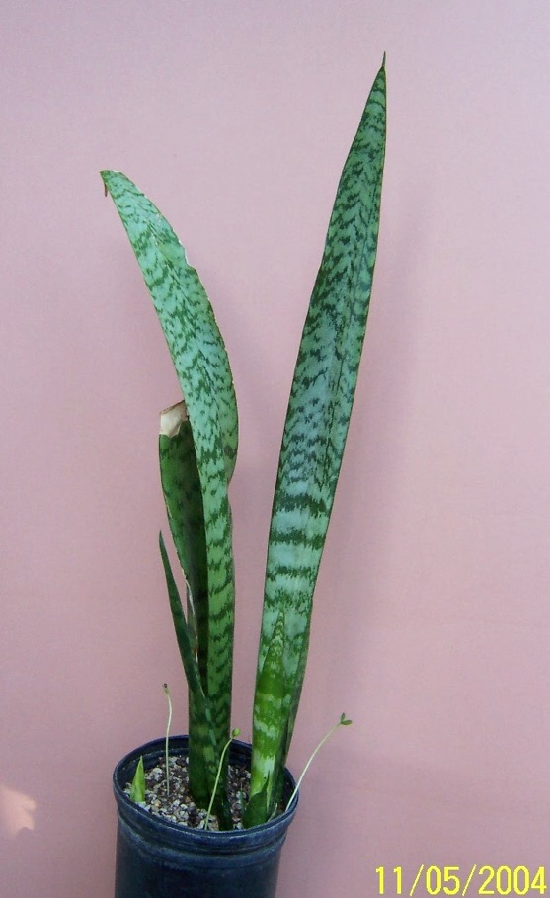
007 28 angustiflora #HBG, ISI 649
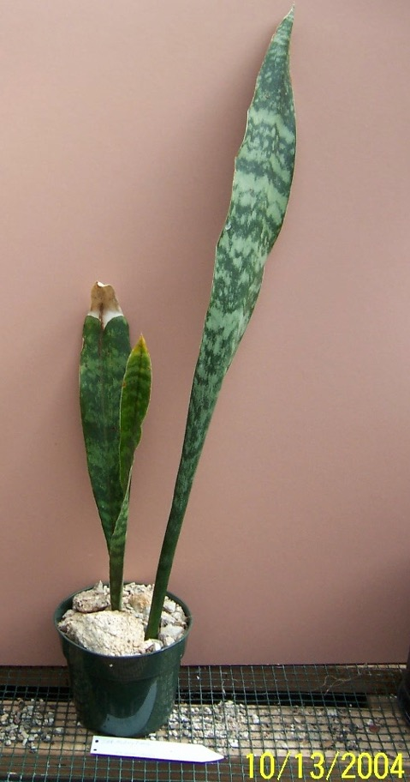
008 071 aubrytiana ex Dan Mahr - longest leaf is ~24” X 4”
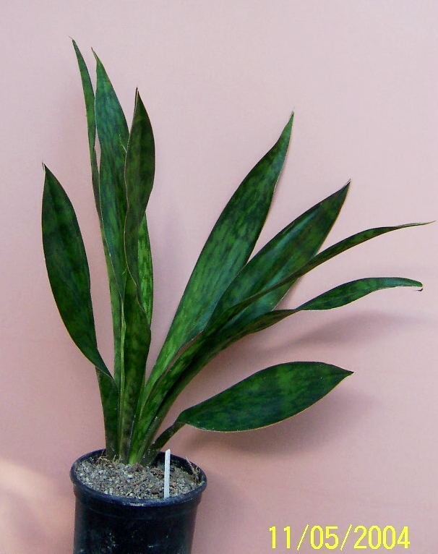
009 27 aubrytiana ex Doctor Mahr.1
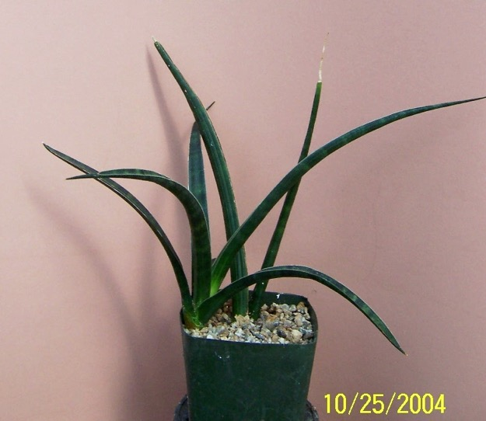
010 022 bracteata HBG 61041 (probably ebracteata)

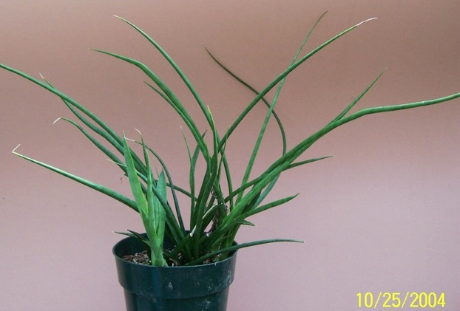
011 011 caespitosa ex JC, clumping, cross-like, SW Africa

012 deleted

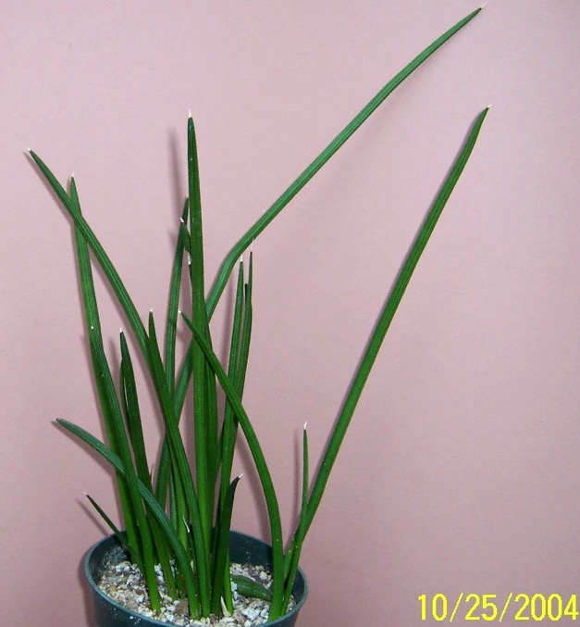
013 055 canaliculata Dwarf ex J.C.

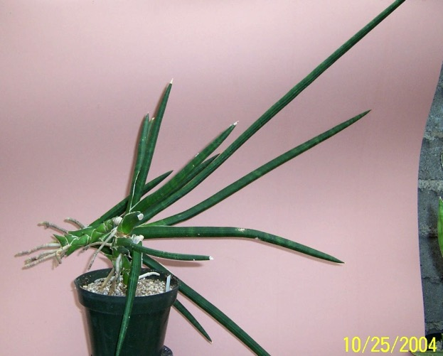
014 003 caulescens could be gracilis

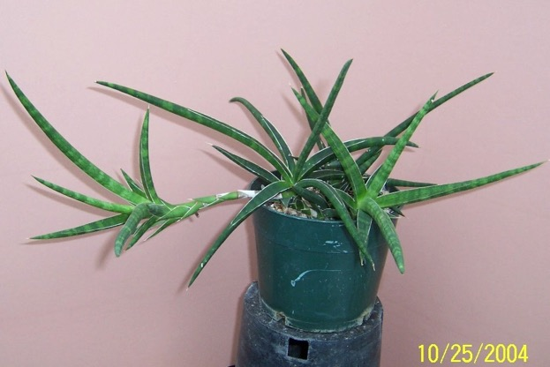
015 042 caulescens

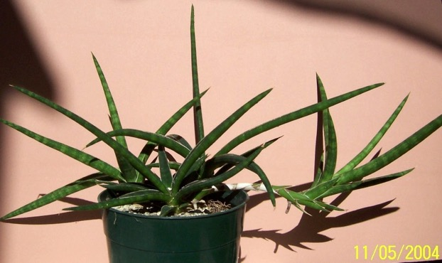
016 18 caulescens HBG

017 deleted
018 deleted
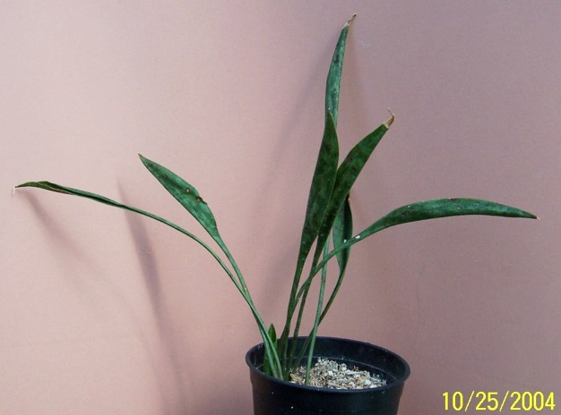
019 027 concinna spoonleaf ex J.C

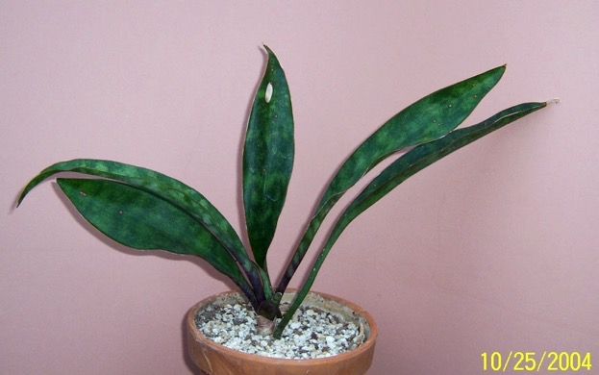
020 059 concinna Pfennig 115 – HBG

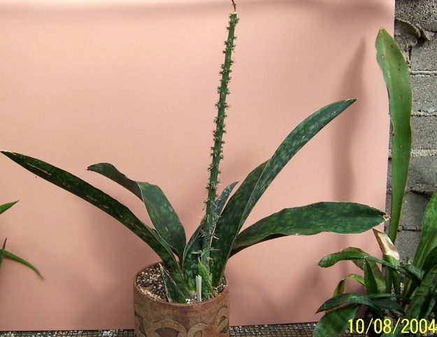
021 073 conspicua

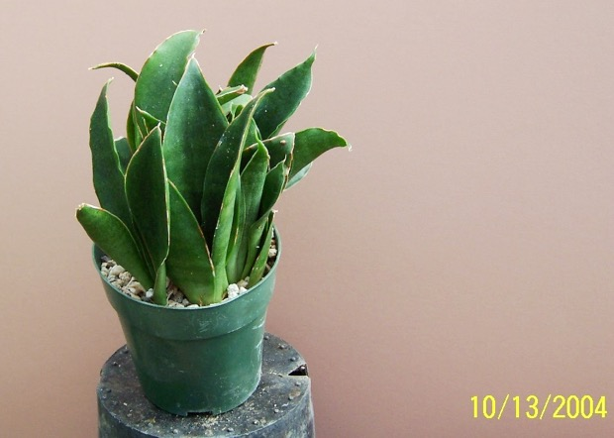
022 074 conspicua Blue Form

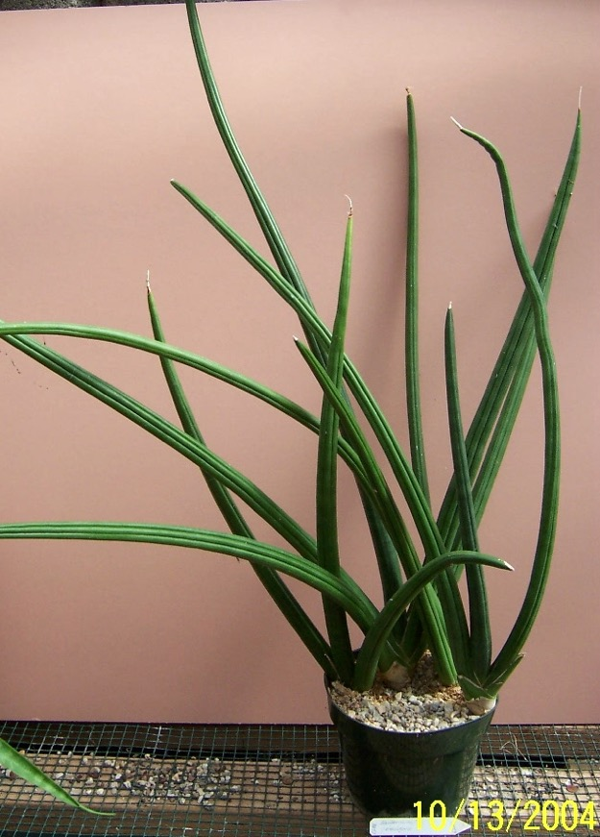
023 07 patens (Ed Eby) HBG 62111, John Bleck e Brown UCSB ‘86021” offset

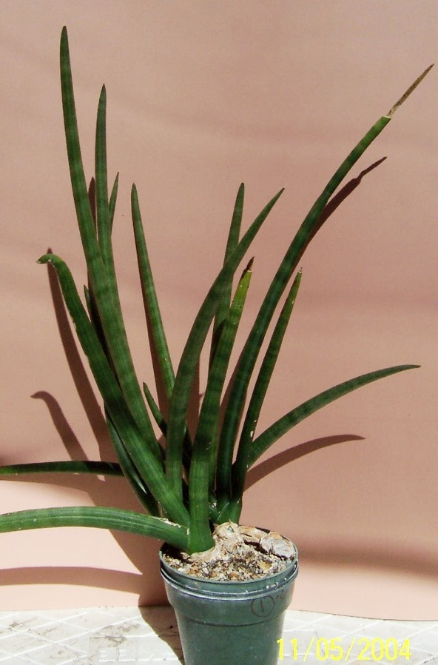
024 01 cylindrica patula ex Vincent Price Estate 1976
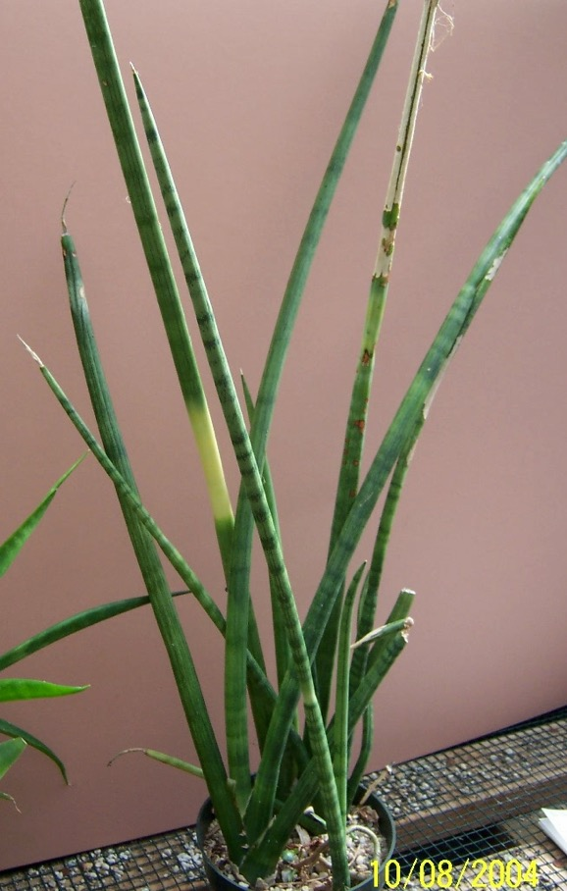
025 076 cylindrica variegata

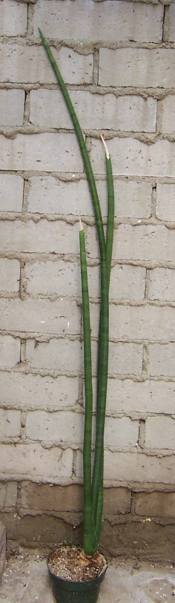
026 077 cylindrica variegateda 3 very long spikes

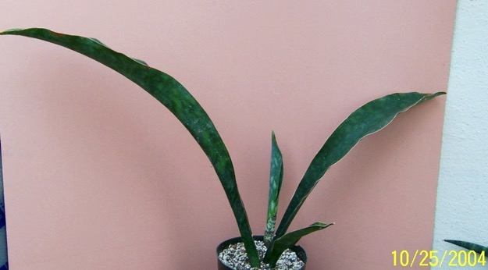
027 036 dawei Uganda, HBG 61031
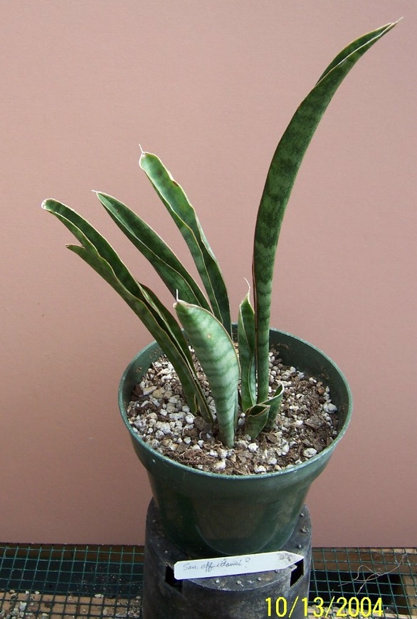
028 069 aff. dawei
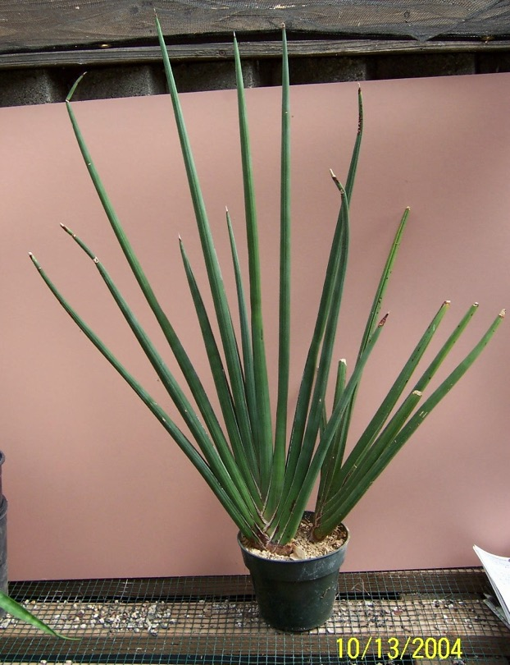
029 078 desertii FC Nyestroom

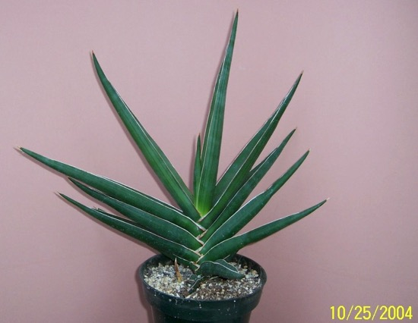
030 054 ehrenbergii juvenille (maybe rorida)

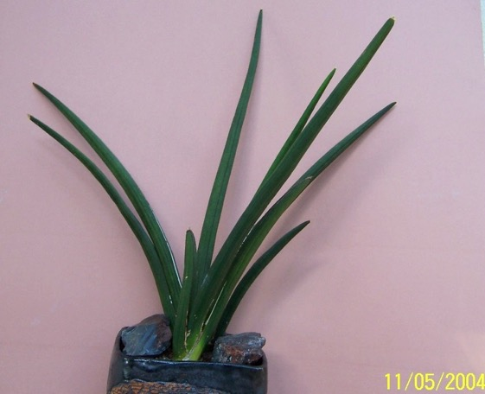
031 26 erhenbergii ex J.C.
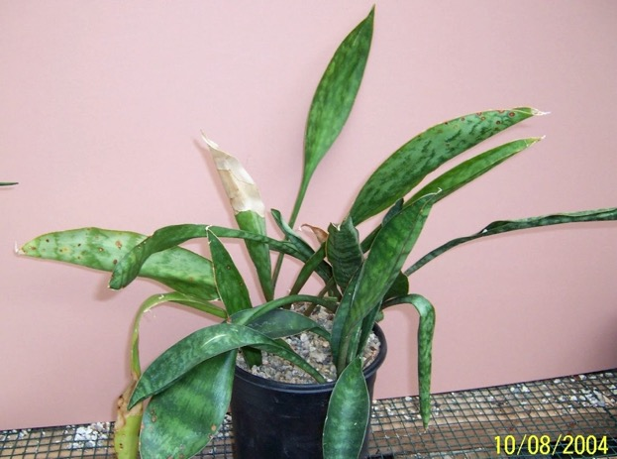
032 080 fasciata

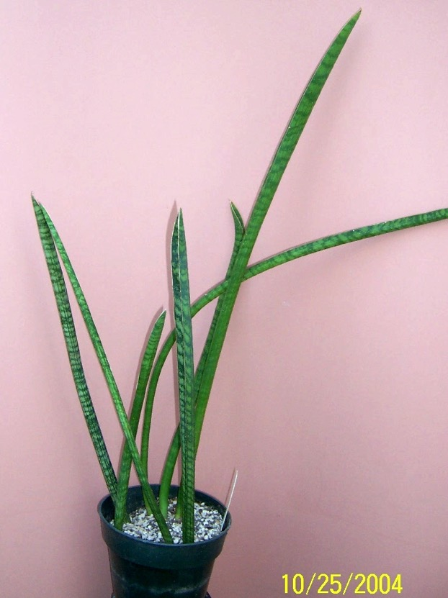
033 033 fischeri formerly singularis

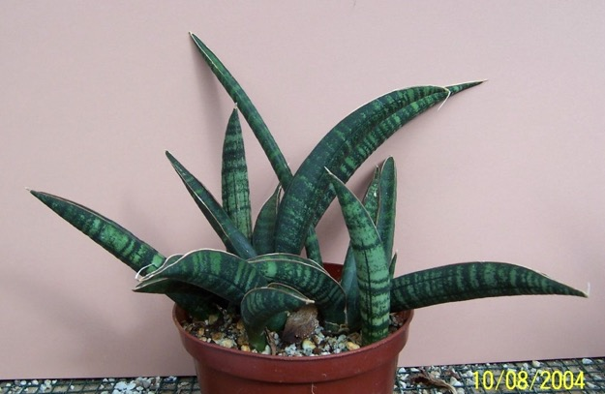
034 082 fischeri Of fl blue, Tanzania

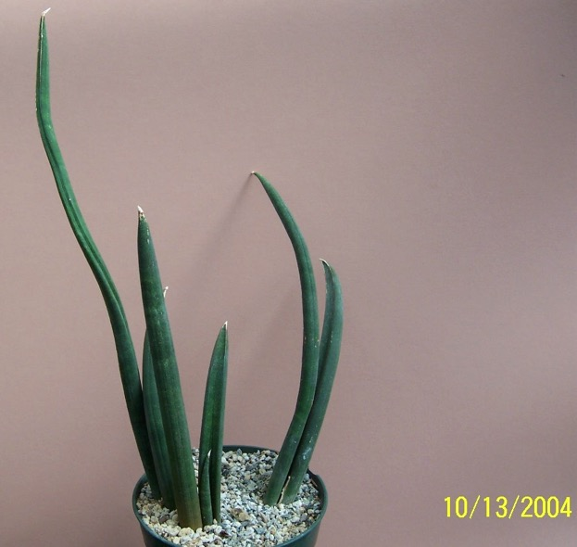
035 083 fischeri ~6 small spikes

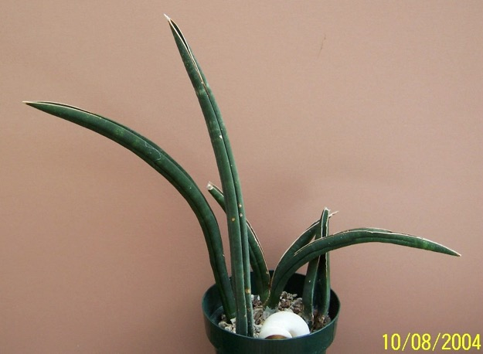
036 081 fischeri – Maktaw

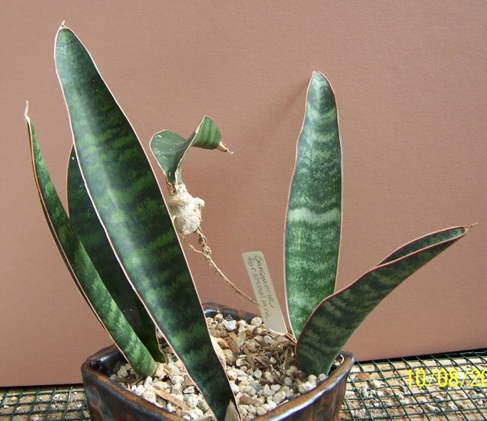
037 084 forskaoliana

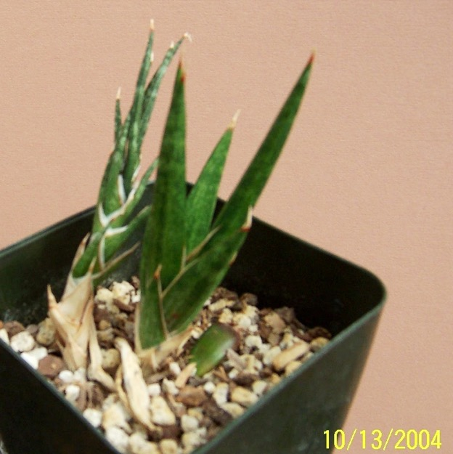
038 085 francissii young plant

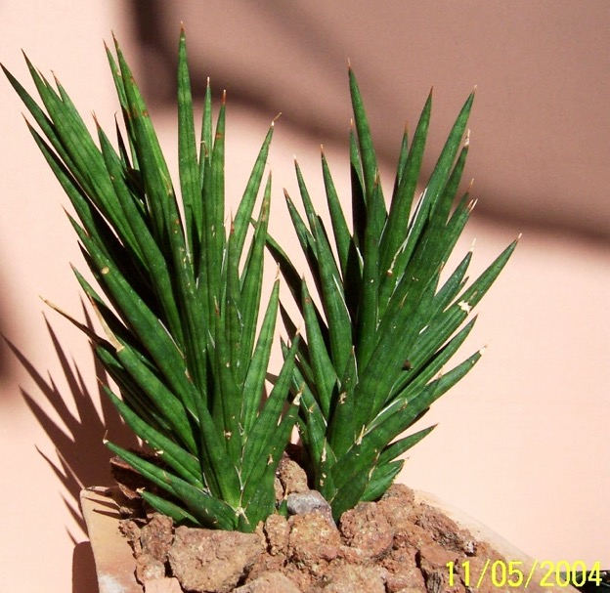
039 14 francissii ex J.C. as FKH 432
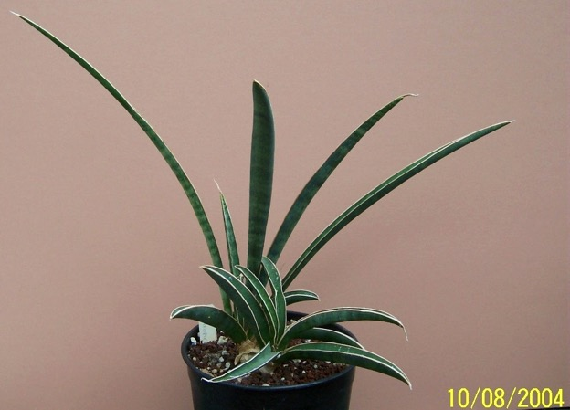
040 086 suffruiticosa

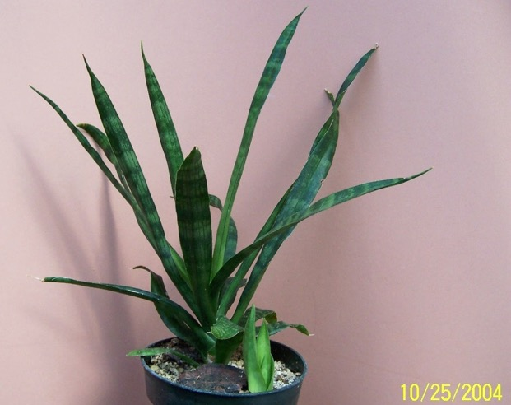
041 024 grandicuspis ex Smoley

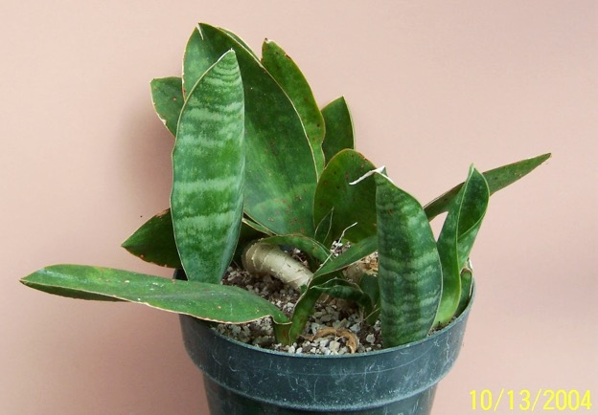
042 087 grandis ex Grigsby's

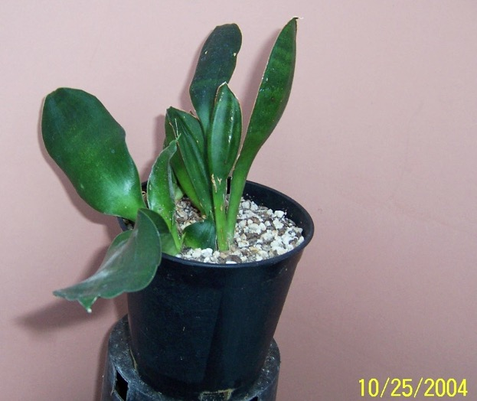
043 066 grandis rosea (subspicata) ex UCBG - ex Rauh – HBG 61019

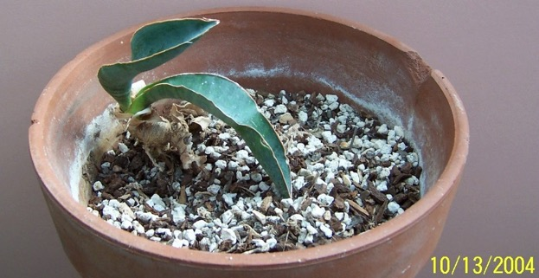
044 088 grandis rosea (subspicata) ex Kirk

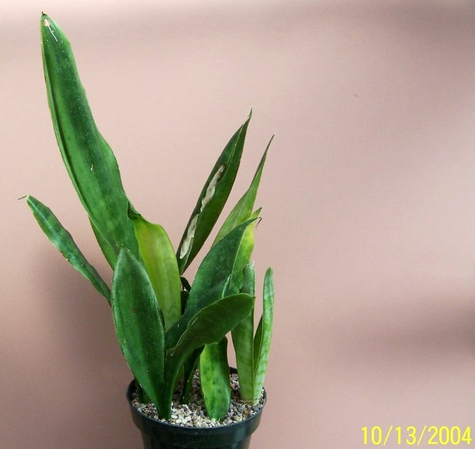
045 089 guineensis 'San Remo

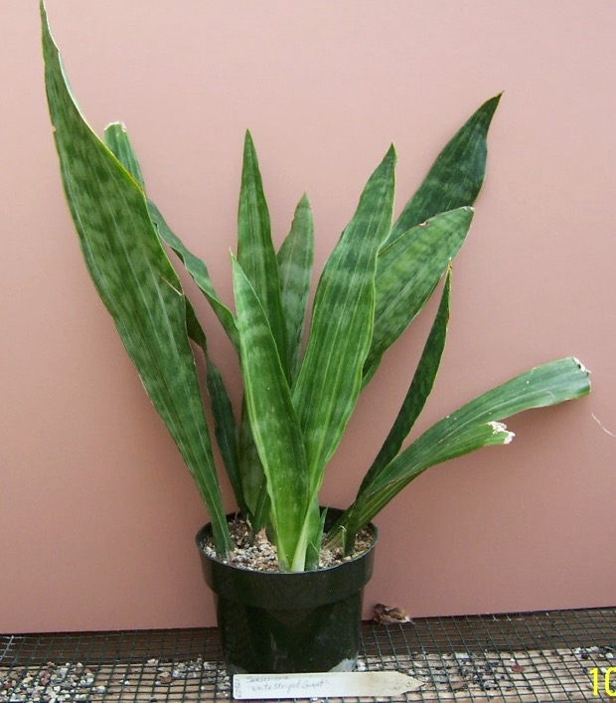
046 090 guineensis 'White Stripped Giant' HBG 60921

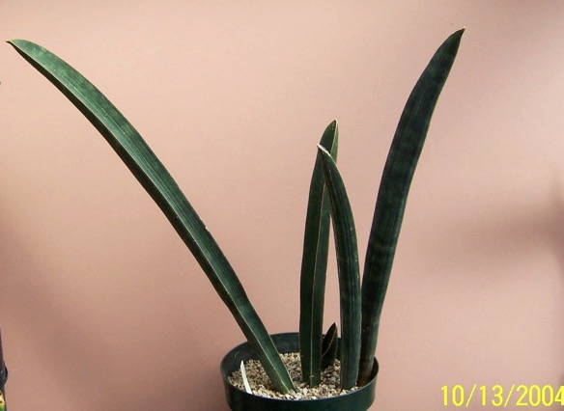
047 091 hallii 'Baseball Bat' #1

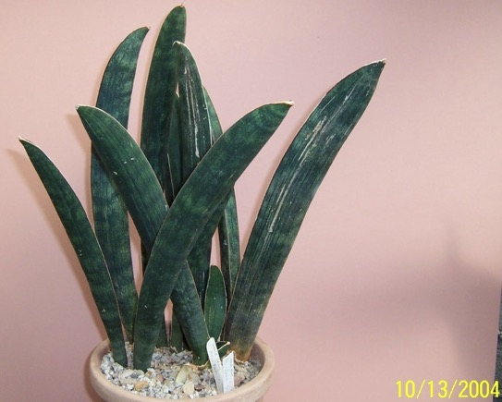
048 092 hallii 'Blue Bat' David Cheng & Juan C. 9

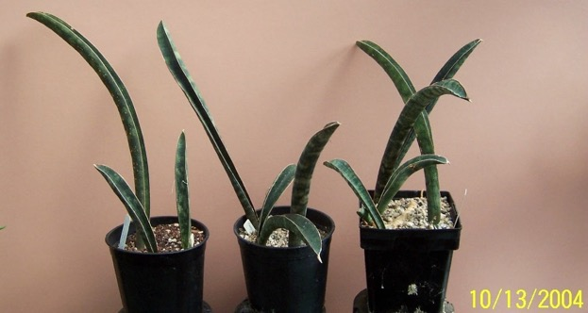
049 093 hallii 'Leopard Bat ex Juan C. [3 similar plants]

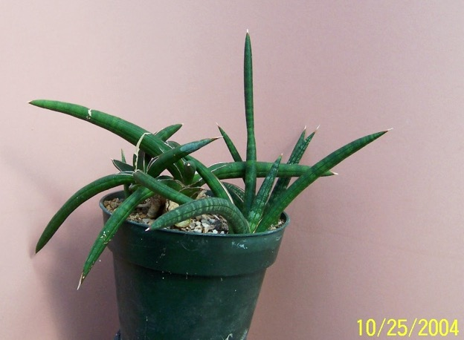
050 019 hargesia ex Grigsby’s – Somalia F/C Lav1970

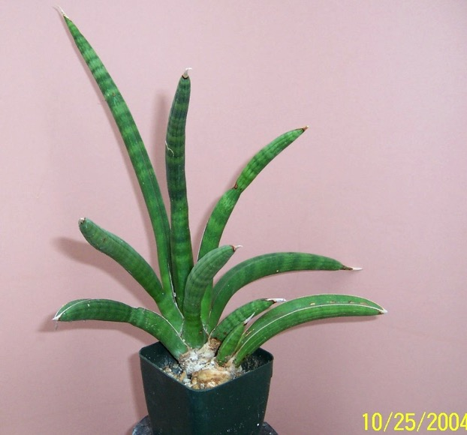
051 037 hargesiana HBG 61013

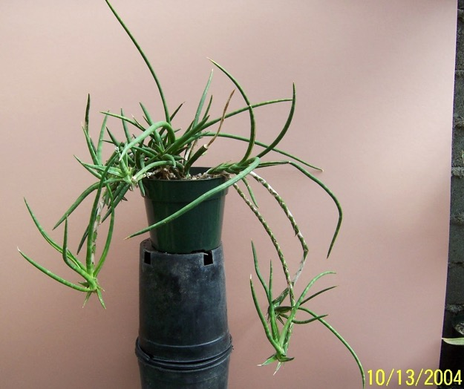
052 094 humbertiana UCSB 81-160 HBG ?

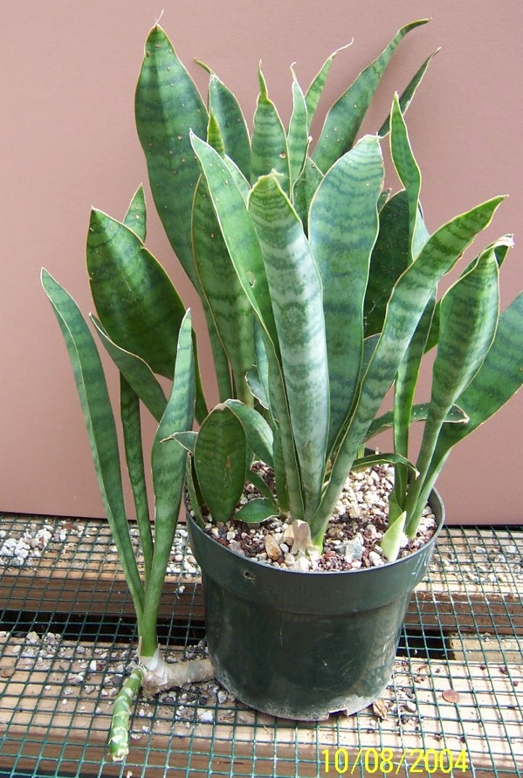
053 095 hyacinthoides ex Manny Singer

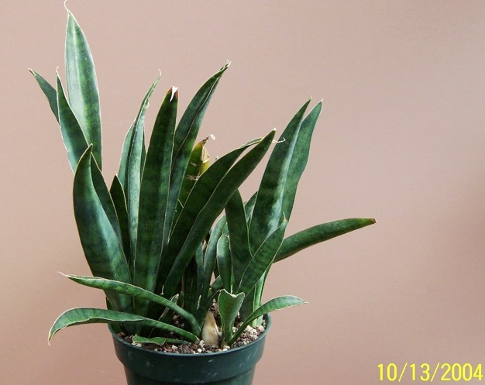
054 096 hyacinthoides MV 4908 HBG 70084
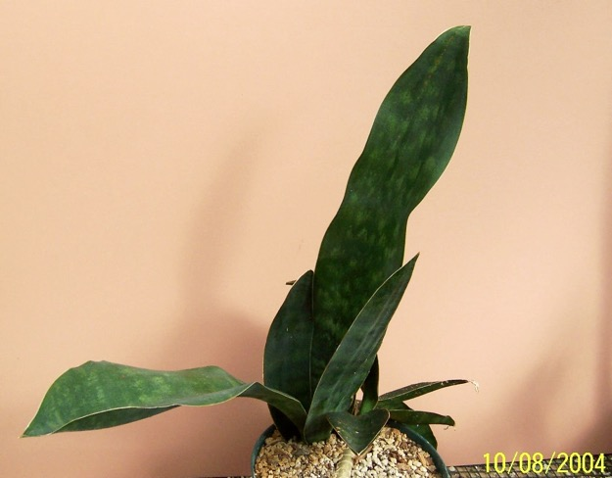
055 097 hyacinthoides 2nd plant

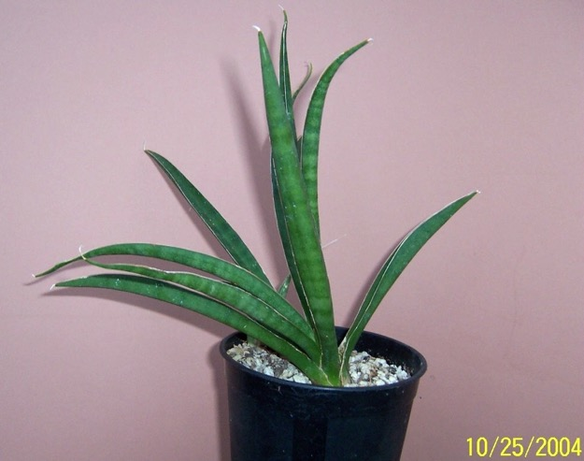
056 060 imbractcata ex Hartelle (correct spelling ebracteata)

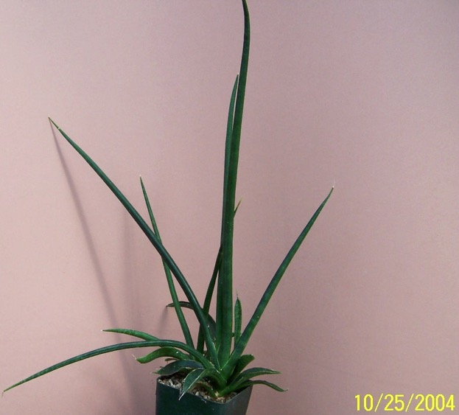
057 020 intermedia ex CSSA show 1993 Pfennig 460, HBG 61071
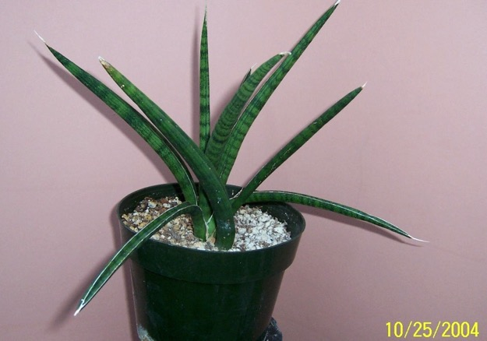
058 061 intermedia ex AH - HBG 80285

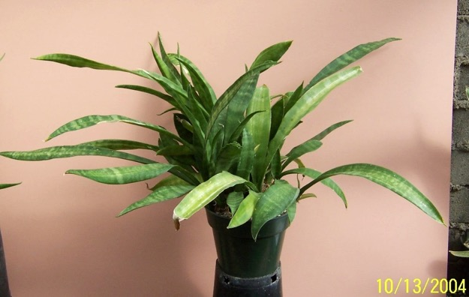
059 098 javanica ex Kenneth Quinn

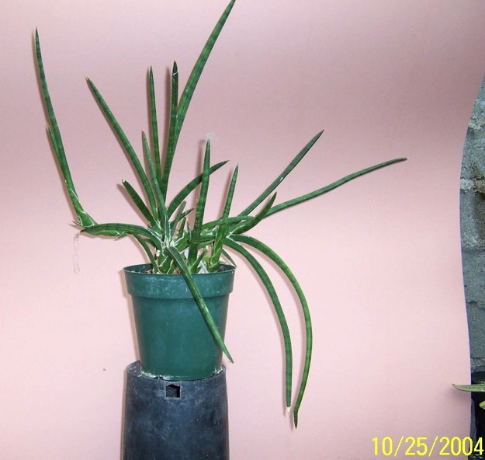
060 007 Juan’s hybrid #10 on his list

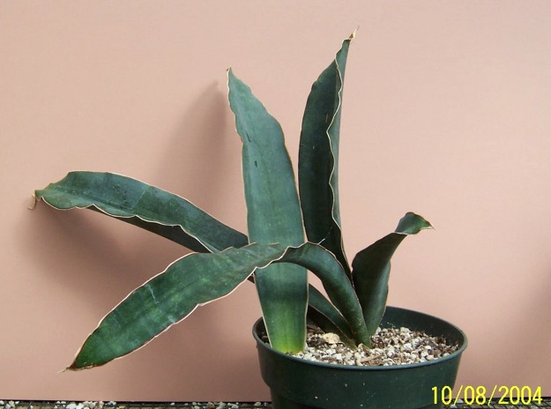
061 100 kirkii Blue Beauty Norma calls it ‘Blue Beauty’

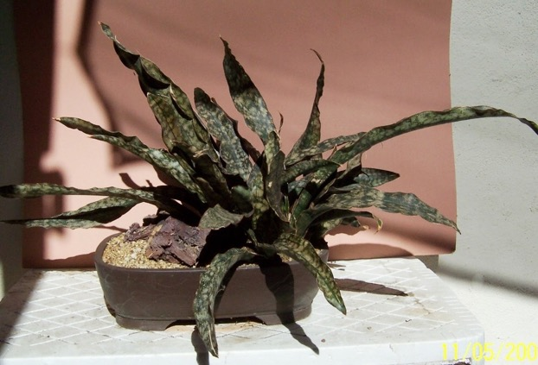
062 04 kirkii pulchra coppertone ex J.C
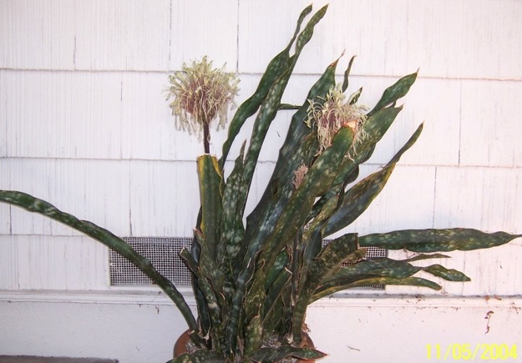
063 02 kirkii pulchra ex HBG Cons (on front porch)
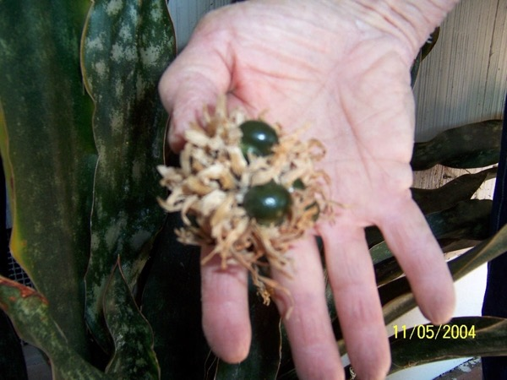
063a 02a kirkii pulchra seed
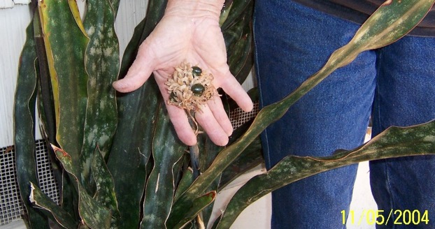
063b 02b kirkii pulchra seed2
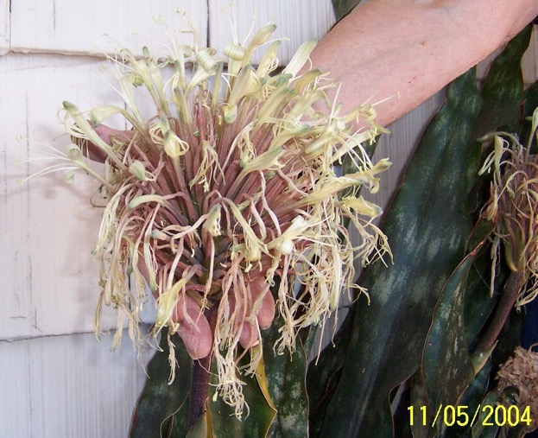
063c 02c kirkii pulchra flower head
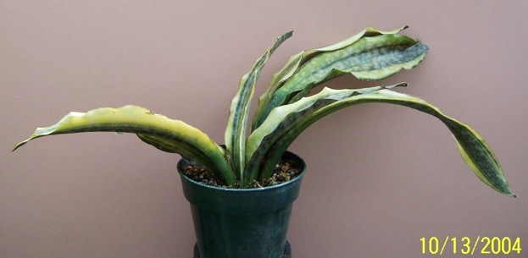
064 101 kirkii pulchra variegata ex The Plant Man

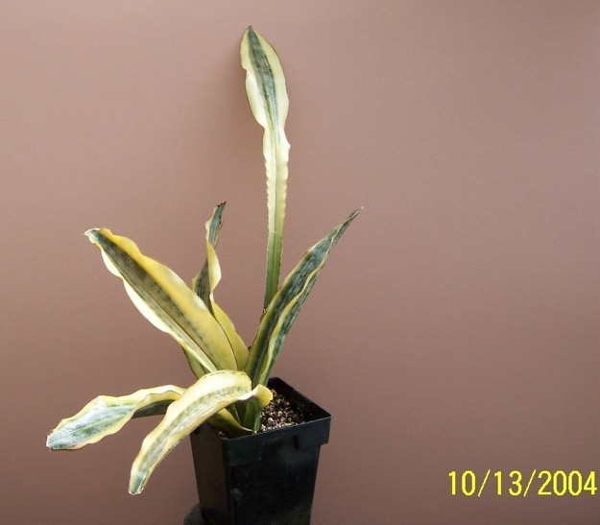
065 102 kirkii pulchra variegata no tag but ID obvious

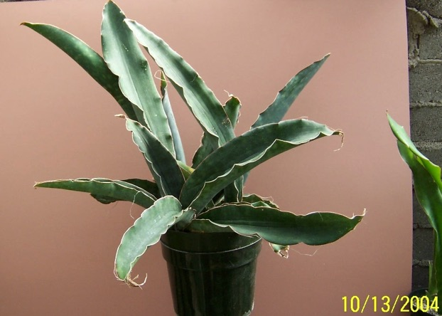
066 103 kirkii var kirkii superclone ex Grigby’s

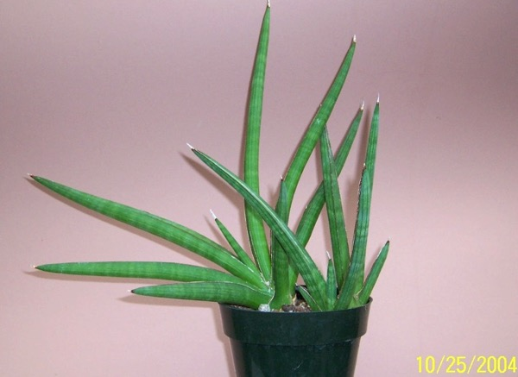
067 006 sp Koko 0-11/98 – ex Lee Eby
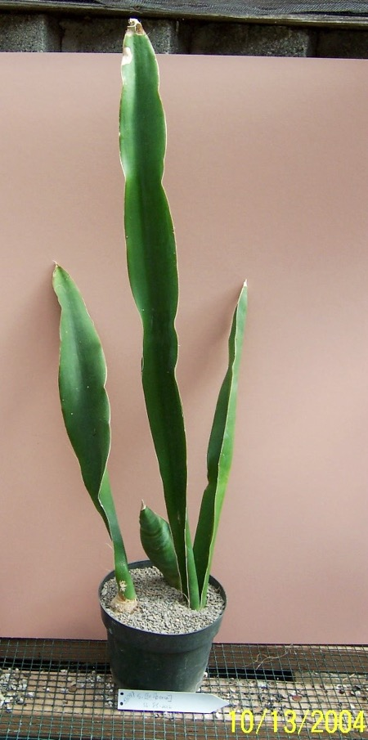
068 cf. liberica SL-85-2012 – HBG 55097

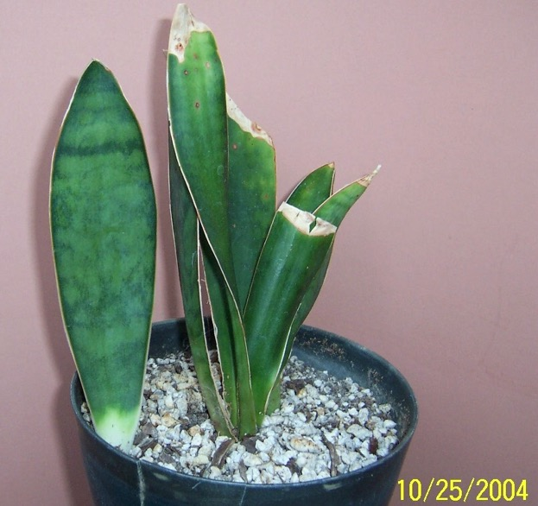
069 067 macrophylla

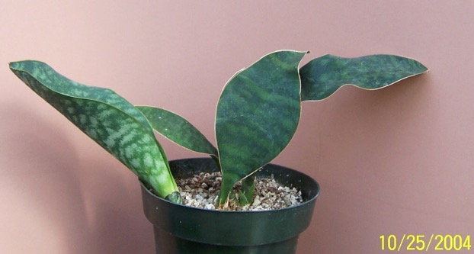
070 030 masoniana

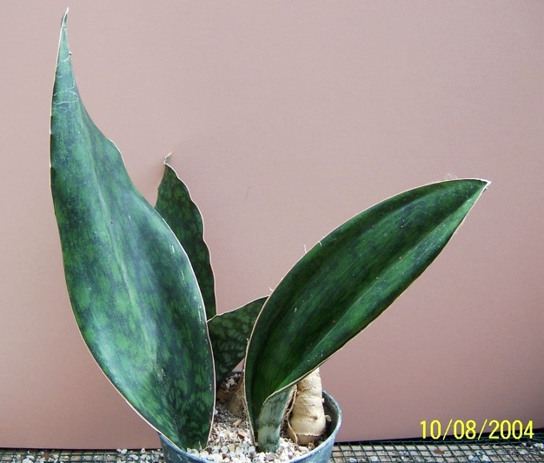
071 104 masoniana

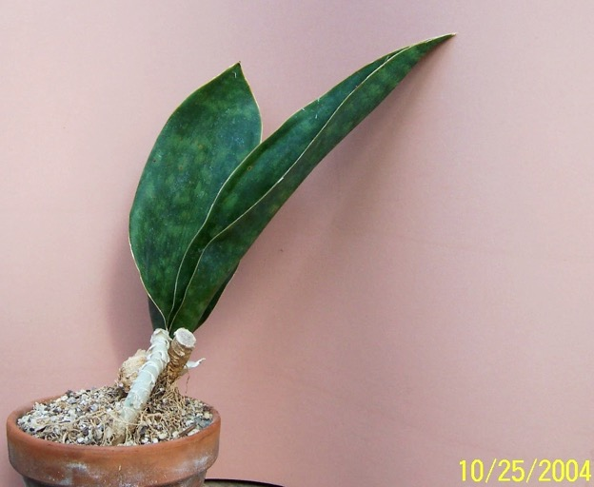
072 015 masoniana (large form) HBG
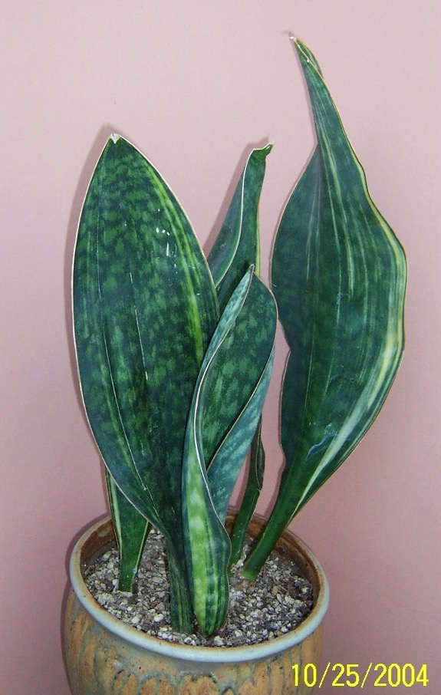
073 034 masoniana variegata ex J.C.

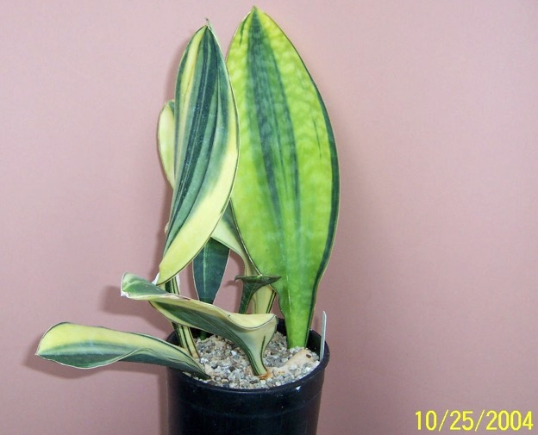
074 044 masoniana variegata ex J.C

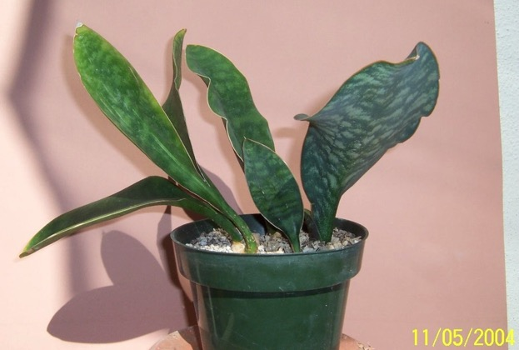
075 05 masoniana variegata ex J.C.

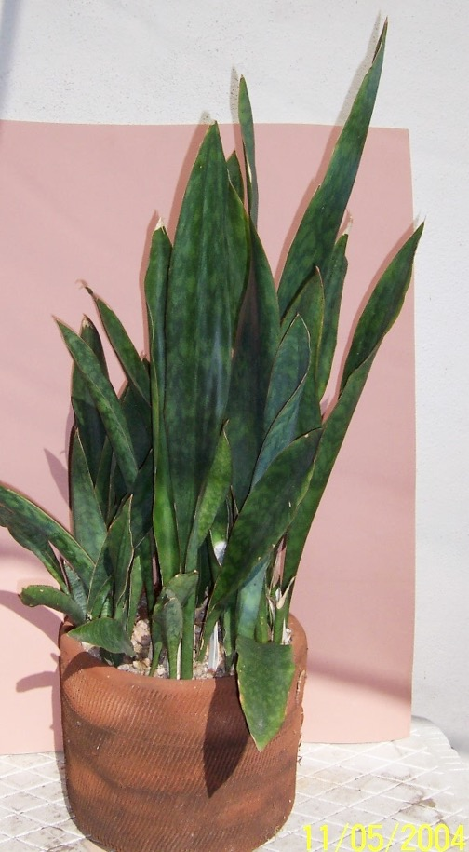
076 03 metalica ex Grigsby’s, 1978
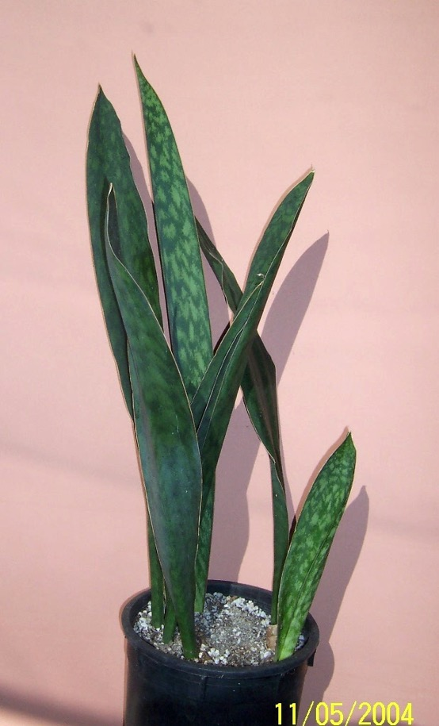
077 22 metalica maybe

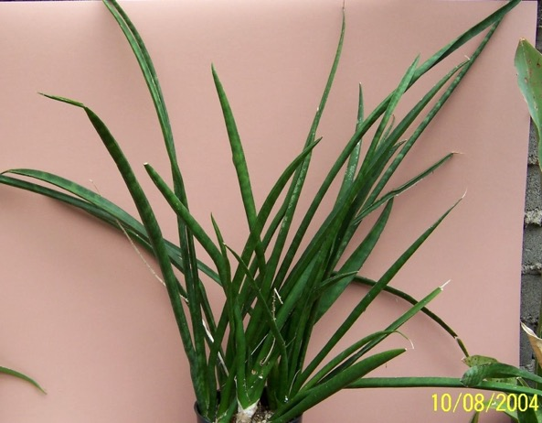
078 105 Midnight Star (deserti x trifasciata) ex Juan USDA 19514

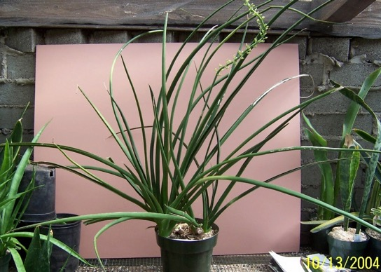
079 105a Midnight Star (2nd plant)
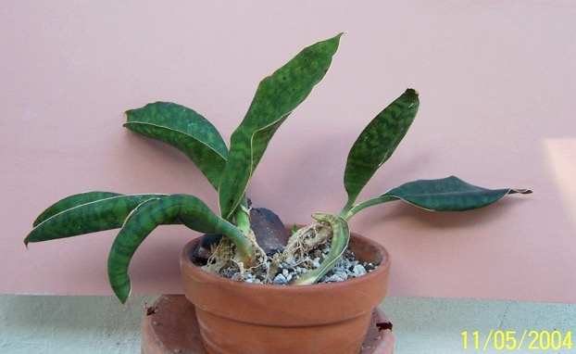
080 25 No Name Seedling ex Teneriffe Botanical Gardens, Canary Islands 4-12-89, End sp AED

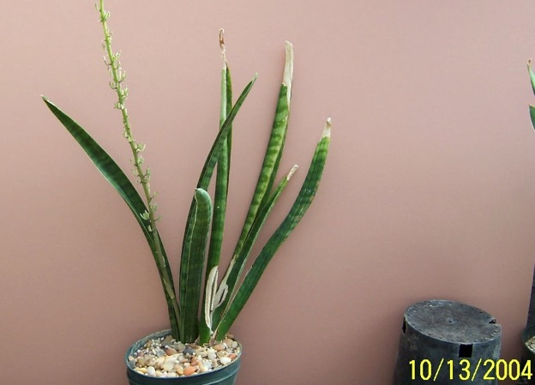
081 106 NOID #01 (aethiopica?) -with inflorescence

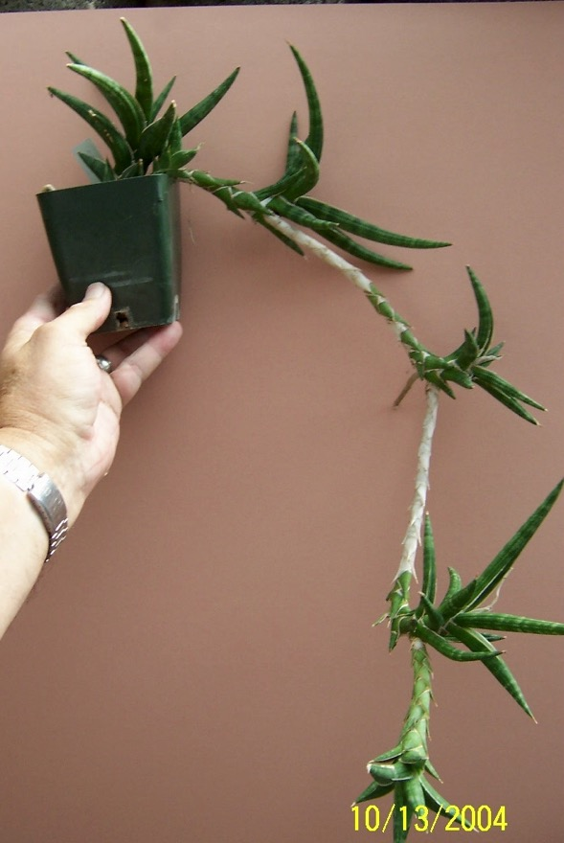
082 107 NOID #02 (ballyi) tag says Alan Butler

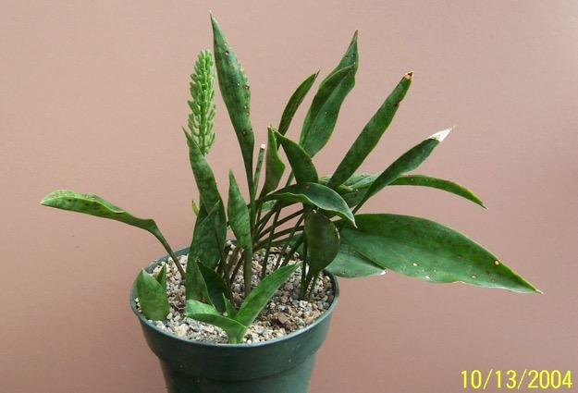
083 108 NOID #03 (concinna?) with inflorescence

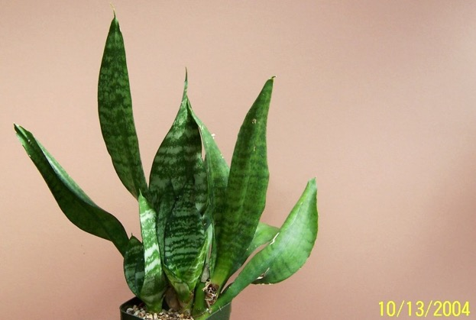
084 109 NOID #04 Moonshine Reversion
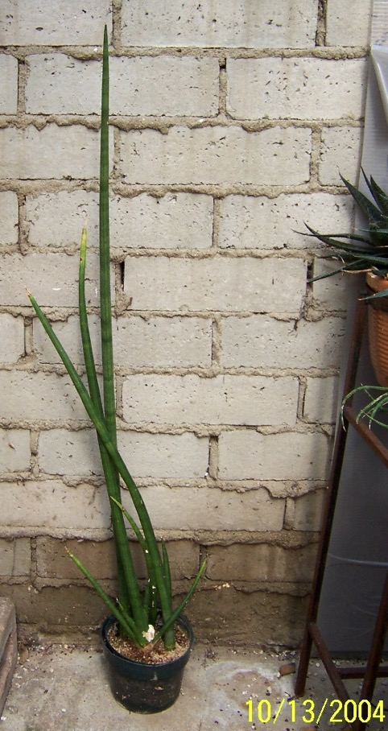
085 110 NOID #05 (cylindrica?)
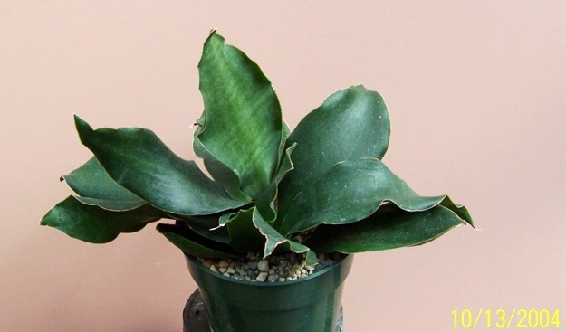
086 111 NOID #06 grandis rosea?) in 6” pot]

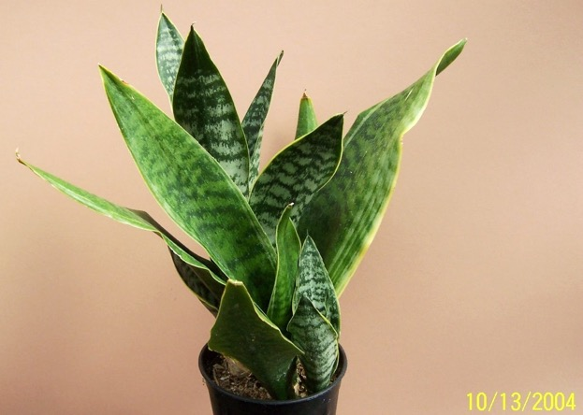
087 112 NOID #07 (trifasciata futura?) short-wide - gilt edge

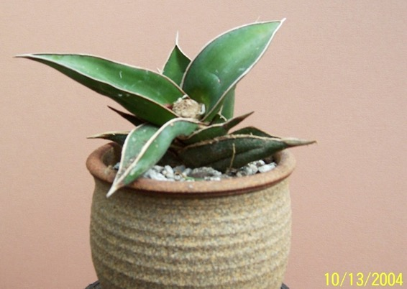
088 117 NOID #08 (pinguicula or rorida?) GIVEN TO DALE 10/22/04
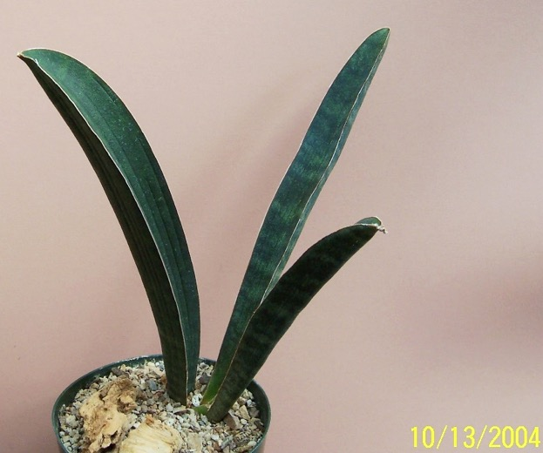
089 113 NOID #09 (hallii Blue Bat’?)
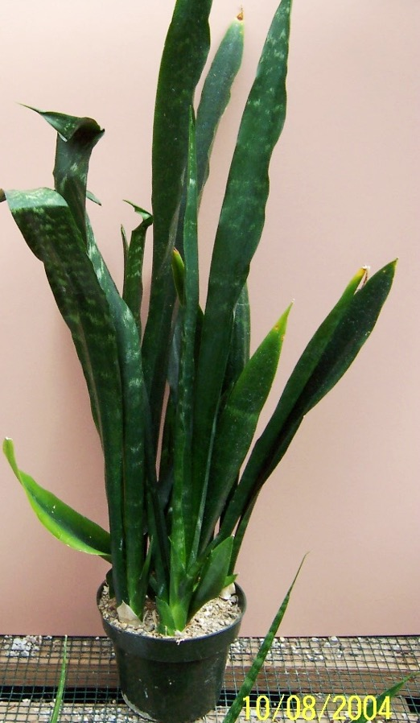
090 115 NOID #10 sp large plant with crescent X section med green
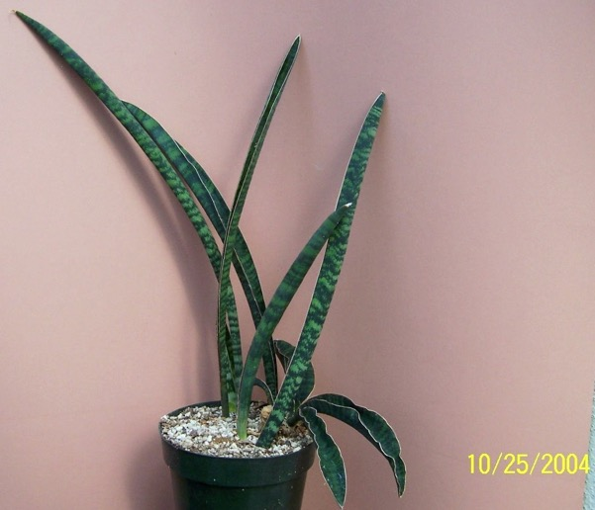
091 017 NOID #11 Hawaiian Sea King (?)

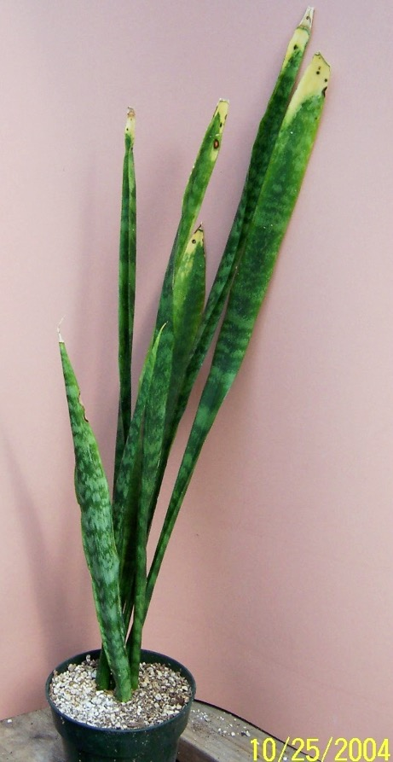
092 018 NOID #12 ex Smoley (note golden tips on lvs)

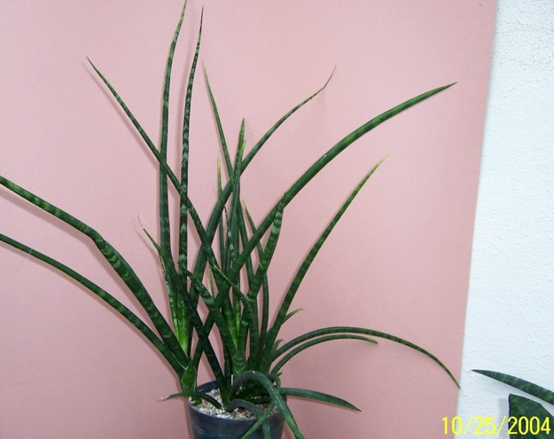
093 043 NOID #13 fountain like – could be t. 'Stellette'

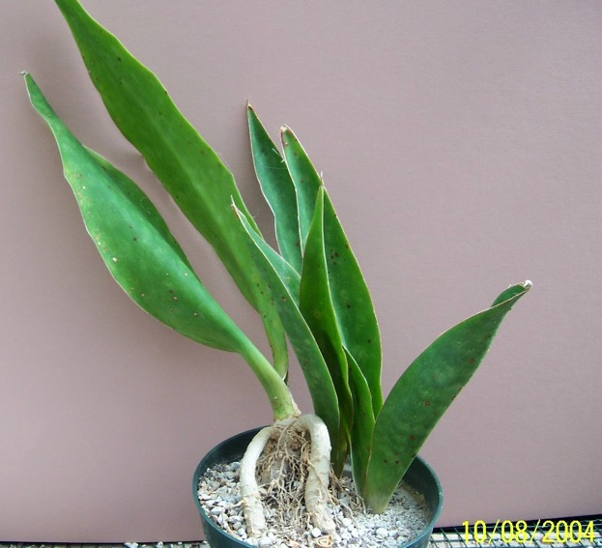
094 116 NOID #14 sp .Kansas University 1-12-83 EnSp from AW

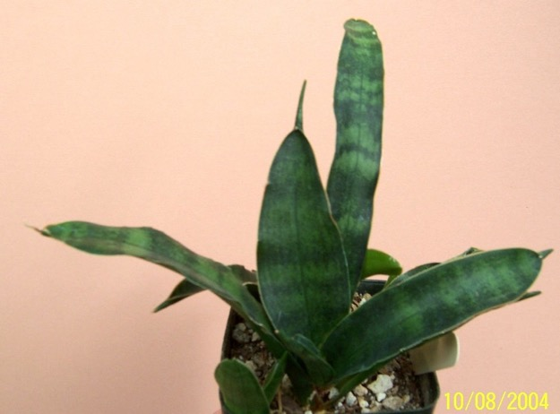
095 114 NOID #15 sp looks like conspicua

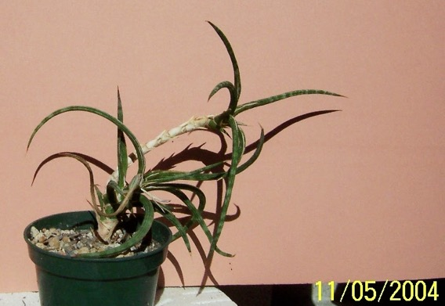
096 19 NOID #16 ex HGB (scrappy plant that looks like ballyi or phillippsiae
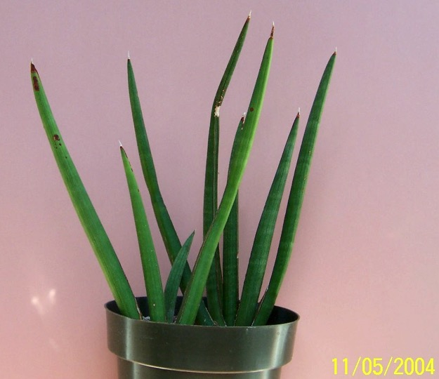
097 20 NOID #17 looks like sp ‘Koko’

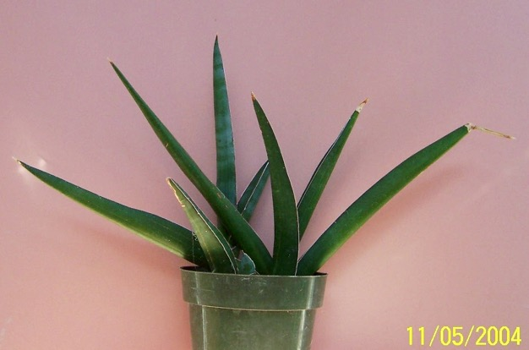
098 21 NOID #18 looks like rorida

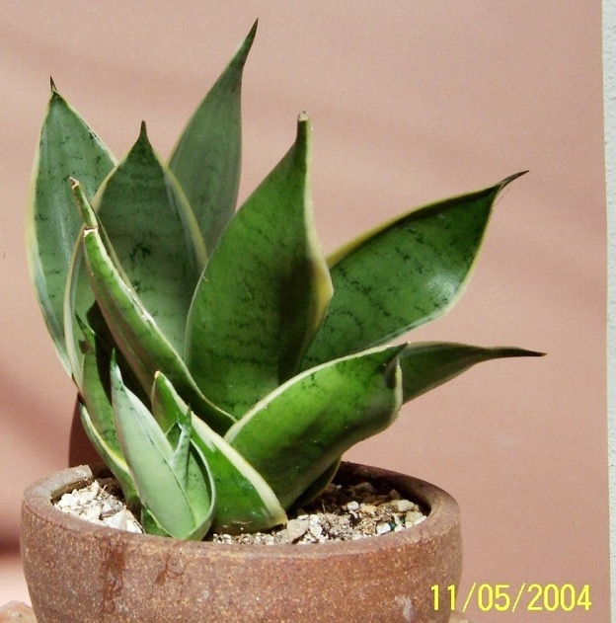
099 07 NOID #19 hahnii silver marginted type

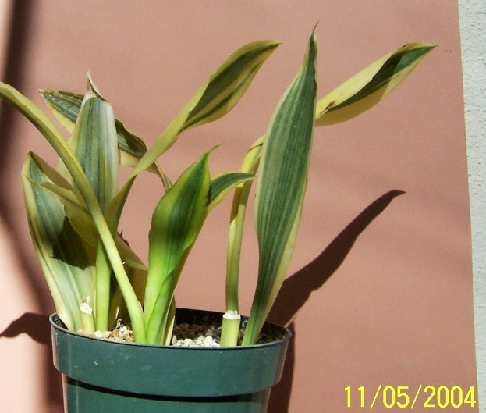
100 08 NOID #20 could be t. ‘Craggi’

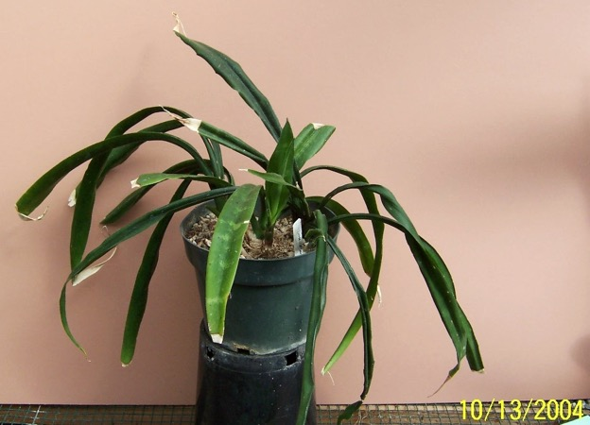
101 118 dooneri (previously named parva)

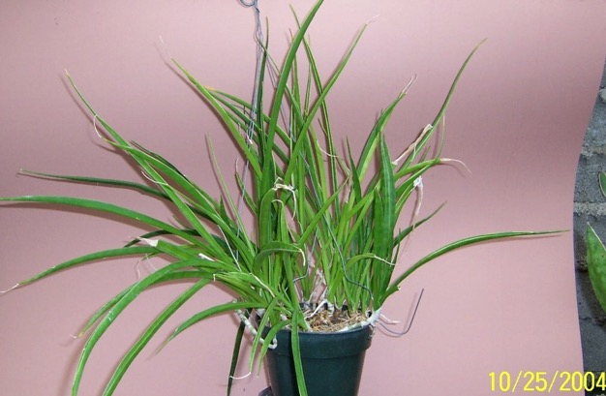
102 005 parva Gilt Edge ex Manny Singer

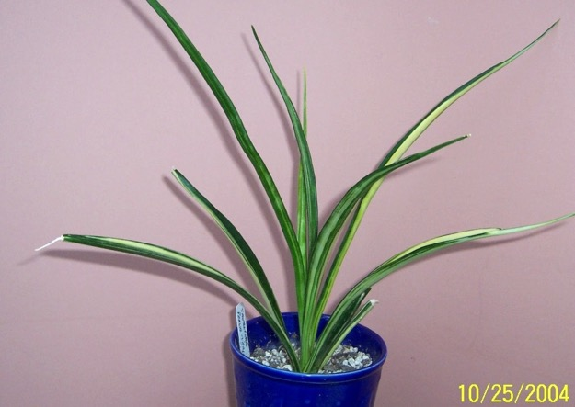
103 063 parva variegata

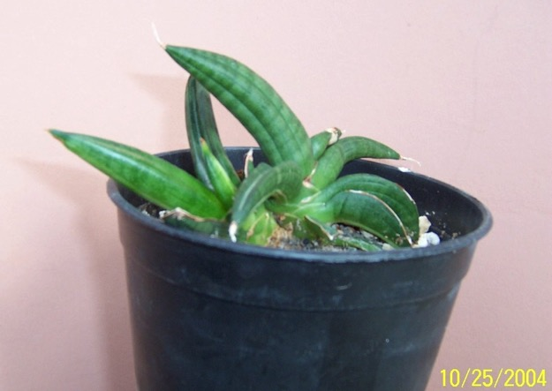
104 021 patens variegata AW – showing variegation in new growth
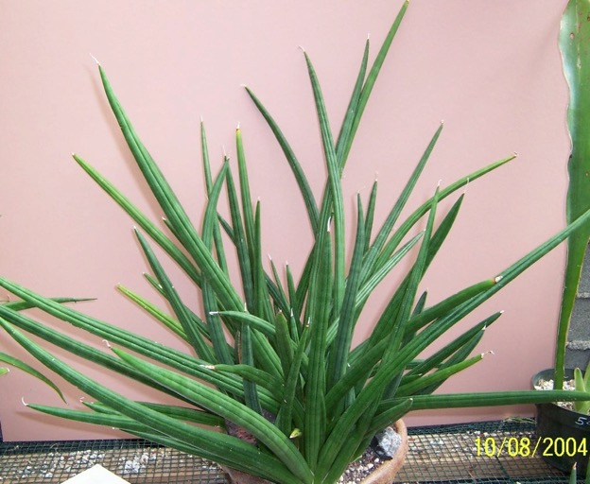
105 119 patens

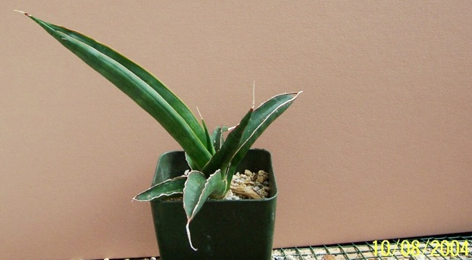
106 120 pearsonii

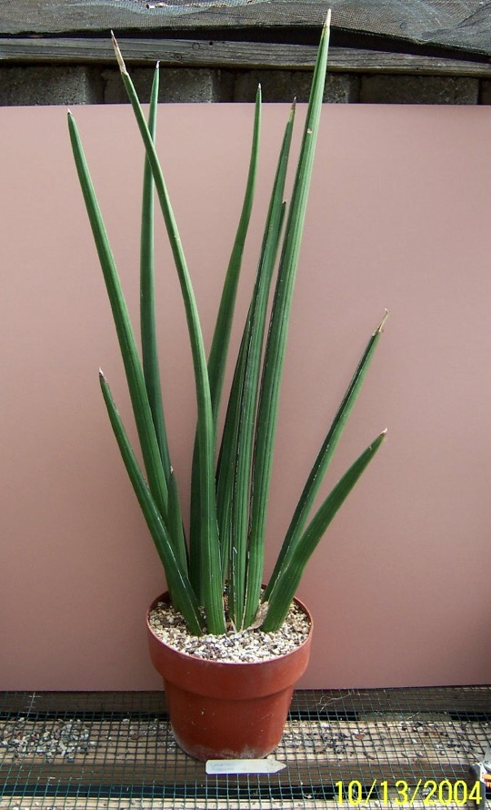
107 121 pearsonii Tumbleweed 1993

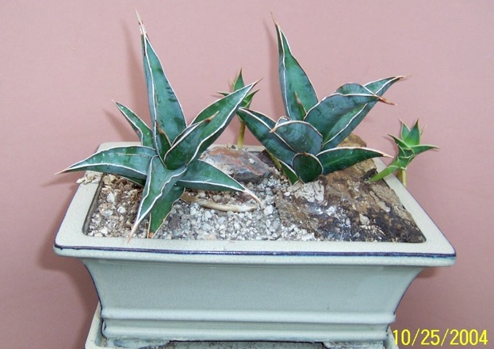
108 039 pinguicula ex Northridge Gardens

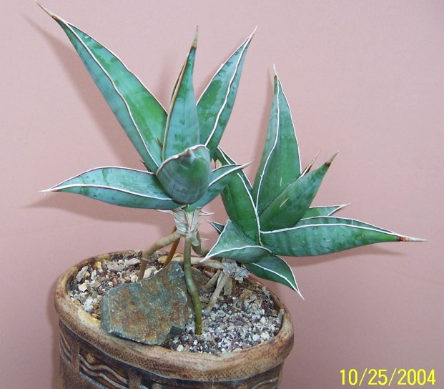
109 040 pinguicula ex J.C., LAV 12240, Kenya

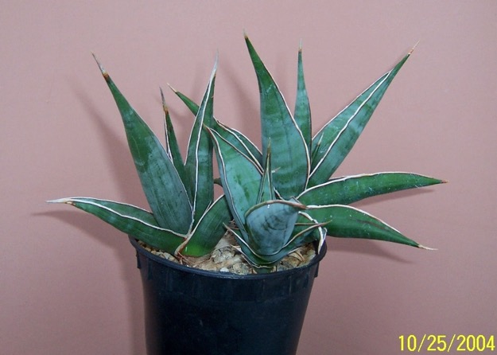
110 045 pinguicula HBG 54463, Kenya, lvs in a loose rosette to 8”,

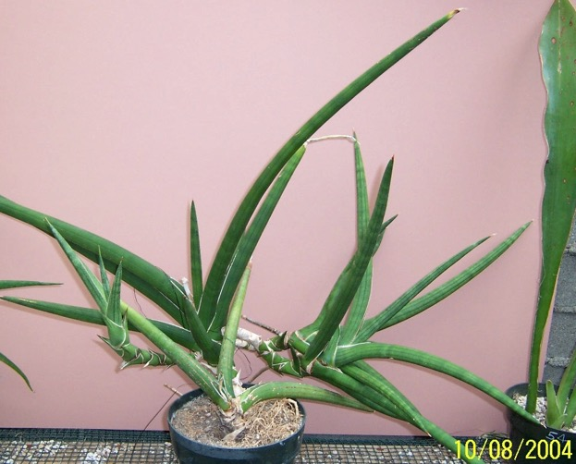
111 123 powelii (or not?)

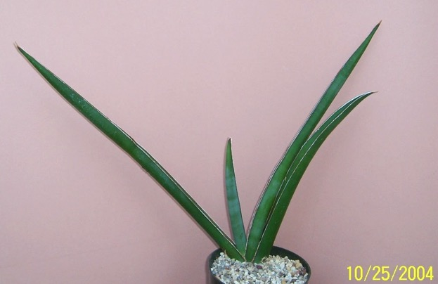
112 050 robusta (?) Not trifasciata robusta – 9.94GR

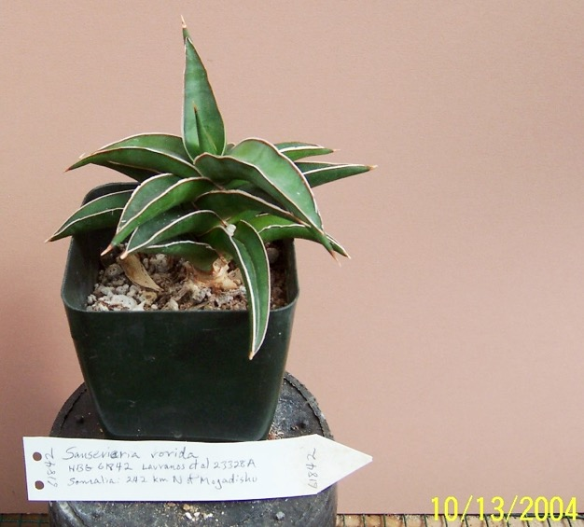
113 124 rorida HGB 61842 Lav et al 23328A

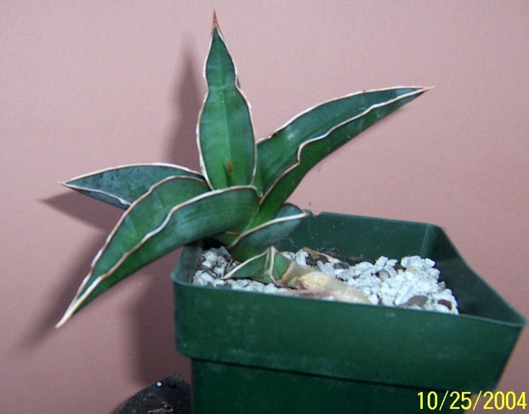
114 062 rorida juvenille

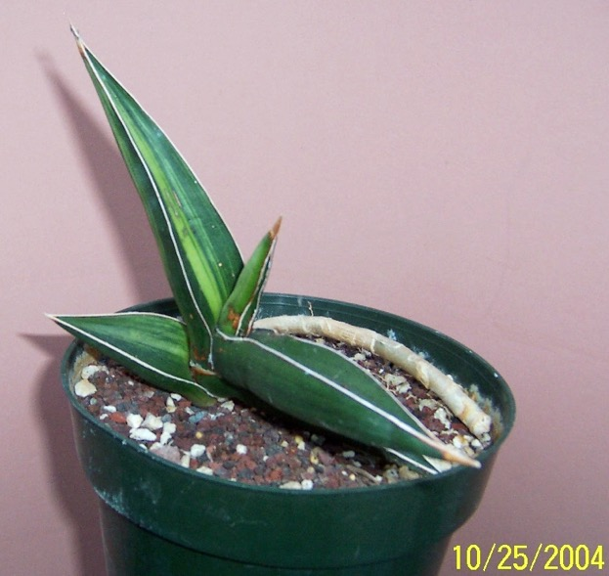
115 057 rorida variegata recurved form ex J.C

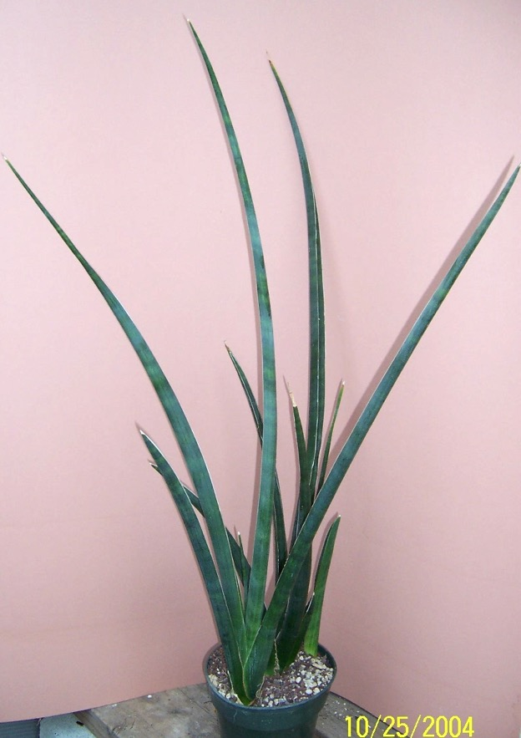
116 047 roxburgiana 08/96\

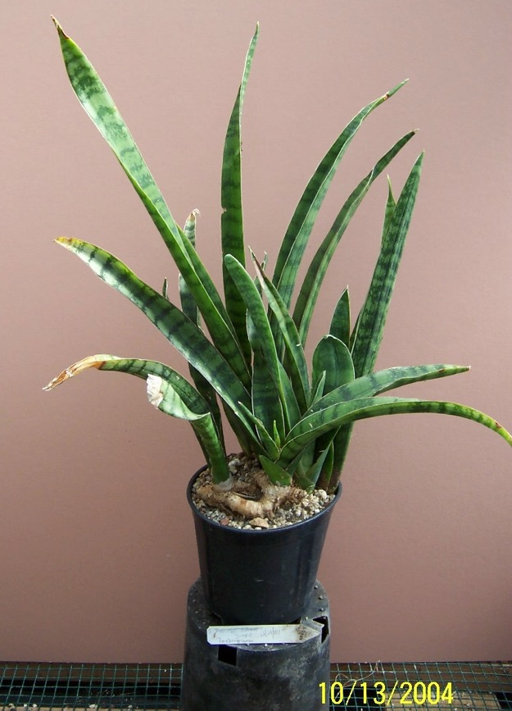
117 125 roxburgiana J C, 12-28-01 {rough under leaf]

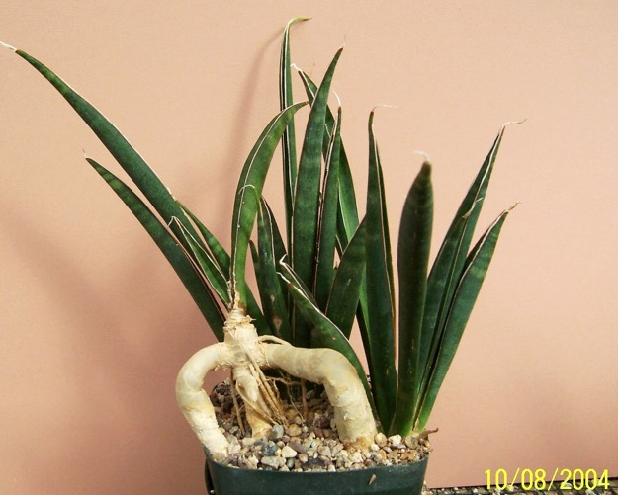
118 126 scabrafolia aka aethiopica

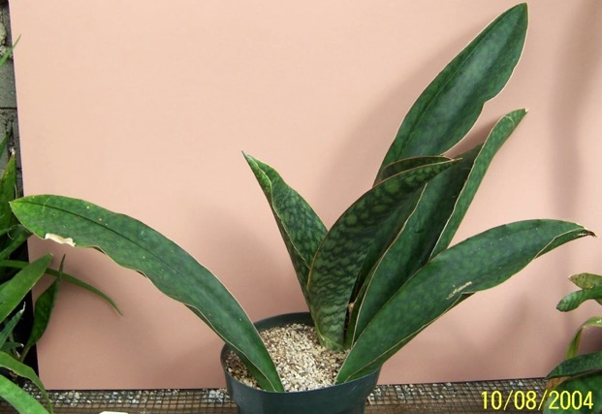
119 127 seronera Jerry Barad, Tanzania

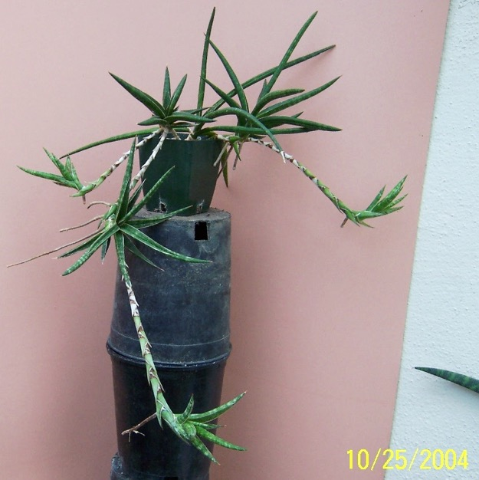
120 038 sp aff ballyi F/C Wangala Sta Lav-Bleck

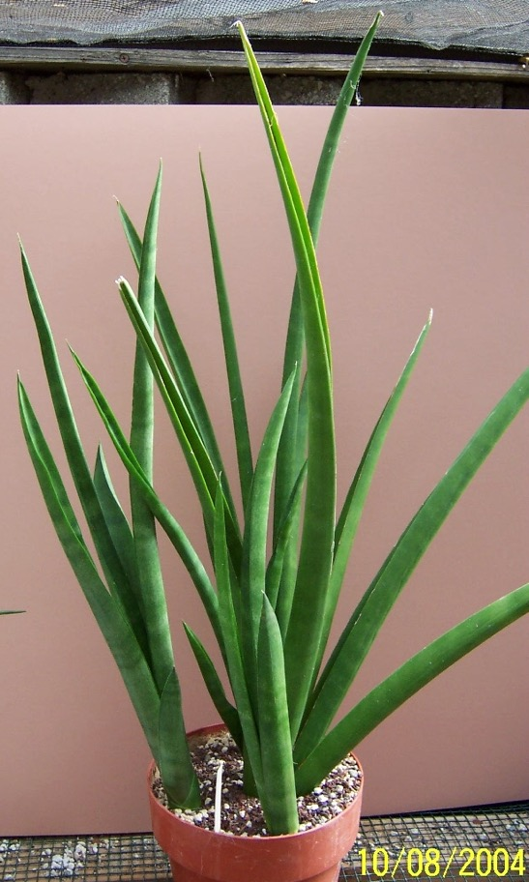
121 128 sp. ‘Alva' from Koko crater
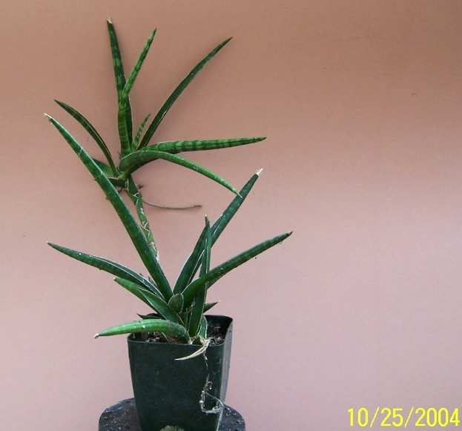
122 010 sp. AW MB FC Wangala Sta. #3, near Voi, Kenya
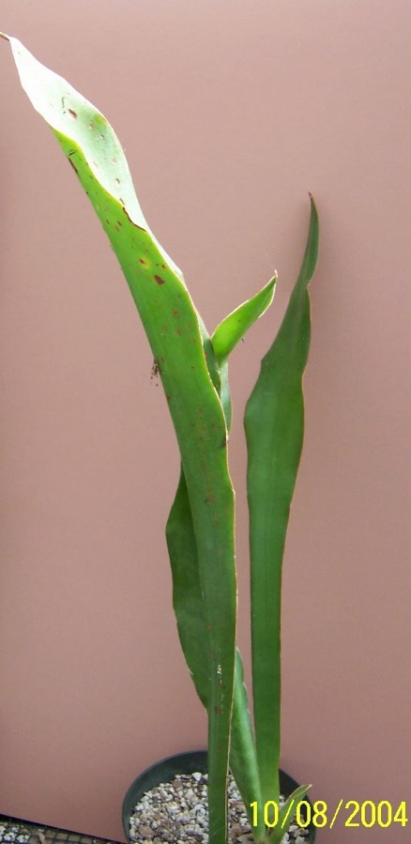
123 130 sp. ‘Chimanimani Mtns 48661021 1st plant'

Missing Photo of this plant
124 129 sp. ‘Chimanimani Mtns 2nd plant

125 131 sp. ‘Dr J. Barad’ Tanzania 1971 (looks like Masoniana)

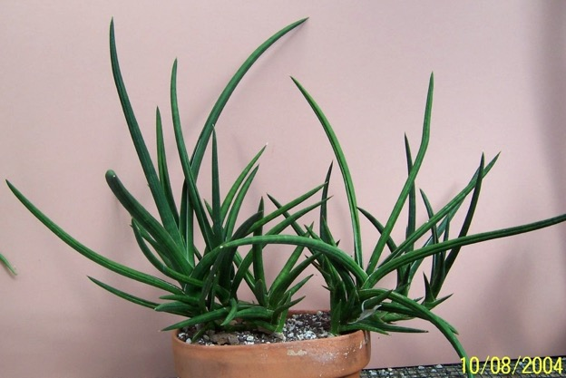
126 132 sp. ‘Galana' 'Galana' is probably sp. 'Galana Ranch'.
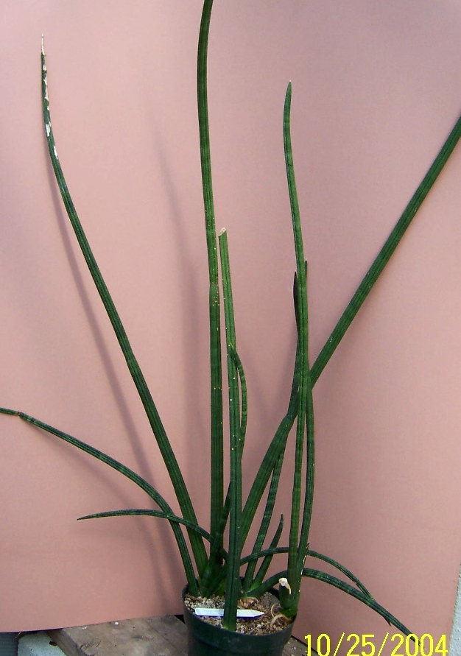
127 013 sp ‘ Galana Ranch’? FC Poways S.N. 8/12/86,
Galana Ranch, Kenya; HBG 65339
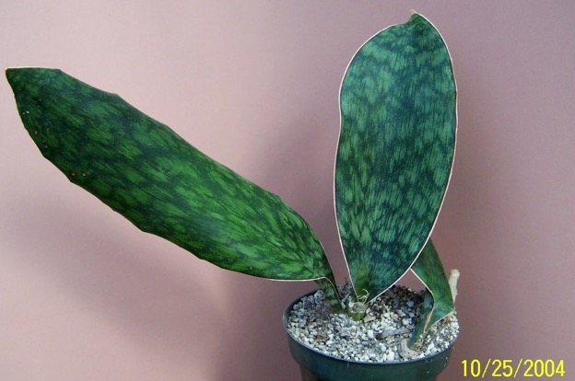
128 028 sp ‘Horwood’ ex Abbey or Northridge Gardens

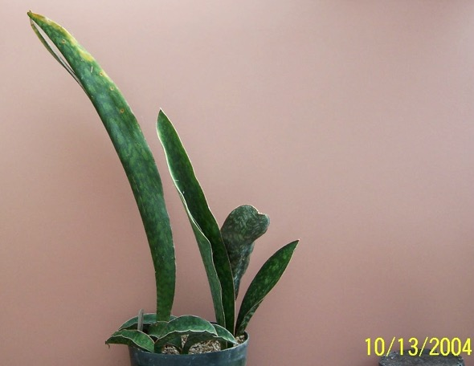
129 133 sp ‘Horwood’
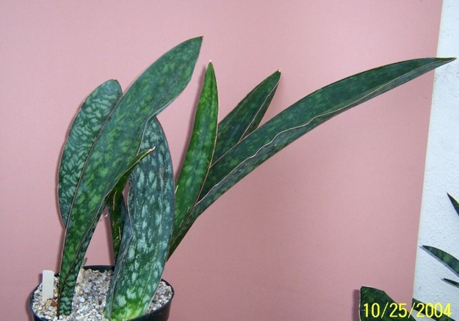
130 058 sp. ‘Horwood’ Large mature plan

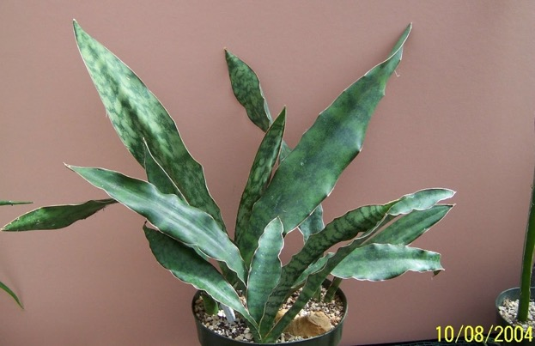
131 134 sp.‘Horwood’ [tag says horwoodi]

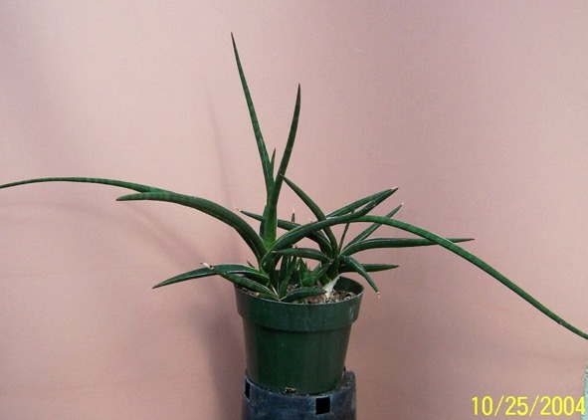
132 014 sp. ‘Ian Turner’ Ian Turner , Zaire

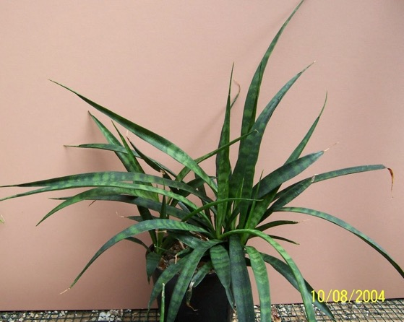
133 135 sp. ‘Kenya'
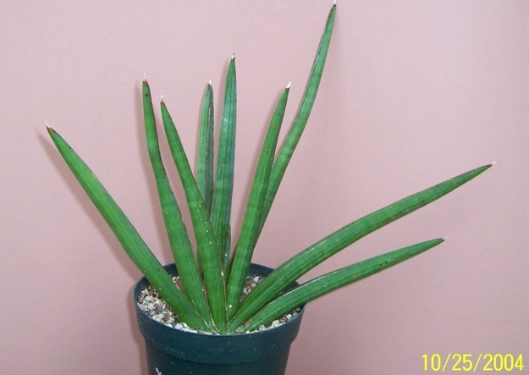
134 041 sp ‘Koko’ ex Ed Eby via Lee Eby

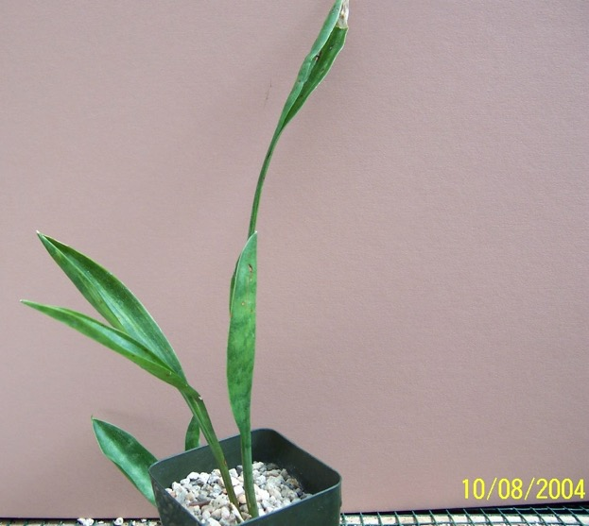
135 136 sp. ‘Lake Sibarya' JC apparently got 'Lake Sibaya' from Manny Singer

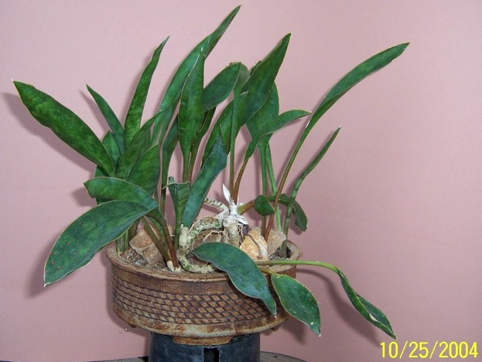
136 064 sp. ‘Lake Sibaya’

137 137 sp. ‘Malawi’ HBG 61017

138 138 sp. ‘Masai' Hartung HBG 71626

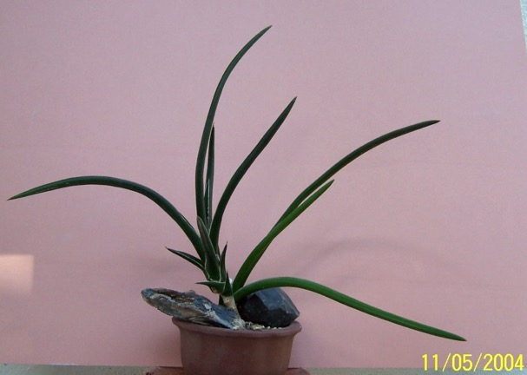
139 24 sp Nova P.L. 6084

Missing Photo of this plant
140 122 sp. ‘PF 1084’

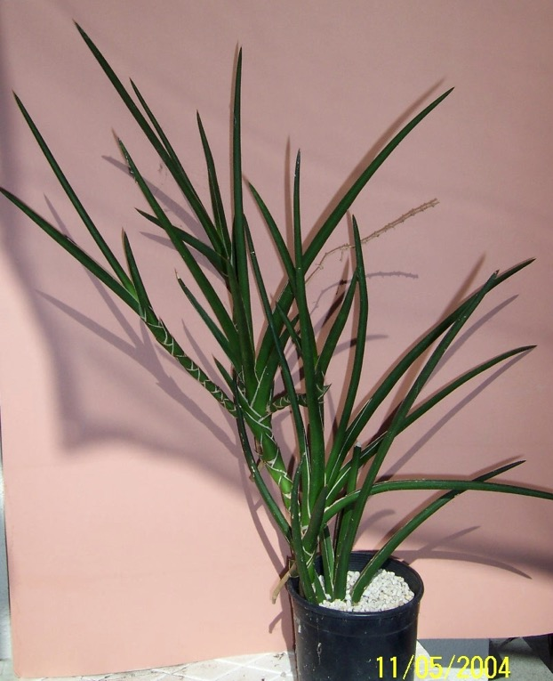
141 11 sp Rauh Rauh 888 Kenya, UCBG-614-1, HBG 61019

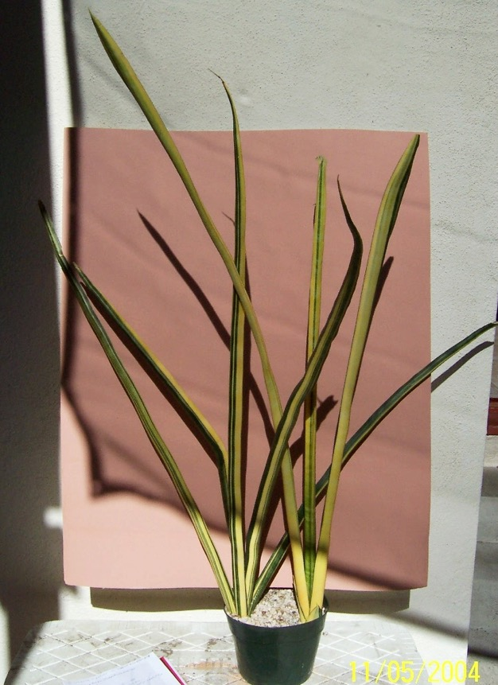
142 09 sp Somalia? Smalia LAV 23154 (has Grigsbys tag)
Looks like t. Wagner’s Gold

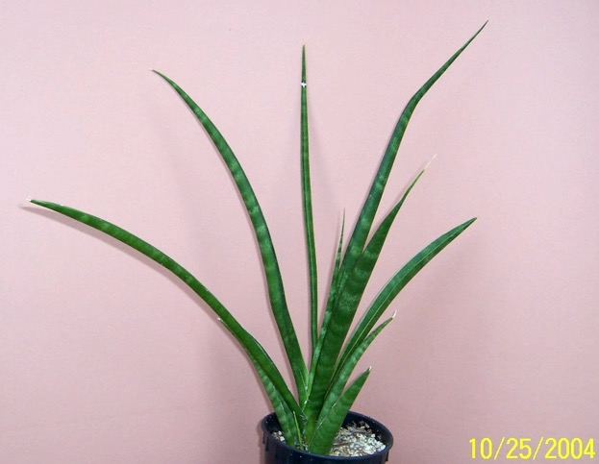
143 023 sp ‘Stella’ ex Smoley

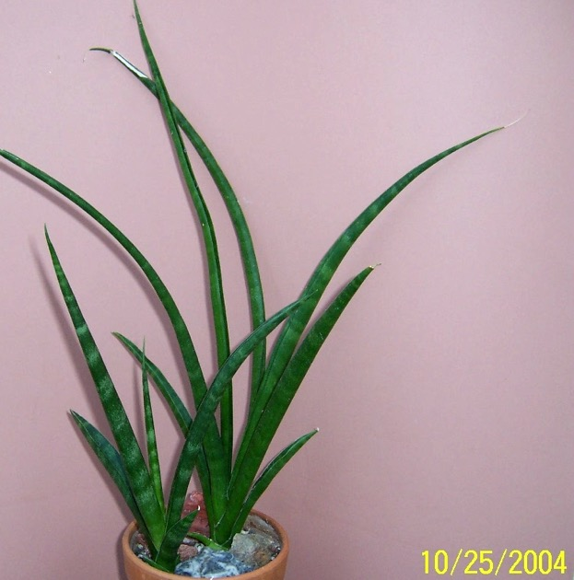
144 051 sp ‘Stella’ (2nd specimen)

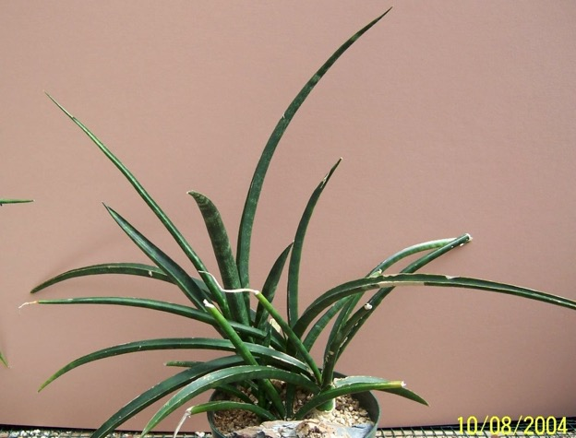
145 139 sp. ‘Stelette'

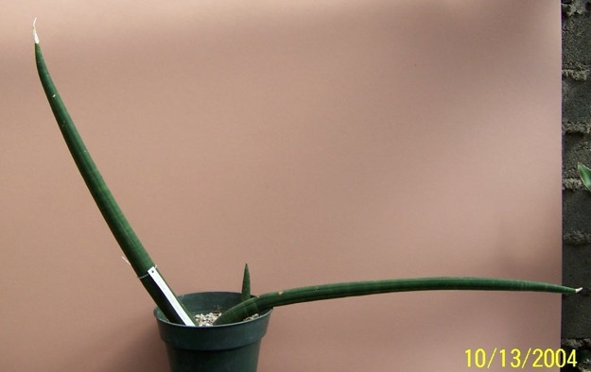
146 elliptica looks like powelii or patens

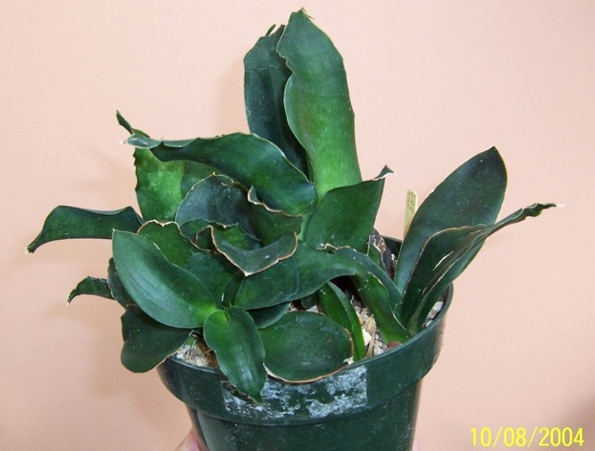
147 sp. ex Wellesley College may be subspicata HBG
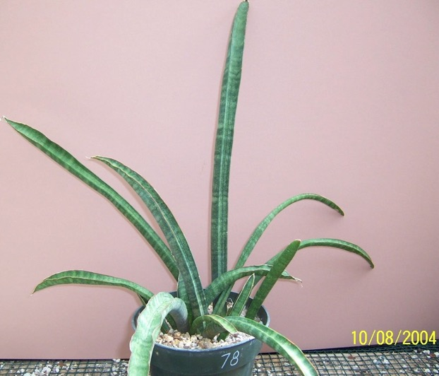
148 142 stuckyi “probably”, according to Norma

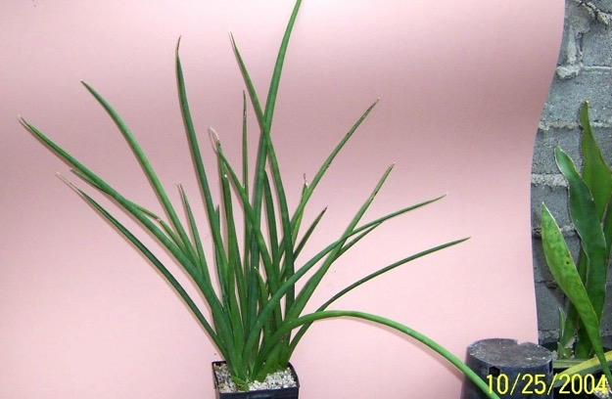
149 008 suffruiticosa (1st speciment) ex Ron Lafon SN 10/8/86
In granite at Kishma Fern House

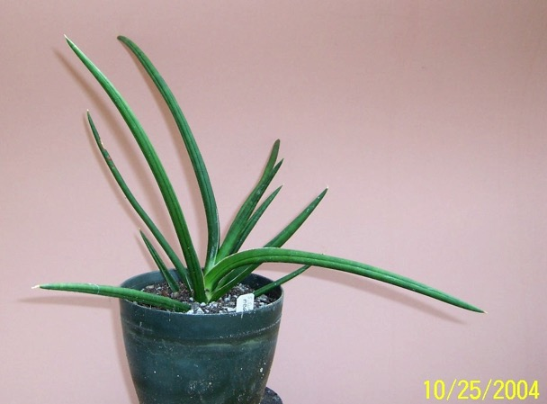
150 009 suffruiticosa 2nd specimen)
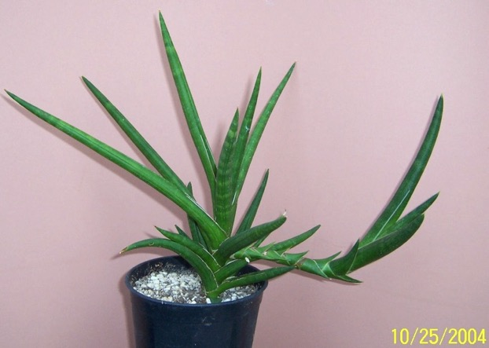
151 048 suffruiticosa (3rd spepcimen) (?)

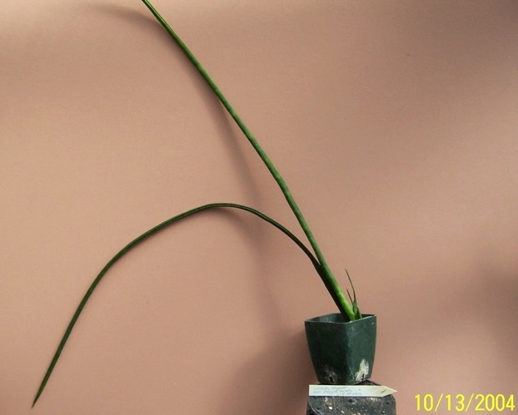
152 143 sulcata

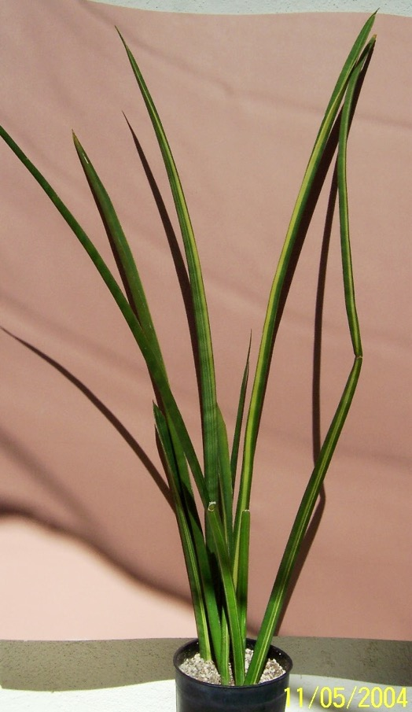
153 10 sulcata variegata ex Grigsby’s 135-78
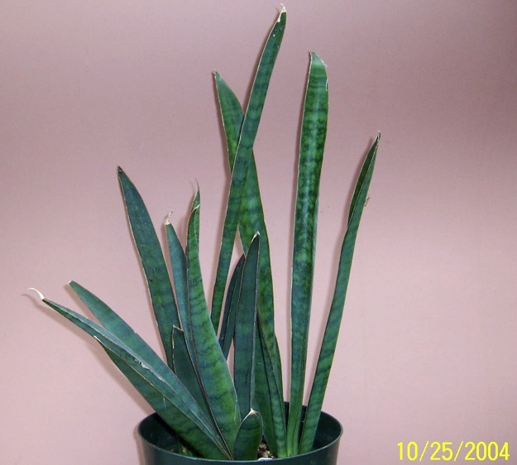
154 002 thrisiflora FC Hill wagt, Uitenhage W1988

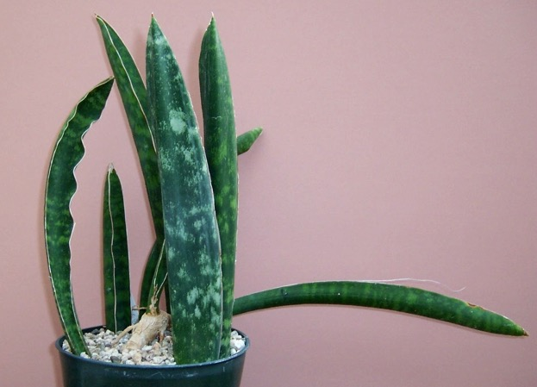
155 144 thrysiflora “Manny’s

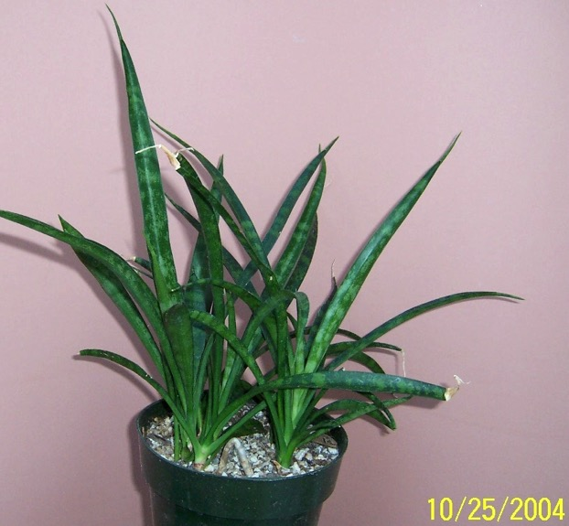
156 052 transvaalensis

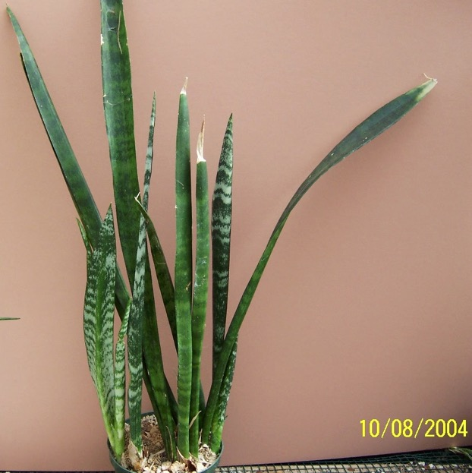
157 145 trifasciata

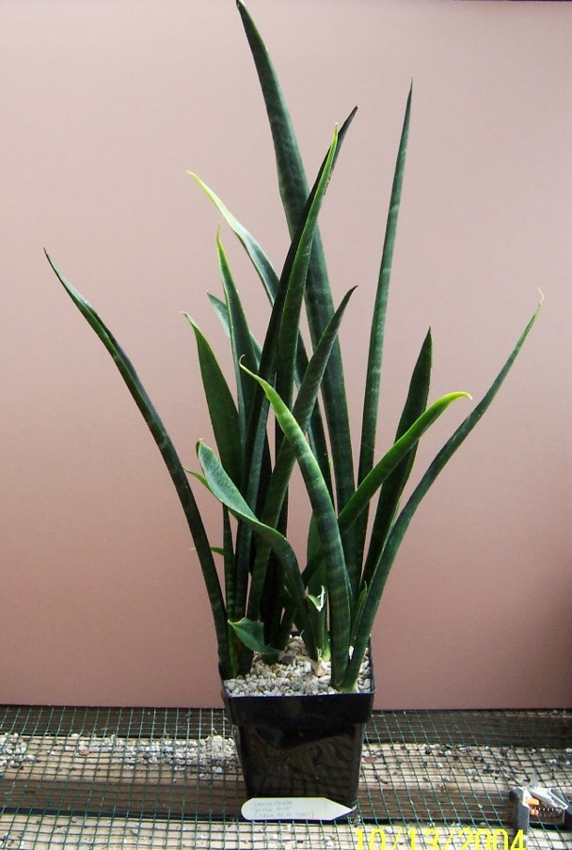
158 146 trifasciata ‘Black Gold' ex Fr.N.Plant

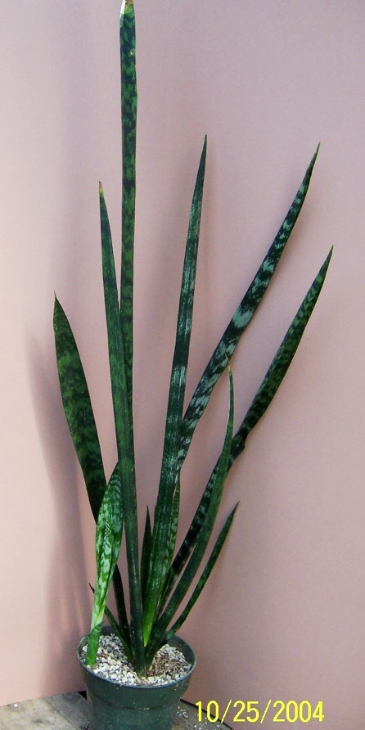
159 029 trifasciata ‘Black Sport’ (1st) ex Northridge Gardens, HBG 77662
aka Austrian Black
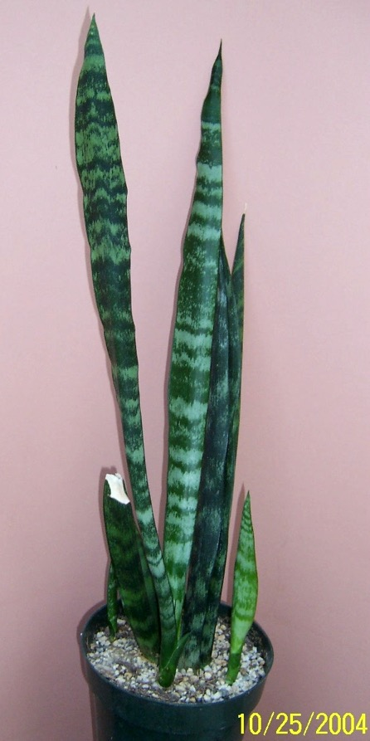
160 049 trifasciata ‘Black Sport’ (2nd)
aka ‘Austrian Black’

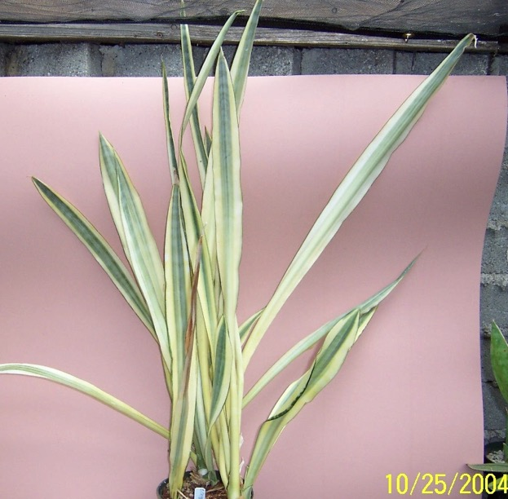
161 001 trifasciata ‘Cragii’

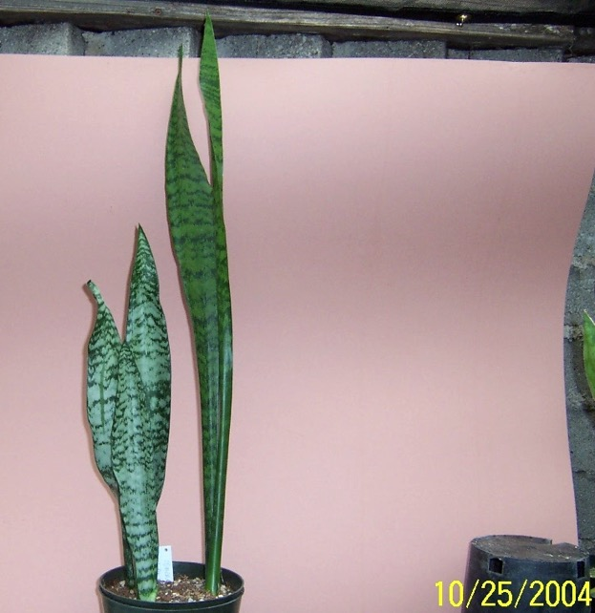
162 004 trifasciata ‘Esmaralda’ ex Dr. Chen – Smoley
aka Manda’s Dwarf

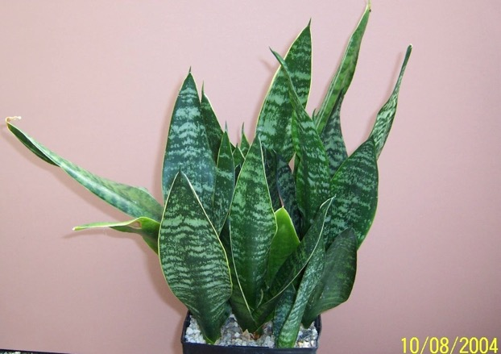
163 147 trifasciata ‘Futura' t. ‘Futura’ has wide yellow edges, this has gilt edges

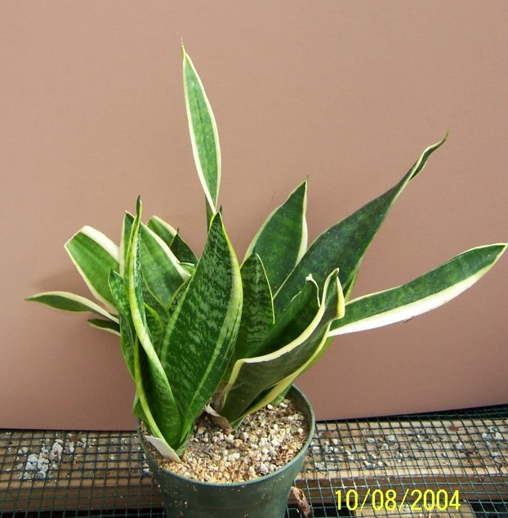
164 148 trifasciata ‘Futura Simplex'

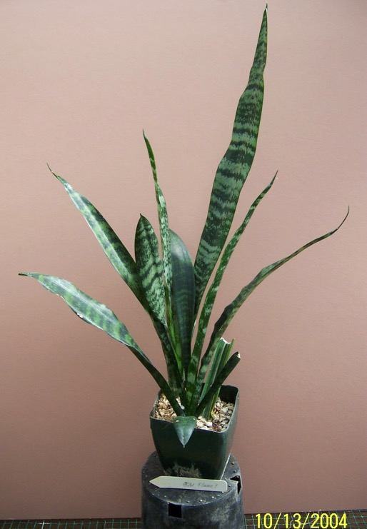
165 149 trifasciata ‘Gold Flame' maybe reverted to trifasciata type

“This variety is compac tlike t. ’Futura, The leaves are thick and the yellow egg-yolk variegation contrasts strikingly with the deep green color of the rest of the leaves. Stripes occasionally do not end at the top of the leaves giving the appearance of flames. The plant consistently produces variegated offsets.’, Juan Chaninian

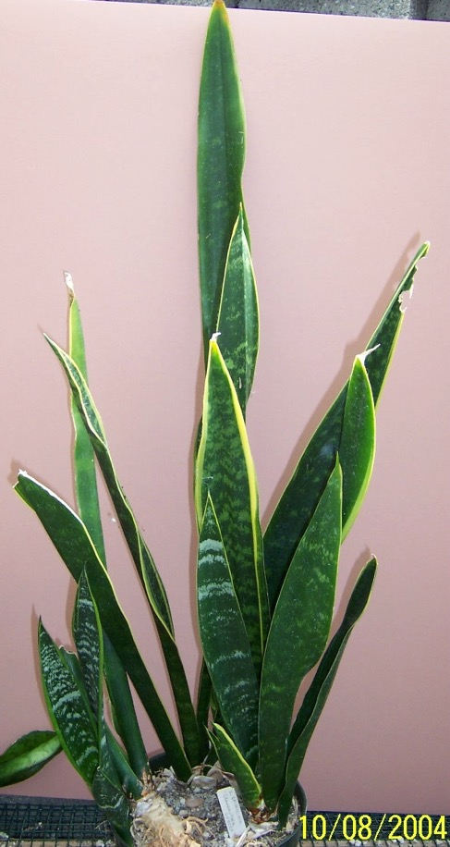
165 150 trifasciata ‘Grandmother Seibert'
Missing Photo

167 16 trifasciata Jade hahnii could be h. ‘Jade Dwarf’

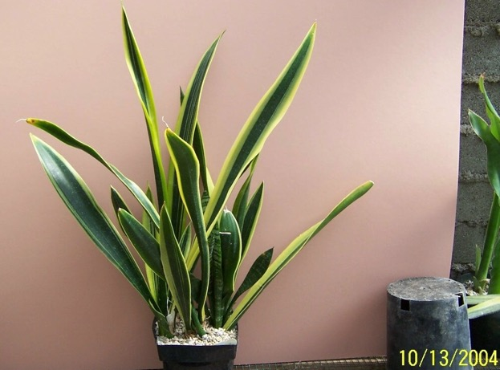
168 151 trifasciata ‘Laurentii Compacta' tag says ’compacta’ - has a trifasciata pup

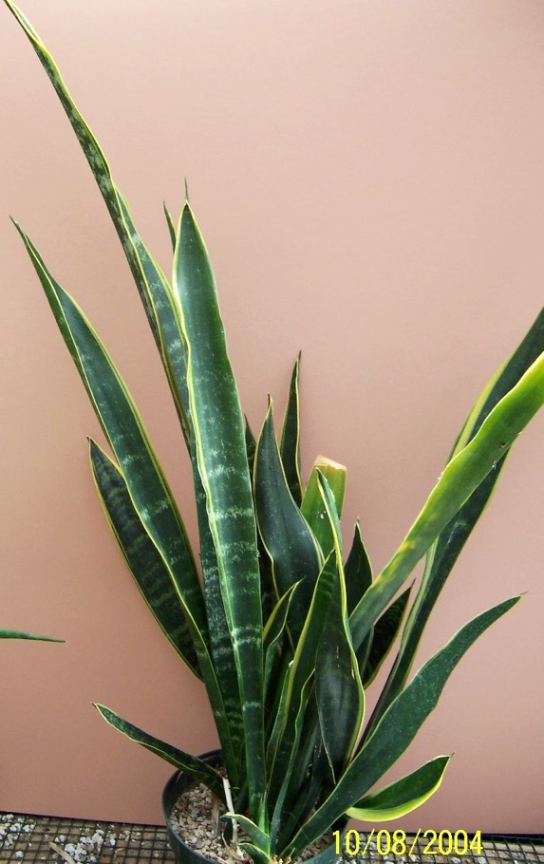
169 152 trifasciata ‘Laurentii Gilt Edge'

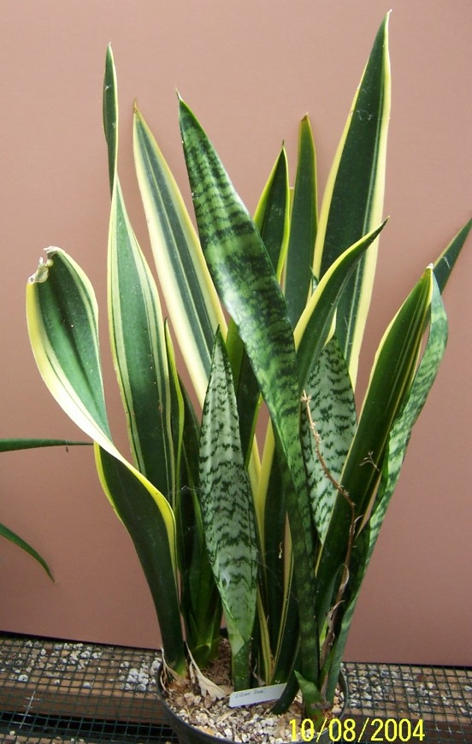
170 153 trifasciata ‘Laurentii Lillian True' 1st plant
Note – plant is reverting to trifasciata
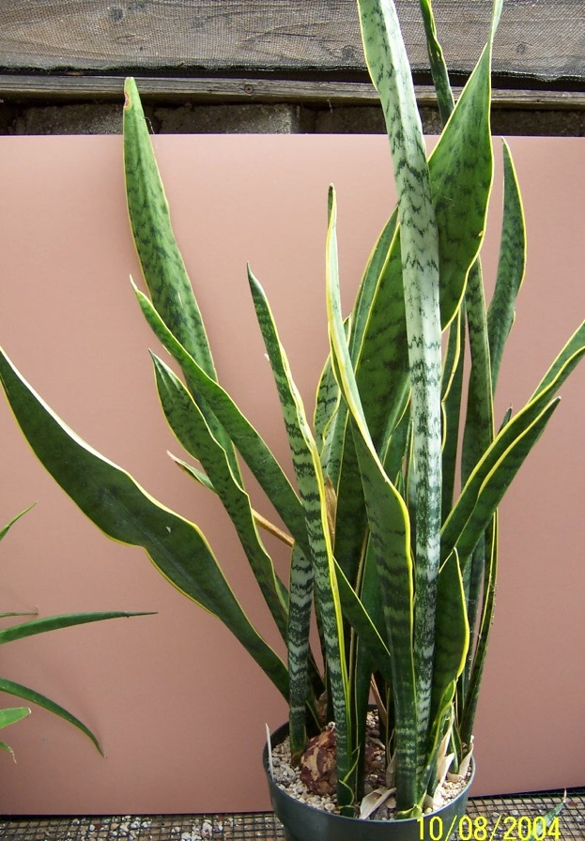
171 154 trifasciata ‘Laurentii Lillian True' 2nd plant
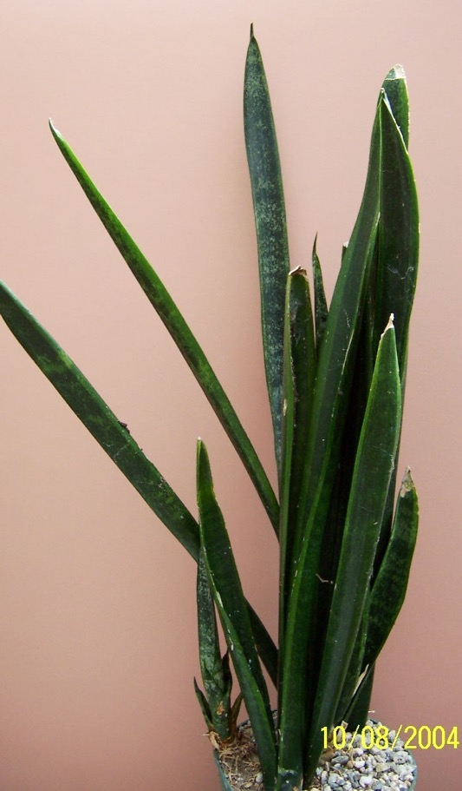
172 155 trifasciata ‘Laurentii Mein Liebling’

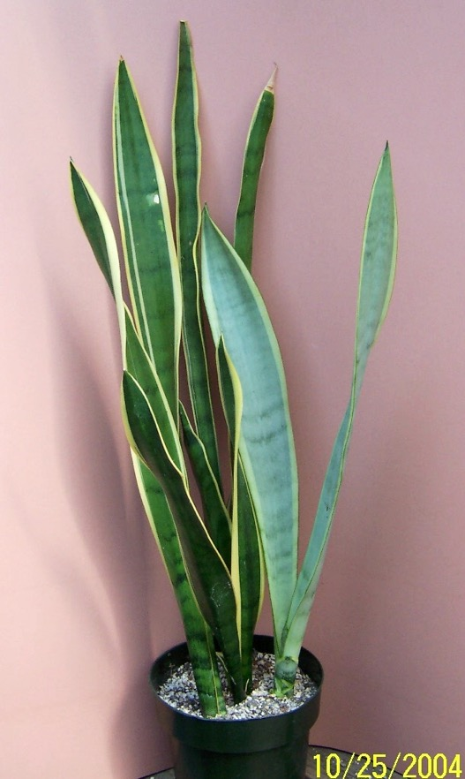
173 032 trifasciata ‘Laurentii Silver” (aka ‘Laurentii Stovers Sensation’
ex HBG 60922 ex Bill Barnett, 1992, N.E. Brown Silver Leaf form

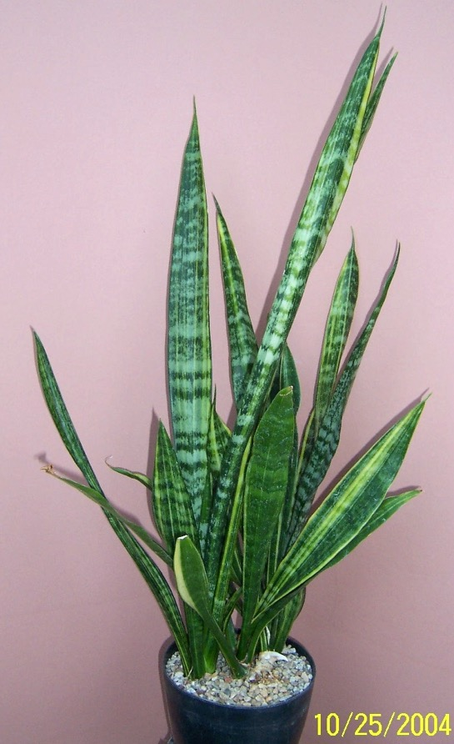
174 053 trifasciata ‘Laurentii Sunrise’ not Sunburst
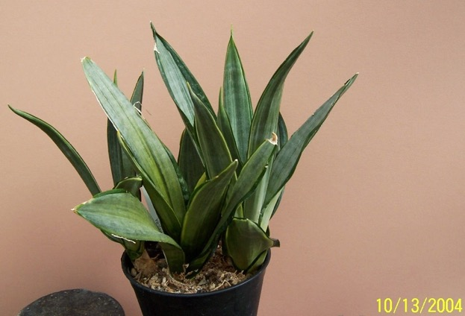
175 156 trifasciata ‘Morgenstern's Futura Aura’

“The lengthy name comes from the fact that this plant was first described in Morgenstern’s book “Sansevierias”. In essence is it a compact sized Sansevieria that is identical in pattern, color and texture as S. trifasciata ‘Silver Frost’ and S. t. ‘Golden Street’, the former being the dwarf size and the latter the full sized plant.
For those who are not familiar with either, this plant has leaves of varying yellow color and striations that can be felt with the finger. It even produces a different pattern, just like the plants mentioned do, that has green edges and silver center.”. Juan Chaninian

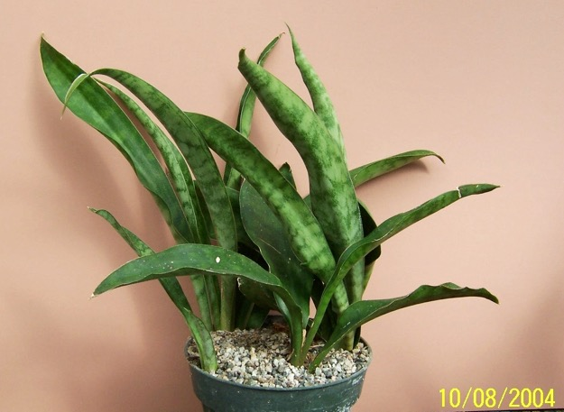
176 157 trifasciata ‘Nelsonii Stacking’ aka Wounded Knee LOL
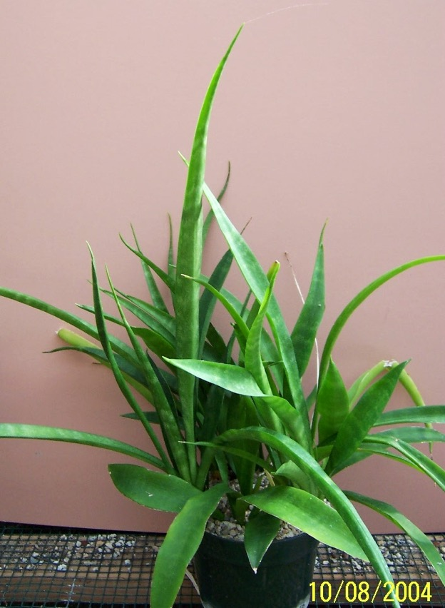
177 158 trifasciata ‘Okeechobee'

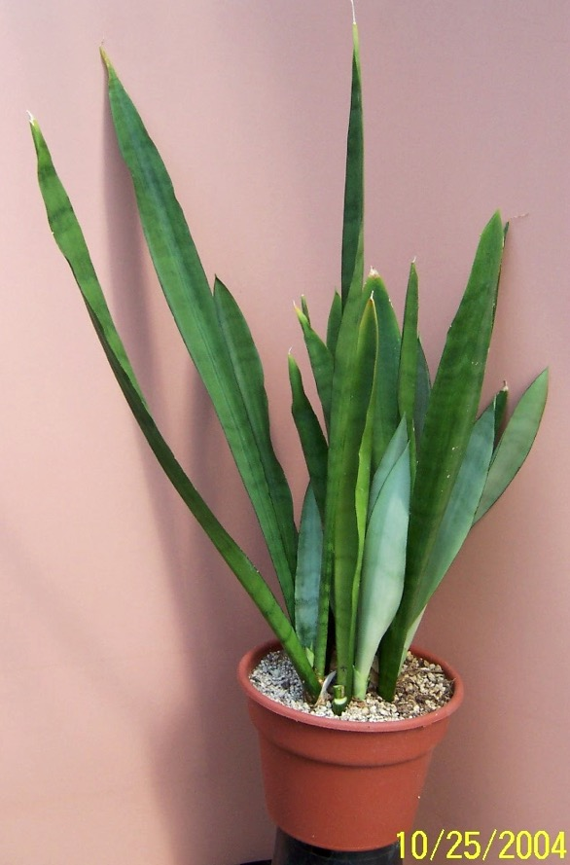
178 026 trifasciata ‘Silver Queen’ ex Manny Singer 1980

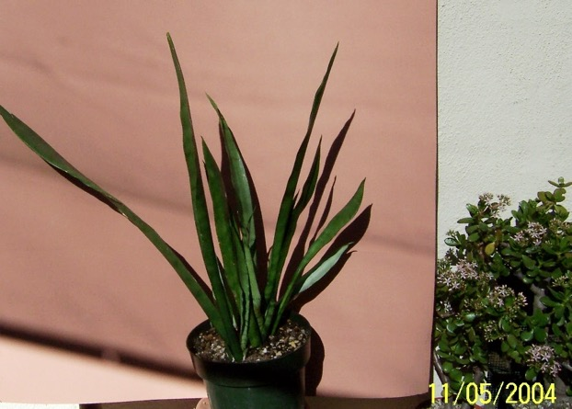
179 23 trifasciata ‘Silver Queen’ ex Manny Singer ~1968

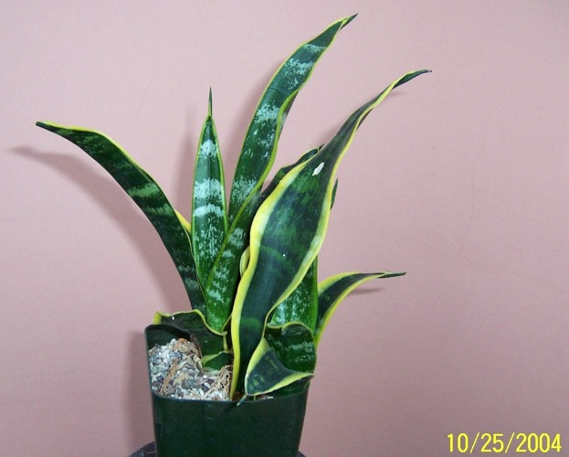
180 065 trifasciata ‘Twisted Sister’

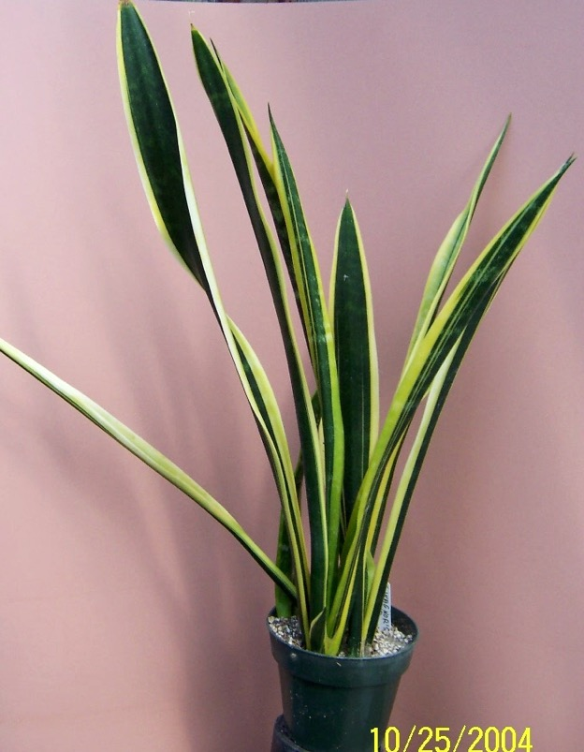
181 025 trifasciata ‘Wagner's Gold’ ex Lee Eby

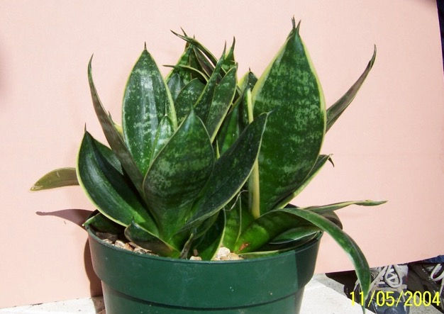
182 17 trifasciata hahnii Gilt Edge ex Tropic World (?)

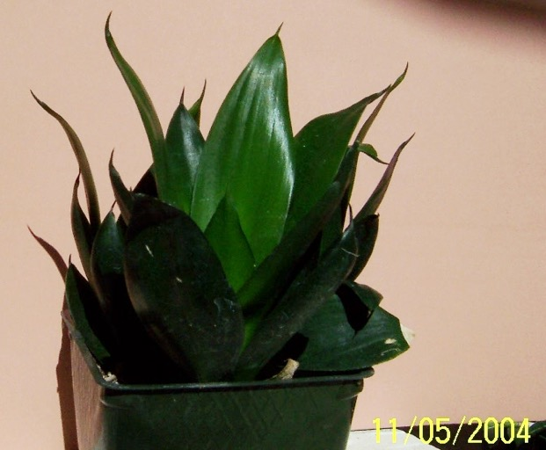
183 15 trifasciata Malachite ex Abby Gardens #300

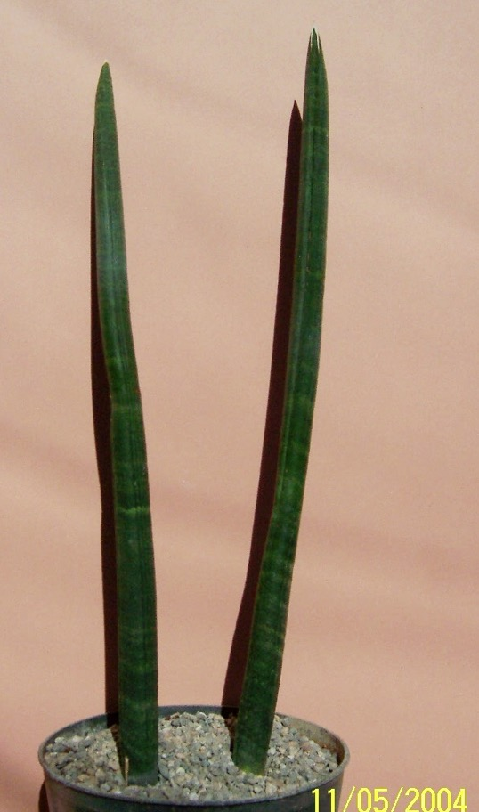
184 06 trifasciata X desertii USDA-19528

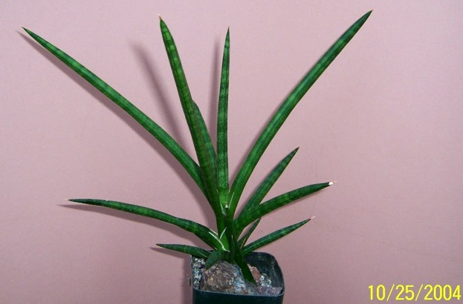
185 056 varians Cape Flora South Africa

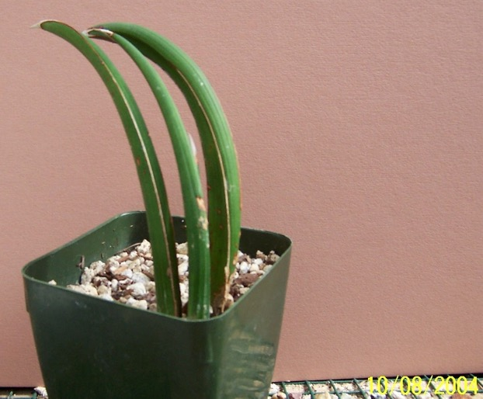
186 159 volkensii
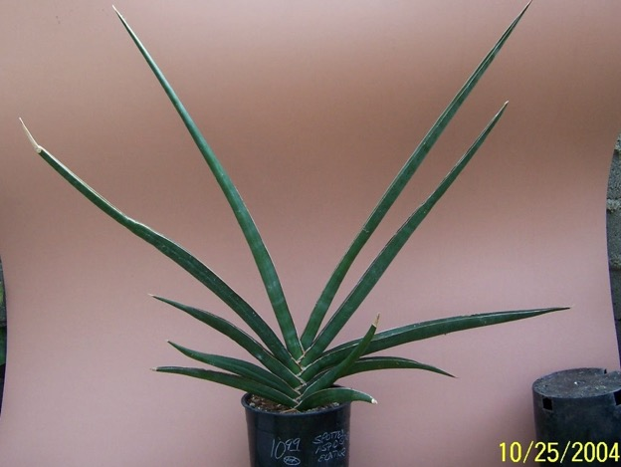
187 012 aff zanzibarica syn erhenbergii JC

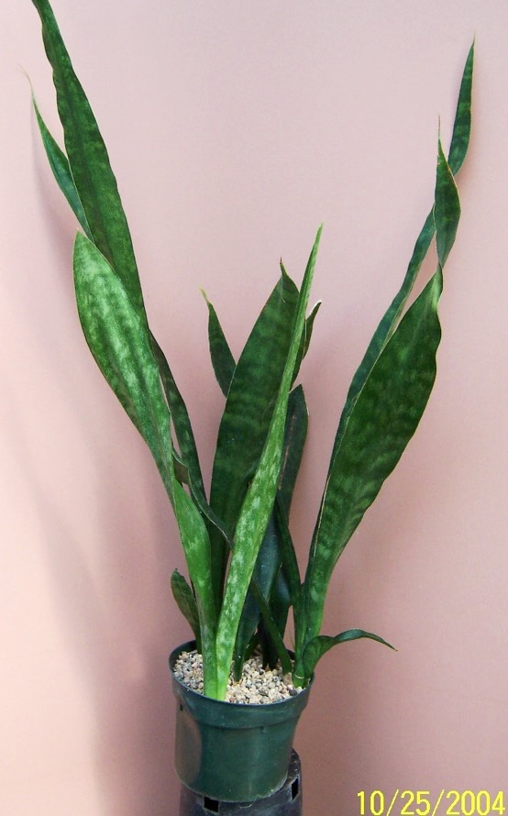
188031 zeylonica Recvd as -St Croix, Virgin Islands 10/12/98, Man. FL

