Species Brown # Page
abyssinica 41 61
aethiopica 30 50
angustiflora 4 68
arborescens 2 18
bagamoyensis 1 17
bracteata 53 77
Braunii 54 77
burmanica 29 48
canaliculata 24 44
caulescens 4 20
concinna 34 53
conspicua 43 63
chinensis 42 62
cylindrica 20 37
dawei 46 67
deserti 13 28
dooneri 32 51
ehrenbergii 12 27
fasciata 40 40
gracilis 7 24
grandicuspis 31 51
grandis 49 70
intermedia 16 31
kirkii 51 74
lanuginosa (ebracteata) 25 45
liberica 45 67
longiflora 52 76
metallica 44 65
nilotica 38 58
parva 33 53
patens 15 30
perrotii 10 26
phillipsiae 6 23
pearsonii 19 36
powellii 3 18
raffillii 50 72
rhodesiana 17 32
robusta 11 27
rorida 8 25
roxburghiana 28 47
senegambica 36 55
singularis (fischeri) 22 42
sordida 18 34
stuckyi 21 39
subspicata 35 54
subtilis 37 57
suffruticosa 5 22
sulcata (bacularis) 23 43
thyrsiflora 48 69
trifasciata 39 59
varians 14 29
Crown Copyright Reserved.
ROYAL BOTANIC GARDENS, KEW.

BULLETIN
or
MISCELLANEOUS INFORMATION.

No. 5] [1915
=====================================================
XXI. - SANSEVIERIA.
A MONOGRAPH OF ALL THE KNOWN SPECIES.
N. E. BROWN.
("With Plates.)

In the Kew Bulletin for May 1887, an account was published
of all the species of Sansevieria then cultivated at Kew, together
with notes concerning the quality and value of their fibres.
Since that date the number of species has been greatly added to,
and at present the collection of species of this genus in cultivation
at Kew is undoubtedly the largest that has ever been got together.
In 1898 there were 12 species known from Tropical Africa, 3
species from South Africa and 3 from India, making 18 in all.
In 1903, Gérôme and Labroy in Dull. Mus. D'Hist. Nat. p. 167
enumerate 20 species known to them. In the present account of
the genus 54 species are described, besides some others that are
only known from very imperfect descriptions, some of which may
possibly be the same as species here , described. Out of this
number 43 are at present in cultivation at Kew, together with a
few new species not yet in a condition for describing.
The genus Sansevieria was established by Thunberg in 1794
in his Prodromus Flora Capensis, Nov. Gen-. Char. No. 29 and
p. 65, where two species (S. thyrsiflora and. S. aethiopica) are
described. Seven years previously (in 1787), however, upon one
of these came plants, Petagna, Institutiones Botanicae, vol. 3,
p. 643, founded the genus Sanseverinia, and what is somewhat
remarkable, gave it the, same specific name (S. thyrsiflora) as
Thunberg did under Sansevieria. Whether Thunberg had any
knowledge that Petagna had already described the plant under
the generic name of Sanseverinia, does not appear, but the
similarity of both generic and specific names seems rather a
suspicious circumstance, especially, as Thunberg in 1818, in his
Flora Capensis, vol. 2 p. 322, spells the name Sanseverina.
Petagna's name, however, is antedated by one year by the
name Acyntha, which Medikus in 1786 (Theodora, p. 76) estab-
lished upon the plant figured by Jacquin as Aletris guineensis in
his Hort. Vindob. vol. 1, t. 84 (=S. trifasciata, Prain).

(38:9.) Wt. 153.601. 1.125. 6/15. J.T.&S. G 14.

This again is antedated by 24 years by the name Cordyline,
which Adanson (Fam. des Plantes, vol. 2, pp. 54 and 543) estab-
hished in 1763 upon S. lanuginosa, Willd. and S. zeylanica,
Willd. So that if priority of generic name is strictly adhered
to, all the species here enumerated should be placed under the
name Cordyline, concerning which and other matters relating
to Sansevieria, see the Kew Bulletin, 1914, p. 273. But in
deference to the ruling of the Botanical Congress at Vienna in
1905, the generic name Sansevieria is here maintained, as it has
been in general use for over a century and any change now made
would only result in very great inconvenience and confusion.
In Bentham and Hooker, Genera Plantarum, vol. 3, p. 679,
this genus is placed by Bentham in the order Haemodoraceae.
This removal of the genus from Liliaceae, where it was formerly
Placed, is most unaccountable and can only be understood upon
the assumption that he entirely overlooked the very obvious
affinity of Sansevieria to Dracaena, which is so pronounced that
several species of Dracaena (one even in recent years) have been
described as species of Sansevieria. Engler in his Pflanzen-
familien, vol. 2, part 5, p. 84, has rightly transferred Sansevieria
together with Ophiopogon, Liriope and Peliosanthes to Liliaceae,
but has separated Sansevieria from Dracaena by 26 other genera
so that the very close affinity of these two genera would appear
to have been overlooked; a discussion of their relationship will
be found in the Kew Bulletin, 1914, p. 273.
The genus Sansevieria is chiefly confined to Africa and the
islands near its coast, and Arabia. Nearly all the species are
congregated in the tropical area of the continent, as only 5, if
my identification of ,S. angustiflora (p. 248) is correct, occur in
South Africa, and none are found in the northern extra-tropical
region. Only 4 species are definitely known to inhabit any other
region, and these are natives of Ceylon, India, Burma, and
perhaps China.
As is well known, many species of this genus are largely culti-
vated in various parts of the Tropics for their valuable fibre,
which is of excellent quality in almost all, although varying with
the species. Unfortunately it is impossible at present to give
particulars concerning the quality and value of the fibre derived
from the various species, for two reasons. In the first place, most
of the fibres examined in our museums are labelled as being
derived from S. guineensis, S. sulcata, and S. zeylanica. From
the evidence accumulated during the progress of this work, I
have every reason to believe that neither of these names belongs
to the fibres to which they are attached, unless it may be that
some samples labelled S. zeylanica were actually obtained from
the wild plant of Ceylon, since the Indian plant is distinct, and
all living cultivated plants so named prove to belong to two or
three other species, whilst at least four distinct species have been
seen in the living state cultivated under the name S. guineensis
and three under that of S. sulcata, neither of them correctly
named. In the second place, the fibres are not accompanied by

leaves of the plants from which they were obtained, so that it is
quite impossible to identify the fibre; and as the market value
varies several pounds per ton in accordance with the quality,
which differs with the species, this want of accurate knowledge
of the species yielding any particular quality of fibre is to be
regretted. Correct identification could only be made where the
fibre is accompanied by an entire adult plant (with dried flowers
if possible) of the particular species from which it is derived;
juvenile plants are useless for purposes of identification.
As there is no existing account of the genus from which the
very numerous species now known can be identified, this mono-
graph has been specially prepared from living plants as far as
possible, and, as it is primarily intended to be useful to those
interested in Sansevierias from their commercial aspect and who
have little or no knowledge of botany, the use of botanical terms
has been avoided as far as possible, and the few that have been
retained are in such general use that they can scarcely be mis-
understood; their meanings, however, are as follows: --

Attenuate, gradually tapering.
Bract, a scale at the base of the stalk (pedicel) of each flower.
Coriaceous, leather-like in substance.
Filiform, thread-like, or very slender, and of equal thickness
throughout.
Glaucous, covered with a whitish or greenish-white
" bloom," like that on a grape.
Lanceolate, broadest at or near the middle and narrowed
towards the apex and base.
Linear, very narrow, with nearly or quite parallel sides.
Linear-lanceolate, narrow, but with the middle part rather
broader than above or below.
Panicle, a flower stem that is branched.
Pedicel, the stalk of each individual flower.
Petiole, the stalk of the leaf.
Petiolate, when the leaves have stalks.
Raceme, the flowering part of an unbranched flower-stem.
Sessile, without any stalk.
Subulate, awl-shaped or tapering like a spine.
Terete, circular in transverse section.

For many of the plants from which the descriptions have been
made, Kew is indebted to Mr. M. T. Dawe, when Director of Agri-
culture, Beira, Portuguese East Africa; Prof. W. R. Dunstan,
Director of the Imperial Institute; Major A. T. Gage, Superin-
tendent of the Botanic Garden, Calcutta; Monsieur L. Gentil,
Curator of the State Botanic Garden, Brussels; Mr. A. P. Gren-
fell, Farringdon Works, Shoe Lane, London; Monsieur E.
Perrier, Director of the Jardin des Plantes, Paris; Mr. H.
Powell, Chief of the Economic Plant Division, Nairobi, British
East Africa; and Dr. J. Medley Wood, Director of the Natal
Herbarium, Durban.
The illustrations have been prepared by Miss M. Smith from
life-size drawings preserved in the Kew Herbarium.

Sansevieria, Thunb.
Stemless plants with a creeping rootstock or with a distinct
stem and bushily branching at or near the base. The number of
leaves produced by each growth is limited, according to the
species. Leaves fleshy or fleshily coriaceous, flat, channelled, half-
cylindric, cylindric or laterally compressed, rigid, firm or
flexible, full of fibre. Flower-stem simple or branching, always
terminating the growth producing it, usually with leaves or a
leaf at its base, but sometimes with only a few scales or sheaths
at the base, the growth producing it being leafless. Flowers
solitary or two or more in a cluster, on pedicels that are jointed
near the middle or apex, the upper part falling off with the
flower (deciduous part), always with membranous or thin scale-
like bracts at the base; each flower with a distinct tube and six
narrow lobes that are usually rolled back or very spreading when
fully expanded, remaining open only one day or night; often
fragrant. Stamens six, much exserted from the tube of the flower,
with slender filiform filaments. Ovary free, 3-celled, with 1 ovule
in each cell; style slender, filiform, about as long as the stamens.
Fruit a berry, containing 1-3 bony seeds.
The key to the species has been prepared chiefly from living
plants cultivated at Kew, and will not be found to be always
applicable to dried specimens, for, although every endeavour
has been made to construct a key that would apply equally to
living plants and dried specimens, after three attempts it has
been found impossible to do so; because, in the first place, col-
lectors rarely preserve more than a few loose leaves, or sometimes
only part of a leaf, quite unattached to the rootstock; even then
it is often only the smaller or outer leaves of a growth that are
preserved, so that no knowledge can be obtained of the number of
leaves to a growth, their arrangement nor the full size and
characteristics of the inner leaves of adult flowering plants, all of
which are important characters that have to be taken into con-
sideration in the discrimination of the species. It is often
utterly impossible to name a species from a single leaf, either
living or dead; the whole plant is required. In the second place,
I find that there are some species which can easily be distin-
guished at a glance when seen alive and growing side by side,
vet when dried their leaves (for often flowers cannot be obtained)
lose their most important distinctive characters, and the species
cannot then be distinguished, or only with difficulty, such as by
a microscopic examination of the epidermis and of very thin sec-
tions of the leaves. Where complete flowering specimens have
been preserved the flowers usually show some specific difference,
even where the leaves do not, when dried.
One of the most interesting characteristics of this genus is the
very remarkable change which takes place in the form of the
leaves of many of the species as the plant advances from the
juvenile to the adult stage. When seeds of any of the species
having cylindric leaves in the adult state are sown, the seedling
plants invariably have moderately thin flattened or concave
leaves. , also pass through the same stages, as examples of which are

<Sic: As the plant> grows older these flat leaves are gradually succeeded by others
that are thicker, less flat, more ascending, and finally by others
of a more and more cylindric type until the adult erect cylindric
type is produced. Young plants raised from cuttings of the
leaves also pass through the same stages, examples of which are
illustrated under 19, S. Pearsonii, and 21, S. Stuckyi. This
change would seem to indicate that all the species having the
cylindric type of leaf have originated from ancestral forms having
flattened leaves. This variability in the form of the leaf, accord-
ing to the age, of the plant, renders it impossible to name speci-
mens that are not of adult age, therefore in the following key
only characters taken from adult flowering plants have been
taken into consideration.
The key is more diagnostic than is usually the case, because it
has been found that one based upon a few briefly stated characters
is absolutely useless for working purposes. Also, in the effort to
make it as useful as possible, where a species is known to vary
in the characters used, it has been inserted in more than one place
in the key, in accordance with that variation. Attempts have
been made by other authors to discriminate the species by sections
of their leaves alone, but this has been found to be quite imprac-
ticable, since not only do different leaves on the same plant often
vary very considerably, but even the same individual leaf will
vary with age or the amount of shrivelling due to drought to
which it has been exposed, causing the margins to infold or
grooves to appear on the back or sides, which are quite absent
when the plant is in vigorous growth. All the leaf sections given
in the illustrations are of natural size, made from nature-printed
ink impressions of healthy fresh leaves from adult plants,- with
the exception of those of 5, S. suffruticosa, 17, S. rhodesiana, and
29, S. burmanica, where sections of old or partly shrivelled leaves
are also given to contrast with those of leaves in a vigorous state
of health.
The measurements are in feet, inches and lines; one line equals
one-twelfth of an inch.

N.B. Detached leaves, living or dead, cannot be determined with this
key, one or more entire growths of the adult plant are required.

I. -- STEM, 1½ - 5 ft., OR PERHAPS MORE, HIGH (UNKNOWN IN S. bagamoyensis), ERECT, BRANCHING AT OR NEAR THE BASE AND OFTEN ABOVE THE GROUND, LEAFY THROUGHOUT OR SCALY AT THE BASE.

Leaves of adult plants, 7-18 in. long, flattish or concave (perhaps
somewhat longitudinally folded in S. bagamoyensis), 1-2 lin. thick at the base: --
Stem in the dried specimens seen less than ½ in. thick;
leaves less than ¾ in. broad 1. bagamoyensis.
Stem ⅔ -1 in. thick; leaves ¾ - 1¾ ins. broad 2. arborescens.
Leaves of adult plants 1-2¾ ft. long, ¾- 1 1/⅓ in. broad,
concave or with a channel down the face, 6-9 lin. thick near the base:
Leaves with a channel down the face as broad as the leaf,
and tapering to a hard pale brown spine-like point;
flower-stem branched 3. Powellii.

Leaves with a channel down their face much narrower than
the leaf, except at the base, and tapering in a cylindric manner
to a slender and very acute green or pale brown or whitish.
point, which at first is slightly horny but; not very hard;
flower-stem not branched 4, caulescent.
Leaves of adult plants 3-7 ft. long, laterally flattened,
1¼ - 1¾ in. thick at the base. with a channel as broad as the
leaf down the face; flower-stem branched 11. robusta.

II.— STEM EITHER NONE OR NOT RISING ERECTLY MORE THAN ABOUT 1 FT. ABOVE THE GROUND. THREE SPECIES PRODUCE AT 2-4 IN. ABOVE THE GROUND, ASCENDING OR TRAILING BRANCHES ¼-3 FT. LONG, WHICH ROOT AND BEAR A TUFT OF LEAVES AT THEIR ENDS, BUT EXCLUDING THEIR TRAILING LENGTH DO NOT RISE ERECTLY MORE THAN 1 FT. ABOVE THE GROUND. (See also 1. S. bagamoyensis, of which the height of the stem is unknown.)

A-- Leaves in transverse section at their middle about as thick as, or
thicker, than they are broad, cylindric or more or less flattened at
the sides, and with or without a channel all down the face above the
sheathing part.
•Leaves of adult plants solitary, or occasionally 2 (very rarely 3) together
(in seedling or juvenile plants there may be 4-6 in a tuft), scattered
along an underground rootstock at distinct intervals or one close
behind another, cylindric: --
Leaves of adult plants 4-9 ft. long (under cultivation, sometimes
1½ -3 ft. long), with a distinct narrow channel down the face: --
Adult leaves 1½ -2½ in. thick at the base, with a channel
3-16 lin. broad down the face, dark green or dull grass
green, with rather paler transverse bands, which become
indistinct on old leaves 21. Stuckyi.
Adult leaves ¾- 1¾ in. thick at the base. with a channel
1½ -3 lin. broad down the face, dull greyish or
bluish-green, or of a brownish tint, rather indistinctly
marked with paler transverse bands 22. singularis.
Leaves of adult plants ½ - 2½ ft. long, 6-11 lin. (or in S. sulcata
when alive perhaps more) thick; flowers in a simple spike-like
raceme not half as long as the leaves:--
Leaves apparently with 8-9 slight grooves 23. sulcata.
Leaves usually with 5-6 (rarely more) distinct grooves 24. canaliculata.

••Leaves of adult plants 3-18 to a growth:--
† Leaves cylindric, not flattened at the sides (the outermost
sometimes half-cylindric) :--
‡ Leaves without a channel down the face above
the basal sheathing part, with hardened brown or whitish tips:--
Stems of adult plants rising erectly 3-12 in. above the
ground and often branching in the air; branches 1-3 ft.
long, ascending when short or trailing over other
branches when long, covered with scale-leaves and
ending a tuft of foliage:--
Leaves distinctly rough to the touch, at least on the
apical part, the hardened apex very acute
and 1½ - 2 lin. long 5. suffruticosa.

Leaves smooth, 5-12 to a growth: --
Leaves ⅓ - 1½ ft. long, 6-9 lin. thick,
rather suddenly acute or obtuse at the
apex, dull bluish-green or dull dark green 6. Phillipsiae.
Leaves ¾ - 1½ ft. long, 3-4½ lin. thick,
gradually becoming very acute at the
apex deep grass green 7. gracilis.
Stem of adult plants none or very short, never
branching in the air. Leaves 3-6 to a growth,
2-ranked, 2-5 ft. long, ¾ - 1¼ in. thick, not grooved: --
Leaves mostly stiffly erect and not very widely
diverging, the longer or all gradually tapering
to a very acute point 20. cylindrica
Leaves all more or less irregularly recurving
or widely spreading, rather shortly
or abruptly pointed 20. cylindrica
var. patula
‡ ‡ Leaves with a distinct channel all down the face
continuous with the sheath, besides and larger than any
grooves that may be present, but in the central leaves of
adult plants (except perhaps in S. rorida and S. deserti)
always much narrower than the full breadth of the leaf at
the middle part. Flower-stem branched in S. rorida, in all
the others (where known) unbranched and the flower-clusters
forming a spike-like raceme: --
Channel with acute whitish or green edges below, passing into
obtusely rounded green edges at the upper part of the leaf;
some leaves almost without a channel apart from the
furrows; flowers mostly 3-6 in a cluster 10. intermedia.
Channel with acute edges from base to apex of the leaf: --
Central leaves of adult plants with green edges to the
channel or with white or red-brown edges only at
the basal or apical part of the leaf: --
Leaves 5-10 to a growth, widely spreading in a
fan-like manner, the outer being horizontally
recurved from the base; central leaves of
adult plants ⅔ - 1⅔ in. thick, somewhat
abruptly narrowed into a short hard white point;
flowers 2-3 in a cluster 15. patens.
Leaves 4-8 to a growth, erect, straight or
slightly carved, ½ - 1 in. thick, gradually
tapering into the acute hard white point;
flowers 4-10 in a cluster:--
Leaves with 9-12 shallow furrows on the sides
and back; pedicels 3 – 3½ lin. long, jointed
below the middle 13. deserti.
Leaves (except from age or when withered)
without furrows; pedicels 2 - 2½ lin. long,
jointed slightly above the middle 14. varians.
Central leaves of adult plants with reddish-brown or white edges
to the channel nearly or quite up to the apex or at least extending
beyond the middle (in 13, S. deserti, the length to which the red

edge extends is at present unknown), straight, with
several longitudinal impressed lines or furrows, besides
the channel down the face:--
Leaves very rough, almost like that of fine glass-paper,
2 - 3½ ft. long, ½ - ¾ in. thick near the base,
dull dark bluish-green 18. sordida.
Leaves nearly smooth or only slightly rough, ¾ -1½ in. thick
near the base:--
Stem erect, up to 9 in. high; leaves spreading 1- ¾ ft.
long; flower-stem branching 8. rorida.
Stem none; flower-stem not branched: --
Central or all the leaves of adult plants gradually
but not widely diverging from base to apex, with the
tips of the inner pair 6-12 in. apart, 2¼ - 3 ft. long,
usually somewhat distinctly banded when young 19. Pearsonii.
Central or all the leaves of adult plants more or
less parallel and scarcely or not at all wider apart
at the tips than at the base, not or very indistinctly
banded when young:--
Leaves 2½ - 3½ ft. long; channel at about 1 ft.
above the base nearly as broad as the leaf,
but much narrower than it above; flower with
a tube 3½ - 4 lin. long, and lobes about 6 lin. long 13. deserti.
Leaves 3-5½ ft. long; channel at about 1 ft. above
the base very much narrower than the breadth of
the leaf; flower with a tube 4-6 lin. long, and
lobes 7½ - 9 lin. long 17. rhodesiana.
++ Leaves with flattened or flat sides and as thick as or
thicker than they are broad; channel at about the middle
of the leaf nearly or quite as broad as the leaf itself (this
character is useless for dried or withered specimens, as
the channel contracts in the process of drying and often
appears much narrower than the leaf), with reddish-brown
margins, usually edged with a white membrane; apex tipped
with a hard, sharp point: --
Stem of adult plants 1 ft or more high; leaves 6-14 to
a growth; persistent part of the pedicels ½ - ¾ lin.
long. 11. robusta.
Stem of adult plants 0-9 in. high; leaves 5-9 to a
growth; persistent part of the pedicels 1 – 1 1½ lin
long. 12. Ehrenbergii.

B. --Leaves in transverse section at their middle 4 lin. or more thick from the bottom of the channel to the back and only ⅓ - ⅔ as thick as they are broad (uncertain in 25, S. lanuginosa), with the channel down the face nearly or quite as broad as the leaf at that mart but in S. rorida much narrower at the upper part of the leaf. (Species No. 26, S. Volkensii belongs here, but the description is insufficient to place it properly.)

• Stem 4-8 in. high; flower-stem paniculately branched
above (See also 9, S. zanzibarica, of which the flowers
are unknown) : --
Leaves of adult plants 1-2 ft. long, broadly channeled
and somewhat half-cylindric at the basal part,
becoming cylindric and narrowly channelled
towards the apex. 8. rorida.
Leaves of. adult plants 3-5 ft. long, with a deep
concave channel as broad as the leaf throughout
its length. 10. Perrotii.
•• Stem none (or 9 S. zanzibarica "scarcely caulescent");
leaves with a channel down the face as broad as the leaf
and rounded or obtusely keeled on the back; flower-stem,
where known, unbranched and the flower-clusters arranged
in a spike-like raceme:--
Adult leaves with reddish-brown edges to the
channel throughout their length 9. zanzibarica.
Adult leaves with green edges to the channel or with
white or red edges only for a few inches at the base
or apex:--
Central leaves of adult plants with slight but evident
grooves down the sides and back, half-cylindric
with a broad concave channel down the face;
flowers 2-5 in a cluster.
(See also 26, S. Volkensii) 25. lanuginosa.
Central leaves of adult plants without grooves on
the rounded back, except when withered,
4-10 lin. broad, 2½ - 4 lin. thick, concave-
channelled down the face. 27. zeylanica.

C. --Leaves either narrow and channelled, hut in transverse section at their
middle not more than 3-4 lin. thick, or flat or slightly concave and six to
many times as broad as they are thick at the mid-rib, never cylindric nor
half-cylindric; flower-stem not branched.--
• Edges of the leaves of adult plants green (or from rubbing
or injury very narrowly whitish in places, not all along),
apex tipped with a soft green subulate point ⅓ -3½ in. long.
† Leaves of adult plants ⅓ -1½ (or in 35, S. subspicata up
to 2¼) in. broad, 4-24 to a growth, deeply channelled,
concave or flattish, broadly linear, strap-shaped or narrowly lanceolate:--
Leaves linear or narrowly linear-lanceolate, and usually more than 1
(and up to 2½) ft. long:--
Central leaves of adult plants 2½ - 4 lin. thick at the
middle, ascending or erect, rather rigid:--
Leaves straight, with several grooves down
the back, which are stated to be woolly. 25. lanuginosa.
Leaves slightly. recurving at the upper part,
not grooved on the back except when
withered, very dark, green. 27. zeylanica.
Central leaves of adult plants 1½ - 2 lin. thick
at the middle: --
Central leaves sub-erectly or ascendingly recurving,
concavely channelled, rather stiff 28. Roxburghiana
Central leaves very erect, straight, flattish,
with a slight angular channel, flexible. 29. .burmanica.

Leaves either not linear or mostly not more than 1 ft.
Long, but varying from ½ -2 ft. long:--
Stem usually evident, 1-5 in. high, leaves very
concave, ⅓ - 1¼ in. broad, not very flexible,
with subulate green points, mostly 1½ -3 in.
long, variegation distinct; lower flowers in pairs 33. parva.
Stem none or scarcely evident (in S. Dooneri
sometimes 1-2 in. high, but concealed by the leaf
sheaths); leaves flattish or but slightly concave:--
Leaves usually numerous, but varying from 4-20
to a growth, 4-2 ft. long:--
Leaves ¼ - 1½ in. broad, with subulate
green points ¼ - 2 in. long; flowers 2 or
more in a cluster:--
Leaves erect or sub-erect, nearly straight,
stiff, very distinctly marked with sub-regular
light green and dark green transverse bands
and several longitudinal dark green lines on
the back 31. grandicuspis
Leaves recurved-spreading, flexible,
indistinctly and very irregularly, transversely
banded, without dark green longitudinal
lines on the back 32. Dooneri.
Leaves 1 – 2¼ in. broad, firm or sub-flexible, with
subulate green points 2-3 lin. long, deep green,
but obscurely variegated when young; flowers
usually solitary, sometimes in pairs,
tube 14-15 lin. long 35. subspicata.
Leaves about 5 to a growth, 6-10 in, long,
½ - 1¼ in. broad, with subulate green points
2 - 4 lin. long, transversely banded; flowers
in pairs, tube 19-21 lin. long 34. concinna.
†† Leaves of adult plants 1-4 in. broad, usually more than 1 ft.,
and up to 4½ ft. long, 1-8 to a growth, flat or concave,
strap-shaped or lanceolate to elliptic:--
Leaves brightly and very conspicuously variegated with
light green or whitish-green and dark green transverse
bars at all edges, and sometimes striped with yellow.
(In 40, S. fasciata, the young leaves also have green edges):--
Pedicels 3½ - 6 lin. long, with the persistent part 2-5 lin.
long; flower with a tube 4½ - 5 lin. long, and
lobes 5½ - 6 lin. long 38. nilotica.
Pedicels 2½ - 4 lin. long, with the persistent part
1-2 lin. long; flower with a tube 3-6 lin. long,
and lobes 7-8 lin. long 39. trifasciata.
Leaves either rather inconspicuously or at least not
brightly variegated with pale green and darker green
transverse bars or cloudings or entirely green:--
Flowers mostly solitary, sometimes in pairs, tube
11-14 lin. long; pedicels 4-1 Un. long; leaves
3-2 ft. long, 1-3 in. broad 35. subspicata.
Flowers 2-6 in a cluster; pedicels 2-4 lin. long: --
Tube of the flower 13-14 lin. long;
leaves 2-4 ft. long 44. metallica.
var longituba

Tube of the flower 3-8 lin. long:--
Leaves of adult plants 1-2¼ ft (rarely more)
long, 1-2¼ in. broad:--
Pedicels jointed at or below the middle
with the upper or deciduous
part 1¾ -3 lin. long 36. senegambica
Pedicels jointed at or near the middle
with the upper or deciduous
part 1-1½ lin. long 37. subtilis.
Leaves of adult plants usually 2-4½ ft. long,
some less: --
Leaves 1-1¾ in. broad; pedicels jointed at
or near the middle, with the deciduous
or upper part 1-1½ lin. long; tube of
the flower 3-4 lin. long 37. subtilis.
Leaves 1½-4 in. broad:--
Pedicels jointed at or above the
middle with the deciduous or
upper part 1- 1¼ lin. long:--
Leaves 14-23 in. broad; tube of
the flower 4 lin. long 38. nilotica var.
obscura.
Leaves 2-4 in. broad; tube of
the flower 7-8 lin. long 44. metallica
var. nyasica.
Pedicels jointed dose to the obconic
base of the flower, deciduous part
scarcely evident; leaves 2-4 in. broad;
tube of the flower 6-8 lin. long 44. metallica.
•• Edges of mature leaves of adult plants reddish-brown or
whitish, sometimes green when young.
† Tube of the flower 24-5 in. long:--
Axis of the flower-spike 3-15 in. long; pedicels
¾ -3 lin. long, jointed at the base of the flower
or just above the middle;
flower tube 2½ -4 in. long 52. longiflora
and var.
Axis of the flower-spike 2-3 in. long, and the spike
often head-like:--
Pedicels 3-5 lin. long, not jointed;
flower tube 4½-5 in. long:--
Leaves greyish-green, rather obscurely
marked with paler spots or transverse bars 51. Kirkii.
Leaves dark green, conspicuously and often
brightly marked with whitish or buff
coloured spots and irregular bars 51. Kirkii var.
pulchra.
Pedicels 1-1½ lin. long, jointed above the middle,
with the persistent part ½ -1 lin. long; flower tube
3½ -4½ in. long 53. bracteata.
(See also 54. S. Braunii).
†† Tube of the flower, where known, under 2 in. long:--
Leaves of adult plants 4-3 in. broad, 12-30 to a growth,
5-17 in. long, linear, deeply channelled down the
face, with a subulate white tip ¾ - 1⅓ in. long
slightly rough 30. aethiopica.
Leaves of adult plants l-6 in. broad, flat or slightly concave,
with the subulate tips hard and reddish-brown, or softer
and green when young, sometimes withering to whitish:--

Leaves very distinctly rough on the under-surface or on
both sides, with very distinct transverse ridges as seen
under a lens; pedicels jointed at the middle 41. abyssinica.
Leaves nearly or quite smooth, or if slightly rough
beneath (in S. thyrsiflora and S. Dawei) not with very
distinct transverse ridges under a lens:--
Leaves elliptic, oblong or very broadly lanceolate,
2½ - 6 in. broad:--
Pedicels 1-2 lin. long, jointed close under the
flower; flower-tube 9 lin. long 49. grandis.
Pedicels 2-3 lin. long, jointed at or slightly above
the middle, tube of the flower 10-14 lin. long 49. grandis var.
zuluensis.
Leaves elongate-lanceolate, narrowly lanceolate or
strap-shaped, 1-5 in. broad:--
Leaves 5-12 to a growth, ascending spreading,
1⅓ -3 in. broad, narrowly lanceolate;
flower-tube 9-10½ lin. long 47. angustiflora.
Leaves 1-6 to a growth, erect to spreading:--
Leaves dull green, marked with blackish-green
longitudinal lines, but without transverse paler
green bands or only faintly marked with them
beneath when young; flower tube 1½ -1⅔ in. long 43. conspicua.
Leaves without blackish-green longitudinal lines:--
Leaves of adult plants mostly under 1 ½ ft.
long, 1 - 3½ in. broad, more or less
conspicuously marked with transverse bands
of pale green; flower-tube about 9 lin. long 48. thyrsiflora.
The larger or most of the leaves of adult plants
more than 2 ft. long, but often mingled with
some that are less, some or all of them with more
or less evident paler markings, at least on the
under surface (according to Dawe, the leaves
of 46, S. Dawei, are uniformly green on both
sides, but on the living plants seen they are
variegated) :--
Leaves of adult plants 2-6 to a growth, the
larger 2-3 ft. long: --
Pedicels jointed close under the flower, with
no deciduous part:--
Leaves with distinct dark red brown
edges 46. Dawei.
Leaves with whitish or pale
reddish-brown edges 44. metallica var.
longituba
Pedicels jointed at or above the middle
with a distinct deciduous part:--

Leaves very flexible, recurved spreading or upper
part sometimes drooping, variegated with narrow
dark green and broader pale or whitish-green
transverse zig-zag bars on both sides, not glaucous 40. fasciata
Leaves rigidly coriaceous, suberect or ..lightly
recurving, variegated with broad dark green and
narrower paler green, transverse bars, more
or less glaucous 42. chinensis
Leaves of adult plants mostly 1-3 (rarely 4) to a growth,
the larger 3-5 ft. long:--
Leaves rigid, 3-4. lin. thick at the middle, distinctly
variegated, more or less glaucous, sheaths of flower
-stem 2-5½ in. long, all green and firm. or the
upper becoming sub-membranous 60. Raffillii
and var.
Leaves more or less flexible or firmly coriaceous,
1½ - 2 lin. thick at the middle, not glaucous; sheaths
of flower-stem ½ - 4 in. long, whitish or
whitish-brown, thin, sub-membranous:--
Leaves mostly 2½ - 5 ft. long, and 2-4 in. broad,
with petioles 4-24 in. long 44. metallica
and var.
Leaves mostly 2-3 ft. long and 3-5 in. broad,
convolute at the base without a very evident
petiole 45. liberica

1. S bagamoyensis, N. E .Brown, in Kew Bull. 1913, p. 306.
Stem erect, height unknown, but evidently frutescent, the speci-
men seen consisting of a terminal piece 2½ in. long and 5 lin.
thick, hearing 8 leaves and a terminal panicle. Leaves from all
round the stem, closely placed, with their sheaths embracing one
another at the base, recurved or recurved-spreading from the base,
smooth, 7-15 in. long, ⅔ in. or less broad, ⅛ in. thick at the
middle, rigid when dry, linear-lanceolate or linear, tapering to a
very acute hard spine-like brown point 1/6 in. or more long,
concave-channelled down the face, with a very narrow red-brown
line edged with a white membrane along the margins. Panicle
terminal, 16 in. long, with a spread of about 10 in., laxly
branched from 1¼ in. above the base, without sheaths or barren
bracts below the lowest branch; branches simple, the lower 6-8 in.
long and 1 -1¼ in. apart, the upper 2½ -4 in. long, with a tendency
to approximate in pairs ¾ - 1 in. apart. Bracts under the branches
lanceolate, tapering to a very acute point, spreading, the lower

\

¾ - 1¹/₆ in. long, the upper gradually smaller; bracts under the
flower-clusters ¹/₁₂ - ⅛ in. long, lanceolate, acute, membranous,
white. Flowers in clusters of 2-4, laxly scattered along the
branches; pedicels in fruit ¼ in. long, jointed at the middle, with
the persistent part about ⅛ in. long; tube ¼ in. long, ½ lin. in diam.;
lobes rather more than ¼ in. long, narrowly linear, obtuse.
GERMAN EAST AFRICA. Near Bagamoyo, Sacleux, 672 !
According to Sacleux this is called Mkonge doume by the
natives, meaning “Male Sansevieria," the distinctive term male
being applied to a useless kind and female to kinds of which they
make some use. Described from a dried specimen in the Paris
Herbarium.

2. S. arborescens, Cornu ex Gérôme and Labroy in Bull. Mus.
D'Hist. Nat. 1903, vol. ix. pp. 170, 172, 173, fig. 20 (fig. 2c and
2d). Stem erect, 3-4 ft. high, ¾ -1 in. thick, terete, leafy through-
out. Leaves directed all ways, not in 2 rows, very spreading or
recurving, and usually slightly twisted, smooth, 8-18 in. long,
¾-1¾ in. broad, ¹/₁₂ - ¹/₆ in. thick at the base, flat or concave, narrowly
lanceolate or broadly linear-lanceolate, acute, with a stout subulate
point ⅓ - l in. long, which is green below, and hardened into a pale
brown pungent spine at the apex, scarcely or but slightly narrow-
ing to the sheathing base, basal part often (more rarely the whole
leaf) channelled, upper part slightly concave to nearly flat above,
with slightly recurved more or less wavy margins, grass-green,
entirely without markings on both sides, with hardened whitish
or reddish edges ¼ lin. broad. Flowers unknown - De Wildeman,
Notices PI. Utiles du Congo, pp. 624-625, fig. 20.
BRITISH EAST AFRICA: Taru desert or jungle, very common;
Powell, 4! Rabai Hills, near Mombasa, Taylor ! Also stated by
Gérôme and Labroy to have been sent from Zanzibar to Paris
Botanic Garden by Sacleux.
Described from a living plant cultivated at Kew.

3. S. Powellii, N. E. Brown (fig. 1). Stem erect, 3-4 (or
more?) ft. high, 1 in. thick, cylindric, leafy throughout or
naked, and marked with ring-like scars for a few inches at the
base. Leaves in two more or less spirally-twisted ranks, spread-
ing, slightly recurved, and often curved to one side, or slightly
twisted, slightly rough, 1-2¼ ft. long, ⅞ -4 in. broad, and
about ½ in. thick (measuring from the bottom of the channel)
just above the shortly clasping base, thence gradually tapering in
a straight line to a hard pale brown very acute spine-like point,
and with a concave channel down the face as broad as the leaf,
extending nearly to the terete apex, bordered by an exceedingly
narrow red-brown line edged with white, very convex on the(,back,
but not at a.11 keeled, at first uniformly somewhat grass-green,
without markings, faintly glaucous, becoming dark bluish green
with age. Panicle in the specimen seen about 18 in. long, with
ascending-spreading branches 4-6 in. long. Bracts very small,
½ -1 lin. long, fleshy and convex, with a minute membranous tip;
{he fleshy part exudes a drop of sweet nectar. Flowers, 4-6 in a

Fig. 1.
S. Powellii, N. E.. Br. Plant ¹/₆ nat. size; A, seedling; B and C, sections
of two different leaves taken at 6 in. above base; D, flower. From
the type cultivated at Kew. Figs. A-D nat. size.
cluster, of a rather dingy greenish-white, marked with dull
brownish-purple slender lines outside; pedicels about ⅛ in. long,
jointed at or slightly above the middle; tube 3 lin. long and about
¾ lin. in diameter above the slightly swollen base; lobes 4½ - 5 in.
long, linear, obtuse. Anthers pale green.
BRITISH EAST AFRICA. Mackinon Road, common, Powell, 5 !
Also at mile 104, near the Afro-American Fibre Works at Voi;
only a few plants seen, Powell, D.
Described from a living plant sent to Kew by Mr. Powell as
No. 5. in 1906, which flowered in June, 1914.
Although nearly allied to S. caulescens and resembling it in
appearance, it is easily distinguished by the channel of the leaves
being as broad as the full width of the leaf and by its paniculate
(not spike-like) inflorescence.

4 S. caulescens, N. E. Brown (Fig. 2). Stem of the only
plant seen erect, 2 ft. high, but perhaps growing taller, branch-
ing at the base above the ground, 1-1½ in. thick, leafy through-
out Leaves directed to all parts of the compass, not at all 2-
ranked, spreading and slightly recurved, slightly rough, 1½ -2¾
ft long, ¾ - 1⅓ in. broad, and ½ - ¾ in. thick, measured from the
bottom of the channel at the base, gradually tapering thence in
a terete manner to a slender and very acute point, which is at
first green, but at length becomes pale brown or whitish, and is
not very hard, with a channel down the face always much
narrower (except at the base) than the breadth of the leaf, extend-
ing nearly to the apex, broad and deeply concave at the base.
gradually narrowing and becoming more shallow (but not acute)
towards the apex, having acute and at first whitish-green, finally
white edges; deep green, and when young with indistinct broad
transverse darker green bands ½ - 1¼ in. apart, which become more
or less obliterated with age, also marked on the very convex
back with 9-12 darker green continuous or interrupted longi-
tudinal lines, some of which, with age, become impressed and
form slight furrows. Flower-stem 2-2¼ ft. long, unbranched,
with about 3 narrow acuminate sheaths 1-2 in. long on the lower
part and a spike-like raceme of flower-clusters at the upper two
thirds, glabrous, fuscous. Bracts very small, inconspicuous.
Flowers 6-12 in a cluster, whitish; pedicels 3½ - 4½ lin. long,
jointed ¾ - 1¼ lin. above the base, horizontally spreading, with the
flower abruptly directed upwards; tube 7 lin. long, nearly 1 lin..
in diameter, very slightly inflated at the base; lobes 9 lin. long,
linear, obtuse.
BRITISH EAST AFRICA. Without locality, Powell !
Described from a living plant sent from Nairobi without a
number or information as to locality where it was collected by
Mr. Powell in 1906. It flowered at Kew in May, 1913. With
it were sent specimens of the somewhat similar S. arborescens, so
that it may possibly be a native of the Taru district, where the
latter species grows.
The leaves of S. caulescens are brittle, so that they are probably
of little or no value for fibre.

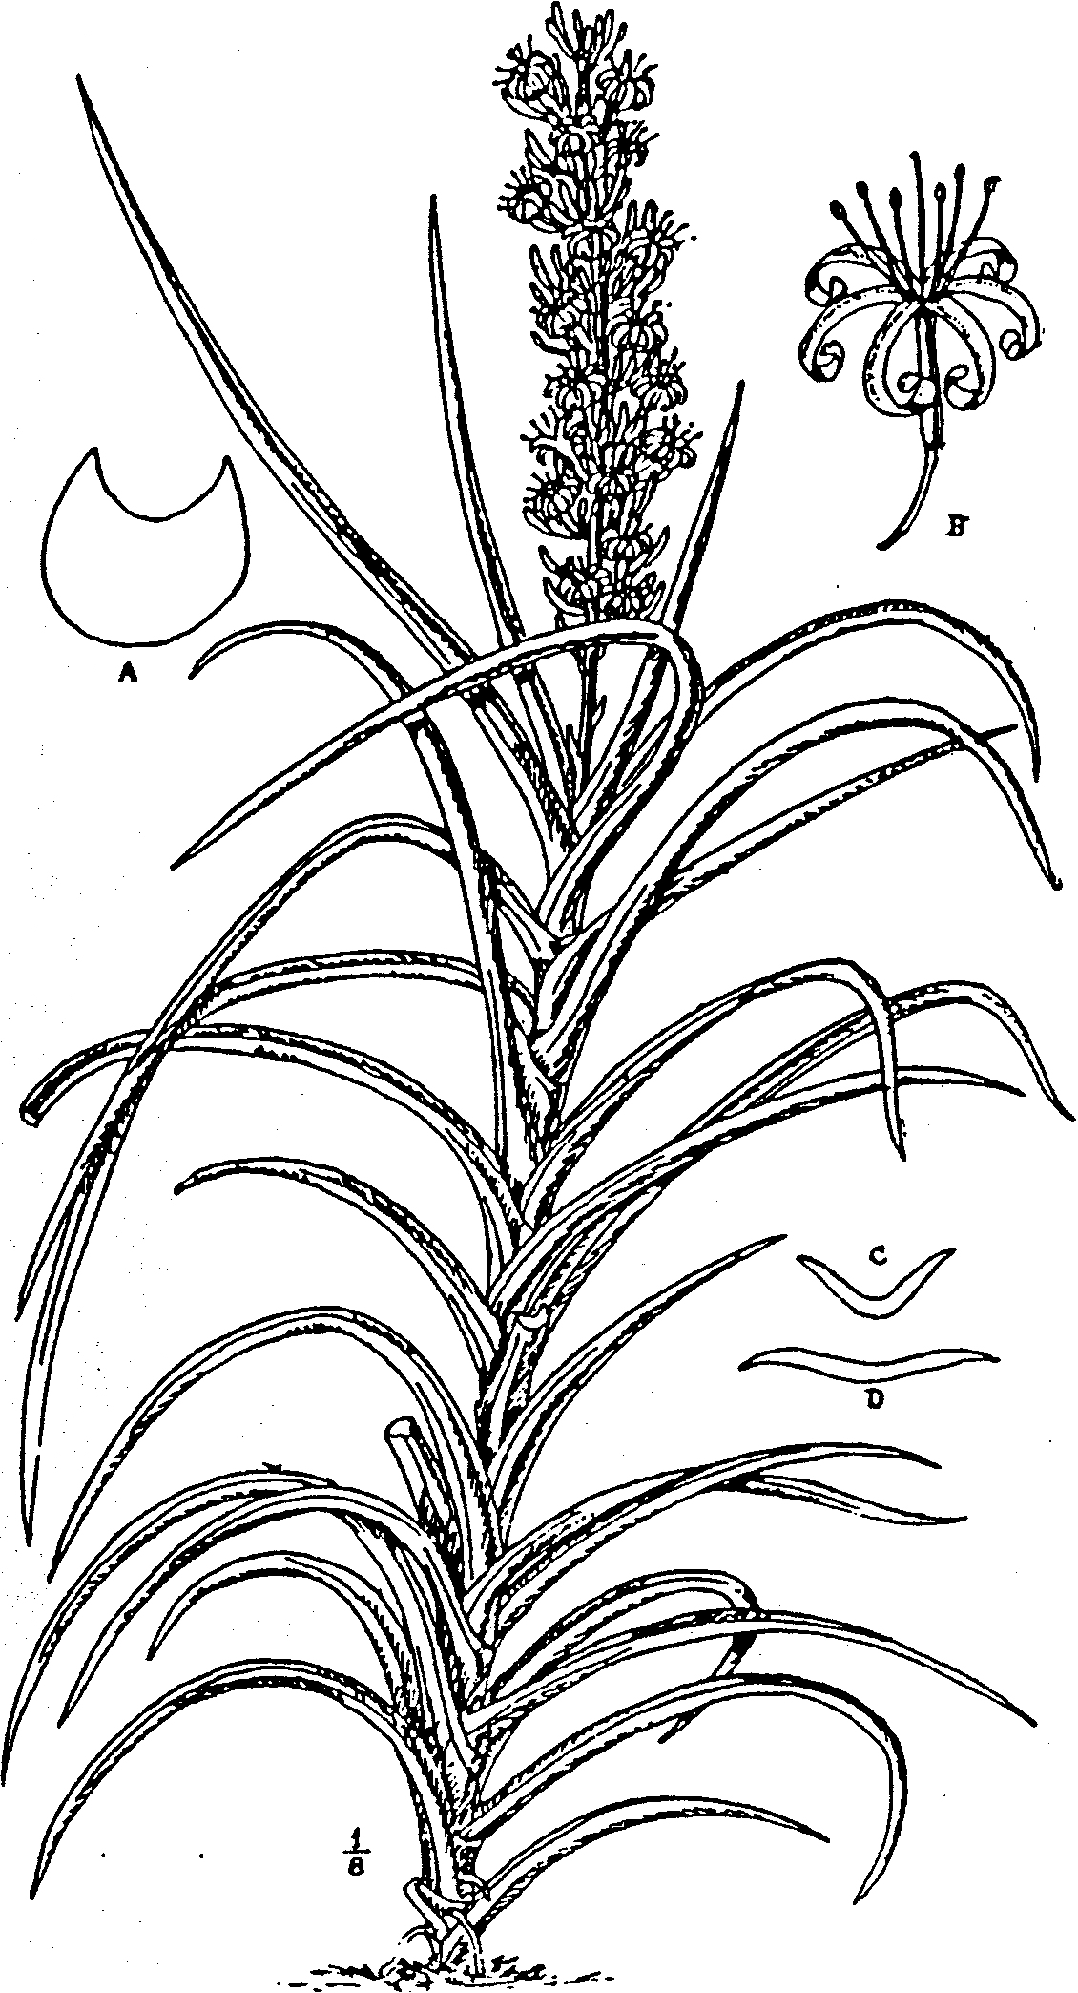

FIG. 2.
S. caulescens, N. E. Br. -Plant ⅓ nat. size; A, section 6 in. above base of
leaf; B, flower.

S. arborescens, Cornu. (Habit like that of S. caulescens.) C and D,
sections above middle of two different leaves. Figs. A-D, 3 nat. size.

All from plants cultivated at Kew.

5. S. suffruticosa, N. E. Brown, (Fig. 3). Stems not rising
erectly more than 1 ft. high. bushily branching ½ - 3 in. above the
ground, forming with the leaves clumps 2-2½ ft. high. Aerial
branches, spreading or ascending, 3-10 in. long, ½ - ¾ in. thick,
rooting, covered on the lower part with very acute or spine-tipped
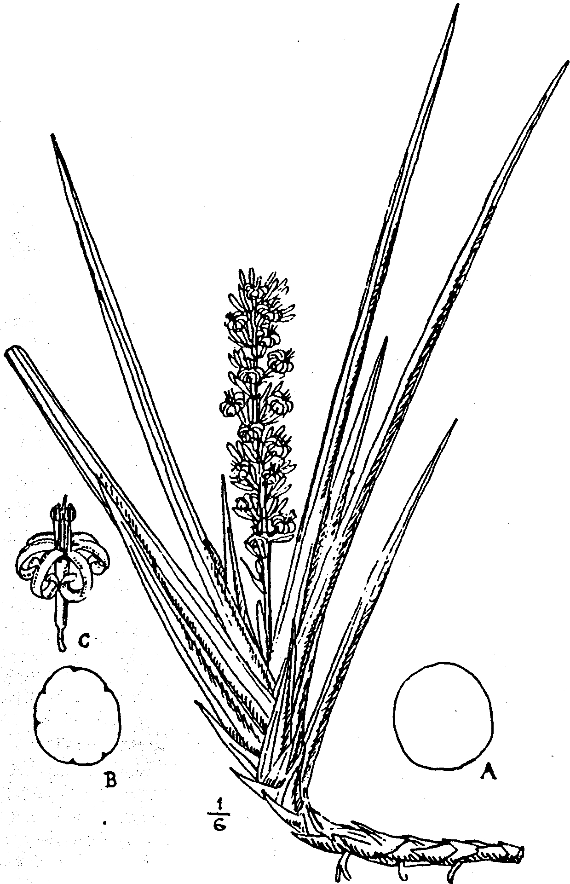

FIG. 3.

S. suffruticosa, N.E.Br. Aerial branch ¹/₆ nat. size; A, section of leaf
just above sheath; B, section above sheath of old leaf, showing slight
groves which form with age from shrivelling; C, flower. Figs. A-C,
all nat. size. From the type cultivated at Kew.
white-edged green scales or sheaths ¾ - 1½ in. long, which gradually
pass into the leaves on the apical part. Leaves 7-18 to a growth,
usually irregularly directed,, but sometimes more or less 2-ranked,
both arrangements occasionally occurring on. the same stem,
ascending or spreading, rough throughout or smooth at the basal
part and rough above, ½ -2 ft.. long, ½ - ¾ in. thick, cylindric,
sheathing at the base and usually with a concave channel extend-
ing from the sheath ¼ - ½ way up the leaf, gradually tapering to
a very acute hard spine-like brown point 1½ - 2 lin. long, dark
green, faintly banded with paler green when young, and marked
with darker green continuous and interrupted longitudinal lines,
which with age or on shrivelled leaves become impressed, form-
ing slight furrows. Flower-stem 1-1¼. ft. high. 2-4 lin. thick at
the base, green, thickly covered with minute whitish linear dots,
and bearing 2-4 membranous long-pointed sheaths 1¾ - 2¾ in. long
on the basal part and a compact spike-like raceme 1¾ -2½ in. in
diam. at the upper part. Bracts ½ - 2 lin. long, membranous,
ovate, acute or acuminate. Flowers 2-5 in a cluster, whitish or
greenish-white, sometimes with a slight reddish tinge outside;
pedicels 1⅓ - 2 lin. long, variably jointed at or above the middle.
with the persistent part 1-1½ lin. long; tube about 5 lin. long,
less than 1 lin. in diameter, scarcely or but slightly enlarged at
the base; lobes 6-7 lin. long, recurved-spreading or with reflexed
(scarcely revolute) tips.
BRITISH EAST AFRICA. Nairobi River Falls, scarce, Powell,
13 ! and without precise locality, Evans !
Described from living plants sent from Nairobi by Mr. W. A.

Evans in 1903, and by Mr. H. Powell in 1906 to Kew, where they
have flowered on two or three occasions.
6. S. Phillipsiae, N. E. Brown in Hook. Ic. Plant, vol. xxx, t.

3000. Plant with abort erect stems branching at or above ground-
level, forming irregular clumps about 1 - 1¼ ft. high. Branches,

3-8 in. long, ½ in. thick, more or less horizontal or spreading on
the ground and ultimately rooting, ending in a tuft of leaves,
clothed below the tuft with overlapping broadly deltoid-ovate
sheaths or scales ⅔ - 1¼ in. long, tapering from the base into the
apical spine, dull green, with a membranous white edge to a
narrow brown border, withering to whitish-brown. Leaves
usually 5-10 to a growth, directed to various points of the com-
pass, when young ascending or suberect, ultimately very spread-
ing and slightly recurved, rigid, smooth, 4-18 in. long, ½ - ¾ in.
thick, cylindric, with 5-10 longitudinal impressed lines or slight
furrows extending from base to apex and a deeply concave sheath-
ing portion 2-3½ in. long at the base, with acute white edges,
gradually tapering upwards and rather suddenly narrowed at the
apex into a hard brown acute or obtuse point ¹/₁₂ - ¹/₈ in. long, or
the outer leaves of each tuft acutely spine-pointed; young leaves
dull dark green, very faintly marked with transverse bands of
slightly paler green, which become obliterated with age; old
leaves uniformly very dark and slightly bluish-green. Flower-
stem 14-18 in. high, bearing on the basal third 2-3 distant
whitish-brown membranous sheaths 1-1½ in. long, which gradu-
ally taper from their base to an acute point, and on the upper two-
thirds a spike-like raceme of flower-clusters. Bracts ¹/₈ – ¼ in. long,
ovate or ovate-lanceolate, acute, membranous. Flowers 3-6 in a
cluster, white; pedicels 1¼ - 1½ lin. long, jointed at or slightly

above the middle, with the deciduous part thickened upwards,
tube 5 lin. long, 1 lin. in diam. at the scarcely enlarged base;
lobes 5½ - 6 lin. long, linear, obtuse, not widely spreading and but
slightly re volute.
BRITISH SOMALILAND. Sirs. Lort Phillips !
Described from a living plant which flowered at Kew, January,

1912, originally received in 1900 from Cambridge Botanic
Garden, where it was introduced from Somaliland by Mrs. Lort
Phillips.

7. S. gracilis, N. E. Brown in Kew Bulletin, 1911, p. 96 (Fig.
4). Stem 1-3 in. high, hidden by the leaf-sheaths, producing
above the ground lateral procumbent and slightly ascending-
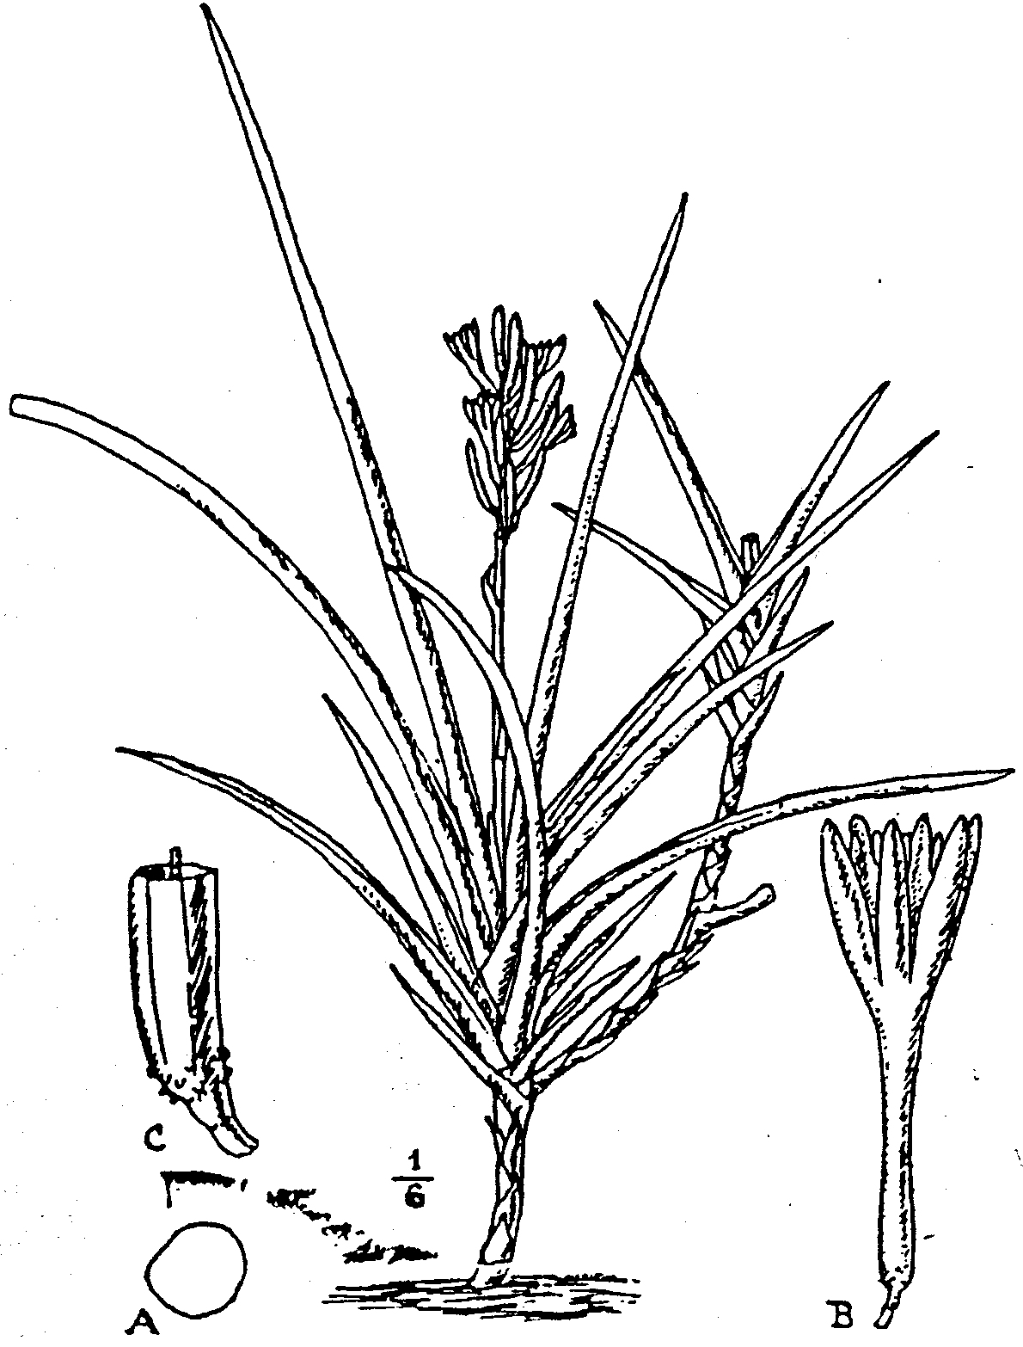

Fig. 4.
S. gracilis, N.E.Br. Plant ¹/₆ nat. size; A, section at middle of leaf,
nat. size; B, flower, not fully open, nat. size; C, part of tube of flower,
showing the minute tubercules at base, enlarged. From the type
cultivated at Kew.

spreading branches ½ - 3 ft. long and ¼ in. thick, covered with
adpressed ovate very acute and somewhat spine-pointed sheaths
½ - 1 in. long, of which the upper gradually pass into the leaves, at
first green with white margins, withering to white. Leaves 8-12
to a growth, directed all ways, closely placed, ascending' or spread-
ing, straight or curved or slightly sinuous, firmly flexible, not
rigid, nearly or quite smooth, the outer of each tuft much shorter
than the inner, concave down the face, very rounded on the back;
inner or fully developed leaves ¾ - 2½ ft. long, sheathing, and con-
cave-channelled for 2-5 in. at the base, cylindric above, 3-4½ lin.
thick at the top of the sheath thence gradually tapering to a very
acute spine-like brown or whitish point 1-3 lin. long, at first
without grooves or channels, becoming- faintly to deeply grooved
on the oldest or shrivelled leaves, deep grass green, sometimes
inconspicuously marked with narrow darker green bands on the
young leaves and with some slightly darker continuous or inter-
rupted longitudinal lines; margins of the basal sheaths with mem-
branous white edges. Flower-stem ½ - 1 ft. high, ¹/₁₀ - ¹/₈ in. thick.
light green, with 2-3 membranous sheaths ⅔ - 1¼ in. long and
tapering to an acute point on the lower half or two-thirds; upper
part with a lax spike-like raceme about 2½ -3 in. long. Bracts
1-1½ lin. long, membranous, lanceolate or linear-lanceolate,
acute, spreading. Flowers in pairs, ascending, white; pedicels
with the persistent part up to the articulation ½ - ¼ lin. long,
smooth, the deciduous part usually formed by the tapering base
of the flower-tube being scarcely pedicel-like in. this species
(except in dried flowers), and is minutely tuberculate, in dried
flowers the tubercles disappear; tube (including the tapering-
tuberculate basal part) ¾ - 1 lin. long, ¾ - 1 lin. in diam. at the
slightly swollen base, more slender above; lobes 5-6 lin. long-,
linear, obtuse.
TROPICAL AFRICA. British East Africa, fairly common at
Mazeras, Powell, 11! German East Africa. Without locality,
Busse, 299!
Described from living plants sent by Mr. Powell to Kew, where
they flowered in Dec., 1910, and Feb., 1912.

8. S. rorida, N. E. Brown. Stem 3-9 in. high, entirely
covered or formed by the sheathing leaf-bases. Leaves, 11-15
to a growth, in 2 ranks, the inner or more fully developed
ascending-spreading, the outer more spreading, becoming smaller
and passing into sheaths. Fully developed leaves " horn-like."
cylindric, and with an acute channel down the face towards the
apex, becoming flattish above towards the base, 1 – 1¾ ft. long,
1 –1 ⅓ in. broad, and ¾ -1 in. thick at the base, straight or slightly
recurved, gradually tapering from the shortly sheathing base to
the spine-pointed apex; rigid, green, marked with very numerous
darker longitudinal lines on the back and sides, somewhat
glaucous; the channel with acute reddish-brown margins,
narrowly edged with whitish. Flower-stem about 3 ft high. twice
as long as the leaves, slightly flexuose, laxly branched into
numerous spike-like racemes at the upper two-thirds, and with 2
acuminate sheaths 1½ - 2 in. long clasping and adpressed to the
stem on the basal third; racemes horizontally spreading or slightly
deflexed, 3-7 in. long, bearing flower-clusters nearly to their base.
Bracts very small, deltoid, acute, membranous. Flowers, 3-6
in a cluster, spreading at a right angle to the branch, and mostly

directed to the upper aide; pedicels about 1 lin. long, jointed at
the apex; tube about 3 lin. long, nearly cylindric, slightly
inflated at the base; lobes 5-6 lin. long, much longer than the
tube, spreading-recurved, linear, obtuse, whitish-yellow, with a.
reddish stripe down their middle. -Sanseverinia rorida, Lanza
in Bull. Ort. Boi. Giard. Colon. Palermo, vol. ix. p. 208,.
t. 5a, 6a.
ITALIAN SOMALILAND. In sandy places on the coast near Maga-
doxo (Mogadiscio), Macaluso.
Of this species 1 have only seen a seedling plant.

9. S. zanzibarica, Gérôme and Labroy in Bull. Mus. Hist. Nat.
1903, pp. 170, 172, 173, fig. 19. " Scarcely caulescent. Leaves
2-ranked, crowded” (ex Gérôme and Labroy); two leaves only
have been seen, which are apparently recurved-spreading, thick
and very rigid, ½ - 1 ft. long (apex not seen), ¾ - 1 in. broad, and
about ½ in. thick measured from the bottom of the channel;
linear-lanceolate, shallowly concave down the face, very obtusely
and triangularly keeled down the back; dull dark green, over-
spread with bluish-grey (from age?) on both sides, with reddish-
brown edges to the channel, but without markings. Flowers
unknown. --De Wildeman, Notices PI. Utiles du Congo, pp. 625,.
636, fig. 19. S. Ehrenbergii, Gérôme and Labroy in Bull. Mus.
Hist. Nat. 1903, pp. 169. 173, fig. 18; and De Wildeman,
Notices PI. Utiles du Congo, pp. 624-625, fig. 18, not of
Schweinfurth.
TROPICAL AFRICA. Zanzibar or German East Africa, Sacleux!
Of this species I have only seen two living leaves from the type
plant, sent to Kew from Paris Botanic Garden, from which the
above description is made, but I am unable to say if they were
the outer leaves of a growth or the fully developed central leaves
of an adult plant; they are not described at the original place of
publication.
The plant described and figured as S. Ehrenbergii by Gérôme
and Labroy is utterly different from that species, and a leaf of it
sent to Kew is certainly not distinct from those of S. zanzibarica.
The authors even state that they are alike, but that the supposed
S. Ehrenbergii differs from S. zanzibarica by the presence of a
furrow on each side of the mid-rib down the back of the leaf.
These furrows are merely due to shrinkage from age or imperfect
root action, and are of common occurrence on old leaves of most
species; they are never of specific importance in any of the species.
having leaves that are broader than thick.

10. S. Perrotii, Warburg in Tropenflanzen, 1901, p. 190, with
a figure. Stem erect, 6-8 in. high, covered by the bases of the
leaves, ¾ - 1 in. thick. Leaves, 8-12 to a growth, 2-ranked, ascend-
ing or spreading, the inner of adult flowering plants 3-5 ft. long,
with a deep concave-channel as broad as the leaf throughout
their length, very obtusely keeled or rounded on the lack, slightly
compressed, about ¾ - 1 in. broad and 5-7 lin. thick from the
bottom of the channel to the back near the base, thence very
gradually narrowing to the apex, with hard whitish acute tips;

margins of the channel acute, reddish-brown, with white mem-
branous edges. Flower-stem 4 ft or more high, bearing 3-4 dis-
tant membranous acute sheaths 1½ -2 in. long on the lower part,
paniculately branched above. Flowers, in clusters of 2-4, some-
what laxly scattered along the branches; pedicels about 1 lin.
long; tube about ¼ in. long, pale greenish; lobes about 4½ lin.
long, recurved-spreading, whitish on the inner surface, purplish
on the back. --De Wildeman, Notices PI. Utiles du Congo, pp.
626, 627, 633.
GERMAN EAST AFRICA. Among bushes, on coral-rock forma-
tion, near Lindi, Perrot.
Described partly from the original description and figure,
partly from a very fine life-sized drawing- at Kew of a plant sent
by Dr. Stuhlmann from Dar-es-Salaam to the Calcutta Botanic
Garden, where it flowered in March, 1904.

11. S. robusta, N. E. Brown. Rootstock stout, creeping.
Stem of adult plants 1-2 ft. high, erect, covered by the bases of
the leaves, 1 in. or more thick. Leaves 6-14 to a growth, 2-
ranked, crowded, erect or slightly spreading in a fanlike manner,
smooth, the inner of adult flowering plants 3-7 ft. long, the outer
shorter, all laterally compressed, with flattened sides, very
rounded on the back, with a triangular channel as broad as the
leaf and 4-5 lin. deep all down the face, ¾ -1⅓ in. thick from side
to side and 1¼ - 1¾ in. thick from front to back near the base,
thence gradually tapering upwards and rather abruptly narrowed
into a hard spine-like brown point ¼- ½ in. long at the apex; dark
preen, faintly glaucous, with 14-30 longitudinal continuous or
interrupted darker green lines, usually arranged in groups of
2-4, which with age shrink into slight furrows, otherwise without
bands or spots, the acute margins of the channel narrowly bor-
dered with red brown and edge with white. Flower-stem about
4 ft. high, paniculately branched above, with the flower-clusters
rather distantly scattered along the branches. Persistent part
of the pedicels ½ - ¾ lin. long. Flowers not seen.
BRITISH EAST AFRICA. Between Voi and the Taifa Hills,
Grenfell, 6 ! 13 ! 18 ! Voi, Powell !
Described partly from living plants cultivated at Kew, partly
from dried specimens, which are without flowers and have only
a very imperfect panicle. This species yields an abundance of
fibre of good quality.
S. robusta is closely allied to S. Ehrenbergii, but the taller
stem and more numerous leaves seem well to distinguish it, the
tubercles bearing the clusters of flowers upon the only inflores-
cence seen are neither so closely placed nor so prominent on the
branches of the panicle as in the Nubian plant, and when flowers
are forthcoming, these may prove to be distinct.

12. S. Ehrenbergii, Schweinfurth ex. Baker in Journ. Linn
Soc. vol. xiv, p. 549. Stem 0-9 in. high, concealed by the leaf-
bases. Leaves 5-9, crowded, 2-ranked, erect or more or less
spreading fanwise, faintly rough, 2½ -6 ft. long, 1-1⅓ in. thick
from side to side, 1¼ -1¾ in. thick from front to back, laterally

compressed, with flattened sides, rounded on the back, tapering
upwards, rather abruptly ending in a stout hard spine-like point
¼ - ½ in. long, with a triangular channel as broad as the leaf all
down the face and 5-12 shallow grooves or impressed lines down
the sides and back, dark green, with the grooves or longitudinal
lines blackish-green, without transverse markings; margins of
the channel acute, reddish-brown, with white membranous edges.
usually spreading to a slightly wider breadth than the rest of the
leaf at the basal part. Flower-stem up to 6½ ft. high,
paniculately branched at the upper three-fourths of its length;
branches ¼ -1¾ ft. long, curved, ascending, the lower branched,
the upper simple. Flowers 4-7 in a cluster; pedicels 1¼ -2 lin.
long, jointed above the middle; tube 2½ -3 lin. long; lobes 3½ lin
long, linear, obtuse. --Baker in Kew Bulletin 1892, p. 129; Oliver
in Hooker, Ic. Plant, t. 2269; Schweinfurth in Bull. Herb.
Boiss, vol. ii, Append. 2, p.78; Engler, Pflanzenw Ost-Afr. C.
p. 144. t. 6; Baker in Fl. trop. Afr. vol. vii, p. 334; De Wilde-
man, Notices PI. Utiles du Congo, p. 631. but not of pp. 624
and 625; Pirotta, Flor. Col. Eritrea, 253; Fiori Boschi e Piante
Legn. Eritrea, 104; not of Gérôme and Labroy.
NUBIA. Wady Ossir, south of Suakin, Schweinfurth, 31! and
other localities in the interior, ex Schweinfurth. ERITREA.
Near Aidereso, 4000 ft. alt., Schweinfurth and Riva, 1835!
SOMALILAND. Without precise locality, Stace !
The above description is made partly from a photograph and
a living plant cultivated at Kew, both of which were received
from Somaliland. and partly from Schweinfurth's specimen 31.
The plant which K. Schuman has figured and described in
his edition of Hemprich & Ehrenberg, Symbolae Physicae, p. 27,
t. 13, fig. 2, as S. Ehrenbergii, is, I believe, a totally different
species, which cannot be determined until living plants of it are
obtained.
Dr. Schweinfurth also states that this plant is a native of
Arabia and German East Africa, but he informed me that he
had not compared living plants from these two regions with each
other nor with the Nubian plant, I therefore have very much
doubt as to the correctness of this identification, as from the
evidence at present before me, the range of the various species,
so far as known, seems limited.
The fibre of S. Ehrenbergii is used in Nubia and Egypt for
making- ropes, &c.

13. S. deserti, N. E. Brown. Stemless, with a stout creeping
rootstock. Leaves, 7-8 to a growth, 2-ranked, erect, rigid,
smooth, 2½ -3½ ft. long. 1-1¼ in. (or perhaps more) thick at the
base, compressed-cylindric, tapering from base to apex into a
hard spine-like whitish point marked with a chestnut-brown
band at its base and about ½ in. long, channelled up to
the apex on the face and with about 9-12 shallow grooves on
the sides and back; the channel is narrow and acute with erect
margins at the apical part, broadening and becoming more and
more obtusely angular, -with somewhat spreading- margins and
nearly as broad as the leaf towards the base; margins acute,

hardened, red-brown. Flower-stem, probably about 2 ft. high,
only portions of the base and apex seen, 3½ -4½ lin. thick at the
base, with about 3 sheaths on the basal part and a long spike-
like raceme of flower-clusters above. Bracts on the apical part
1½ -2 lin. long, ovate, obtuse, membranous, those below not seen.
Flowers 4-6 (or more?) in a cluster; pedicels 3-3½ lin. (or more?)
long, jointed below the middle, with the persistent part 1¼ -1½ lin.
long on the dried specimen seen. Tube 3½ -4 lin. long, scarcely
or but slightly inflated at the base, about 1¼ lin. in diam.; lobes
about ½ in. long, linear, obtuse, revolute.
BECHUANALAND. On the banks of the River Botletle in the
Kalahari desert, 3000 ft. Mrs. Lugard, 9 ! shore of Lake Ngami
and the River Botletle, Nicolls !
There is also a specimen that was sent from Buluwayo in
Rhodesia, in the collection at the Imperial Institute and a
portion of it at Kew, which appears to belong to this species.

14. S. varians, N. E. Brown. Stemless. Leaves 4-8 to a
growth, two-ranked erect or ascending, straight or slightly
curved, very slightly rough, 1¼ -3¾ ft. long, ½ - ⅞ in. thick at the
base, variable, on some growths of adult plants all or most of
the leaves are cylindric, with an acute channel much narrower
than the leaf and having green acute edges all down the face,
gradually tapering to an acute hard whitish point ¹/₆ -⅓ in. long;
on other growths a few of the outer leaves are half cylindric,
shortly and somewhat abruptly acute, having a flattish or
shallowly trough-shaped channel as broad as the leaf down the
face, with acute hard red-brown margins often edged with a
white membrane when young, dull dark grass-green, not
glaucous, with numerous longitudinal dark green lines, some of
which, with age. become impressed, forming slight furrows,
when young indistinctly banded with dark and lighter green.
Flower-stem 2-2½ ft. high, light glaucous-green or greyish-green,
indistinctly marked with transverse mottlings on the upper part,
bearing 2 distinct whitish membranous acuminate sheaths
¾ -1½ in. long on the basal part and a long spike-like raceme of
flower-clusters above. Bracts membranous, ¹/₆- ¼ in. long, linear
or filiform from a broadened base, acute, white. Flowers 6-10
in a cluster; pedicels 2-2½ lin. long, jointed slightly above the
middle; tube 5-6 lin. long, white; lobes 7-8 lin. long, recurving
or revolute, linear, obtuse, white, speckled with purple at the
tips.

COUNTRY UNKNOWN.

Described from a living plant which had been cultivated for
many years at Kew under the name of S. zeylanica, so that it
may possibly be of Asiatic origin, but it is very closely allied
to S. patens, differing by its leaves not being nearly so stout,
fewer to a growth, erect or ascending instead of spreading from
the base, and by having more flowers in a cluster. When seen
growing side by side, S. patens and S. varians are quite different
in appearance, although there is little to distinguish them
technically. The plant flowered at Kew April 23, 1909, and
May 2, 1914.

15. S. patens. N. E. Brown (Fig. 5). Stemless. Rootstock
creeping ¾ -1 in. thick. Leaves 5-10 to a growth, 2-ranked,
recurved-spreading from their base in a fan-like manner,
slightly rough, the inner of adult plants 1½ -3 ft. long, ⅔ - 1⅔ in.
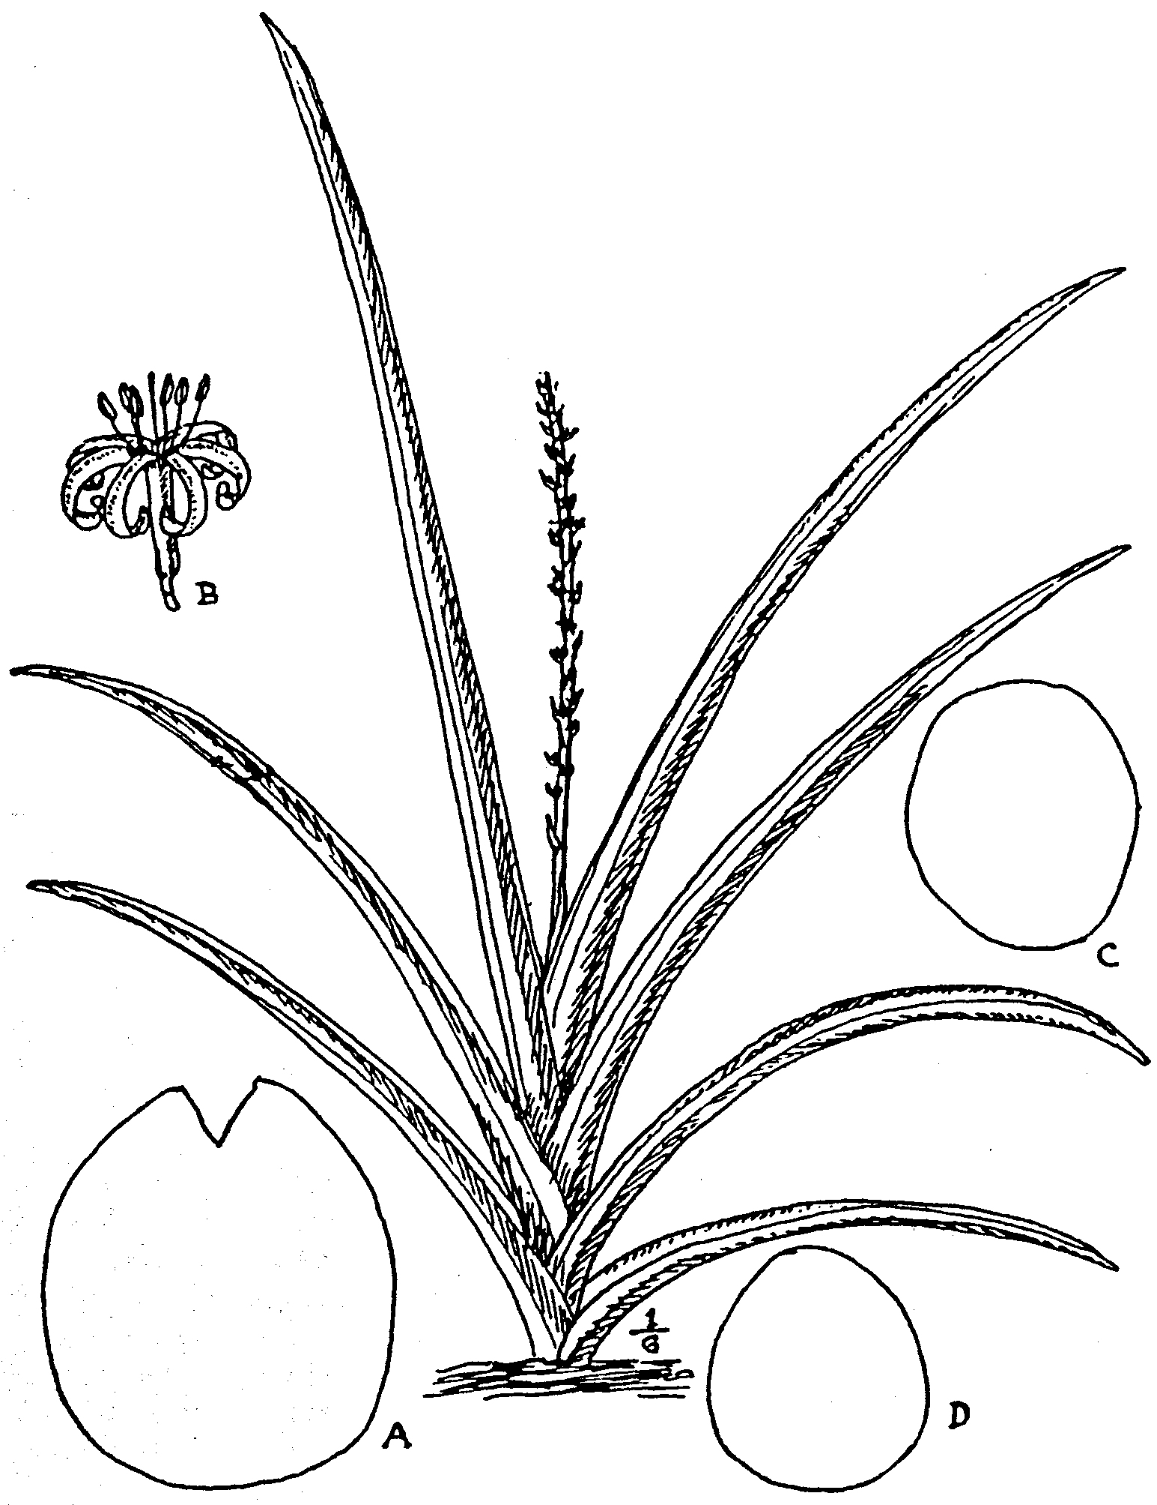
Fig. 5.
S. patent. N.E.Br. Plant ¹/₆ nat. size; A, section at middle of leaf, nat.
size; B, flower, nat. size.
S. cylindrica, Boj. C, section at middle of leaf of type; D, section at
middle of leaf of var. patula, N.E.Br., both nat. size. All from
plants cultivated at Kew.
thick from front to back and ⅔ - 1¼ thick from side to side at the
base, the outer gradually shorter, compressed-cylindric, with an
acute channel much narrower than the leaf extending from base
to apex on the face, tapering upwards and at the apex somewhat
abruptly contracted into a hard acute whitish point ¼ -½ in. long,
marked with a brown band at its base, somewhat indistinctly
marked with dark green and paler green transverse bands,
becoming bluish-green with age, longitudinally marked with
numerous blackish-green lines, several of them continuous to the
apex, others interrupted; margins of the channel acute, green,
or only whitish along the basal 1-6 in. Flower-stem 1¼ -(2½?)
ft. long, pale green, bearing 2-3 acuminate sheaths ¾-2 in. long
on the basal third and a spike-like raceme of flower-clusters on
the upper two-thirds. Bracts 1^-3 lin. long, lanceolate, acute,
membranous. Flowers 2-3 in a cluster, white; pedicels 2½ -3 lin.
long, jointed at the middle, with the persistent part 1½ -1¾ lin.
long; tube 4½-5 lin. long, ½ lin. in diam. slightly inflated at
the base; lobes 6 lin. long, ½ lin. broad, linear, revolute.
TROPICAL AFRICA. Origin unknown, but probably British East
Africa.
Described from a living plant which flowered at Kew on
April 4, 1910.

16. S. intermedia, N. E. Brown in Kew Bulletin, 1914, p. 83
(Fig. 6). Stemless. Leaves of adult plants 2-7 to a growth, not
2-ranked, erect or ascending, slightly recurving, stiff, not quite
smooth, but with a surface something like that of ground glass,
1½ -4 ft. long, ½ - ¾ in. thick; the outer sometimes somewhat half
cylindric with acute edges to the concave channel; the inner
cylindric, channelled all down the face or occasionally the
central leaf is without a channel, gradually tapering from the
base to a very acute spine-like but not very rigid whitish point,
with the channel much narrower than or at the basal part some-
times nearly as broad as the leaf, and having acute green or
whitish edges at the basal part, passing into obtusely rounded
green edges at the upper part, and with numerous slight grooves
or impressed longitudinal lines on the sides and back, at first dull
deep green, becoming slightly bluish-green, with or without a
faint indication of transverse banding. Flower-stem 8-18 in.
high, with 2-3 acuminate sheaths on the basal 2-3 in. and a
dense spike-like raceme of flower-clusters above, light greyish-
green, from being covered with minute spots composed of
“frosted” cells when examined with a lens. Clusters 3-6
flowered, very crowded. Bracts 1-2 lin. long, ovate or ovate
lanceolate, acute, membranous. Flowers ascending-spreading;
pedicels 1 lin. or less long, jointed at the apex; tube 7-9 lin.
long, slightly ovoid-inflated and 1¼ lin. in diam. at the base,
more slender above, pale greenish; lobes ½ - ¾ in. long, linear,
obtuse, revolute, white or greenish-white and minutely dusted,
with purplish on the back at the apex.
BRITISH EAST AFRICA. Tsavo district, Powell, 9! and without
precise locality, Powell 4!
Described from a living plant received from Nairobi in 1906.
which flowered at Kew Nov. 5, 1913.

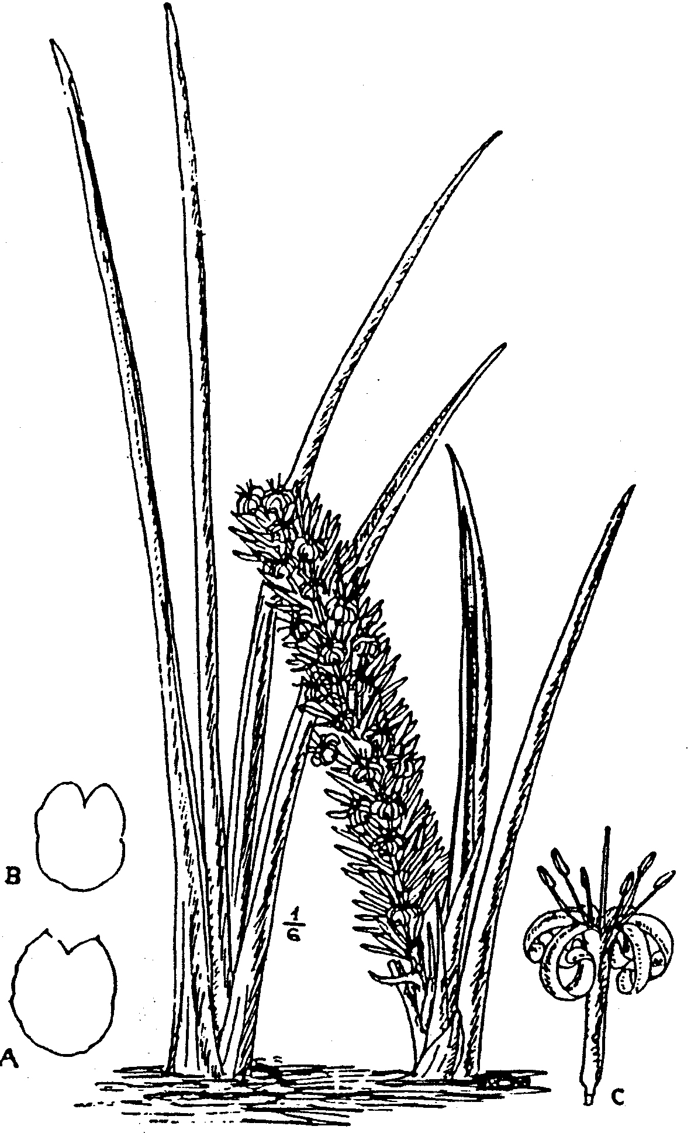

Fig. 6.
S. intermedia, N. E. Br. Plants nat. size; A. section 6 in. above base,
and B, 15 in above base of the same leaf, showing alteration from
acute to rounded edges of the channel, nat. size; C. flower. nat. size.
From the type plant cultivated at Kew.
17 S. rhodesiana, N. E. Brown (Fig. 7)-Stemless, with a
stout creeping rootstock. Adult leaves, 3-4 to a growth, two-
ranked, straight, or nearly so, and stiffly erect, sub-parallel, with
the tips of the inner pair not or scarcely farther apart than at
the base; slightly rough or nearly smooth, 3-5½ ft. long, 1⅛ 1¼ in
thick from side to side, and ¾ -1¼ in. thick from front to back at
the base; sub-cylindric, gradually tapering from the base to a
stout hard acute whitish or whitish-brown point ¼ - ½ in. long,
with a broad open concave channel on the face of the outer leaves
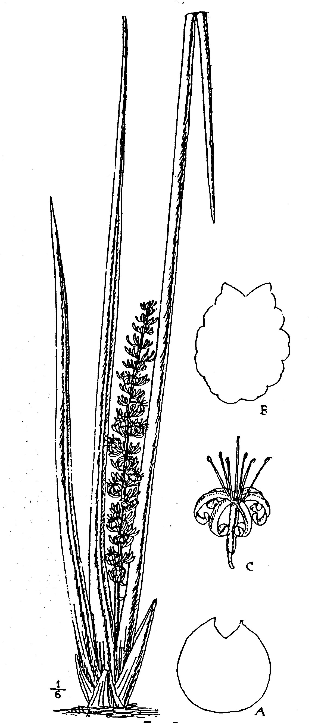

Fig 7

S. rhodesiana, N.E. Br. Plant ¹/₆ nat. size; A, section 15 in. above base
of a leaf grown, at Kew; B, section 12 in. above base of a leaf of same
plant on arrival from Rhodesia, showing formation of grooves in
withering; C, flower. Figs. A-4, nat. size. From the type cultivated at Kew
and an acute channel much narrower than the breadth of the leaf
on the inner leaves, extending from the base nearly or quite
to the apex, uniformly deep green, without transverse bands,
but marked with very numerous continuous or interrupted longi-
tudinal darker green lines, of which 10-12 or more are impressed
forming slight furrows; margins of the channel acute, dark red
brown, with or without white membranous edges. Flower-stem
about 1¾ ft. high and ⅓ in. thick at the base, pale green, mottled
with darker, bearing about 2 narrow acuminate sheaths 1½ - 2½ in
long on the basal part, and a compact raceme about 16 in long
of numerous flower-clusters above. Bracts inconspicuous, 1½ -2 lin
long, membranous, acuminate. Flowers 8-9 in a duster;
pedicels 2½ -3 lin. long, jointed at or slightly below the middle,
with the persistent part 1-1¼ lin. long and the deciduous part
thickened upwards, dingy whitish-green; tube 4-6 lin lone
1 lin. in diam. at the very slightly swollen base, rather more
slender above, white; lobes 7½ -9 lin. long, linear, obtuse, white.
The flowers seem sometimes to open at night or early morning
and close about 10 a.m.; at others they open in the forenoon and
close about 4.30 p.m. The odour resembles that of an Acacia
RHODESIA. Without precise locality. Described from a living
plant sent by the Director of the Imperial Institute to Kew in
1908, where it flowered in January, 1912.
This species is closely related to S. Pearsonii, N. E. Br , but
certainly seems distinct when the living plants are placed side
by side. The leaves of S. rhodesiana do not taper nearly so
rapidly as those of S. Pearsonii, are parallel, and not diverging
more compressed, especially at the much less acute point, and the
dark green lines are continuous (not interrupted) and more evident
than in S. Pearsonii.

18. S. sordida, N E. Brown (Fig. 8) --Rootstock, creeping.
Stem none or very short, and concealed by the closely imbricating
leaf-bases. Leaves, 4-12 to a growth, 2-ranked, slightly spread-
ing fanwise, straight, or slightly curved, remarkably rough.
2¼ -3½ ft long, ½ - ¾ in.. thick from front to back and ⅓ -½ in. thick
from side to side at the base, slightly compressed-cylindric,
tapering into an acute spine-like whitish or grey point marked
with brown at its base ⅓ -½ lin. long, with a channel all down the
face, which is acute, and much narrower than the leaf for the
greater part of its length, becoming flattened towards the base,
and with 11-15 or perhaps more grooves down the sides and back,
not caused by shrinkage, dull bluish-green, with numerous darker
longitudinal lines, those in the grooves continuous, those between
them interrupted; margins of the channel with a very narrow
hardened dark brown border extending to the apex and more or
less edged with a white membrane. Flower-stem 1-2 ft high and
¼ in. thick at the base; dull light green, minutely dotted with
white, the upper ⅔ -¾ with a spike-like raceme of numerous flower-
clusters, and the lower third bearing 2-3 distant membranous
sheaths ¾ -1½ in. long, tapering from their base to a fine subulate
point. Bracts ⅛ -1½ in. long, subulate and soon withering from
a stout green base, becoming rather inconspicuous. Flowers 7-14

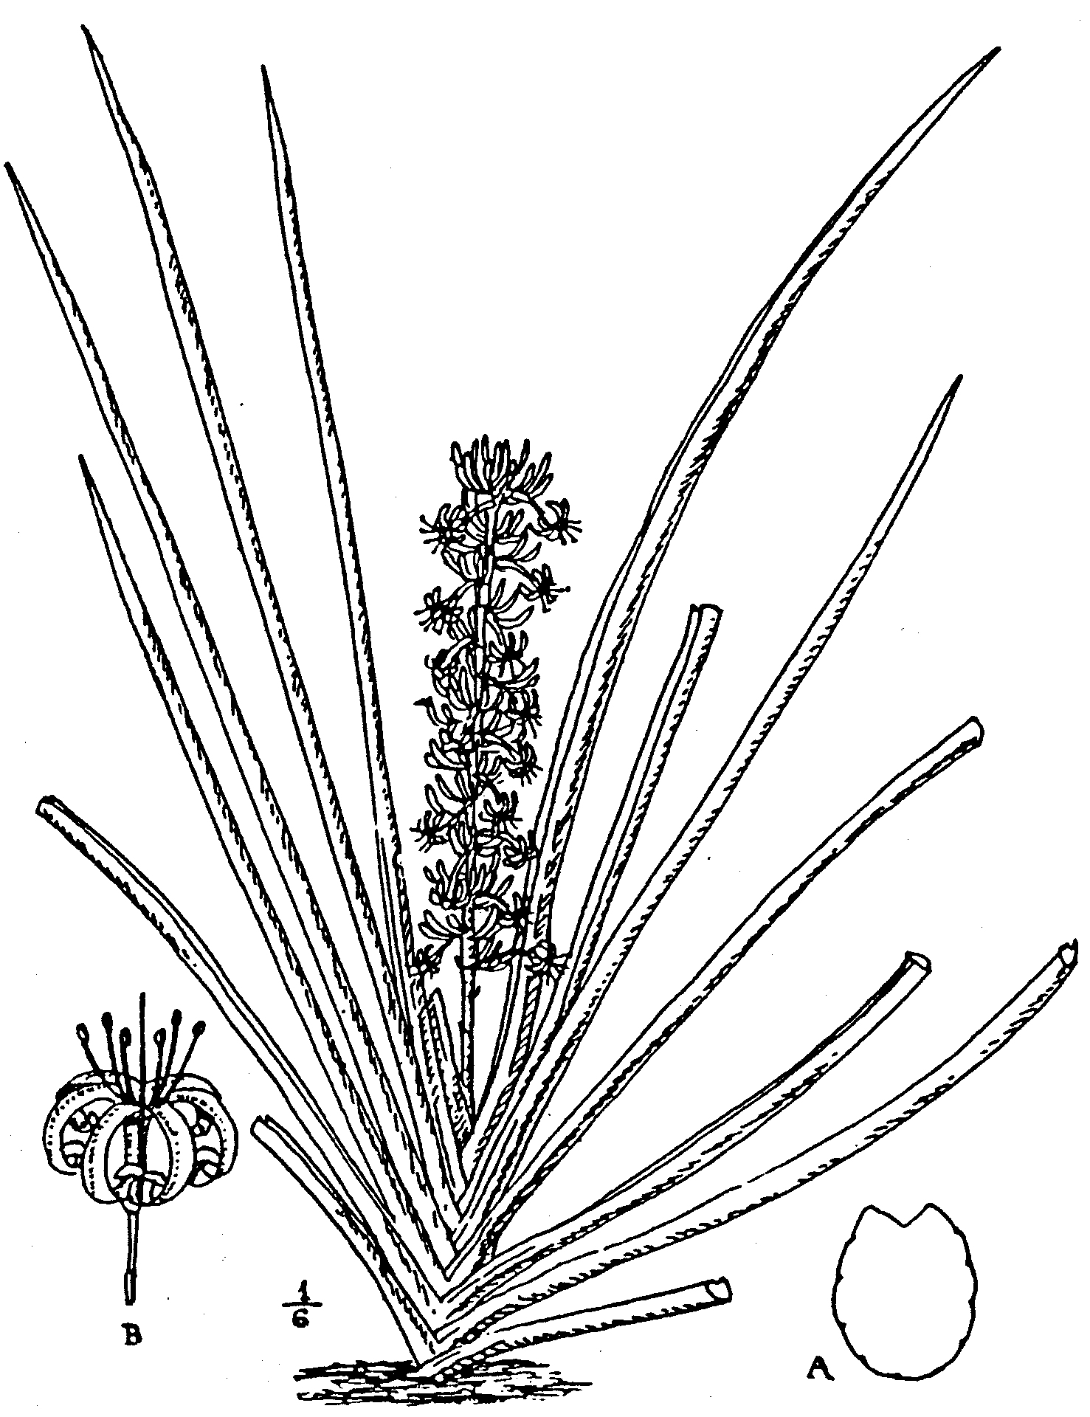

Fig. 8.
S. sordida N E Br. Plant ¹/₆ nat. size; A, section at middle of leaf, show-
ing the grooves; B, flower, both nat. size. From the type cultivated
at Kew.
in a cluster, erect or ascending and pale dingy greenish when
in bud becoming horizontal or distinctly drooping when
expanded; pedicels ⅓ - ½ in. long, jointed at or below the middle,
with the persistent part ⅛ - ¼ in. long, slender; tube 3½ -5 lin.
long, white or greenish; lobes 7-8 lin. long, revolute, linear
obtuse, white on the inner face, green with minute dull purplish
dots on the back. The inflorescence collectively is of a pale dull
greenish colour.
NATIVE COUNTRY Unknown. Described from a living plant culti-
vated at Kew, which flowered in March, 1910.

19. S. Pearsonii, N. E. Brown, in Kew Bulletin, 1911, p. 97
(Fig. 9).--Stemless, with a stout creeping rootstock. Leaves of
seedling or juvenile plants 8-10 in a rosette, directed to all parts
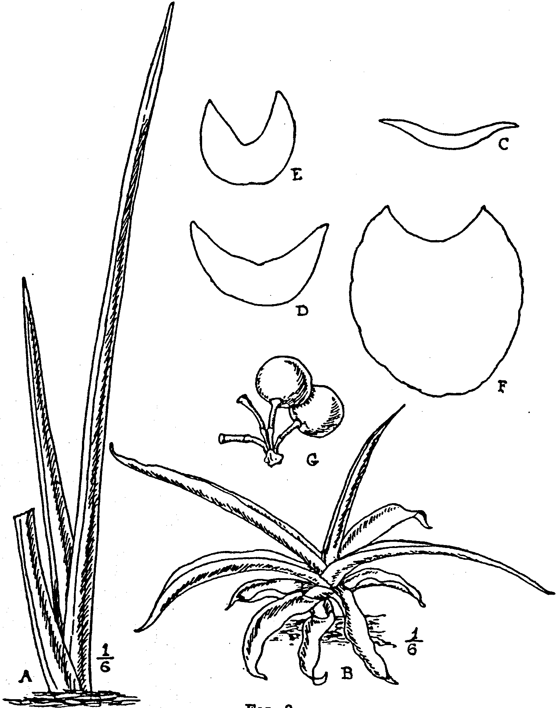

Fig. 9.
S, Pearsonii, N.E.Br. A, adult plant; B, seedling, both ¹/₆ nat. size,
C, D and E, sections at middle of three successive leaves on a seedling,
shoving progressive stages towards the final cylindric leaves; F, sec-
tion of leaf of adult plant 6 in. above base; G, fruit. Figs C-G nat.
size. From the type cultivated at Kew.
of the compass, and recurved-spreading, rigid, 2½ -12 in. long, the
outermost or smaller ⅛ -1¼ in. broad, lanceolate, acute or acumi-
nate, broadly and shallowly concave above, convex beneath and
about ¹/₆ – ¼ in. thick, the inner gradually becoming thicker, more
deeply concave, narrower, and finally passing into the erect and

cylindric form; dull dark green, indistinctly or the inner dis-
tinctly banded with paler green; margins acute, with a red-
brown line inside a membranous white edge; epidermis rather
rough. Leaves of adult growths 3-5, in two ranks, straight, or
nearly so, rigid, erect, but gradually diverging from base to apex,
so that the inner are about ½-1 ft. apart at the tips; smooth,
2¼ -3 ft. long, about 1⅓-1½ in. thick from front to back and
1¹/₆ -1¼ in thick from side to side at the base, cylindric, slightly
compressed, gradually tapering from the base to a very acute,
rigid, terete-subulate (not compressed) whitish point ⅓-l in. long,
and with a channel much narrower than the breadth of the leaf
on the inner face and extending nearly to the apex, concave at
the basal part, acutely triangular at the upper part, slightly
glaucous-green or bluish-green, when young somewhat faintly
banded with paler green, rather inconspicuously marked with
numerous very interrupted darker lines, and 9-12 continuous
slightly impressed lines, forming slight longitudinal grooves;
margins of the channel acute from base to apex, greenish-white
in young leaves, becoming red-brown with a whitish edge.
Flower-stem unknown; only one flower-cluster in fruit wag found,
with 4 pedicels ⅓ in. long, jointed at about ^ in. above the base.
|Berries orange.
TROPICAL AFRICAN. South Angola: among rocks in open
forest near Km. 108-5 on the Mossamedes Railway at 1700 ft.;
Pearson, 2073! Also occurs between Gambos and Houmbe, ex
Pearson. Damaraland: Grootfontein, in Upingtonia, Schinz, 15 !
Described from a living plant sent to Kew by Prof. Pearson,
and from seedlings raised from the fruit that accompanied it.
I have not seen an inflorescence, and Prof. Pearson informs me
that when he discovered the plant the flowering season was over,
and, although he examined many plants, only some remains of a
single inflorescence was found, consisting of the base of the flower-
stem still attached to the plant, a single cluster of fruit and some
loose berries laying on the ground, from which it could not be
determined if the inflorescence was a panicle or a spike-like
raceme. In all probability S. Pearsonii is the same species as
that mentioned under the name of S. cylindrica by Baum
(Kunene-Sambesi Expedition, pp. 25, 28, 78, 197, 460, 470 and
510), and (on p. 197) stated to have a narrow channel down the
face of the leaf, found growing under trees and shrubs on termite-
anthills along the Chitanda River, between Kakele and Goudkopje
at 4000 ft. elevation, and in the region of the Cunene and
Kubango Rivers; also by Schinz (Deutsch-Sudwest-Africa,
pp. 238, 472) as occurring near the Cunene River in Amboland,
which is about 150 miles south-east of where Prof. Pearson col-
lected the plant here described. The true S. cylindrica, Bojer, is
a native of Loanda in Northern Angola, and its leaves are desti-
tute of the acute channel down the inner face which characterises
S. Pearsonii; they are also of a darker green.

20. S. cylindrica, Bojer, Hort. Maurit. p. 349 (Fig. 5, c).--
|Stemless, with a stout creeping rootstock 1-1^ in. thick. Leaves
3-4 to a growth, besides some basal sheaths, 2-ranked, stiffly erect,

not at all recurved near the base, faintly rough, 2½ -5 ft. lone,
cylindric or slightly compressed-cylindric, ⅞ - 1¼ in. thick from
front to back and ¾ -1 in. thick from side to side at the base, imme-
diately above their 3-5½ in. long sheathing portion, gradually
tapering thence to a hardened acute whitish point ¹/₆ – ¼ in. long
the outer sometimes with a very shallow and narrow groove down
the inner face, green, or sometimes whitish-green, with distinct
transverse bands of darker green, the banding becoming fainter
with age; glaucous when exposed to the sun, marked with
numerous interrupted and continuous longitudinal dark preen or
blackish-green lines, of which 4-6 extend nearly to the apex, and
with age and the withering of the leaves become more or less.
impressed as slight grooves. Flower-stem 2-3 ft. high, its basal
part bearing 2-3 distinct pale brownish sheaths 1¾ -2¾ in lone
its upper part with a spike-like raceme 1¼ -2½ ft. long, with 5-6
flowers in each cluster. Bracts ¹/₆ - ²/₆ in. long, lanceolate or ovate-
lanceolate, acuminate; bracteoles smaller, all spreading mem-
branous, very pale brownish when the flowers are expanded.
Flowers 5-6 in a cluster, white or tinted, with reddish pedicels
jointed below or sometimes at the middle, with the persistent and
deciduous parts each 1-2 lin. long; tube ⅔-1 in. long, slender,
¾ lin. in diam. and before the ovary swells scarcely enlarged
at the base; lobes ⅔ -¾ in. long, linear, obtuse, revolute. Hook,
Bot. Mag. T. 5093; Carrière Rev- Hort- 1861 p- 447' figs. 109-
110, and 1901, p. 192; Morren in Belg.- Hort., vol. ix., p. 274,
fig. 27; Baker in Journ. Linn. Soc., vol. xiv, p. 549; in Kew
Bulletin, May, 1887 p. 9, fig. 6; and in Fl. Trop. Afr., vol.
vii., p. 335; Rudolph in Rev. Hort., 1901, pp. 191-192, fig 70;
Godef. --Leb., Sansev, Gigant. Afr. Orient., p. 14; Gérôme and
Labroy in Bull. Mus. Hist. Nat., 1903, pp. 169, 173, fig. 16;
De Wildeman Notices PI. Utiles du Congo, p. 624, fig .16,
and pp. 625, 631, with fig.; and Etud. Fl. Bas-et Moyen Congo
vol. ii. p. 121, t. 50-51; Volkens in Notizbl. Bot. Gart. Berlin.
Append. 22, p. 52, fig. 21. S. angolensis, Welw. ex Hook, in
Report on Veget. Prod. Paris Exhib., 1855, p. 148; Welw
Apont. p. 543; Carrière in Rev. Hort.. 1861, pp. 447, 449;
Monteiro, Angola and the River Congo, vol. i. pp. 45, 103; Hiern;
Cat. Afr. PI. Welw., vol. ii. p. 25.
S. guineensis, Weiner Illustr. Gart. --Zeit, 1887, p. 421 fig.
80, not of Willdenow.
ANGOLA. Loanda; plentiful on sunny hills from Loanda to
Cacuaco and elsewhere. Welwitsch, 3749! and cultivated
Specimens !
Known in Angola as the "Ife" or "Ifi" plant, and used
for making ropes, etc.
Described from a living plant; a portion of the original figured
in the Botanical Magazine at t. 5093. According to Monteiro.
“Sansevieria angolensis is very plentiful all over the littoral
region of Angola." Replacing S. longiflora at about Musserra,
a little to the north of Ambriz. He. however, collected no dried
specimens of either species, so that it is possible more than these
two species may have been included by him under these names.

Var. patula, N. E. Brown (Fig. 5, D). --Leaves, 3-6 to a

growth, sometimes erectly diverging, but more often variably re-
curving or spreading, from a slight but somewhat abrupt recurva-
ture near the base, ⅔-1 in. thick from front to back and ½ - ⅞ in.
thick from side to side immediately above the 1½ -3 in. long
sheathing portion; rather shortly or somewhat abruptly pointed.
Tube of the flower 5½ -9 lin. long; lobes 7-9 lin. long. Other-
wise as in the type.
ANGOLA. Cultivated specimens!
Described from living plants cultivated at Kew.
Although Bojer, when publishing the name in 1837, stated
that this species was a native of Zanzibar, there appears to be no
evidence that it has ever been found wild there. Its history is as
follows: --Bojer states that it was only cultivated (not wild) in
Mauritius. According to Gérôme and Labroy in Bull. Mus. Hist.
Nat., 1903, p. 169, it was introduced into the Jardin des Plantes,
Paris, from the Isle of Bourbon, by Richard, in 1845. In 1861
Carrière published two excellent figures of it in the Revue
Horticole, made from a living plant which had been sent from
Mauritius to the Paris Exhibition in 1855, and Sir William
Jackson Hooker (Botanical Magazine, t. 5093), writing at the end
of 1858, also states that living roots had then been recently
received from that island. So that up to that period S. cylindrica
was only known from the islands mentioned. But in 1855 a
plant was received at Kew from Angola under the name of Ife,
which was found to be the same as one of which fibre was
exhibited at the Paris Exhibition of 1855 under the mss. name
of Sansevieria angolensis, Welw. This plant flowered and was
figured for the Botanical Magazine. When, however, the plant
of S. cylindrica, Boj., above alluded to, was received in 1858 from
Mauritius, it was discovered to be identical with that from Angola.
It is therefore probable that it was introduced by the Portuguese
from Angola into Zanzibar or Mauritius, as the identity of the
Angola and Mauritius plants seems to be beyond dispute, for on
the back of the original drawing of plate 5093 of the Botanical
Magazine the artist, Mr. W. Fitch, has written “Sansevieria
angolensis. Hort. Kew, Aug./58." From which it is certain
that the drawing was made from the Angola plant, a descendant
of which is still thriving at Kew, and this drawing and the
living plant exactly agree with the figure made from the
Mauritius plant published in the Revue Horticole by Carrière.
whilst none of the allied species at all coincide with the latter
figure, especially as to the stiffly erect leaves. The variety patula
is also in cultivation under the names of S. cylindrica and S.
angolensis, but may at once be distinguished from the typical
form by the leaves being distinctly spreading from a curvature
near the base, not straight and stiffly erect.

21. S. Stuckyi, Godefroy-Lebeuf, Les Sansevierias Gigantes-
ques de l’Afr. Orient, pp. 13, 17 & 33 with fig . also fig. of habit
as frontispiece and on the outside cover (Fig. 10). Stemless, with
a stout creeping rootstock up to 2 in. thick. Seedling plants
with a rosette of 4-6 leaves, spreading and recurved, thick and
rigid, 4-6 in. long, ¾ -1¼ \ in. broad, ⅛ - ⅓ in. thick, somewhat strap-

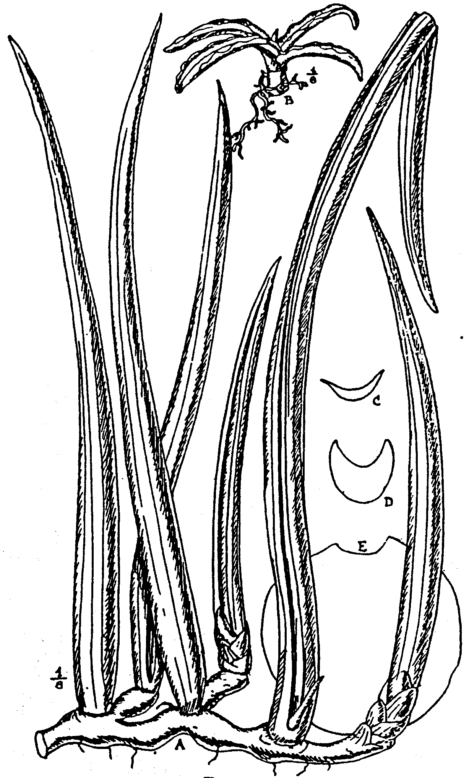

Fig. 10.
S. Stuckyi. Godefr.-Ieb. A adult, and B seedling plants, ¹/₆ nat. size;
C and D, sections at middle of two different leaves of juvenile plants,
¾ nat. size; E, section 18 in. above base of adult leaf, ¾ nat. size
A, from a plant cultivated in Durban Botanic Garden, the remainder
from plants cultivated at Kew.
shaped or narrowly oblong-lanceolate, acute, broadly channelled
down the face, very rounded on the back, with more or less wavy
hardened reddish-brown acute edges, dark green marked with
narrow closely placed sub-parallel transverse bands of pale green.

These leaves are succeeded by others that are ascending or sub-
erect, rigid, 1½ -2½ ft. long, ½ ⅞ in. broad, and as much in thick-
ness, sub-cylindric, with a broad concave channel extending

from base to apex, having acute edges, but with hardened
red-brown margins at the apical part only, rather abruptly acute
or tapering from 2-3 in. below the apex into a subulate point

¼ - ¾ in. long, dark green, marked with subparallel transverse
pale green bands ⅛ - ½ in. apart.

Adult plants with 1-2 or rarely 3 leaves to a growth, stiffly
erect, cylindric or nearly so, with a concave channel having acute
green edges extending from the base quite to the apex on the
face, nearly smooth or very slightly rough, 4-9 ft. long, 1½ -2½
in. in diameter at the base, gradually tapering to an acute
hardened pale brown apex with a short stout subulate point; the
larger leaves are as much as 11 in. in diameter at 1 ft. below the
apex, and the channel is ^ in. deep and ¹/₆ - ⅓ in. broad at the
base, becoming ⅜ - ⅔ in. broad near the apex; the sides and back
are marked with 6-20 continuous or interrupted impressed dark
longitudinal lines or slight grooves, and there are 2-5 in the
channel, dull green, transversely and usually obliquely banded
with paler green, slightly glaucous, the bands nearly or quite
disappear with age. Flowers unknown. --Gérôme & Labroy in
Bull. Mus. Hist. Nat. 1903, pp. 171-173. fig. 14; De Wildeman,
Notices PI. Utiles du Congo, pp, 623, 624, U25, fig. 14, and 632.
with fig. & t. 31-32 (not t. 30). S. Andradae Godefroy-Lebeut,

Les Sansevierias Gigantesques de l'Afr. Orient, pp. 17 & 33, with
fig. of a leaf-section. Gérôme & Labroy in Bull. Mus. Hist. Nat.

1903, pp. 171-173. fig. 15; De Wildeman, Notices PI. Utiles du
Congo, pp. 623, 624, 625 (fig. 15), & 633. with fig. Sansevieria
species, Journ. d'Agric. Trop. 1901, p. 64.

PORTUGUESE EAST AFRICA. Bena & Enhambara, according
to Godefroy-Lebeuf, & Boror, according to De Wildeman.

Described from living plants, one of which is derived from the
type. In the original place of publication only a very vague
account of S. Stuckyi and S. Andradae is given; beyond stating
that they came from Eastern Africa, there is no indication of
their native country, and practically no description of either.
Both are stated to have cylindric leaves 6 ft. and more long,
chiefly differing in the number of slight grooves on the sides and
back. These grooves, however, are not specific characters, they
vary with the age of the leaf in many species; when young, none
or few may be present, but as the leaf grows older slight shrinkage
along certain lines takes place and more and more grooves are
formed. I very much doubt if the two illustrations of S. Stuckyi
given by Godefroy-Lebeuf (and repeated by De Wildeman)
represent the same plant, that of the frontispiece (repeated by

De Wildeman at t. 30) is evidently a plant with 8-12 leaves to a
growth in two ranks, whilst that on the back of the cover

(repeated by De Wildeman at t. 31) appears to me to represent
about three growths, with 1-3 leaves to a growth and irregularly
placed, not strictly 2-ranked. This latter agrees in habit with
the plant I understand as S. Stuckyi, and with the Boror plant
figured by De Wildeman in PI. Utiles de la Flore du Congo,
t. 32, but it never has nearly so many leaves to a growth nor go
decidedly 2-ranked as represented on the plant of the frontispiece.
With regard to S. Andradae, I believe there is no difference

whatever between it and S. Stuckyi, the outlines of sections of
leaves of the two supposed species given by Godefroy-Lebeuf are
evidently very crude and inaccurate. All the difference they
show in diameter, number of grooves, and form of the channel
can, in many species, often be found in different leaves taken
from the same growth. I have no hesitation whatever in con-
sidering them to belong to the same species.
Messrs. Gérôme & Labroy, when writing their account of
Sansevieria asked Mr. Godefroy-Lebeuf for information con.
Corning S. Stuckyi and S. Andradae, and according- to their state-
ments in Bull Mus. Hist. Nat., Paris, vol. ix, pp. 171, 175
they received from Mr. Godefroy-Lebeuf a portion of a leaf of
S. Stuckyi, with the statement that it came from the region of
Bena, and a piece of the rootstock of S. Andradae, without roots,
Buds, or shoots, said to be from the region of Enhambara. The
Piece of leaf of S. Stuckyi agreed with the larger sectional figure
given by Godefroy-Lebeuf, and together with the piece of root-
stock of S. Andradae, were sent to be Propagated in the Jardin
des Plantes. From them young plants were raised, one of which,
raised from the leaf of S. Stuckyi, was sent to Kew, from which
the juvenile state is above described. Plants raised from the
rootstock of S. Andradae I have not seen.
In 1910 Mr. J. Medley Wood sent a living plant from Durban
Botanic Garden, Natal to Kew of what Is evidently the adult
state of S. Stuckyi and exactly agreeing with the Boror plant
figured by Wildeman on t. 32 of the work above quoted
Mr. Wood informs me that the plant was sent to him in 1892
from Zanzibar by Dr. Murray, who was then residing there, with
the information that the plant was one that had been discovered
by Sir John Kirk, and that it has never flowered during the 18
years it has been in cultivation at Durban. De Wildeman (PI
Utiles de la Flore du Congo, p. 623) states that S. Stuckyi and
S. Andradae are natives of Abyssinia and Somaliland, but I can
find no evidence of this being their native country, and believe
that statement to be founded upon an error.

22. S. singularis, N. E. Br. in Kew Bulletin, 1911, p. 97
Stemless. Rootstock creeping, up to 1¾ in. thick. Leaves
Solitary, erect, rigid, slightly rough, 1½ - 8 ft- long, ¾ -1¾ in.
thick at the base, cylindric, slightly tapering upwards until near
the apex, which shortly narrows to a stout acute whitish point
when young, with one concave channel 1½ -3 lin. broad and
1-1½ lin. deep down the face and 4-6 longitudinal impressed lines
on the sides and back, which deepen into furrows with age dull
greyish- or bluish-green, often with a brownish tint or perhaps
entirely brownish when mature, slightly sub-glaucous, rather
brighter when young and then marked with numerous closely^
placed transverse pale green bands, which nearly or quite dis-
appear with age. Flowers unknown.
BRITISH EAST AFRICA. Rather common at Voi, growing- in
large clumps, Powell, 2! scarce at Mwatate, Powell, 10 ! by the
river at mile 150-200 Tomson !
Described from living plants cultivated at Kew. In a letter
dated Dec. 5, 1905, accompanied with a sketch, Mr. H. B. Dooner

states that this plant grows in a more or less sandy soil amongst
thick scrub, and does not thrive in the open country; it never
grows in swampy ground, and prefers a dry, fairly warm climate
This species is nearly allied to S. Stuckyi, but may readily be
distinguished from that by the channel down the face of the
leaves being only 1½ -3 lin. broad, by the old leaves having well-
marked furrows on the sides and back, which are nearly as large
as the channel down the face and much more evident than any
I have seen on the old leaves of S. Stuckyi, also the greyish-green
or brownish colour is quite distinct from the green of the leaves
of S. Stuckyi.
23. S. sulcata, Bojer ex Baker in Journ. Linn, Soc., vol. xiv.,
p. 549, under S. cylindrica, Bojer. Rootstock creeping, ⅔-1 in.
thick, reddish. Leaves apparently solitary; in one specimen seen
the leaf arises from the apex of a piece of rhizome 5 ins. lone,
surrounded at its base by 3-4 broadly ovate rather thin scaled
leaves 1-3½ in. long, 1¼ -1½ in. broad; the other two leaves seen
are detached, erect, smooth, 1½ -2 ft. long, ²/₅ –¾ in. thick in dried
specimens, probably much stouter when alive, cylindric, with
8-9 broadly-rounded ribs, separated by shallow furrows (scarcely
or not discernible in dried specimens, except after boiling a very
thin section in water), tapering near the apex to a hardened
abruptly acute pale brown point about ⅛ in. long. Flower-stem
5-9 in. high, stout, ⅛ - ¹/₅ in. thick when dried, with 2-3 distant
ovate sheaths or scales ⅓ -½ in. long on the basal half and a
raceme of numerous flower-clusters at the upper half. Bracts
¹/₁₀ - ¹/₈ in. long, ovate or ovate-lanceolate, acute, membranous,
spreading or deflexed. Flowers 3-6 in a cluster; pedicels 1-1½
lin. long, jointed above the middle, with the persistent part ¾ -1
lin. long; tube ¾ in., or rather more long, slender, in dried
flowers (after boiling in water) ½ lin. in diam. at the middle,
slightly swollen and 5-ribbed at the base; lobes 7 lin. lone,
linear. --Baker in Kew Bulletin, May, 1887, p. 10, partly, as to
Bojer's specimen only, not as to the figure and living plant, and
not of the Flora of Tropical Africa, vol. vii. p. 335, which all
belong to S. canaliculata, Carrière.
TROPICAL AFRICA. Eastern shore of South Africa, Bojer!
Comoro Isles, Mayotte Island, sea shore at Pamanzi. Boivin.
3070 !
As Bojer's Herbarium at Mauritius has been destroyed by fire.
the only authentic specimen existing is the type in the Kew
Herbarium. This consists of one detached leaf and a detached
flower-stem without flowers, the rhizome is also absent. But
these are so completely identical in all particulars with the
leaves and flower-stems of Boivin's specimen in the Paris
Herbarium that I think there can be no possible doubt that both
specimens belong to one and the same species.
The description under S. sulcata in the Flora of Tropical
Africa, vol. vii. p. 335, was made from a living plant of S.
canaliculata, Carrière, which I believe originally formed part of
the same specimen from which the description of S. Schimperi,
Baker, was made, the two plants being quite identical.

24. S. canaliculata. Carrière in Rev. Hort., 1861, p. 449 (Fig.
11). – Rootstock creeping rather slender, ²/₅ - ½ in., thick, light
brown. Leaves, solitary. or occasionally 2 together, sometimes
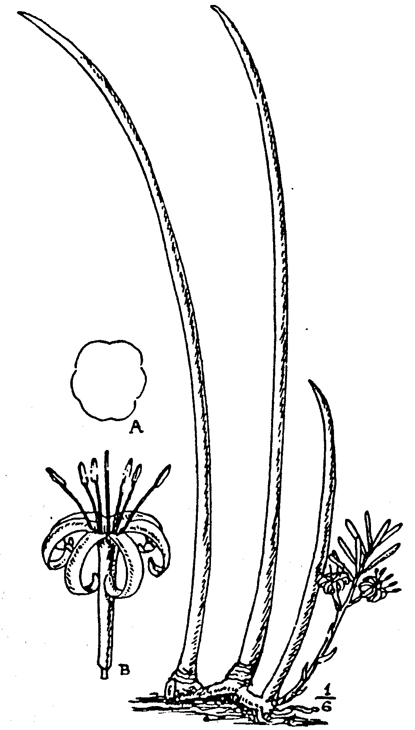
Fig. 11.
S. canaliculata, Carrière. Plant ¹/₆ nat. size. A, section of leaf grown
at Kew, nat size. B, flower, nat. size.

arising from the rhizome close together one before another, some-
times at intervals of ½ -2 in. apart; erect, usually slightly curv-
ing, firmly flexible (not at all rigid), nearly or quite smooth,
½ - 2½ ft long, cylindric or slightly compressed, with 5-6 shallow
longitudinal grooves and rounded rib-like spaces between them.
5-11 lin, thick, of nearly the same diameter up to near the apex.
or slightly thicker along the middle part. shortly tapering near
the apex into a hard whitish acute point; dark green, without
markings. Flower-stem (in the only specimens seen), 2-3½ in.
high, ⅛ -¹/₆ at the base, bearing 2-3 small ovate, acute
whitish--brown membranous sheaths on the lower half and a spike-
like raceme of flowers on the upper part. Bracts about ¹/₆ in.
long, ovate, acutely pointed, membranous. Flowers, 3 in a cluster
at the lower part, solitary at the top of the raceme, or occasionally
in weak specimens all solitary, suberect; pedicels ½ - ¾ lin. long,
much shorter than the bracts, jointed at the apex to the flower,
with no deciduous part; tube nearly or quite 1 in. long,
slender, ⅔ lin. in diam., slightly swollen at the base, white,
tinged with green on the basal part; lobes ⅔ in. long, linear,
slightly broadening upwards, obtuse, white. S. Schimperi, Baker
in Fl. Trop. Apr., vol. vii., p. 335. S. sulcata, Baker, in Kew
Bulletin, May, 1887, p. 10, as to living plant and fig. 7 on
p. 3; and Fl. Trop. Apr., vol. vii., p. 335. Godef.-Leb., Sansev.
Gigant, Apr. Orient., p. 16; Gérôme & Labr. In Bull. Mus. Hist.
Nat., 1903, pp. 169 and 173. fig. 17; De Wildeman, Notices
PI. Utiles du Congo, p. 624, fig. 17 and pp. 625, 631. with fig.;
not of Bojer.
SOMALILAND. Stace ! The country of the original plant is
unknown, but it was sent from the Isle of Bourbon to the Paris
Exhibition in 1855 and has since been cultivated in the Jardin
des Plantes, Paris.
This very distinct species is easily recognised by its usually
solitary leaves and insignificant inflorescence. Described from
living plants, one of which was received from Paris Botanic
Garden as being typical S. canaliculata. Car.; other plants of
it have been cultivated at Kew for 40 years or more, and one
is the type of S. Schimperi, Baker, which was sent by Lieut.-Col.
E. V. Stace in June, 1892; it is still in cultivation at Kew, and
differs in no way from typical S. canaliculata, but the specimen
quoted under S. Schimperi in the Flora of Tropical Africa, vol.
vii. p. 335, as sent from Somaliland by MacConkey, is quite
a different plant, with tufted leaves, and to my personal know-
ledge is not the plant from which any part of the description of
S. Schimperi was made, but, being supposed to be the same, the
collector's name was merely added to the manuscript; the speci-
men, however, is too incomplete for identification.
25. S. lanuginosa, Wild. Sp. PI. vol. ii p. 160.--Stemless.
Rootstock creeping, stout, with a reddish skin. Leaves about
3-4 to a growth, 1½ -3 ft. long and apparently about 8-9 lin.
broad and 3 lin. thick, rigidly erect, concavely semiterete, thick
and fleshy, with a concave channel nearly or quite as broad as the
leaf down the face and with several grooves down the back and
sides, shortly sheathing at the base, tapering at the upper part to
an acute point; green, with "woolly" (?) veins (grooves).
Flower-stem about 2 ft. high, with 2-3 small ovate acute
sheaths on the lower part and a raceme of flower-clusters at the
upper part. Bracts neither described nor figured. Flowers 2-3
(according to description, but according to the figure 2-5) in
a cluster; pedicels about 2 lin. long; tube (according to the
figure) 4-5 lin. long, slightly inflated at the base; lobes
6-7 lin. long, white. Berries globose, or of 2-3 globose
lobes, 1-3 seeded, pale green (ex Rhede, but perhaps immature.
Sprengel, Syst. Veg. vol. ii. p. 93; Schultes, Syst. Veg. vol.

vii. p. 358; Kunth, Enum. PI. vol. v. p. 19; Baker in Journ.
Linn. Soc. vol. xiv. p. 549. Aletris Zeylanica var. B, Lam.
Encycl. vol. i. p. 79. Salmia ebracteata, Cavanill. Ic. vol. iii.
p. 24 under S. spicata. Katu Kapel seu Cadenaco, Rhede Hort
Malabar. vol. xi. p. 83, t. 42.
INDIA. Malabar, in sandy places, Rhode.
Unknown to me. Described from Rhode's figure and descrip-
tion. It appears to be similar to S. zeylanica, Willd., but if the
statement that the grooves on the leaves are woolly is correct
then it is perfectly distinct from all known species in the genus;
but no indication of any woolliness is represented in the figure'
and I very much doubt the accuracy of the statement. I suspect
that this is the plant which Roxburgh has chiefly described in
his Pl. of the Coast of Coromandel, vol. ii. p. 43, and in Fl.
Ind. vol. 11. p 161, as S. zeylanica, but it is certainly not the
plant he has figured under that name, for which see S. Rox-
burghiana.
26. S volkensii, Gürke in Engl. Pflanzenwelt Ost-Afr. C.
144. Stemless, with a creeping rootstock. Leaves semiterete,
channelled on the face, rounded on the back, rigid, gradually
tapering to a sharply pointed apex; green, sometimes marked
with transverse bands formed of whitish spots. Flower-stem
shorter than or as long as the leaves. Flowers white.--Baker in
Fl. Trop. Afr. vol. vii. p. 334.
GERMAN EAST AFRICA. Kilimanjaro; at Rombo, Holst, 4080.
Crater-edge of Lake Chala Volcano, 3700 ft., Volkens, 1779.
27. S. zeylanica, Willd. Sp. PI. vol. ii. p. 159, excluding all
synonyms not quoted here (Fig. 12 c).--Stemless, with a creeping
rootstock ½ in. thick. Leaves of adult plants 5-11 to a growth,
erect at the lower part and slightly recurving above, nearly
smooth, slightly shining, 1 ½ -2½ ft. long, 4-10 lin. broad, 2½ -4
lin.. thick, measured from the bottom of the channel to the back;
linear-semiterete, concave-channelled down the face, very
rounded on the back, gradually tapering from the base to a very
acute soft subulate green point ½ - 1½ in. long, which withers to
whitish, very dark green, transversely banded throughout with
rather lighter green, and with 4-7 darker green longitudinal
lines on the back, which on withered leaves become alight
furrows; margins green. Flowers not seen. --Willd., Enum.
PI. Hort. Berol, p. 375 ? (this may have been S. aethiopica);
Haw. Synop. PI. Succ. 66; Link, Enum. PI. Hort. Berol. vol. i
p. 342; Sprengel, Syst. Veg. vol. ii.p. 94; Schultes, Syst. Vep.
vol. vii. p. 357; Trimen, Handb. Fl. Ceylon vol. iv. p. 267,
partly (excluding from the above references all synonyms not
quoted here). Aloe zeylanica pumila foliis variegatis, Pluk
Almagest. Bot. p. 17, t. 256, fig. 5; and Commelin Hort. Med.
Amsterdam, Rar. PI. vol. ii. p. 41, t. 21. Aloe hyacinthoides
var. zeylanica, Linn. Sp. PI. ed. i. p. 321. Aloe zeylanica,
Jacq. Enum. Stirp. Agro. Vindob. p. 310. Aletris hyacinthoides
var. zeylanica. Linn. Sp. PI. ed. ii. p. 456, and Mantissa ii.
&d67. Aletris zeylanica, Lam. Encycl. vol. i. p. 79, not of
Miller.

CEYLON. Common in rocky or sandy places in the dry region,
according to Trimen. Wild specimens were specially collected
by Dr. J. C. Willis and sent alive to Kew for the purpose of this
monograph in 1912. The native name for this plant in Ceylon
is Niyanda.
It is remarkable that, although this species was one of the
earliest to be .described, yet it is one of the least known, or rather
is practically an unknown plant to science, since in all modern
descriptions, it is inextricably mixed up with the Indian S. Rox-
burghiana and S. lanuginosa, and the South African S. aethi-
opica. The confusion was began by Willdenow himself, who
mixed up two other species with this; but as the name and
description clearly point to the Ceylon plant as here understood
and not to either of the South African species included under it
by Willdenow, I think the specific name zeylanica should be ex-
clusively applied to the Ceylon plant, which, with the exception
of the living plants now at Kew, from which the above descrip-
tion has been made, does not appear to be anywhere in
cultivation out of Ceylon, nor have 1 seen in any British or
foreign Herbarium good dried specimens that I should unhesi-
tatingly refer to the true Ceylonese plant. Such as I have
examined bearing the name of S. zeylanica, belong either to
S. Roxburghiana, S. aethiopica, or some other totally different
species and are often from cultivated specimens, in no single
instance have I seen a localised dried specimen from Ceylon.
The description of S. zeylanica given in the Kew Bulletin for
May, 1887, p. 8, belongs to S. aethiopica, and the figure on p. 4 to
S. Roxburghiana, whilst the accounts of the fibre obtained from
plants grown in India, Mauritius and Jamaica probably refer
to those or some other species and not to the true Ceylon plant.
28. S. Roxburghiana, Schultes Syst. Veg. vol. vii. p. 357
(Fig. 12, D E). --Stemless, with a creeping rootstock. Leaves 6-24
to a growth, not 2-ranked, those of juvenile plants and sometimes
the outer of the tuft spreading, smooth above, slightly rough
beneath, 4-8 ins. long, 1-1½ ins. broad, flat, strap-shaped or nar-
rowly lanceolate, usually abruptly rounded into a stout subulate
point ¼ -1 in. long; inner or adult leaves ascending and slightly
recurving, somewhat stiff, mostly more than 1 ft., but varying
from ⅔-2 ft. long ½ -1 in. broad. 1½ -2 lin. thick, linear, deeply
concave-channelled down the face, rounded or very obtusely
keeled on the back, gradually tapering into a stout subulate
soft green point ¼ -2 in. long, green, transversely marked with
darker green rather regular bars on both sides and with 6-11
longitudinal dark green lines on the scarcely paler under-surface
and often 1-3 on the upper; edges green, with age becoming
very narrowly whitish. Flower-stem 1-2½ ft. high, with 4-5
erect acuminate sheaths 1-4 in. long on the lower part and a
spike-like raceme 1-4 ft. long of flower-clusters above; bracts
1½ -2 lin. long, lanceolate-attenuate, membranous. Flowers
about four in a cluster pedicels 2½ lin. long, jointed near the
middle, with the persistent part 1½ -2 lin. long; tube 3-3½ lin.
long; lobes 4-4½ lin. long, linear, obtuse; Kunth, Enum. Pl.,

vol. v. p. 18; Voigt, Hort. Suburb. Calcutt, p. 656; Baker in
Journ. Linn. Soc., vol. xiv. p. 549; Hooker, Fl. Brit. Ind.,
vol. vi., p. 271; Gérôme and Labroy in Bull. Mus. Hist. Nat,
1903, pp. 172-173, fig. 12; De Wildeman, Notices PI. Utiles
du Congo, pp. 624-625, fig. 12, and p. 031; S. zeylanica, Roxb.
PI. Corom., vol. ii. p. 43, t. 184, as to figure only, and Fl. Ind.,
vol. ii. p. 161, partly; Baker in Kew Bulletin, May, 1887, as to
figure on p. 4 only, not as to the description; Gérôme and Labroy
in Bull. Mus. Hist. Nat. 1903, pp. 172-173, fig. 10; De Wilde-
man, Notices PI. Utiles du Congo, pp. 624-625, fig. 10, not of
p. 631; Murva, Asiatick Researches, vol. iv. p. 271.
INDIA. Coast of Coromandel, Roxburgh; Madras (Triplicane),
collector not stated! Goghat, in the Hoogli district, Hossian!
Lower Bengal, at Ulubaria, Kurz! Palandu Tea Estate in
Ghota Nagpur, Cooke ! Peninsula, Rattier! and cultivated speci-
mens !
Described from living plants cultivated at Kew. The plant
here described is unquestionably identical with that figured on
t. 184 of Roxburgh's Plants of the Coast of Coromandel, but it
does not agree with the description which Roxburgh has given,
for in that description he has evidently mixed with it another
plant that I think will probably prove to be S. lanuginosa,
Willd., since he states that the leaves are 1 to 4 ft. long
and semicylindric. Now Roxburgh's figure is an excellent one
of the plant here described, but none of the adult flowering speci-
mens of it that I have seen, either of those grown in India or
of those cultivated at Kew, have leaves more than 2 ft. long,
usually they are very much less, and none of them are semi-
cylindric, the adult form being only crescent-shaped in trans-
verse section. As Roxburgh's description has been more or less
embodied in those of subsequent authors, this is the first to be
published that is based on the plant alone.
Hitherto S. Roxburghiana has been more or less confused with
S. zeylanica, but when seen growing by the side of that species,
it can easily be discriminated, for its leaves are mostly shorter,
much thinner and consequently less rigid than those of S. zey-
lanica, also of a rather lighter and different tint of green, with
more numerous longitudinal dark green lines on the back. Pos-
sibly the flowers may also differ, but I have not seen those of
S. zeylanica. The plant figured as S. Roxburghiana in the
Botanical Magazine at t. 7487 is S. burmanica, which does not
occur in the region where S. Roxburghiana grows.
29. S. burmanica, N.E. Brown (fig. 12). --Stemless, with a
creeping rootstock ½ -⅔ in. thick. Leaves of adult plants 8-13 to a
growth, smooth, 1½ -2½ ft. long, ½ -1¼ in. broad. 1½ -2 lin. thick,
very erect, straight and all close together, flexible, linear or
linear-lanceolate, flattish or with a slight .broad angular channel ,
down the face, obtusely keeled on the back, tapering to a soft
green subulate point 1-3½ in. long at the apex, sessile and sheath-
ing at the base, grass-green, transversely banded with paler
green, with 6-9 slightly impressed-lines down the back and 1-3
on the face; margins green, with age becoming very narrowly

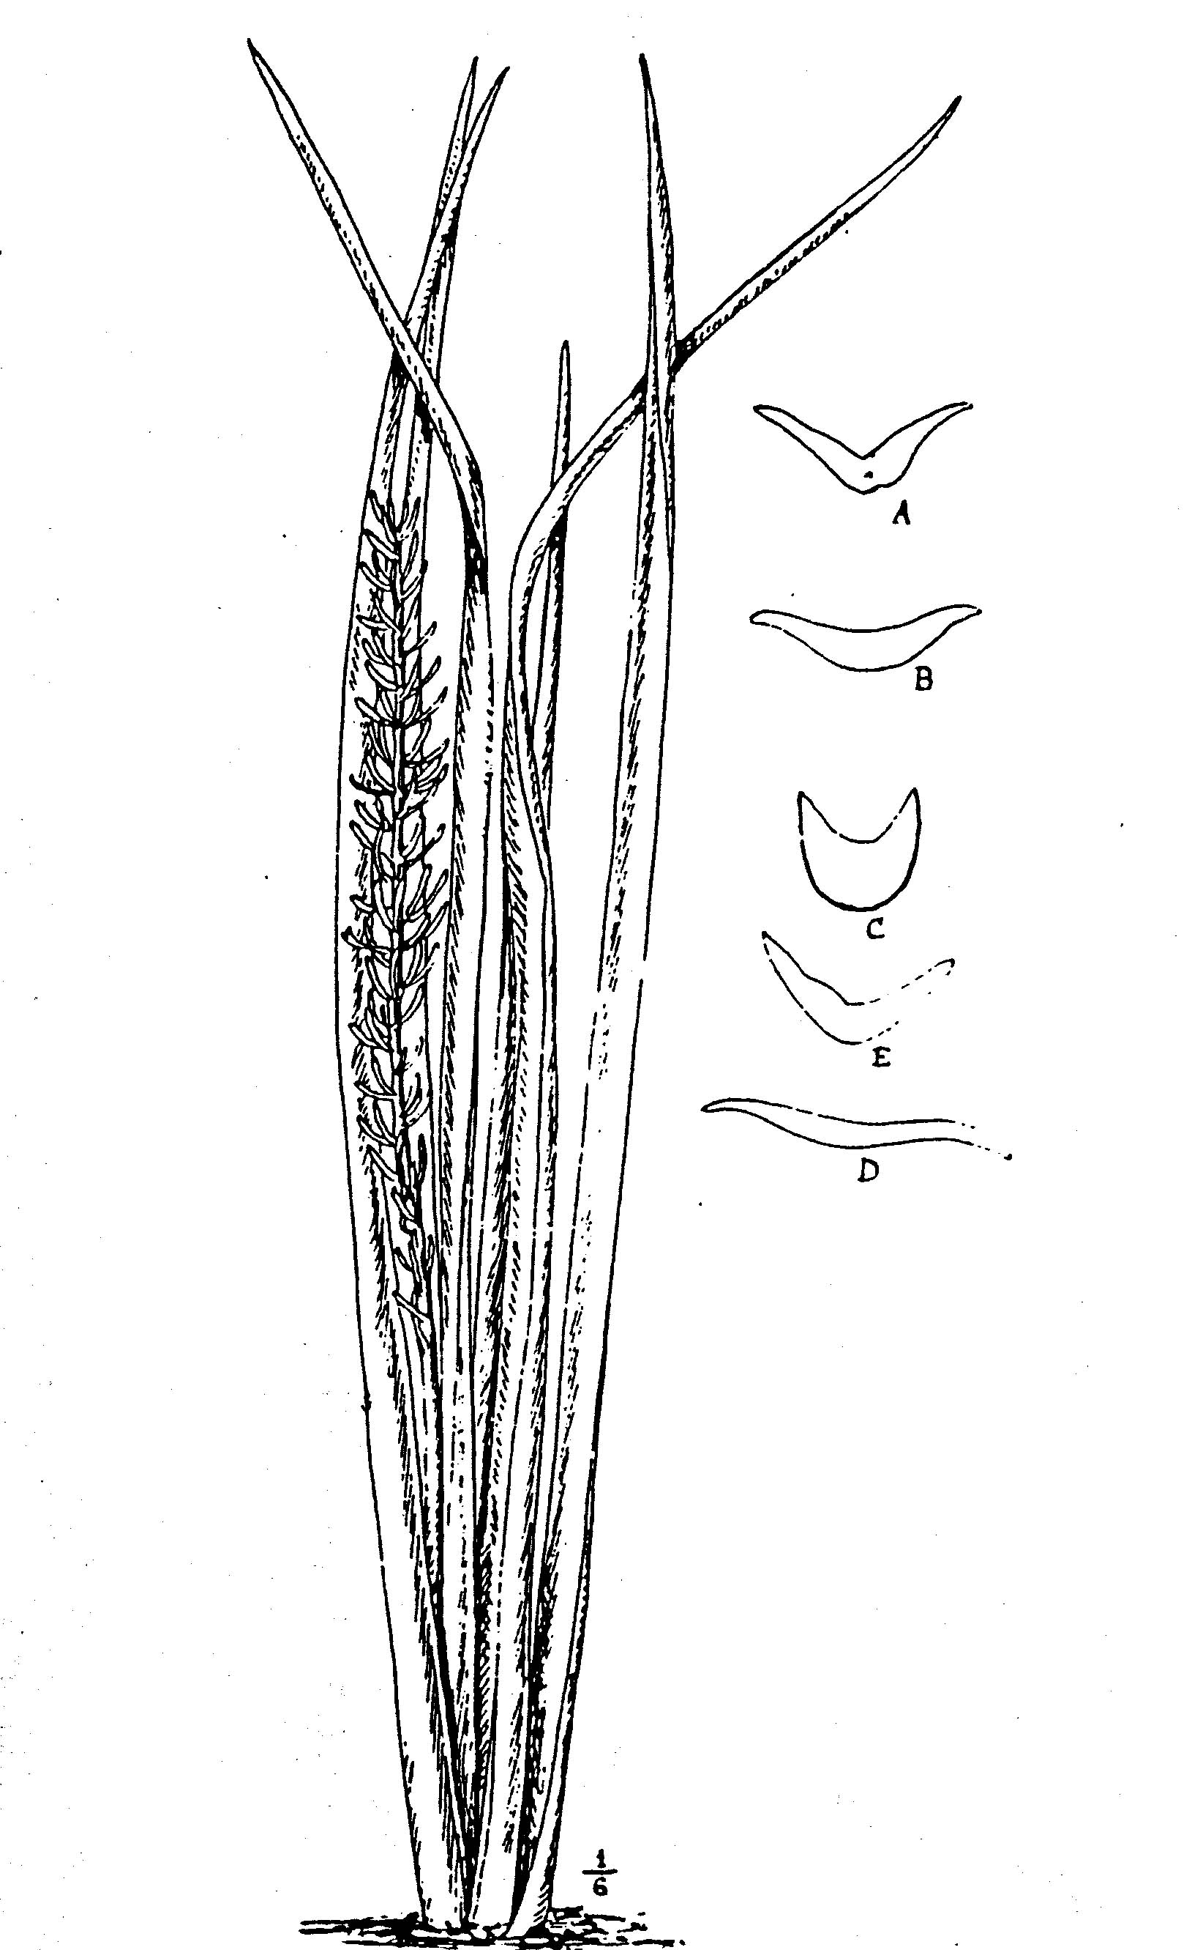
Fig. 12.
S. burmanica, N.E.Br Plant ¹/₆ nat. size; A, section of leaf when first
received at Kew, showing groove formed by shrivelling on the back;
B, section of leaf on the same plant grown at Kew.
S. zeylanica, Willd. C, section of leaf grown at Kew.
S. Roxburghiana, Schultes. D and E. sections of two different leaves on
the same plant, grown at Kew. Figs. A-E, nat. size.

whitish, not or scarcely shining. Flower stem 2-2½ ft. high, with
about 3 sub-membranous whitish sheaths ½ -1½ in. long on the
basal third and a lax raceme of flower-clusters above. Bracts
1-2 lin. long, lanceolate, acute, membranous. Flowers 2-5 in a
cluster, pedicels 3½ -4 lin. long, jointed at the middle; tube about
4 lin. long; lobes about 4 lin. long, greenish-white. S. Rox-
burghiana, Hook f. in Bot. Mag. t, 7487, not of Schultes.
UPPER BURMA. Near Kyaukse, Abdul Huk ! In the scrub
forest around the village of Partar, two miles south-east of the
town of Kyaukse, H. Clayton! Pyogingon, Aubert & Gage!
Described from living plants, dried flowers and a photograph
sent to Kew by Mr. H. Clayton, Director of Agriculture, Burma,
in September, 1912. It is nearly allied to S. Roxburghiana and
S. zeylanica, but when alive the adult plant is readily dis-
tinguished from S. zeylanica by its much thinner and more
flexible leaves, which are erect and straight, not recurving, with
more numerous lines on the back at the middle part, as well as
by the lighter green colour and less shining surface. From
S. Roxburghiana it is easily distinguished in both the living
and dried states by its much more erect and very straight leaves,
which are also usually longer and more uniform in width for a
greater part of their length.
30. S. aethiopica, Thunb. Prodr. PI. Cap., p. 65 (excluding
synonym). --Stemless, with a creeping rootstock. Leaves 13-30
to a growth, not 2-ranked, ascending-spreading, somewhat rough,
5-17 in. long, 5-7 lin. broad, about 1¾ -2¾ lin. thick at the
middle, linear or linear-lanceolate, sessile or only slightly nar-
rowed to the base, gradually tapering from the middle to a
subulate point ¾ -¹/₆ in. long, which, when young, is green, but
very soon withers to white, very concave down the face, dark
green with a somewhat bluish hue and more or less glaucous,
sometimes transversely banded with paler green; margins red or
whitish (drying red). Flower-stem 16-30 in. high, 3½ -5 lin.
thick at the base, with 5-7 whitish membranous sheaths ¾ -2¾ in.
long on the lower half, and a compact spike-like raceme of flower
clusters at the upper half. Bracts spreading or reflexed, 2½ -5 lin.
long, ovate-lanceolate, acute. Flowers 4-6 in a cluster; pedicels
2-4 lin. long, jointed above the middle; tube ¾ -1 in. long;
lobes 7-9 lin. long, white. --Thunb. Nov. Gen. 127, and Fl.
Cap. ed. Schultes, p. 329; Schultes Syst. Veg., vol. vii. p. 358;
Kunth Enum. Pl., vol. v. p. 19; N. E. Brown in Bot. Mag.. t.
8487. S. zeylanica, Redoute Lil. vol. v. t. 290; Ait. Hort. Kew
ed. 2, vol. ii. p. 278; Lindl. Bot. Reg. vol. ii. t. 160; Kunth,
Enum. Pl., vol. v. p. 18; Baker in Kew Bull., 1887, No. v. p. 3
& 8, fig. 5, not of p. 4; Hooker, Fl. Brit. India, vol. vi. p: 270;
and Baker Fl. Cap., vol. vi. p. 5, not of Willdenow, excluding
all synonyms except those quoted here. S. glauca, Gérôme &
Labr. in Bull. Mus. Hist. Nat., 1903, pp. 169, 172-173, fig. 11,
and De Wildem, Notices Pl. Utiles du Congo, pp. 624-625,
fig. 11, not of Haworth. Aletris zeylanica. Mill Diet. ed. 8,
No. iv. not of Lamarck. A. hyacinthoides var. zeylanica. Ait.
Hort. Kew, ed. 1, vol. i. p. 464.

TROPICAL AFRICA. Rhodesia: near Bulawavo, Mrs. Evelyn
Cecil. 103! Southern Rhodesia. Allen, 054!
SOUTH AFRICA. Griqualand West: Lower Campbell, Burchell,
1824 ! Transvaal: Shiluvane, Junod, 1212! South African Gold-
fields, Baines ! Warmbath, Miss Leendertz, 2354 ! Graaf Reinet
Div.: near Graaf Reinet Bolus, 720! Uitenhage Div.; Uiten-
hage, Burchell, 4420 ! Sandfontein, Burke! Alexandria Div.:
Zuurberg Range, Cooper, 3267! Albany Div., Cooper, 3268!
According to Mr. Baines, in a note upon a drawing at Kew,
the Bushmen and Bechuanas make their cord from the fibre of
this plant. Described from living plants cultivated at Kew.
31. S. grandicuspis, Haw. Synop. PI. Succ. 67. Stemless,
with a stout creeping rootstock. Leaves 5-15 in a tuft, erect, sub-
erect or ascending-spreading, nearly straight, smooth, 7-20 in.
long, ½ -1½ in. broad, ¹/₁₀-¹/₈ in. thick at the middle, coriaceous, stiff,
linear-lanceolate, with a very open angular or concave channel
down the face or strap-shaped and flat or nearly so, shortly
tapering or somewhat abruptly narrowed into a stout subulate
somewhat flexible (not at all hardened) green point ⅔-2 in.
long, the broader and flatter leaves narrowed at the base but
scarcely petiolate, and the narrower gradually tapering into a
deeply channelled petiole 2-6 in. long, so that the distinction
between blade and petiole is lost, somewhat regularly marked
with transverse bars of dull dark and lighter green on both
sides to the apex, with 5-7 longitudinal continuous or interrupted
darker green impressed lines or slight furrows on the back; mar-
gins green, sometimes with age or injury becoming very nar-
rowly whitish. Flowers not seen. --Sprengel, Syst Veg., vol. ii.
p. 93; Schultes, Syst. Veg., vol. vii. p. 359; Kunth, Enum.
PI. vol. v; p. 20; Baker in Fl. Trop Afr., vol. vii. p. 336;
Gérôme & Labroy in Bull. Mus. Hist. Nat., 1903, pp. 172-173,
fig. 13; De Wildem, Notices PI. Utiles du Congo, pp. 624-625.
fig. 13. S. ensifolia, Haw. Synop, PI. Succ., p. 66; Kunth
Enum. PI., vol. v. p. 20. .9. pumila, Haw. Synop. PI. Succ.,
p. 67; Link, Enum. Hort. Berol., vol. i. p. 342; Schultes, Syst.
Vee., vol. vii. p. 359; Kunth, Enum. PI., vol. v. p. 20.
ORIGIN UNKNOWN.
Described from living plants that have long been in culti-
vation. Haworth originally described it in 1812 from a living
plant, and S. pumila which he described at the same time, is
evidently only the juvenile state of S. grandicuspis. S. pumila,
De Spin., appears to have been quite a different plant.
32. S. Dooneri, N. E. Brown (fig. 13).--Rootstock creeping,
¼ -⅓ in. thick, orange-brown, or, when above ground, dull olive-
green, with broad whitish sheathing scales about ½ in. long.
Stem, none on some growths, but sometimes up to 2 in. high,
concealed by the leaf-bases, and not very evident. Leaves on
the barren growths up to 20, crowded on the short stem; on
the flowering growths 6-8 in a lax rosette, coriaceous, flexible,
very recurved-spreading from an erect or ascending basal part,
very smooth, 4-17 in. long, ⅓ - 1¹/₆ in. broad; strap-shaped or

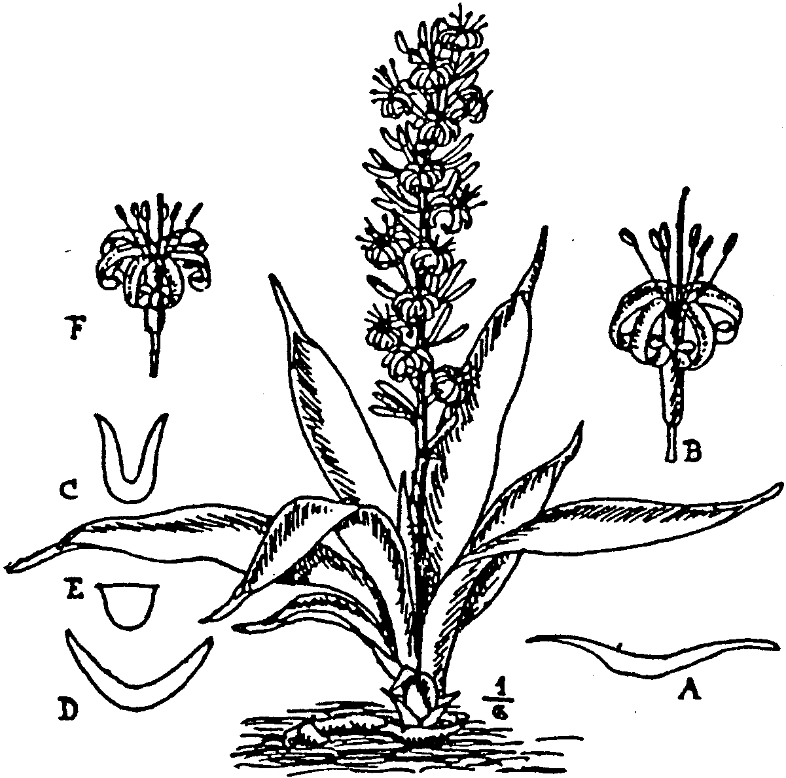
Fig. 13.
S. Dooneri, N.E.Br. Plant ¹/₆ nat. size. A, section at middle of a leaf;
B, flower.
S. parva, N.E.Br. C and D, sections at middle of different leaves; E,
section of petiole; F, flower. Figs. A-F, nat. size. From the type
plants cultivated at Kew.
narrowly lanceolate, gradually narrowing downwards from near
or above the middle to a scarcely petiolate base and more rapidly
tapering upwards into a stout soft subulate green point ¼ -2 in.
long, flatfish or but slightly concave down the face, dark green,
slightly paler and without longitudinal lines beneath, very
faintly and irregularly marked with transverse paler green bands
on both sides; margins green, not hardened. Flower-stem
1-1¼ ft. high, green, with a lax raceme of flower-clusters at the
upper half, and on the lower part 4 membranous clasping sheaths
½ - ¾ in. long, tapering to an acute point. Bracts membranous,
1-2 lin. long, ovate-lanceolate, acute. Flowers 3, or near the top
2 in a cluster, ascending-spreading; dull pink or pale purplish
outside, whitish within; pedicels 1½ -2 lin. long, jointed to the
shortly obconical base of the flower; tube about 5½ lin. long;
lobes 5½ -6 lin. long, linear, subobtuse.
BRITISH EAST AFRICA. Rift Valley, near the Kedong River,
Dooner !
Described from living plants collected by Mr. H. B. Dooner
and sent by Mr. W. G. Freeman in Aug., 1907, to Kew, where
they flowered in March and May, 1910.
This is very similar to S. parva, but when both species are
seen growing side by side S. Dooneri can at once be distinguished
by its less evident stem and less erect habit, the leaves being

much more recurved; they have no very distinct petiole, and
their subulate points are usually much shorter; also the colour
is of a much darker and duller green, with very inconspicuous
paler markings. In S. parva the green is rather bright and
the paler bars quite conspicuous on the younger leaves.

33. S. parva, N. E. Brown (Fig. 13, C-F). --Rootstock creep-
ing, ⅓ in. thick, brownish-orange. Stem usually evident and
often rising 1-5 in. above the ground, sometimes concealed by
the leaf-bases. Leaves 6-14 to a growth, the inner ascending or
suberect and slightly recurved-spreading at the upper part,
smooth, 8-18 in. long, 4-7 lin. broad, the outer gradually
shorter, more spreading and up to 14 lin. broad, all sub-fleshy or
firmly coriaceous, not very flexible, linear or linear-lanceolate
to lanceolate, concave or deeply channelled down the face or
folded longitudinally, rounded or obtusely keeled on the back,
tapering at the apex into a stout subulate soft green point,
mostly 1½ -3 in. long, narrowed into a petiole up to 2 in. long,
flat on the face and very rounded on the back, or sometimes only
broadly clasping at the base, the younger marked on both sides
with very distinct irregular transverse bands of dark bright
green and paler green, becoming with age of a nearly uniform
green or the markings very obscure; margins green, not
hardened nor reddish. Flower-stem about 1 ft. high, scarcely
⅛ in. thick at the base, smooth, light green, bearing a lax raceme
of flower-clusters at the upper third, and on the lower two-thirds
3 membranous distant clasping sheaths ½ -1 in. long, tapering
to a finely pointed apex. Bracts spreading, membranous, ⅛-¹/₆ in.
long, narrowly lanceolate, acute. Flowers in pairs or the upper
solitary, ascending; pedicels 2-2½ lin. long, jointed above the
middle, the upper or deciduous part being thickened upwards;
tube 5-5½ lin. long, ¾ lin. in diameter, swollen at the base, pale
pinkish-white; lobes 4-4½ lin. long, linear obtuse, more or less
tinted with mauve within, dull mauve or purplish on the back.
BRITISH EAST AFRICA. Near the Gilgil River, scarce, Powell
15. Uganda: Semliki Valley, Dawe, 687.
Described from living plants sent by Mr. H. Powell in 1906
to Kew, where it flowered in January. 1910. The flowers open
in the morning and close between 1 and 2 p.m.
34 S. concinna, N. E. Brown (Fig. 14).--Stemless. Rootstock
creeping, about ½ in. thick. Leaves, about 5 to a growth, ascend-
ing-spreading and slightly recurving, coriaceous, smooth, 6-10
in long ½ - 1¼ in. broad, narrowly lanceolate, acute, with a green
subulate point 2-4 lin. long. shortly narrowing at the base into
a channelled petiole 1½ -3½ in. long and 2-3 lin. broad; blade
apparently somewhat folded longitudinally, with the margins
green and scarcely hardened, apparently transversely banded on
both sides with pale green and the bands much broader
on the upper surface than on the lower, but on dried specimens
often entirely obliterated on both sides. Flower-stem ½ -1 ft. high,
with a compact raceme of flowers on the upper half and 4 lanceo-
late acuminate sheaths 1-1¼ in. long on the lower half,
apparently tinged and dotted with purple. Bracts spreading

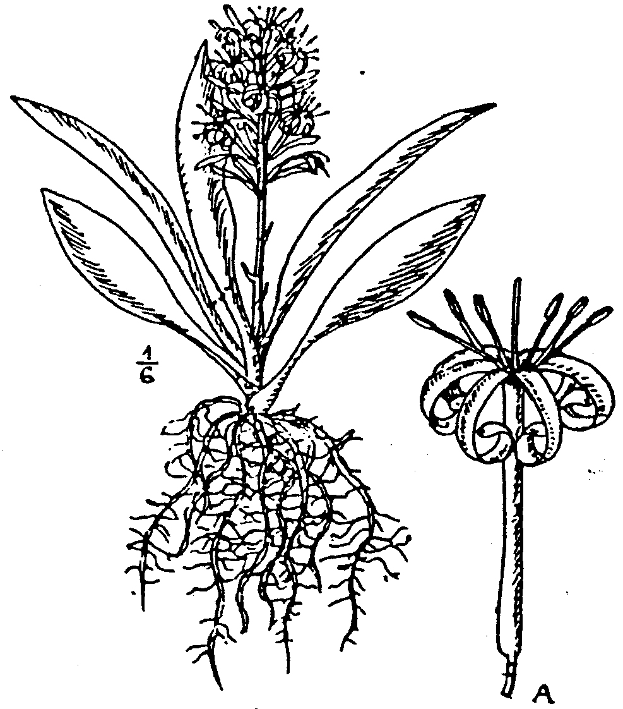
Fig. 14.
S. concinna. N.E.Br. Plant ¹/₆ nat. size. A, flower, nat. size. From a
dried specimen.
¼ -⅓ in. long, lanceolate, acuminate, membranous. Flowers in
pairs or a few of them solitary; pedicels jointed close under the
flower with the persistent part l½ -2 lin. long; tube 1¾ in. long,
about 1 lin. in diam.. cylindric, swollen at the base; lobes 10 lin
long, linear, 1 lin. broad near the apex, slightly tapering to the
base, white.
PORTUGUESE EAST AFRICA. Near Beira, Dawe, 1!

35 S. subspicata Baker in Gard Chron. 1889, vol. vi. p.
436 (Fig. 15). --Stemless with a creeping rootstock, ½ -l in. thick
pale yellowish, brown. Leaves, 4-8 (up to 10 ex Baker) in a tuft;
coriaceous, rather flexible, or somewhat firm, erect or recurved-
spreading smooth, ¾ -2 ft. long, 1-2¼ in. broad, 1 lin. or less
thick at the middle of the blade, lanceolate or narrowly lanceo-
late, acute, with a subulate soft green (withering to white) point
¹/₆ –¼ in. long, mostly tapering from the middle or above into
a comparatively slender petiole 1½ -9 in. long and 2-3 lin. broad
and thick and concave-chanelled down the face; deep green
slightly shining, sometimes very faintly glaucous with age- when
young sometimes obscurely marked with transverse paler green
bars, which soon disappear; edges of young leaves green, of old
ones (apparently from rubbing or damage) very narrowly
whitish. Flower-stem 12-16 in. high, ¹/_{6 – ¼} in. thick, with 3-4
membranous distant lanceolate-attenuate bracts ⅓- ¼ in. long
on the basal half, and a spike-like raceme above. Bracts 1-3 lin
long, lanceolate, acute, membranous. Flowers solitary or in
pairs, white; pedicels ½ -1 lin. long, articulated close under the

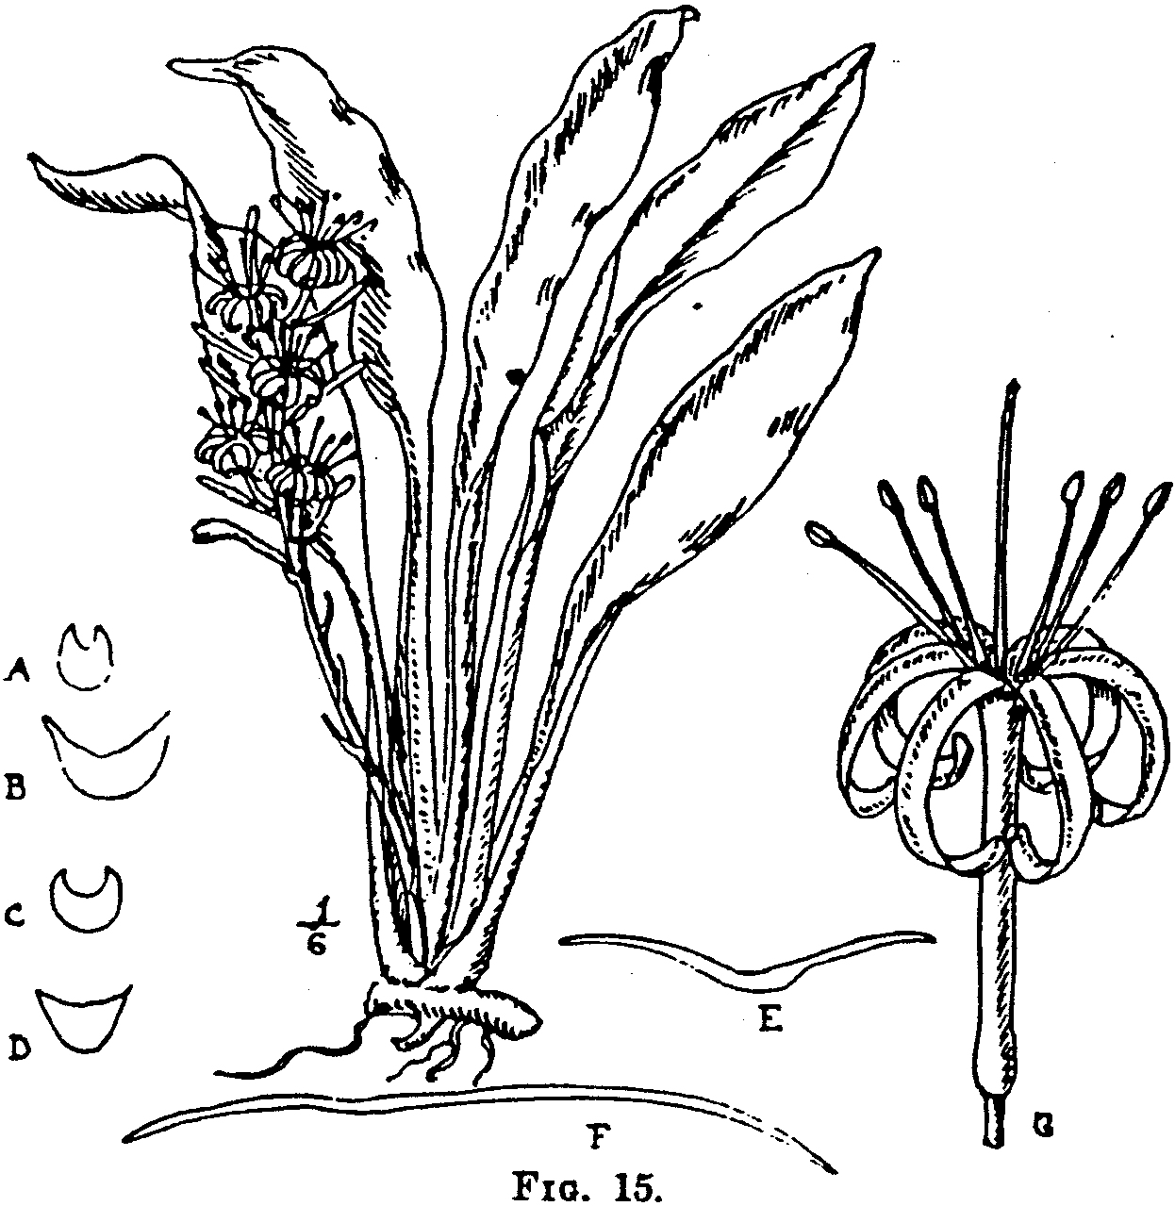
S. subspicata, Baker. Plant ¹/₆ nat. size. A-D, sections of petioles of four
different leaves; E and F, sections at middle of two different leaves;
G, flower. Figs. A-G, nat. size. From the type cultivated at Kew.

base of the flower, with no deciduous part; tube 11-14 lin.
long, greenish-white; lobes ⅔-¼ in. long, linear, obtuse.
revolute. --Baker in Flora Capensis, vol. vi. p. 5.
SOUTH AFRICA. Delagoa Bay (cultivated specimens), Mrs.
Monteiro !
Described from the type plant, still in cultivation at Kew,
originally sent from Delagoa Bay by Mrs. Monteiro in 1860.
36. S. senegambica. Baker in Journ. Linn. Soc., vol. xiv. p.
548 (Fig. 16). Stemless, with a creeping rootstock ½ -¼ in.
thick, bright red, changing to very pale brownish where exposed
to the light. Leaves 3-4 to a growth, coriaceous, smooth, 1-2¼
ft. long, 1¹/₆ -2½ in. broad, 1-2½ lin. thick at the middle, suberect
at the basal third or half, then recurved-spreading, linear-
lanceolate to lanceolate, gradually tapering from the middle
upwards into an acute subulate soft green point ¹/₆- ½ in. long,
and downwards into a stout, flattened concave-channelled petiole
1-3 in. long, or, in juvenile forms, scarcely petiolate, concave to
almost flat, scarcely or not at all wavy; upper surface entirely
dark green or somewhat indistinctly marked with transverse bars
of paler green, under surface slightly paler than the tipper, with
the transverse bars much more distinct, but often becoming
nearly obliterated with age; margins green, like the rest of the
leaf, not becoming whitish or reddish. Flower-stem 12-20 in.
high, 2-2½ lin. thick at the base, light or dark green or mottled
with purplish, according to intensity of light, not glaucous; the
lower half with 4-6 distant sheaths, of which the lower are 1¼ -
2½ in. long, stem-clasping at the base with a long slender awl-like
free point, and the upper ⅓-1 in. long, ovate, acute, stem-clasping,
white or tinted with reddish-brown; upper half with a spike-like
lax raceme of flower-clusters, which sometimes are grouped 2-3
together. Bracts spreading, 3-4 lin. long, 1-1½ lin. broad,
ovate-lanceolate or oblong-lanceolate, acute, membranous, white.
Flowers 3-6 in a cluster, white, tinged with purple where exposed
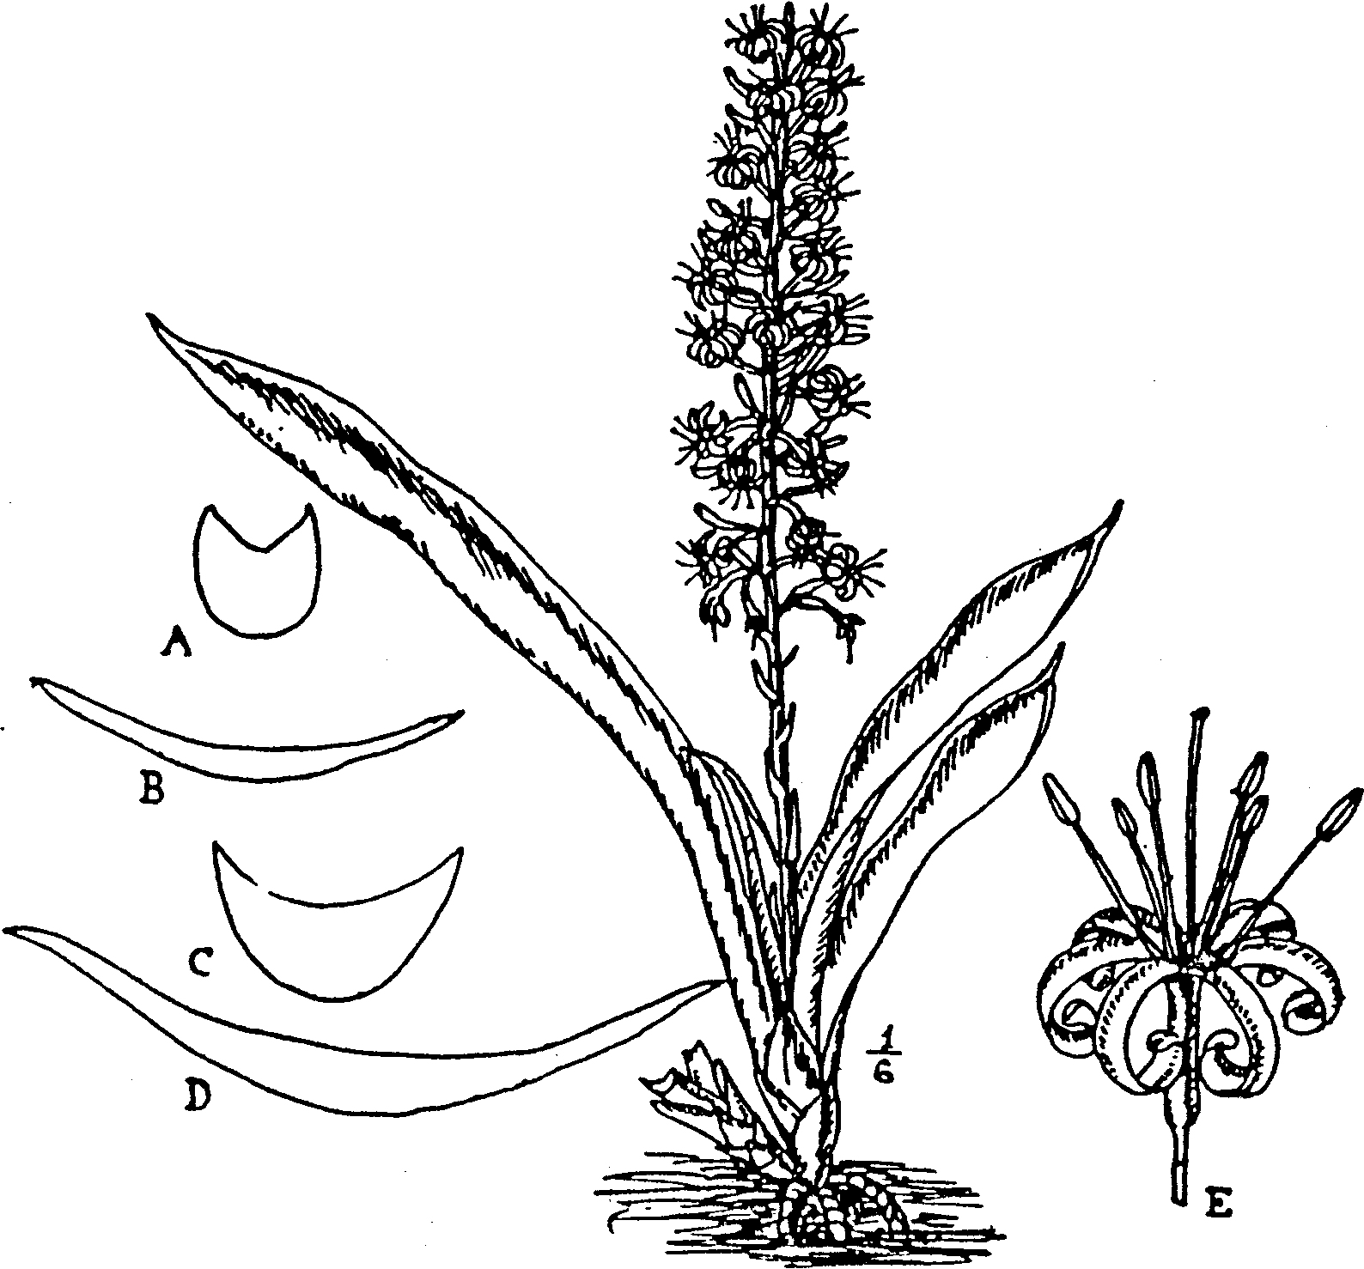
Fig. 16.
S. senegambica, Baker. Plant ¹/₆ nat. size. A and C, sections of petioles;
B and D sections at middle of blades of two different leaves; E,
flower. Figs. A-E, nat size. From a plant cultivated at Kew.
to the sun; pedicels 2½ -4 lin. long, jointed at or below the
middle, with the upper or deciduous part 1¾ -3 lin. long; tube vary-
ing from ¼ - ½ in. in length on different specimens of the same
plant, ⅔-1 lin. in diam. at the slightly swollen ellipsoid base,
½ -⅔ lin. in diam. above; lobes 5-9 lin. long, linear, obtuse,
revolute. --Baker in Fl. Trop. Afr., vol. vii. p. 332. S. Comui,
Ger. & Labr. in Bull. Mus. Hist. Nat. Paris, 1903, p. 170, 173.
fig. 5; De Wildem. Notices PI. UtiIes du Congo, pp. 624-625,
fig. 5.

SENEGAMBIA. Richardtol, Richard, 72! and without precise
locality, Perrottet, 782 ! and 76 ex Baker, also cultivated
specimens !
Described from a living plant, a portion of the type of S.
Cornui, received from Pans Botanic Garden in 1903, which first
flowered at Kew in 1905. S. Cornui, Ger. & Labr. is absolutely
identical with the type of S. senegambica, Baker.
37. S. subtilis, N.E. Brown (Fig. 17). Stemless, with a
creeping rootstock 4-5 lin. thick. Leaves 2-4 to a growth, erect
or slightly recurving, very flexible, smooth, 1¾ -2¼ ft. long, 1-1¾
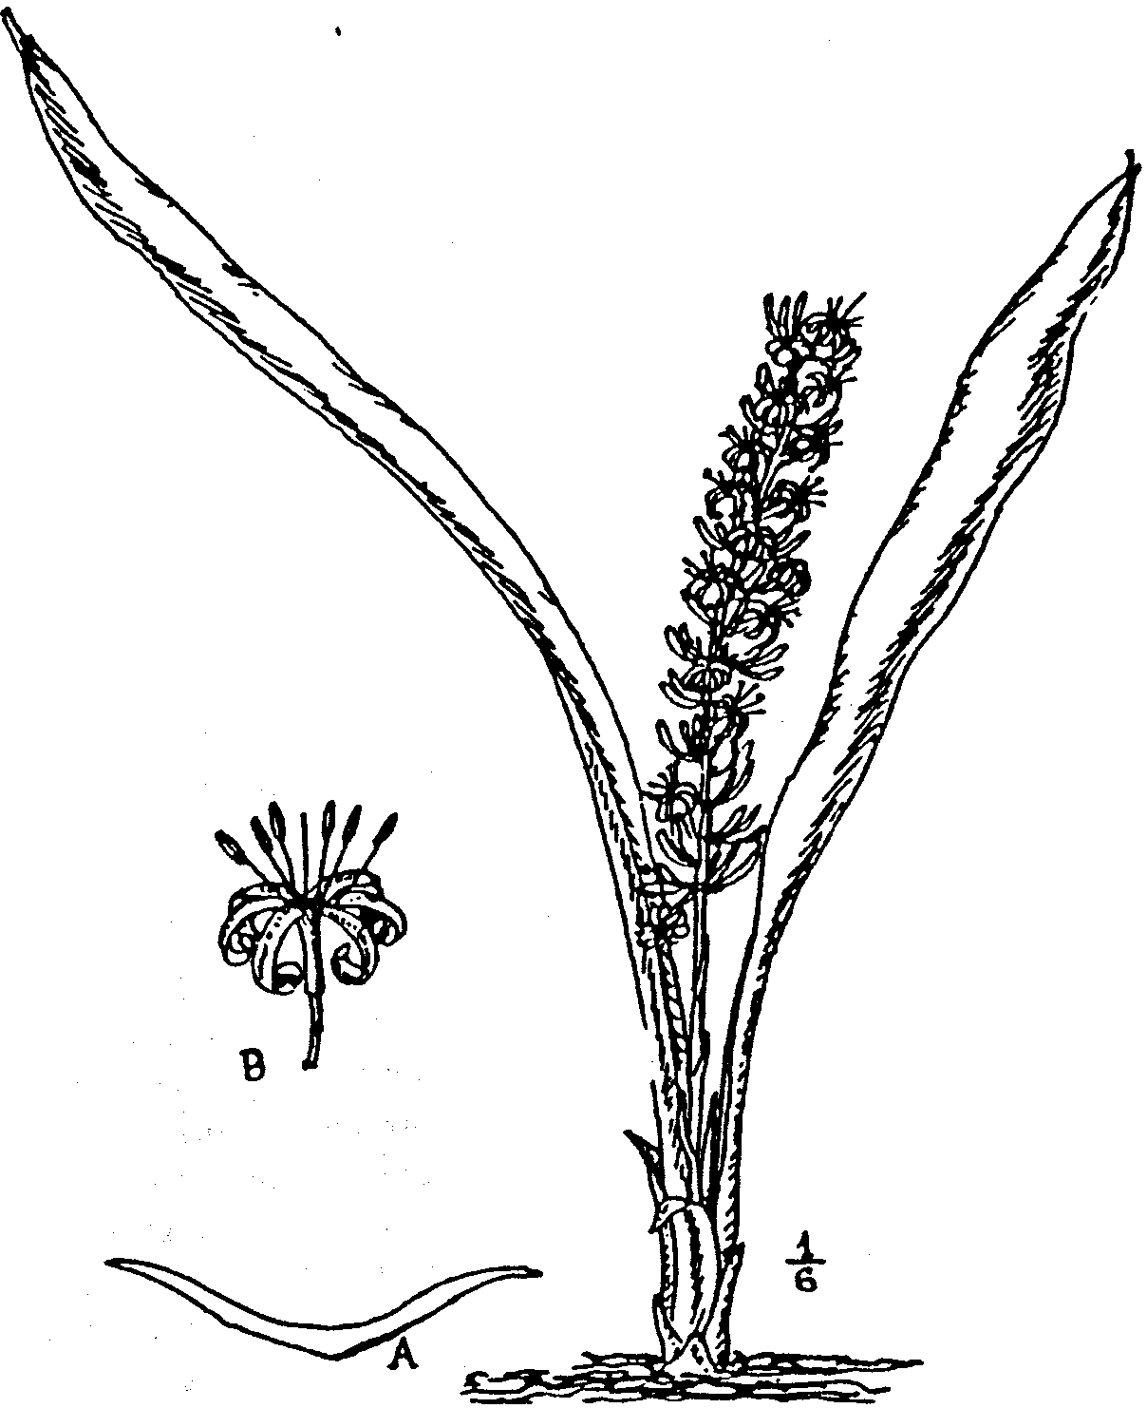
Fig. 17.
S. subtilis, N.E.Br. Plant ¹/₆ size. . A, section at middle of leaf, nat.
Size; B, flower, nat. size. From the type cultivated at Kew.

in. broad, 1¼ lin. thick at the midrib, linear-lanceolate, gradually
tapering from the middle or above upwards into a subulate soft
green point ½ -1 in. long and downwards into a channelled petiole
2-12 in. long, uniformly green and shining on both sides, or
with here and there a very faint trace of transverse banding on the
under surface; margins green, not hardened. Flower-stem 15-21
in. high, rather slender, 2 lin. thick at the base, the lower half
bearing about 3-distant membranous acuminate sheaths 5-6 lin.
long and the upper a lax raceme of flower-clusters. Bracts

membranous, 1½ -2 lin. long, lanceolate, acuminate. Flowers
2-3 in each cluster; pedicels 2-3½ lin. long, articulated at about
the middle, with the persistent part 1-2 lin. long and the decidu-
ous part 1-1½ lin. long; tube 3-4 lin. long, slender, 1 lin. in
diam. at the slightly enlarged but not distinctly inflated base;
lobes 5-6 lin. long, ¾ lin. broad, linear, obtuse, white, recurved
or somewhat revolute.
TROPICAL AFRICA. Uganda; without precise locality, Dawe !
Described from B living plant sent from Uganda by Mr. M. T.
Dawe to Kew. This and S. nilotica var. obscura were received
at the same time, without information, and are so very similar in
foliage that they were supposed to belong to one species and were
planted together in the same pot. When, however, they both
flowered at the same time on June 4th, 1913, it was at once seen
that they are certainly quite distinct in their flowers, and after
separating the two plants it was noted that they can be distin-
guished by the foliage of S. subtilis being uniformly green on both
sides, with scarcely a trace of markings and having a shining
surface, whilst S. nilotica var. obscura has indistinct transverse
bars and a dull surface to its leaves.

38. S. nilotica. Baker in Journ. Linn. Soc., vol. xiv. p. 548.
Stemless, with a creeping rootstock about ¾ in. thick. Leaves
2-3 to a growth, smooth, adult forms (including the petiole)
3-4 ft. long, 1-2¼ in. broad, strap-shaped, with the sides for a
foot or more of the central part quite parallel, narrowing at the
apical part into a soft green subulate point ¹/₆-⅔ in. long and
gradually tapering at the basal point into a deeply concave-
channelled petiole 1-2 ft. long, conspicuously marked with very
numerous closely placed irregular zigzag transverse narrow bars
of dark green and paler green; margins green. Flower-stem
1¾ - 2½ ft. high, of which 1-1½ ft. is occupied by a lax raceme
of irregularly scattered flower-clusters, and on the lower part are
about 5 clasping sheaths, of which the lower are about 3 in. long
and taper into a long subulate point, the upper ⅔-1¼ in. long,
ovate-lanceolate, acute. Bracts spreading, 2-5 lin. long, nar-
rowly lanceolate, acute, membranous. Flowers 4-10 in the lower
and 2-3 in the upper clusters; pedicels 3½ -6 lin. long, jointed
above the middle, with the persistent part 2-5 lin. long; tube
4½ -5 lin. long; lobes 5½ -6 lin. long, linear, subacute, white.--
Gürke in Engler, Pfl.-Ost-Afr. B, p. 367, t. 5, fig. J; Baker in
Fl. Trop. Afr. vol. vii. p. 332.
TROPICAL AFRICA. Muro or Moru Territory: in woods near
the river bank at Wayo, Murie ! Mittu Territory: at Mvolo,
near the Bahr el Rohl, Schweinfurth, 3834! Ruwenzori, Scott
Elliot !
Described from dried specimens. The type is stated by Mr.
Baker to have been collected by Petherick, but this is an error;
it was collected by Dr. J. Murie, formerly assistant secretary to
the Linnean Society, but was forwarded to Kew, with others
collected by Dr. Murie, by Mr. J. Peterick, when acting as
Consul in Central Africa.
Var. obscura, N, E. Br.--Leaves, 4-5 to a growth, erect,

flexible, smooth, 2-2¾ ft. long (including the petiole), 1½ -2¾ in.
broad, very narrowly lanceolate or strap-shaped, tapering near
the apex into a soft green subulate point ½ -1¼ in. long and below
into a deeply concave-channelled petiole ½ -1 ft. long, opaque
(not at all shining) grass-green, with or without a few incon-
spicuous transverse bars of slightly paler green 1-1½ in. apart;
margins green. Flower-stem 2-3 ft. long, 2½ -3 lin. thick at the
base, dull mottled green, with a raceme of flower-clusters on the
upper part and 3 sub-membranous acuminate sheaths ½ -1 in.
long on the lower part. Bracts 2-4 lin. long, ovate-lanceolate,
acute or acuminate, membranous, spreading. Flowers 3-6 in a
cluster; pedicels jointed above the middle, with the persistent
part dusky or dull purplish, 1¾ -2¼ lin. long and the deciduous
part much paler and greenish, 1-1¼ lin. long; tube 4 lin. long,
1 lin. in diam. at the very slightly enlarged base, dingy greenish-
white, marked with 6 longitudinal lines of dull purplish; lobes
7 lin. long, rather more than 1 lin. broad, linear, obtuse, very
revolute, whitish, with a purplish stripe on the back of each,
very shining.
TROPICAL AFRICA. Uganda, without precise locality, Dawe!
Described from a living plant sent by Mr. M. T. Dawe from
Uganda to Kew, where it flowered in June, 1913.
This variety may prove to be specifically distinct from S.
nilotica, when living plants of both can be compared side by
side. Dried specimens of S. nilotica differ in having longer
leaves, more gradually tapering at the apex, and are very dis-
tinctly marked with rather crowded and very zigzag transverse
bars whilst in the living plant of var. obscura the transverse
paler bars are indistinct and distant. See also a note under S.
subtilis.
39. S. trifasciata, Prain. Bengal Plants, vol. ii. p. 1054
(1903}. --Stemless, with a creeping rootstock ½ -1 in. thick.
Leaves often 1-2. but in vigorous plants 2-6 to a growth,
smooth. 1-4 ft. long, 1-2¾ in. broad, very erect, straight, stiff
or firmly coriaceous, linear-lanceolate or narrowly elongated-
lanceolate, acute, with a stout green (not hardened) subulate
point ⅛-1½ in. long, gradually narrowing from above or about
the middle into a concave-channelled petiole very variable in
length, transversely banded on both aides from base to apex with
very distinct light dull green or clear whitish-green and deep
grass-green to almost blackish-green, finally overspread with a
slight glaucous bloom; margins green, mostly without, but some-
times with narrow cartilaginous edges. Flower-stem 1-2½ ft.
high, 11-4 lin. thick, green, dotted with paler preen, with 3-4
attenuate acute whitish or very pale brownish membranous
sheaths ½ -2¼ in. long on the basal part and a lax raceme of
flower-clusters above. Flower-clusters solitary or in scattered
groups of 2-3 from ¼ -1½ in. apart. Bracts ⅛- ½ in. long, ovate or
ovate-lanceolate, acuminate, membranous, spreading. Flowers,.
3-8 in a cluster, pale greenish or greenish-white; pedicels 2½ -4
lin long. jointed at or just above the middle, with the persistent
part 1-2 lin. long; tube 3-6 lin. long; lobes 7-9 lin. long. linear,

obtuse. Berry globose, about ⅓ in. in diam., bright orange,
1-seeded, with 2 cells aborted in the specimens seen. --Prain in
Accords of the Botanical Survey of India, vol. iii. p. 287, and
contributions to Indian Botany, p. 339. S. guineensis, Gérôme
& Labroy in Bull. Mus. Hist. Nat. Paris, 1903, pp. 172-173,
fig. 1; De Wildem. Mission E. Laurent, p. clvi., with fig., and
Notices Pl. Utiles du Congo, pp. 624-625, f. 1, not of p. 629
nor of Willdenow. S. zebrina, Gentil, Liste PI. Cult. Jard.
Bot. Brux, 1907, p. 172, name only. S. Jacquinii, N. E. Brown
in Kew Bulletin, 1911, p. 97. Aloe guineensis, Jacq. Enum.
Stirp. Agro Yindobon, 308, not of Linnaeus. Aletris hyacin-
thoides. Miller, Diet. ed. 8, No. 3, not of Linnaeus. Aletris
guineensis, Jacq. Hort. Vindobon, vol. i. p. 36, t. 84; Lamarck,
Encycl. Meth. vol. i. p. 79. Acyntha guineensis, Medik.,
Theodora Speciosa, p. 76. Salmia guineensis, Cavanilles, Icon.
vol. iii. p. 24. Pleomele aloifolia, Salish. Prodr. p. 245.
WEST TROPICAL AFRICA. Southern Nigeria; Oban district,
Talbot ! and cultivated specimens!
Var. Laurentii, N. E. Brown.--Leaves longitudinally striped
with golden yellow, otherwise exactly as in the type. --S.
Laurentii, De. Willdem. in Rev. Cult. Colon., 1904, vol. xiv.
p. 231; Mission E. Laurent, p. 45, fig. 9-10, and Notices Pl.
Utiles du Congo, p. 628; Gentil in Rev. Hort. Belg., 1904, vol.
xxx. p. 169, with plate; Gard. Chron., 1909, vol. xlv. p. 347.
WEST TROPICAL AFRICA. Belgian Congo, cultivated plants,
discovered near Stanleyville and introduced into cultivation by
Emile Laurent.
Both the type and the variety are described from living plants
cultivated at Kew. When I published the name S. Jacguinii,
I believed that the plant figured by Jacquin might be distinct
from that here described, on account of the flowers being figured
as nearly sessile and having a longer tube, but I now feel con-
vinced that his figure is not correct as to these details and that
it is the same plant as S. trifasciata. The name S. zebrina is
published without a description, but a living specimen of it
having been kindly sent to Kew by Monsieur L. Gentil, its
identity with S. trifasciata is certain.
The typical form of this species has been in cultivation for
over 150 years, and during the greater part of that period has
been confused with S. guineensis; but it is utterly different from
the plant figured and described by Commelin, upon which that
name is founded, and is also one of the most distinct and easily
recognised of the genus.
The more recently introduced variety Laurentii is a rather
remarkable plant. Not so much on account of its beautifully
variegated foliage, but because that variegation is not repro-
duced in plants raised from leaf-cuttings. At least all efforts
made at Kew to propagate the variegation from cuttings of the
variegated leaves have resulted in failure, as all the plants so
raised have reverted to the typical form, without a trace of the
yellow striping. Even plants that have originated directly from
the yellow part of a leaf-cutting have no trace of the yellow
in them, so that it would appear the power to produce the yellow

variegation resides entirely in the rootstock, as cuttings of the
latter always reproduce the variegated plant.
40. S. fasciata. Cornu ex Gérôme and Labroy in Bull. Mus.
Hist. Nat. Paris, 1903, pp. 170, 172, 173, fig. 3. --Stemless, with
thick creeping rootstock and crowded leaf-tufts. Leaves fre-
quently 2 (sometimes 3-5) in a tuft. with the basal half erect
and the upper part recurved-spreading or sometimes drooping
coriaceous, but rather flexible, smooth, 1¼ -2¾ ft. long, 1½ - 4½ in
broad, ¹/₆ in. thick at the middle of the blade, lanceolate, acute,'
with a green point 1-3-lin. long, withering to whitish at the tip
tapering from about the middle into a stout concave-channelled
petiole, pale green above, whitish-green beneath, very distinctly
marked on both sides with irregular narrow zig-zag transverse
dark green bands; on the upper surface the pale green areas are
more or less interrupted or broken up into irregular spots and
longitudinally traversed by dark green lines; beneath the colour-
ing is much brighter, with fewer and more distant dark green
bands not so much broken up into spots nor traversed by dark
green lines; margins at first green, finally very narrowly
whitish or reddish, with age sometimes decomposing into very
fine fibres. Flowers not seen. De Wildem. Notices Pl. Utiles
du Congo, pp. 624-625, fig. 3. S. lasciata. Gentil, Liste Pl. Cult.
Jard. Bot. Brux., 1907, D. 172.
CONGO FREE STATE. Sent to Paris Botanic Garden from the
Congo region by Dybowski in 1891 and by Lecomte in 1894.
Described from a portion of the type plant cultivated at Kew,
originally received from Paris Botanic Garden in 1903. This
species appears to be closely allied to S. bracteata, Baker; its
leaves are very similar in their very pronounced variegation, but
the hardened margin is only half as broad as in that species. I
think it probable that specimens distributed by A. S. Curtiss,
No. 112, under the name of S. guineensis, Willd., belong
to this species; it is stated to be common along roadsides near
Nassau, in the Bahamas, where it is introduced.
41. S abyssinica, N. E. Brown in Kew Bull., 1913, p. 306 --
Rootstock creeping, ¾ in. or more thick. Leaves, 1-2 to a
growth in the specimens seen, apparently erect, firm or sub-rigid,
rough, with fine transverse rugosities on both sides, but more dis-
tinctly beneath, 2 ft. or rather more in length, 2½ -3 in. broad,
lanceolate, acute, with a hardened brown apical point 1 lin. (or
more?) long, tapering from the middle into a stout concave-
channelled petiole ¹/₅ -⅓ as long as the blade, wavy along the
margins, with hardened. reddish-brown edges ½ lin. broad
apparently green, without markings on either side, or the mark-
ings obliterated in drying. Flower-stem 2¼ -2½ ft. high, ¼ in. or
more thick at the base, with 5-6 ovate-lanceolate acute or
acuminate distant sheaths on the lower half and a spike-like
raceme of flower-clusters occupying the upper half. Bracts and
flowers not seen, the specimen being in fruit. Flowers 4-5 in a
cluster, or fewer in the upper clusters; pedicels in fruit 3-4 lin.
long, jointed at the middle, with the persistent part 1-2 lin. long.

Berries 1-3-seeded, ¼ -½ in. in diam. in the dried state, apparently
green, but perhaps not ripe.
ABYSSINIA. On mountains near Dschana (Jana), 4000-5000 ft.
Schimper, 1468.
Described from a dried specimen in the Paris Herbarium.
According to Schimper's note with the specimens, this plant is
known to the natives of various tribes as Bisca, Besca and Eggua.
Its fibre is used for making ropes.
Probably the following specimens (S. guineensis, Schweinfurth
in Bull. Herb. Boiss. vol. ii, Append. 2, p. 79; Pirotta, Flor.
Col. Eritrea, p. 253, and Fiore, Boschi e Piante Legn. Eritrea,
p. 104. not of Willdenow) also belong to this species: Eritrea,
Plain of Keren, Steudner, 475; Mai Golgol, Schweinfurth and
Riva, 1270; Mogod Valley. Schweinfurth and Riva, 1609; near
Acrur, Schweinfurth and Riva, 1763, but the material I have
seen is too imperfect for proper identification. Schweinfurth
also quotes his No. 1835 for this plant, but at Kew this belongs
to S. Ehrenbergii.
42. S. chinensis, Gentil, Liste Pl. Cult. Jard. Bot. Brux.
1907, p. 171, name only (fig. 18). Stemless, with creeping root-
stock, 1-1¼ in. thick. Leaves 3-6 to a growth, erect or ascending-
spreading, nearly straight or slightly recurving, rigidly cori-
aceous, nearly smooth, 1½ -2¼ ft. long, 1¼ -4 in. broad, varying
from nearly strap-shaped to lanceolate, acute, with a subulate
pale brownish or whitish and rather soft point, 2-6 lin. long,
narrowing from above or below the middle into a concave-
channelled petiole 2-7 in. long, wavy, with reddish-brown or
whitish margins, sometimes having a broader membranous edge,
which nearly or quite disappears with age, both sides about
equally marked with transverse dark green and lighter green
bands, slightly or distinctly glaucous, with the under-surface
scarcely paler than the upper, not marked with longitudinal lines
on either side. Flower-stem 2-2¾ ft. high, light green, without
spots; the lower part about ⅓ in. thick with 5 membranous
sheaths ¾ -3½ in. long, gradually tapering from the base to an
acute point; the upper part a rather compact raceme 1- 1¼ ft.
long and 4-4¼ in. broad. Bracts 3-4 lin. long, linear-lanceo-
late, acute, white and membranous, or at first with a green
central stripe. Flowers 2-3 in a cluster, and sometimes 2 or 3
clusters crowded together, so that each cluster may appear to
be 6-8-flowered; pale greenish-white; pedicels 2½ -3½ lin. long,
jointed at the middle, with the persistent part 1½ -2 lin. long;
tube 1 in. long, 1 lin. in diam., slightly inflated at the base;
lobes 10-12 lin. long, linear, obtuse, spreading and more or, less
revolute.
ORIGIN UNKNOWN. Cultivated plant.
Described from a portion of the type, sent from Brussels
Botanic Garden by Monsieur L. Gentil in 1909 to Kew, where
it flowered June 1st, 1910. Monsieur Gentil informs me that he
received it from some other garden under the name of S.
chinensis, which he suggests is a gardener's corruption of S.
guineensis, a name indiscriminately applied to several species in
cultivation.

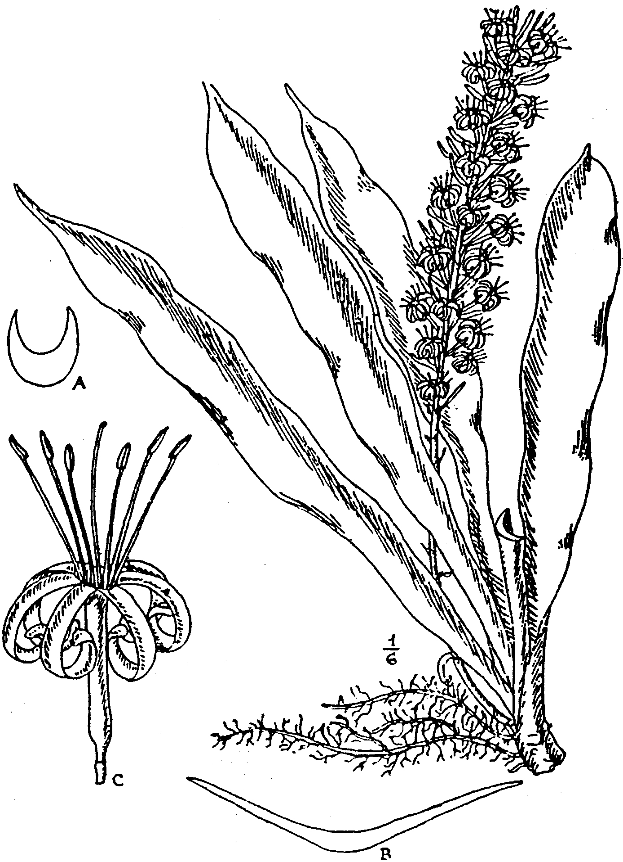
FIG. 18.
S. chinensis, Gentil. Plant ¹/₆ nat. size. A, section of petiole; B, section
of blade of leaf; C, flower. From part of the type plant cultivated
at Kew. Figs. A-C nat. size.
43. S. conspicua, N. E. Brown in Kew Bull. 1913. p. 306
(Fig. 19). Stemless, with a creeping reddish or purplish-red
rootstock ⅔- ¾ in. thick. Leaves 3-5 to a growth, ascending-
spreading, smooth, ¾ -2½ ft. long, 2-3¼ (mostly 3) in. broad, ¹/₁₂ in.
thick at the middle, lanceolate or elongated lanceolate, acute,
with a hardened point ¹/₁₂ -⅛ in. long- at the apex, narrowed from
below the middle to the base, where the leaves embrace one
another, not forming' a distinct petiole, often slightly twisted,
more or less wavy along the sides, with hardened brownish-red
margins ½ lin. broad, narrowly edged with white; dull green
on both sides, but somewhat darker above, with numerous inter-
rupted longitudinal lines of darker green from base to apex;
beneath, with a few longitudinal lines at the base only and
faintly marked when young with irregular transverse rows of
blotches or broken bands of paler green, which disappear with
age. Flower-stem 12-20 in. high, ⅓ in. thick, greyish-green,
suffused with dull purple and marked with minute paler specks;
basal part with 4-5 distant sub-membranous pale brownish
sheaths 1¼ -3½ in. long, gradually tapering from the base to a
very acute point; upper part with a rather compact spike-like
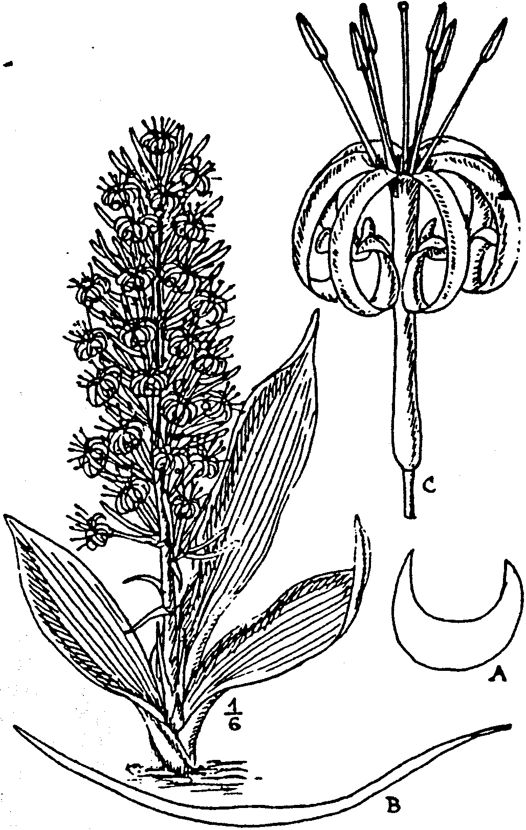
FIG. 19.
S. conspicua, N.E.Br. Plant ¹/₆ nat. size. A, section of petiole; B, sec-
tion at middle of leaf blade; C, flower. From a plant cultivated at
Kew. Figs. A-C nat. size.
raceme 10-12 in. long. Bracts membranous ¼ -½ in. long, linear-
lanceolate, subacute, reflexed. Flowers 3 in the lower and 1-2
in the upper dusters; pedicels 2-3 (when dried 1-2½) lin. long,
articulated close to the base of the perianth, with no deciduous
part; tube l½ -1⅔ in. long, rather slender, about ¹/₁₆ in. diam.,
but swollen and about ¹/₆ in. in diam. at the base, greenish-white;
lobes 1-1¼ in. long, linear, obtuse, revolute, white.
BRITISH EAST AFRICA. Near Mazeras, scarce, Powell, 12!
Described from a living plant sent in 1906 by Mr. H. Powell to
the Royal Botanic Gardens, Kew, where it flowered on Sept. 10,
1909. Specimens in the Paris Herbarium, collected near the
sea-shore of Zanzibar (this may mean the cost of German East
Africa and not the island of Zanzibar) by Sacleux (No. 1497),
may possibly belong to this species.
44. S. metallica. Ger. & Labr. in Bull. Mus. Hist. Nat. Paris,
1903, pp. 170, 173, fig. 2. Stemless, with a creeping rootstock
¾ -1 in. thick, of a rather bright red, changing to pale brown
when dry or exposed to the light. Leaves of adult plants 1-3 (very
rarely 4) to a growth, erect or with the upper part more or less
spreading or recurved, firmly coriaceous, smooth, 1½ -5 ft. long,
2-5 in. broad, 1-2 lin. thick at the middle, elongated lanceolate
or broadly strap-shaped, acute, with a soft subulate green point
1½ -3 lin. long at the apex, tapering downwards from about the
middle into a deeply channelled petiole ⅓-2 ft. long and ½ -1 in.
broad, sometimes there is a more or less evident channel down
the face of the leaf between the midrib and the margins, dull
dark green, not glaucous, somewhat obscurely marked above and
rather more distinctly beneath with irregular or interrupted
transverse bands or irregularly scattered or grouped blotches of
paler green, which often almost disappear with age; margins at
first green, becoming whitish or pale reddish-brown, not
hardened. Flower-stem 1½ -4 ft. high, ¹/₆ -²/₅ in. thick at the base,
light green, bearing on the lower half 3-6 distant membranous
whitish ovate-lanceolate very acute sheaths ^-4 in. long-, and at.
the upper part a somewhat lax spike-like raceme of flower-
clusters. Bracts ¼ -½ in. long, spreading, lanceolate, acuminate.
membranous, whitish. Flowers 2-4 in a cluster, white; pedicels
2-3½ lin. long, jointed close under the obconic base of the flower,
with no evident or but a very short (up to ½ lin. long) deciduous
part when alive, but when dried the base of the flower sometimes
contracts into a stalk-like part ½ -¾ lin. long; tube 6-8 lin. long,
shortly obconic but scarcely stalk-like at the base; lobes 8-11 lin.
long, linear, obtuse, revolute. --De Wildem., Notices Pl. Utiles
du Congo, pp. 624, 625, fig. 2. S. guineensis. Baker in Journ.
Linn. Soc. vol. xiv, p. 547, in Kew Bull., May, 1887, p. 5, fig. 1,
and Fl. Trop. Afr. vol. vii. p. 333, excluding all synonymy not
mentioned here; Engler, Pflanzenwelt, C, t. 5, figs. A-F;
De Wildem. Notices Pl. Utiles du Congo, p. 629, with fig., only;
Ann. Inst. Colon. Marseille, 1902. t. 1; Volkens in Notizbl.
Bot. Gart. Berlin, Append. 22, p. 52, fig. 120, not of Willdenow.
S. guineensis var. β, Schultes, Syst. Veg. vol. vii, p. 355.
TROPICAL AFRICA. Locality unknown, cultivated plants!
Described from a living plant, a portion of the type received
from the Paris Botanic Garden in 1903 at Kew, where it flowered
April 30. 1909 and Aug. 4, 1910. This plant is identical with
one that has been cultivated at Kew and elsewhere for many
years under the wrong name of S. guineensis. Gérôme and
Labroy, indeed, state that it appears to be only a variety of S.
guineensis, meaning the plant commonly cultivated. under that
name. They describe the leaves as having a metallic tint, but
this I have not observed on the plant as cultivated at Kew.

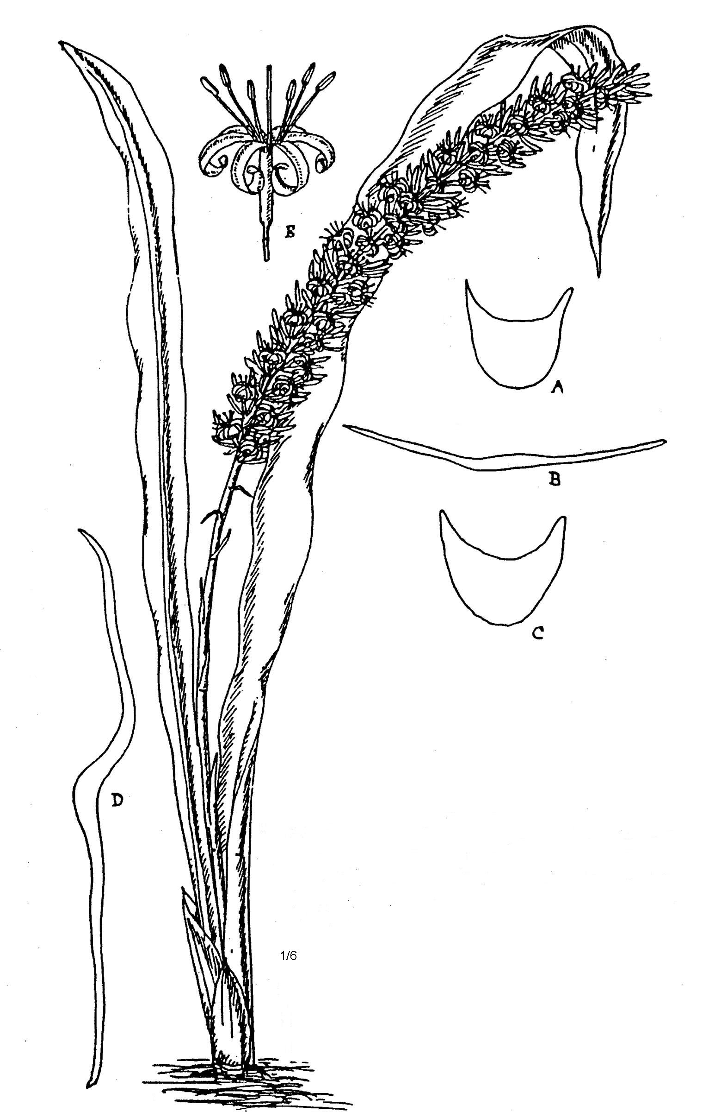
Fig. 20.
S. metallica, var. nyasica Ger & Labr., N.E. Br.
Plant ¹/₆ nat. size. A and C, sections of two
Different petioles; B and D, sections at the
Middle of a narrow and a broad leaf; E. a flower.
Figs A-E, nat size. From the type cultivated
At Kew.
Var. longituba, N. E. Brown. Flower-stem, brownish-green
or dull purplish, thickly speckled with pale green. Flowers with
pedicels 2-3½ long, jointed close under the However, with the
deciduous part 0-½ lin. long; tube 14 lin. long; lobes 14 lin. long.
Otherwise as in the type.
TROPICAL AFRICA. Locality unknown, cultivated plant!
Described from a living plant received from Paris Botanic
Garden in 1906, which flowered at Kew Nov. 8, 1909.
Var. nyasica, N. E. Brown (fig. 20). Flowers with pedicels
2-3 lin. long, jointed at or a little above the middle, with the
deciduous part about 1 lin. long; tube 7-8 lin. long, greenish-
white or tinged with red; lobes 9 lin. long, white. Otherwise as
in the type.
TROPICAL AFRICA. British Central Africa: Nyasaland,
Buchanan!
Described from a living plant sent to Kew from Nyasaland,
probably near Blantyre, by Sir John Buchanan, in 1892.
45. S. liberica, Gér. & Labr. in Bull. Mus. Hist. Nat. 1903,
pp. 170, 173, fig. 4. Stemless, with a creeping rootstock about
¾ in. thick, pale greyish. Leaves 1-3 to a growth, erect or suberect
when young, more or less spreading when old, firmly coriaceous,
at least when old, smooth, l½ -3¼ ft. long, 2-5 in. broad, lanceo-
late, tapering from above the middle or somewhat abruptly at
the upper part into an acute apex, with a subulate point 1-4 lin.
long, which is at first green, becoming whitish, but not much
hardened with age. tapering below the middle to a convolute
base, but scarcely forming a petiole, slightly wavy; at first deep
grass green, becoming dark green, sometimes without markings,
out usually with some rather indistinct transverse paler green
bands, often confined to the basal part of the leaf on the upper
side, but occurring far up or to the apex of the underside; mar-
gins cartilaginous, pale reddish-brown, at first with membranous
white edges, which disappear with age. Flowers not seen.--De
Wildem. Notices Pl.Utiles du Congo, pp. 624-625, fig. 4.
TROPICAL AFRICA. Liberia: Introduced into cultivation at
Paris by Dr. Julien in 1886.
Described from a living plant, a portion of the type, received
at Kew from the Paris Botanic Garden in 1903.
46. S. Dawei Stapf in Journ. Linn. Soc. vol. xxxvii, p. 529
(see Plates). Stemless, with a creeping rootstock up to 1 in. or
more thick. Leaves of adult plants 2-3 to a growth, ascending
or suberect, smooth above, slightly rough beneath, 2-5 ft. long,
2¼ -4½ in. (or more?) broad, elongate-lanceolate, tapering from
above the middle upwards to an acute apex and downwards into
a short or long concave-channelled petiole or sometimes almost
without a petiole, uniformly dull deep green and somewhat glau-
cous on both sides (Dawe), but in living plants seen, variegated
with pale green on both sides when young, margins reddish-
brown. Flower-stem 1½ -2½ ft. high, with 5-6 ovate or lanceo-
late acuminate membranous white sheaths on the basal third,
and a rather compact spike-like raceme of flower-clusters above.

Bracts ¼ -⅔. in. long, this the secondary being about half as large as
the primary and conspicuously, ovate or ovate-oblong, acute or
sub-obtuse, greenish or tinged with dull purplish. Flowers 3-4
in a cluster, white; pedicels 3-3 lin. long, jointed close under
the flower; tube ¾ -1 in. long; lobes ⅔-⅞ in. long
UGANDA. Busiro. Dawe, 109 ! Entebbe, Matron, 3 !
Described from the type specimens and living plants There
we also specimens at Kew collected between Voi and the Taita
Hills in British East Africa (Grenfell 2 & 12), and another
received from the Imperial Institute under No. 21342 as the
“Tuor. fibre plant from Uganda.” A living plant at Kew has
leaves green or bluish-green on both sides without markings
when full grown, but when young they are sometimes irregularly
marked with pale green spots or bands and usually with a dis-
tinct glaucous " bloom," they vary from 2½ up to 4¾ in. in
breadth. The flower-stem is of a lighter green than the leaves,
with indications of being tinged with purple where exposed to
the sun. Bracts up to ⅓ in. long, reflexed or very spreading,
ovate-lanceolate or narrowly lanceolate, acute. Tube of the
flower about 1¹/₆ in. long; lobes about 1 in. long. In all other
particulars it agrees with S. Dawei.
The photographs of this species have been kindly sent by Mr.
T. D. Maitland, District Agricultural Officer, Uganda, and were
taken from plants growing in a native compound.
47. S. angustiflora, Lindb. in Acta Soc. Fennicae, vol. x,
p. 130, t. 5. Stemless, with a thick creeping rootstock. Leaves
up to 12 to a growth, ascending or spreading, stiff, 1½ -2 ft long
l⅛-3 in. broad. 2-2½ lin. thick at the middle, narrowly or
elongated-lanceolate, acutely tapering above the middle to a sub-
ulate green or withered point ¹/₆-1 in. long, narrowed below into
a rather short deeply concave-channelled petiole, dull green,
marked -with numerous paler green transverse bands; margins
pale reddish (" whitish purple " Lindberg), but more or less
green or whitish-green when young. Flower-stem 1½ -2 ft. high,
⅓ in. thick at the base, green, obscurely marked with darker
green, indistinctly glaucous, with 4-5 tapering pale brownish
sheaths on the basal part and a spike-like raceme of flower-
clusters at the upper two-thirds. Bracts membranous, 3-4 lin.
long, ovate-lanceolate, acute. Flowers 3-6 in a cluster, whiter
with a greenish line down the back of the lobes; pedicels 1½ -2
lin. long, jointed near the apex; tube 9-10½ . lin. long; lobes
about &e long as the tube, linear, obtuse, revolute. --S. angusti-
folia (by error for S. angustiflora), Baker in Journ. Linm Soc.
vol. xiv. p. 547, under S. thyrsiflora.
SOUTH AFRICA. Natal or Zululand, Wood !
The native country of this species was unknown to Dr. Lind-
berg, but a plant sent to Kew from Durban Botanic Garden by
Dr. J. Medley Wood. as being a native of either Natal or
Zululand, so completely agrees with Dr. Lindberg's figure and
description that I cannot doubt its identity with that species,
of which Dr. Lindberg informs me no specimen has been pre-
served and that the plant is now dead. So that unless a portion

of the plant from which this species was described is still in
cultivation elsewhere, there seems little probability of confirming
my identification, which I nevertheless believe to be correct,
and this species is therefore the eastern representative of S.
thyrsiflora, to which it was referred as a synonym by Mr.
Baker, but essentially differs from that species by the more
numerous leaves (usually varying from 5 to 12) to a growth, by
their more elongated-lanceolate form, with the central part
more even in breadth, by their brighter and more pronounced
variegation and narrower reddish margin. Dried specimens or
living plants of it placed aide by side of those of S. thyrsiflora
seem perfectly distinct and are easily recognised. The above
description is entirely copied from that of Lindberg, without
reference to Dr. Wood's plant, but completely agrees with the
latter.
48. S. thyrsiflora, Thunb. Prodr. Pl. Cap. p. 65. Stemless,
with a stout creeping rootstock. Leaves, 2-4 to a growth, erect,
smooth, ½ -1½ ft. long, 1-3½ in. broad, about ⅛ in. thick at the
middle, lanceolate, acute or obtuse, and usually with a white
withered point up to 8 lin. long at the apex, but on some leaves
it is absent, tapering from or below the middle into a concave-
channelled petiole, dull green, marked on both sides with
numerous closely placed transverse paler green bands, which
become obscure or almost disappear with age; margins hardened,
brownish-red or sometimes whitish under cultivation. Flower-
stem 1½ -2½ ft. high, with 5-7 narrowly lanceolate or ovate-lanceo-
late sheaths 1-3 in. long and ½ in. broad on the basal part and
a spike-like raceme of flower-clusters above. Bracts 2-6 lin. long,
⅔-1½ lin broad, ovate-lanceolate to narrowly lanceolate. Acute,
spreading membranous. Flowers 2-6 in a cluster; pedicels 1½ -3
lin long, sometimes jointed a little above the middle, with a
distinct deciduous part, sometimes close under the flower, with
no evident deciduous part; tube about 9 lin. long, greenish-white;
lobes about 9 lin. long, linear, subobtuse. revolute, whitish. --
Thunb. Fl. Cap. ed Schultes, p. 329, excluding synonym; Pappe,
Flor. Cap. ed. 2, p. 40; Baker in Journ Linn Soc. vol. xiv,
p 547. in Kew Bulletin, May, 1887. pp. 8 and 3, fig. 4, and in
Fl Cap. vol. vi, p. 5. excluding synonyms S. fulvocincta. Haw.
and S. angustifolia, Bak.; Schinz in Bull Herb Boiss vol. iv.
Append. 3, p. 45. Gérôme and Labroy in Bull. Mus. Hist. :Nat.
Paris, 1903, pp. 172-173. fig. 6: De Wildeman Notices Pl.
Utiles du Congo, pp. 624-625, fig.,6, and p. 630 with fig.
S guineensis, Willd. Sp. Pl. vol. ii, p. 159, and Enum. Pl.
Hort. Berol. p. 375 (excluding synonym Aletris guineensis,
Jacq): Gawler in Bot. Mag. T. 1180 (1179 by error), Alton Hort.
Kew ed. 2, vol. ii. p. 278; Redouté. Liliarées. vol. v., t. 330
Drapiez, Herb. Amat. de Fl. vol.i. t. 67; Haworth. Synop Pl.
Succ. P. 65; Link. Enum. Pl. Hort. Berol. vol. i, p. 342;
Sprenge. Syst. Veg: vol. ii. p. 93; Schultes Syst. Veg.vol.
vii, p. 355. S. guineensis var. ß. Kunth. Enum.Pl. vol. v,
p. 16. S. spicata. Haw. Synop. Pl. Succ. p 66; Link Enum.
Plant. Hort1 Berol. vol i, p. 342; Sprengel, Syst. Veg. vol.

ii, p. 94; Schultes, Syst. Veg. vol. vii, p. 359; Kunth, Enum.
Pl. vol. v, p. 20. S. latifolia, Bojer, Hort. Maurit. p. 348.
S. hyacinthoides, Steud. Nom. Bot. ed. 2, vol. ii, p. 511.
S. rufocincta. Baker, in Journ. Linn. Soc. vol. xiv, p. 548, under
S. thyrsiflora. Sanseverinia thyrsiflora, Petagna, Institutiones
Botanica, vol. iii, p. 643. Salmia spicata, Cavanilles Icon. vol.
iii, p. 24, t. 246: Aloe guineensis radice geniculata etc., Com-
melin, Hort. Mod. Amstel. Rar. vol. ii, p. 39, fig. 20, and
Praelud. Bot. p. 84, fig. 33. Aloe hyacinthoides, var. guineensis,
Linn. Sp. Pl. ed. 1, p. 321. Aletris hyacinthoides var.
guineensis. Linn. Sp. Pl. ed. 2, p. 456; Aiton, Hort. Kew,
ed. 1, vol. i, p. 464.
SOUTH AFRICA. Uitenhage Div.: in woods by the Zwartkops
River, Zeyher, 612 ! near Enon, Drège, 8613 ! Baur, 1099 !
Albany Div.: without precise locality, Cooper, 3269 ! and culti-
vated specimens ! Very common along the coast region of East
London and Albany Divisions and extending into Queenstown
Div., where it grows on the summits of hills at 4000 ft. above sea
level, according to Galpin.
Described from living plants cultivated at Kew. Mr. Galpin
informs me that a factory was established in Grahamstown many
years ago to manufacture fibre from the leaves of this plant, but
it did not prove successful. Pappe states that the fleshy root-
stock "when boiled, is made use of internally in piles, and is
called t'Kay by the natives."
This plant appears to have been introduced into Dutch gardens
before 1701 and was supposed to have come from Guinea. In
consequence of this statement the identity of the plant figured by
Commelin with a South African species appears not to have been
suspected and hence much confusion has arisen. For although
Willdenow quoted S. thyrsiflora as a synonym, no attention has
been paid by later authors to this, and the specific name has been
applied to more than one Tropical African species, although bear-
ing little resemblance to Commelin's figure. One plant that has
been supposed to be S. guineensis is S. trifasciata, Prain (Aletris
hyacinthoides. Mill. and A. guineensis, .Jacq.). Another, which
is very widely cultivated under the name of S. guineensis, is
S. metallica, Gérôme. & Labroy., which see. The name Sanseverinia
thyrsiflora, Petagna, -was founded in 1787 upon Commelin's
figure, upon -which S. guineensis, Willd. was also founded at a
later date.
49. S. grandis, Hook. f. in Bot. Mag. t. 7877. Stemless, with
a creeping rootstock sometimes as much as 2 ft. long without
producing leaves, 1-1½ in. thick, whitish or green. Leaves 4-5
to a growth, ascending or ascending-spreading, very slightly
rough, 1-2 ft. long, 3½ -6 in. broad, ¹/₁₂-¹/₆ in. thick at the middle,
stiffly coriaceous, elliptic, oblong or broadly lanceolate, acute,
with a soft white point ¹/₆-¼ in. long, narrowed and all convolute
at the base, but scarcely petiolate, flat, with slightly wavy recurv-
ing borders having reddish-brown hardened margins ⅓ lin. broad,
with narrow membranous white edges when young, but soon dis-
appearing, dull glaucous-green or somewhat bluish-green, with

rather inconspicuous irregular transverse bars of lighter preen
on both sides, but more evident on the undersurface. Flower-
stem about 2 ft. high, 4-5 lin. thick below, the lower third with
4-5 distant sheathing membranous sheaths ½ -¾ in. long and as
much in breadth, ovate obtuse; upper two-thirds a compact spike-
like raceme. Bracts ⅛ -¼ in. long, membranous, ovate or ovate-
lanceolate, acute. Flowers white; pedicels 1-22 lin. long, jointed
at the apex, with scarcely any deciduous part; tube ¾ in. long,
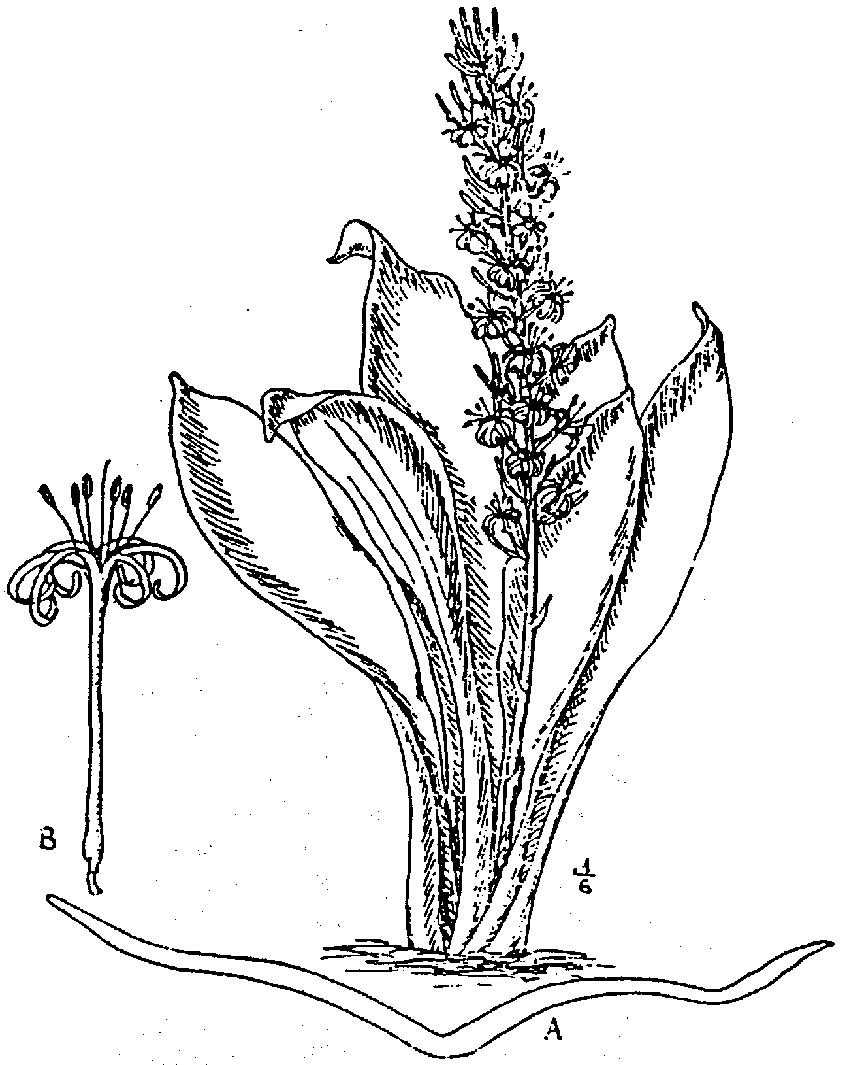
Fig. 21.
S. grandis. Hook. f. var. zuluensis, N.E.Br. Plant ¹/₆ nat. size. A, sec-
tion at middle of leaf, nat. size; B, flower, nat. size. From the type
plant cultivated at Kew.
rounded at the base; lobes ¾ in. long, linear, obtuse, revolute. --
De Wildeman, Notices Pl. Utiles du Congo, pp. 627, 633; Holland
in Kew Bulletin 1907, p. 369. S. nobilis, Godefroy-Lebeuf, Les
Sansevierias Gigantesques, p. 12, name only.
ORIGIN UNKNOWN. Probably native in South Africa, since
the variety described below seems only to differ in its flowers.
Described from the type plant, cultivated at Kew, originally
obtained from Cuba, where it had been imported for cultivation.

According to Messrs. Ide and Christie, Bot. Mag., it yields "a
good class fibre, much liked." Its value was then ₤35 per ton
(Sept., 1902).
Var. zuluensis, N. E. Brown (fig. 23). Leaves 2½ -4 in. broad.
Flowers with pedicels 2-3 lin. long, jointed at or slightly above
the middle, with a distinct deciduous part; tube 10-14 lin. long;
lobes 10-11 lin. long. Otherwise as in the type.
SOUTH AFRICA- Zululand, at Somkele, Wylie in Herb. Wood,
12,010 ! and cultivated specimens !
Described from living plants sent by Dr. J. Medley Wood in
1910 to Kew, where it flowered in September, 1911. The flowers
expand at about 4.30 p.m. The specimen from Nelspruit (see
Kew Bull. 1907, p. 369, under S. grandis) probably belongs to
this variety. The material consists of leaves only, which are
narrower than in the typical form.
50. S. Raffillii, N. E. Brown (fig. 24). Stemless, with a very
stout creeping rootstock ¾ -2 in. thick, whitish. Leaves of juvenile
plants 3-4, and of adult flowering plants 1-2 to a growth, with
some sheaths surrounding their base, erect, rigid, smooth
2-3½ ft. long, 2¼ -5 in. broad, ¼ -⅓ in. thick, elongated
lanceolate or broadly strap-shaped, acute, with a short hard
reddish-brown point, narrowed below the middle to a sessile base
or into a short stout concave petiole; when young handsomely
variegated with large elongated oval closely placed blotches or
broad irregular transverse bars of yellowish-green on a darker
green ground on both sides, or the paler markings on the back of
the leaf sometimes whitish, the paler colour occupying the greater
area, slightly glaucous, with age the markings become less con-
spicuous; margins hardened, reddish-brown. Flower-stem 3-3¾
ft. high, ½ -⅔ in. thick at the basal part, and there bearing 5-6
lanceolate acuminate or subulate pointed sheaths 2-5½ in. long,
of which the lower are rather rigid and coloured like the leaves,
the upper becoming thinner or membranous; the upper part of
the stem bears a spike-like raceme 2-2½ ft. long. Bracts 2½ -8 lin.
long, 1¼ -2½ lin. broad, ovate-lanceolate, acuminate, membranous,
pale greenish-white. Flowers 2-5 in a cluster; pedicels 2-3 lin.
long, jointed above the middle, with the persistent part 1¼ -2
lin. long and a very distinct deciduous part ⅔ -l lin. long; tube
1-1⅛ in. long, greenish-white, slightly glaucous; lobes l⅛-l¹/₆ in.
long, linear, obtuse, revolute, white.
BRITISH EAST AFRICA. Tsavo district, scarce, Powell, 7!
Described from a plant, which flowered at Kew Dec. 20, 1910.
Var. glauca, N. E. Brown --Leaves very dark bluish-green.
marked with distinct, but not very conspicuous, irregular spots
or somewhat zig-zag transverse bands of lighter green 1-2 in.
apart, very distinctly bluish-glaucous all over. Flower-stem
bluish-glaucous below, lighter green speckled with pale green
above, with the sheaths on its basal part very pale green or
whitish-green, dusted or banded with darker green, with sub-
membranous greenish or reddish tinted margins, not or but
slightly glaucous. Bracts incurved-spreading; the lower about
1 in. long and the upper about ⅓ in. long, linear-lanceolate, very

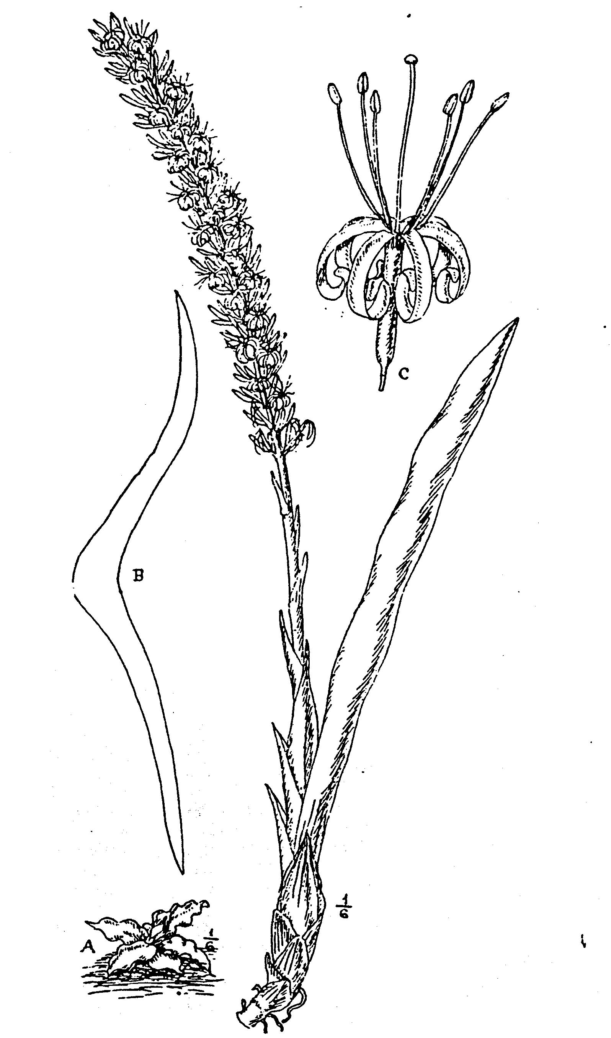
FIG. -22.
S. Raffillii, N.E.Br. Adult plant, and A, seedling, ¹/₆ nat. size; B, section
below middle of adult leaf, nat. size; C. flower, nat. size. From
the type cultivated at Kew. The anthers had fallen.
acute, green, with broad whitish margins. Pedicels 2½ -3 lin.
long, jointed at the apex, close under the swollen base of the
flower, with no distinct deciduous part, slightly glaucous. Other-
wise as in the type.
BRITISH EAST AFRICA. Tsavo district, scarce, Powell, 8 !
Described from a living plant, which flowered at Kew in
August, 1911. This species and its variety is very distinct from
all others, and has rather handsome foliage. From the length
and thickness of its rigid leaves it would probably yield a fibre
of about the same quality and bulk as that of S. Kirkii.
51. S. Kirkii, Baker in Kew Bull., May, 1887, pp. 8 and 3,
fig. 3 (Fig. 25). Stemless, with a stout creeping rootstock and
crowded leaf-tufts. Leaves 1-3 to a growth, very rigid or some-
times becoming stiffly coriaceous towards the apex, smooth. In
juvenile plants spreading or recurved-spreading, 7-15 in. or more
long, 1¾ -3¾ in. broad, scarcely or but shortly petiolate, concave
or flatfish, lanceolate, acute, tipped with a firm or hard pale
whitish-brown point ⅓-½ in. long, very wavy along the sides;
margins hardened, reddish-brown, and when young edged with
white, at length often breaking up into thread-like fibres. In
adult plants the leaves are 2½ -6 (or according to Kirk up to 9) ft.
long, 2⅓-3½ in. broad, 4-7 Tin. thick at about the middle, erect
or ascending-spreading, or in some cases the upper part is more
or less recurved or even drooping, elongate-lanceolate or broadly
strap-shaped, with the apex, wavy margins and edges as in the
juvenile leaves, but more or less hooded at the base of the stout
tip, flatfish or concave above, with a very broad rounded midrib
on the back, gradually narrowed from about the middle into a
very stout deeply concave-channelled petiole 1- 1¼ in. broad and
1½ in. thick from the edges to the very rounded back; both sur-
faces of all forms of leaf greyish-green on both sides or rather
light grass-green above and greyish-green beneath (as if densely
dusted with green and whitish or pale green), slightly shining
above, opaque beneath, mottled or with a tendency to be trans-
versely barred with whitish-green or with pale green above and
whitish-green beneath, more distinctly on the juvenile than on
the adult forms, both sides of the adult and some of the juvenile
leaves are marked with longitudinal dark green lines (becoming
slight furrows as the leaves wither from age), usually about 3-4
on the upper surface and 3-9 on the under surface, sometimes
extending a of the way up the leaves, sometimes very much
shorter. Flower-stem 1¼ -2 ft. high, ½ in. thick, dull purplish-
brown, thickly speckled with pale green or dull whitish, with 5-6
distant ovate acute sheaths 2-3 in. long and 1½ in. broad (when
flattened out), the upper of which are more or less spreading from
the stem and deeply boat-shaped, green, speckled with fuscous or
dull purplish brown at the tips. Flower-spike head-like, dense,
many-flowered, with an axis 1½ -2½ in. long. Lower bracts 1-1½
in. long, ⅓-¾ in. or more broad, the others gradually smaller;
ovate or oolong-ovate, acute or subobtuse, green, suffused with
dull purplish-brown and dotted with paler, the lower with 4, the
upper with 2 flowers in each axil. Flowers erect or ascending;

pedicels 3-5 lin. long, not jointed; tube about 4½ . long, pale,
purplish or dull pink; lobes 1¼ -1 ¾ lin. broad,
linear, obtuse, spreading, with revolute tips, white, tinged with
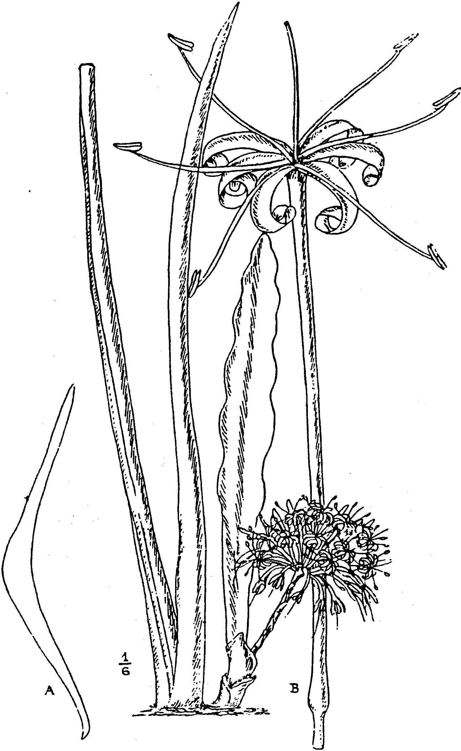
FIG, 23.
S. Kirkii. Baker. Plant ¹/₆ nat. size, the two longer leaves have their
margins inrolled in an unusual manner. A, section 4 ft. above base
of adult leaf, nat. size; B, flower, nat. size. From a plant cultivated
at Kew.

green on the back and at the tips. Baker in Kew Bull. 1893, p.
186, in Bot. Mag. t. 7357, and in Fl. Trop. Afr., vol. vii, p. 334;
Gérôme & Labroy in Bull. Mus. Hist. Nat. 1903, pp. 170, 172,
173, fig. 7; De Wildem. Notices Pl. Utiles du Congo, pp. 622,
624, 625, fig. 7, and pp. 632, 635. S. Aubrytiana, Gérôme &
Labroy in Bull. Mus. Hist. Nat. 1903, pp. 169, 172, 173, fig. 9,
not of Carrière. S. Aubryana, De Wildem. Notices Pl. Utiles du
Congo, pp. 623, 624, 625, f. 9, and p. 634. May.
TROPICAL AFRICA. German East Africa: Abundant near
Pangane, Kirk ! Zanzibar: Growing on the coral, Lyne, 3 ! at
the entrance of a cavern at the south of the island (this may
possibly be var. pulchra), Sacleux, 1496 !
Described from the type plant, cultivated at Kew, sent by Sir
John Kirk (see Kew Bull. May, 1887, p. 7, under S. longiflora).
Var. pulchra, .N. E. Br. --Leaves, especially the younger, hand-
somely and conspicuously marked with whitish-green or somewhat
buff-coloured or sometimes almost reddish spots or irregular
bands on both sides and with a white membranous edge to the
red-brown margin. Bracts lanceolate; otherwise as in the type.
S. longiflora, Gérôme & Labroy. in Bull. Mus. Hist. Nat. 1903,
pp. 172-173, fig. 8; and De Wildem., Notices Pl. Utiles du
Congo, pp. 624-625, fig. 8, and p. 630, not of Sims.
TROPICAL AFRICA. Zanzibar, Last !
Described from a living plant sent to Kew by Mr. Last from
Zanzibar in 1903, which flowered Sept. 10, 1912; a plant identical
with it was received from Paris Botanic Garden in 1904 under
the name of S. longiflora, from which it is quite distinct.

52. S. longiflora, Sims, Bot. Mag. t. 2634. --Stemless, with a
creeping rootstock. Leaves apparently smooth, 15-18 in. long,
3-3½ in. broad in the specimens seen, but perhaps attaining larger
dimensions, coriaceous, lanceolate, acute, with a hard brown spike-
like point ⅛-¼ in. long, narrowed at the base into a concave-
channelled petiole about 3 in. long, with hardened red-brown
margins and having (always?) a shallow channel or fold towards
each margin down the upper surface; dark green, marked on
both sides with blotches and spots of paler green, which are
scattered or arranged in irregular transverse bands. Flower-stem
with the part below the flowers 10-12 in. long, perhaps more in
robust specimens, bearing 5-7 thin sheaths 1-2¾ in. long, tapering
from the stem-clasping base to a very fine point; flowering part
3-15 in. long, forming a head or dense spike-like raceme. Bracts
ascending, ½ -l in. long, lanceolate, tapering to an acute point,
sub-membranous. Flowers, apparently 2-3 in the axil of each
bract, erect; pedicels ¾ -1½ lin. long, jointed close under the
flower, no deciduous part; tube 3½ -4 in. long and about ¹/₁₀ in.
in diam., greenish-white; lobes 1⅓ -½ in. long, linear, obtuse,
revolute, white. Schultes, Syst. Veg., vol. vii. pp. 357, 1678;
Kunth Enum. Pl., vol. v. p. 17; Monteiro, Angola and the River
Congo, vol. i. pp. 45, 103; Baker in Kew Bulletin, May, 1887,
p. 7, and Fl. Trop. Afr., vol. vii. p. 334, partly, as to the Congo
and Angola plant only; De Wildem., Mission E. Laurent, p. clvi.
TROPICAL AFRICA. Lower Congo. Chr. Smith ! Angola:
Ambriz, Monteiro ! Belgian Congo; Eala, Laurent.

Described from dried specimens. According to Monteiro it "is
only noticed north from Ambriz to Congo, and only growing very
near the sea: S. angolensis is but rarely seen with it. and it is
very curious how distinctly these two types ore separated." Else-
where he states that S. longiflora is extremely abundant and
disappears south almost entirely about Musserra, where it is in
turn replaced by ,S. angolensis" {S. cylindrica, Boj.).
Var. fernandopoensis, N. E. Brown. --Flowers with pedicels
2½ -3 1m. long, jointed just above the middle, and a tube 2½-3
in. long; otherwise apparently tlie same as the type.
TROPICAL AFRICA. Fernaudo Po, Barter, 2060 ! Mann, 1169 !
The plant figured in Karsten and Schenck Vegetationbilder,
vol. 5, t. 41 as being ,S. longiflora is not in the lenst like that
species, but is one of the kinds having cylindric leaves allied to
S. rhodesiana, which I nm unable to identify from the figure
53. S. bracteata, Baker in Trans. Linn. Soc. ser. 2, vol. i,
p. 253. Stemless with a creeping rootstock, ‘very thick, orange-
vermilion outside, white inside. Leaves erect, very thick and
rigid” (Welwitsch), adult forms 1¼ -2 (or more?) ft. long. 2 2¾
(or more?) in. broad, lanceolate, tapering into ;i point ¼ in. or
more long, and from or below the middle (in .specimens seen) into
a stout concave-channelled petiole, variegated on both sides with
irregular zigzag pale green or whitish-green bands or blotches,
which are usually much broader than the dark green ones alter-
nating with them, two or three of those at the base1 in. or more
broad, the rest. about half as broad, closely placed and more or less
spotted, "glaucous, spotted with white and green" (Welwitsch);
margins hardened, brownish-red, sometimes with whitish edge.
Flower-stem erect, 1½ -2 ft. high, with distant ovate acute sheaths
1-2 in. long on the basal part and a short dense spike-like raceme,
with an axis 2-2½ - in. long above. Bracts erect, ½ -¾ in. long,
lanceolate or oblong-lanceolate, acute. Flowers erect, white;
pedicels 1-1½ lin. long, jointed above the middle, with the per-
sistent part 1-1½ lin. long;; tube 3½ -4½ in. long; lobes about
1-1¼ in. long 1 lin. broad, linear-snb-spathulate. --Baker in Fl.
Trop. Afr. vol. vii, p. 333; Hiern, Cat. Afr. Pl. Welw. vol. ii,
P. 25.
ANGOLA. Plentiful in the districts of Icolo e Beno and
Loanda, from Quicuxe to Mutollo and towards Fnnda. Wel-
witsch, 3750 ! Pungo Andongo; in rather dry lofty parts of
the Praesidium. towards the south, Welwitsch, 3751 ! between the
Kubango and Kuito Rivers, Baum, 517 !
Baum states (Kunene-Sambesi Expedition, p. 510) that the
fibre of this species is used by the Kaffirs for making- nets. and
by the Bushmen for nooses to snare animals. This must be closely
allied to S. Aubrytiana, Carrière (not of Gérôme & Labroy) and
possibly a form of it.
54. S. Braunii, Engler & Krause in Engl. Jahrb. vol. Xlv,
p. 153. Leaves rigid. coriaceous l¾ -2¼ ft. long. 2 ¾ -4⅓ in. broad,
flat, lanceolate-oblong, acuminate, slightly narrowed to the base,
green, sparingly blotched or banded with whitish and having

hardened red-brown edges. Flower-stem 1½ ft. high, reddish,
with a flower-spike or head 6 in. in diam. Bracts small, lanceo-
late, acute, reddish. Flowers white; pedicels short, slender; tube
about 3¼ in. long; lobes about 1-1¼ in. long.
EAST AFRICA. Tjiji and Sigital, near Amani, Braun, 1976.

___________________

IMPERFECTLY KNOWN AND EXCLUDED SPECIES.
S. Aubrytiana, Carrière in Rev. Hort. 1861, pp. 448, 449. A
very vigorous plant, near S. longiflora, but distinguished from
that species by its greater vigour, usually larger leaves, more
tapering at the apex, of a lighter colour, very strongly banded
on both surfaces and more conspicuously than in S. longiflora.
GABOON. Sent to Paris Botanic Garden by Aubry-le-Comte,
when Governor of Gaboon.
Plant not seen, but S. bracteata, Baker, may possibly be the
same species. That which in 1909 was cultivated in the Paris
Botanic Garden under the name of S. Aubrytiana (doubtless of
Gérôme and Labroy) proves to be S. Kirkii, Baker, a native of
East Africa and Zanzibar.
S. cannaefolia, Spreng. Syst. Veg. vol. ii, p. 93, is Cordyline
cannaefolia, R. Br.
AUSTRALIA.
S. carnea, Andr. Bot. Rep. vol. vi, t. 361 (1804), is Reineckea
carnea, Kunth.
CHINA AND JAPAN.
S. cylindrica, Schweinfurth in Bull. Herb. Boiss. vol. ii,
Append. 2, p. 77, and Flori, Boschi e Piante Legn. Eritrea,
p. 105, not of Bojer.
TROPICAL AFRICA. Eritrea, Schweinfurth, 830, 1468 ! 1833,
1886.
This plant is totally different from S. cylindrica, Bojer, and
possibly an undescribed species. I have only seen No. 1468,
which is insufficient for a description. S. canaliculata, Carrière,
may possibly be included under the above name.
S. flavescens, Index. Kewensis, Suppl. 1, p. 379, is an error
for Schieckia flavescens, Maury.
S. flexuosa, Blume, Enum. PI. Jav. p. 11; Schultes, Syst. Veg.
vol. 7, pp. 360, 1678; Kunth, Enum. vol. v, p. 21, excluding
references to Hasskarl, is Pleomele flexuosa, N. E. Br.
This is quite distinct from Dracaena angustifolia, Roxb. (Pleo-
mele angustifolia, N. E. Br.), to which Mr. Baker has referred
it, and also from the plant formerly known in gardens as D.
flexuosa, under the supposition that it was the same as Blume's
plant. Both of those plants have a paniculate inflorescence,
whilst Blume's plant has a simple dense raceme.
Formerly cultivated in gardens in JAVA, perhaps a native.
S. flexuosa, Hasskarl in Tijdschrift Natur. Geschied. en Phys.
vol. ix, p. 135 & PI. Jav. Rar. p. 113, not of Blume, is Pleomele
falsa, N. E.Br.
This is a Pleomele which I fail to identify with any known
species and have therefore given it the above name. It is quite

distinct from the above mentioned S. flexnusa, Blume, in having
a paniculate inflorescence instead of a simple spike-like raceme.
JAVA.
S. fragrans, Jacq. Fragm. Bot. p. 5, t. 2, fig. 6 & p. 29, t. 33,
fig. 1, is Pleomele fragrans, N. E. Br. (Dracaena fragrans,
Gawler, Bot. Mag. t. 1081).
WEST TROPICAL AFRICA.
S. fruticosa, Blume, Enum. PI. Jav. p. 11; Schultes, Syst.
Veg. vol. 7, pp. 361, 1679, is Pleomele fruticosa, ;N. E. Br.
MOLLUCCA ISLES & JAVA.
S. fulvocincta. Haw. Suppl. Pl. Succ. p. 30. Leaves of a
young plant about 5, 6 in. long. (1 in. and 5 lin. broad, ex
Link), revolutely recurved, lurid green, obsoletely spotted,
slenderly margined with fulvous. (Flowers in fascicles,
racemosely arranged. Bracts longer than the pedicels. Style
rather longer than the stamens, ex Sprengel). --Link. Enum. PI.
Hort. Berol. vol i, p. 342; Spreng. Syst. Veg. vol. ii, p. 94;
Schultes, Syst. Veg. vol. iii, p. 300; Kunth, Enum. PI., vol. v,
p. 20.
BRAZIL. (?)
Described from a plant cultivated at Kew in 1818, and is evi-
dently only the juvenile state of possibly a well-known species.
S. glauca. Haw. Syn. PI. Succ. p. 65, not of Gérôme & Labroy.
Leaves about 11 to a tuft, spreading, somewhat flaccid, broadly
lanceolate-sword-shaped, glaucous, obsoletely banded. --Sprengel,
Syst. Veg. vol. ii, p. 93; Schultes, Syst. Veg. vol. vii, p. 359;
Kunth, Enum. PI. vol. v, p. 20.
Country unknown.
S. javanica, Blume, Enum. PI. Juv. p. 11; Schultes, Syst. Veg.
vol. vii, pp. 360, 1678, is Dracaena javanica, Kunth, Enum. Pl.
vol. v, p. 12, but probably belongs to the genus Pleomele.
JAVA.
S. laetevirens. Haw. Synop. PI. Succ. p. 66. Leaves about 3
to o growth, spreading, flaccid, broadly lanceolate-eusiform,
without veins, light green, with the transverse markings usually
obliterated. --Link, Enum. PI. Hort. Berol. vol. i, p. 342;
Sprengel, Syst. Veg. vol. ii, p. 93; Schultes, Syst. Veg. vol. vii,
p. 356; Kunth, Enum. PI. vol. v, p. 17.
Origin unknown and no plant seen.
S. paniculata, Schinz in Dur. and Schinz, Consp. Fl. Afr.
vol. v, p. 141, is Pleomele Hookeriana, N.E.Br.
SOUTH AFRICA.
S. polyphylla, Haw. Synop. PI. Succ. p. 65. Leaves about 19
to a growth, suberect, rigid, somewhat fragile, broadly lanceolate-
sword-shaped, obsoletely banded, glaucous. --Sprengel, Syst. Veg.
vol. ii. p. 93; Schultes, *Syst. Veg. vol. vii, p. 359; Kunth, Enum.
PI. vol. v, p. 20.
Country unknown. This may not belong to the genus.
S. pumila, De Spin, Jard. St. Sebast. ed. 2, p. 28 (not of Haw.).
Leaves short, thick, recurved, keeled, obscurely green-spotted.--
S. guineensis var. γ, Schultes, Syst. Veg. vol. vii, p. 355.
Country not stated, said to have been introduced before 1796.

Schultes states that De Spin had the plant in cultivation for 15
years without flowers being developed. From the description
given, it appears to me that there can be very little doubt that
this was a .seeding orjuvenile plant of some species that is now
probably well known. The juvenile state of several species is
very similar to such a plant as De Spin describes
S. rosea, Dietr- Bollstand. Lexic. Gaertn. & Bot. vol. viii,
p. 504, is Reineckea carnea, Kunth.
CHINA AND JAPAN.
S. sarmentosa, Jacq. Frngm. pp. 68 & 83, tt. 102 & 132, fig. 4,
is Reineckea carnea, Kunth.
CHINA AND JAPAN.
S. sessiliflora, Ker Gawl. in Bot. Mag. t. 739 is, Reineckea
carnea, Kunth.
CHINA AND JAPAN.
S. stenophylla. Link, Enum. PI. Hort. Berol. vol. i, p. 342.
Leaves very. long, not tapering to the base, slightly channelled
and marked with 3 longitudinal lines on the upper side, convex
and marked with 4 longitudinal lines on the under side, green,
not transversely banded. --Schultes, Svst. Vee. vol. vii p 359;
Kunth, Enum. PI. vol. v, p. 20.
Origin not stated.
S. striata, Don ex Steud. and S. venosa, Don ex Steud.
Nomencl. Bot. ed. 2, vol. ii, p. 511. Names only.
INDEX TO SPECIES AND SYNONYMS.

Acynthia guineensis. Medik. Sansevieria abyssinica, N. E. Br.
Aletris guineensis, Jacq.. “ aethiopica, Thunb
“ hyacinthoides, L. “ Andradae, Godefr. Leb.
“ “ var guineensis, L. “ angolensis, Welw.
“ “ var. . zeylanica. Ait. “ angustifolia, Baker
“ “ var. zeylanica, L. “ arborescens, Cornu
“ hyacinthoides, Mill “ Aubryana, De Wildem.
“ zeylanica, Lam “ Aubrytiana, Carr.
“ var. β Lam. “ Aubrytiana, Ger. & Labr
“ “ Mill “ bagamoyensis, N. E. Br
Aloe guineensis, Jacq “ bagamoyensis, N. E. Br
“ guineensis Radice. &c.Comm “ bracteata. Baker
“ hyacinthoides, L. “ Braunii, Engl & Krause
“ “ var. guineensis, L. “ burmanica, N. E. Br.
“ “ var. zeylanica, L. “ canaliculata, Carr.
“ zeylanica, Jacq. “ cannaefolia, Spreng.
Cordyline cannaefolla, R. Br. “ carnea, Andr.
Dracaena angustifolia, Roxb. “ caulescens, N. E. Br.
“ flexuoaa, Hort . “ chinensis. Gent.
“ fragrans, Gawl “ concinna, N. E. Br.
“ javanica, Kunth “ conspicua, N. E. Br.
Pleomele aloifolia, Saliab “ Cornui, Gér. & Labr.
“ angustifolia, N. E. Br. “ cylindrica, Baum
“ falsa, N. E. Br . “ cylindrica, Bojer
“ flexuosa, N. E. Br. “ “ var. patula, N.E. Br.
“ fragrans, N. E. Br. “ “ var. patula, N.E. Br.
“ fruticosa, N. E. Br. “ cylindrica, Schweinf.
“ Hookeriana, N. E. Br. “ Dawei, Stapf
Reineckea carnea, Kunth “ deserti. N. E. Br.
Salmia ebracteata, Cav . “ Dooneri, N. E. Br.
“ guineensis, Cav. “ Ehrenbergii, De Wildem.
“ spicata, Cav. “ Ehrenbergii, Ger. & Labr.
Sanseverinia rorida, Lanza “ Ehrenbergii, K. Schnm.
“ thyrsiflora, Petag. “ Ehrenbergii, Schweinf.

Sansevieria ensifolia, Haw Sansevieria patens, N. E Br.
" fasciata, Cornu “ Pearsonii,.N. E. Br.
" flavescens, Ind. Kew “ Perrotii, Warb.
" flexuosa, Blume “ Phillipsiae. N. E Br.
" flexuosa, Hassk. “ polyphylla, Haw.
“ fragrans, Jacq. “ Powellii, N. E Br.
“ fruticosa, Blume “ pumila. Haw.
" fulvocincta, Haw “ pumila, De Spin
" glauca, Gér. & Labr “ Raffillii, N. E. Br.
" glauca, Haw “ “var. glauca, N. E. Br.
“ gracilis, Haw . “rhodesiana. N. E. Br.
" grandicuspis, Haw “ robusta, N. E Br.
" grandis, Hook. f. “ rorida, N. E. Br.
" “ var. zuluensis. N. E. Br. “ rosea, Dietr.
" “ var. zuluensis. N. E. Br. “ Roxburghiana, Hook. f .
" guineensis, Baker & others “ Roxburghiana, Schult.
“ guineensis, Gér. &. Labr “ rufocincta, Baker
“ guineensis, Hort. “ sarmentosa, Jacq.
" guineensis, Willd. “ Schimperi, Baker
“ guineensis, Schweinf “ senegambica, Baker
“ guineensis, var. γ, Schult. “ sessiliflora, Ker.
“ hyacinthoides, Steud “ singularis, N. E. Br.
“ intermedia, N. E Br “ sordida, N. E. Br .
“ Jacquinii, N. E. Br. “ spicata, Haw.
“ javanica, Blume “ stenophylla, Link.
“ Kirkii, Baker “ striata, Don
“ “var. pulchra. N. E. Br. “ Stuckyi. Godefr. Leb.
“ laetevircns. Haw. “ subspicata, Baker
“ lanuginosa, Willd. “ subtilis, N. E. Br
“ lasciata. Gent . “ suffruticosa, N. E Br.
“ latifolia, Bojer “ sulcata. Baker & others
“ Laurentii, De Wildem. “ sulcata, Bojer
“ liberica. Gér .& Labr “ thyrsiflora, Thunb.
“ longiflora, Sims “ “ trifasciata, Prain
“ “ var. fernandopoensis, N. E. Br. “ “ var.Laurentii,N. E. Br
“ longiflora, Gér. &. Labr. “ varians, N. E. Br.
" metallica, Gér. & Labr “ venosa, Don
“ “ var. longituba, N E. Br. “ Volkensii, Gürke
“ “ var. longituba, N E. Br. “ zanzibarica, Gér. & Labr.
“ “ var. nyasica, N.E. Br “ zebrina, Gent.
“ nilotica. Baker “ zeylanica, Hort
“ “ var. obscura, N. E Br. “ zeylanica, Redoute
“ nobilis. Godefr.-Leb. “ zeylanica, Roxh.
“ paniculata, Schinz. “ zeylanica, Willd.
“ parva, N. E. Br Schieckia flavescens, Maury

Notes on Copying Brown’s Monograph

I decided to copy Brown’s Monograph for at least a couple of reasons – 1). To make the document more widely available to Sansevieria enthusiasts and 2). To “force” me to read it more closely.

Rather than just copy the pages as images I decided to turn them into an editable WORD document, thus forcing me to read VERY closely. But, although I decided to not change anything, this process will result in errors – hopefully not critical.

Italicized words are Italicized, spelling is the British form – thus travelling rather than the American form traveling; fibre rather than fiber. I may have caught Brown in a few misspellings, but I chose not to correct them. Bear in mind, it is particularly difficult to ensure correct copying of proper names and foreign words, especially Latin.

I conserved the line length, so individuals can depend on referring to a given page, paragraph, and line when making references.

At the bottom of page 7 and top of page 8 there appears to be some type-setter errors.

The indentation on the KEY was particularly troublesome. I did my best to ensure consistency.

Throughout the text, my scanner often “translated “rn” as “m” and “s” is sometimes interpreted as “a”. It is difficult to find and correct these if the resulting word in not misspelled.

In the key several line items are preceded by various special symbols. The original document offered no key to explain these, but I left them in anyway.

